Supplemental Material
Table of Contents
S-1 – Full project Overview. 2
S-2 - Confidentiality and security of the data. 3
S-3 – BERTopic pipeline breakdown. 3
S-4 - Intertopic Distance maps. 5
S-4.1 Full intertopic map 5
S-4.2 Reduced intertopic map 6
S-5 Discovered topics and definition table: 7
S-5.1 Summaries of ChatGPT for the intersection of EBP and Stigma by county 10
Description for County A: 10
Description for County B: 10
Description for County C: 11
Description for County D: 11
Description for County E: 11
Description for County F: 11
Description for County G: 11
Description for County H: 12
Description for County I: 12
Description for County J: 12
Description for County K: 12
Description for County L: 12
Description for County M: 13
S-6 - Nonparametric pairwise multiple comparisons in independent groups using Dunn’s test for Discussion Counts Table : 14
S-7 - Paragraphs example on the association between EBP and stigma: 15
S-8 Sentence examples for EBP types, race, and stigma separately. 16
EBP’s: 16
Individual Topics: 19
S-9 Sentence examples for the intersection of topics using context windows. 21
S-10 Contingency tables 23
S-11 Comparisons summaries about stigma and race between counties: 24
County A vs County B: 24
County A vs County C: 25
County B vs County C: 25
County A vs County D: 26
County A vs County E: 26
County B vs County E: 27
County D vs County E: 27
County A vs County F: 28
County C vs County F: 29
County E vs County F: 29
County A vs County G: 30
County B vs County G: 30
County C vs County G: 31
County D vs County G: 31
County F vs County G: 32
County A vs County H: 32
County B vs County H: 33
County C vs County H: 33
County D vs County H: 34
County E vs County H: 35
County F vs County H: 35
County G vs County H: 36
County A vs County I: 36
County G vs County I: 37
County H vs County I: 37
County A vs County J: 38
County B vs County J: 39
County C vs County J: 39
County D vs County J: 40
County E vs County J: 40
County F vs County J: 41
County H vs County J: 41
County I vs County J: 42
County A vs County K: 42
County B vs County K: 43
County C vs County K: 44
County D vs County K: 44
County E vs County K: 45
County F vs County K: 45
County G vs County K: 46
County I vs County K: 46
County J vs County K: 47
County A vs County L: 47
County B vs County L: 48
County C vs County L: 49
County D vs County L: 49
County F vs County L: 50
County H vs County L: 50
County I vs County L: 51
County K vs County L: 51
County A vs County M: 52
County B vs County M: 53
County D vs County M: 53
County F vs County M: 54
County H vs County M: 54
County I vs County M: 55
County J vs County M: 55
County K vs County M: 56

S-1 – Full project Overview.
During the HCS coalition meetings, researchers informed the coalition members that the meeting were recorded and the recordings would be used for research purposes in accordance with the IRB. Due to the COVID-19 pandemic, HCS conducted most of the coalitions’ meetings over Zoom, which allowed for the secure recording of coalition meetings. We analyzed a total of 127 meeting minutes. Of these meeting minutes, 37 were zoom recordings and/or audio recordings, and the remaining were transcriptions.
In the analysis, we considered sentences from these 127 minutes (totaling 67969 sentences) as the units of text mining analysis. We employed Machine Learning (ML) and Natural Language Processing (NLP) techniques, including Named Entity Recognition (NER), to de-identify the dataset, identify topics, and extract themes across the entire collection of documents. Additionally, we leveraged Large Language Models (LLMs) such as ChatGPT and BERT (Bidirectional Encoder Representations from Transformers) model's architecture, which is a pre-trained model in natural language processing (NLP). BERT is used to summarize, categorize, and classify relationships within the dataset, focusing either on the entire collection of sentences or specific topics of interest. We used an Application Programming Interface (API) to connect with Columbia University’s ChatGPT Enterprise to automate summaries across counties and various topics.

S-2 - Confidentiality and security of the data.
HCS research staff communicated to coalition members, both verbally during meetings and through the coalition charter, that all meeting transcripts would be de-identified and used solely for research purposes. This process aligns with the study’s IRB, including the protocol and related amendments for meeting recordings. For this study, we utilized Columbia University's ChatGPT Enterprise under a specific Columbia University contract, ensuring a walled guarded approach focused on data protection, privacy, and encryption. This system complies with the General Data Protection Regulation (GDPR) and the Health Insurance Portability and Accountability Act (HIPAA) to protect personal data. The server housing the data is protected by a firewall and is restricted through authenticated access, which includes features for traceability, trackability, and the maintenance of an audit trail.

The AI tools we employed operated on Columbia University's CUIT servers, equipped with four Nvidia A6000 GPUs. This infrastructure ensured more time-efficient processing and secure confidentiality of the results. Additionally, we used topic segmentation to manage summaries effectively, considering the token limitations of large language models (LLMs).

S-3 – BERTopic pipeline breakdown.

The BERTopic pipeline is a modern approach to topic modeling, designed to identify and extract coherent topics from large collections of text data. Unlike traditional topic modeling techniques such as Latent Dirichlet Allocation (LDA), BERTopic leverages state-of-the-art machine learning techniques, specifically transformer-based embeddings, dimensionality reduction, and density-based clustering, to generate more nuanced and semantically meaningful topics. This pipeline is highly flexible, offering various options at different stages, which allows researchers to tailor the approach to their specific needs. In this implementation, we have selected specific techniques for each stage to maximize the efficiency and interpretability of the topic modeling process.
Below is a detailed breakdown of the BERTopic pipeline and the choices made at each step:
- Document Embedding:
At the core of the BERTopic pipeline is the conversion of text into numerical representations, also known as document embeddings. For this, we use BERT (Bidirectional Encoder Representations from Transformers), a state-of-the-art language model that captures the semantic meaning of words and sentences. BERT generates dense vector representations of each document, where each vector reflects the contextual relationships between words, allowing for deeper understanding of the content. While there are multiple embedding models available, such as Doc2Vec or Sentence-BERT, we chose BERT for its ability to capture nuanced language and contextual relationships, making it ideal for topic modeling on diverse datasets.
- Dimensionality Reduction:
Once document embeddings are generated, the next challenge is the high dimensionality of these vectors. To address this, we apply UMAP (Uniform Manifold Approximation and Projection), a technique for dimensionality reduction. UMAP compresses these dense vectors into a lower-dimensional space, preserving the essential structure of the data while minimizing noise. Dimensionality reduction is crucial for improving the efficiency and interpretability of the subsequent clustering step. While alternatives like Principal Component Analysis (PCA) or t-SNE could have been used, we selected UMAP for its ability to maintain local and global structure, which is important for retaining semantic relationships during clustering.
- Clustering:
With the reduced document embeddings, we proceed to cluster the data into distinct groups or topics using HDBSCAN (Hierarchical Density-Based Spatial Clustering of Applications with Noise). HDBSCAN is a density-based clustering algorithm that identifies clusters of varying sizes and can effectively handle noise by labeling outliers. This flexibility makes it ideal for text data, where not every document fits neatly into a specific topic. In comparison to other clustering algorithms like K-means, which requires the number of clusters to be predefined, HDBSCAN dynamically determines the number of clusters based on the data’s density, making it more suited for discovering topics without prior knowledge of how many topics might exist.
- Topic Representation:
Once clusters (topics) are identified, the next step is to represent these topics in a meaningful way. For this, we generate a matrix of word counts using a bag-of-words (BoW) model, where the frequency of each word within each topic is recorded. However, simple word frequency alone is insufficient for differentiating between topics. To refine this, we use c-TF-IDF (Class-based Term Frequency-Inverse Document Frequency), which adjusts the word counts by considering the importance of words across all topics. This technique emphasizes words that are frequent within a particular topic but rare in other topics, allowing for clearer topic representation. While there are other methods, such as standard TF-IDF, we chose c-TF-IDF because it is specifically designed for topic modeling, offering better topic discrimination.

By following this pipeline, we ensure that the topics discovered are both semantically meaningful and well-separated, allowing for clearer insights into the underlying themes within the data. This approach provides flexibility at each stage, and our specific selections, BERT for embeddings, UMAP for dimensionality reduction, HDBSCAN for clustering, and c-TF-IDF for topic representation, were made to maximize the clarity and relevance of the topics generated from our dataset.

S-4 - Intertopic Distance maps.

S-4.1 Full intertopic map

The BERTopic library provides this visualization map, where circles represent topics: larger circles indicate more frequent topics, and overlapping circles suggest related topics. This visualization provides a valuable tool for exploring the identified topics and assessing their relevance within the corpus.

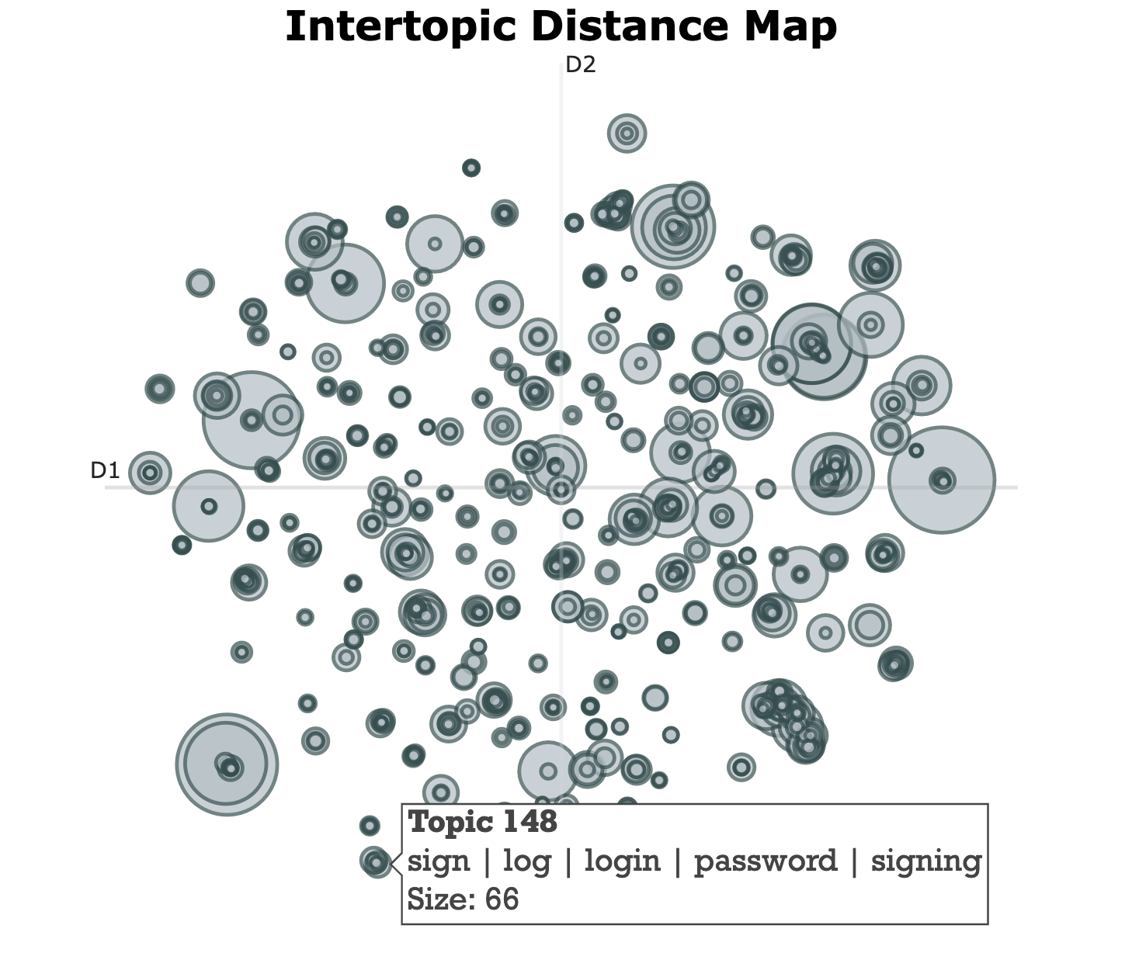
Figure 4.1 – The Topic Map of the Initial Set of 859 topics.

S-4.2 Reduced intertopic map
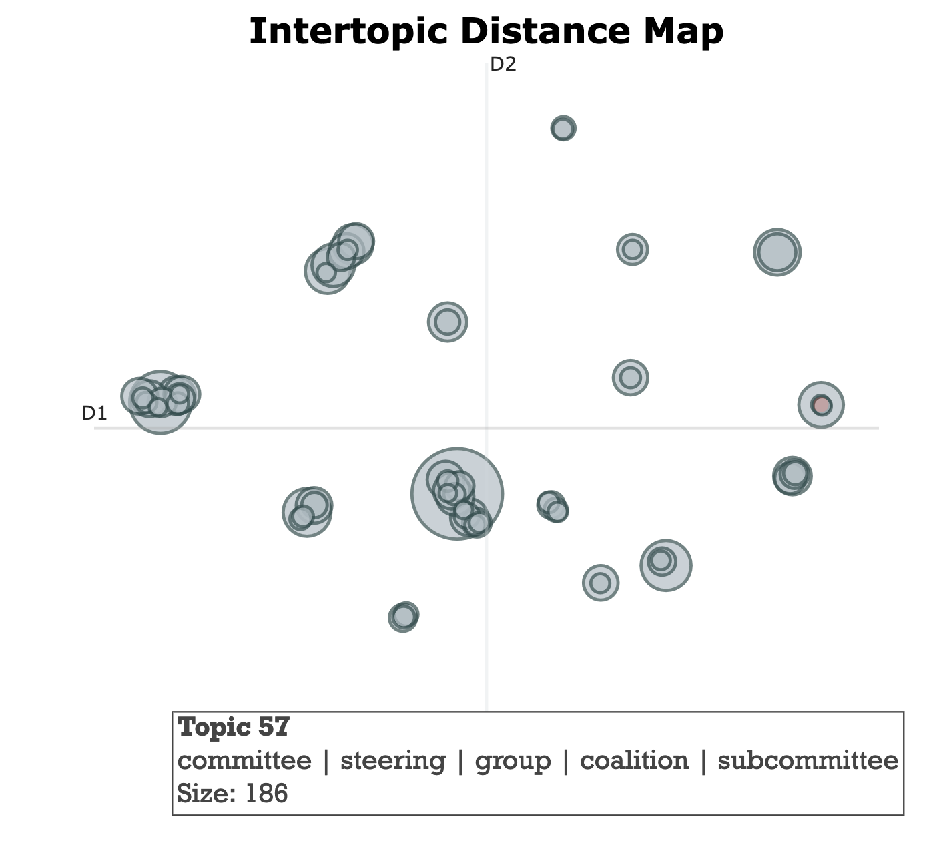
Figure 4.2 - Refined Topic Maps.

S-5 - Discovered topics and definition table:
Topic Number | Topic Name | Topic Definition | Percentages of Sentences
-1 | Outliers | Not related to other topics | 67.9%
1 | ‘Time management in discussions’ | Timing based on coalition meeting agenda | 5.9%
2 | ‘Patient Retention and Integrated Mental Health Treatment Services’ | People with OUD staying in treatment | 2.7%
3 | ‘Data Collection and Analysis’ | Research related topics | 1.8%
4 | ‘Campaign Media Materials and Strategy’ | Implemented communications and media projects used to combat stigma | 1.6%
5 | ‘Overdose Prevention and Post-Overdose Outreach Efforts’ | Related to Naloxone distribution | 1.4%
6 | ‘Fentanyl-Related Overdoses and Risks’ | A synthetic opioid found widely in the drug supply currently | 1.3%
7 | ‘Naloxone Education and Distribution’ | Naloxone is an opioid antagonist. It is used to rapidly reverse the effects of opioids and is available in both injectable and insufflated formulations. | 1.1%
8 | ‘Incarceration and judicial system’ | The full range of law enforcement and legally impacted social service programs | 1.1%
9 | ‘MOUD (Medication for Opioid Use Disorder)’ | The three FDA-approved medications used to treat OUD to improve patients’ health and wellness by reducing or eliminating withdrawal symptoms (methadone, buprenorphine); blunting or blocking the effects of illicit opioids (methadone, naltrexone, buprenorphine); and reducing or eliminating cravings to use opioids (methadone, naltrexone, buprenorphine) | 1.0%
10 | ‘Community harm reduction and recovery efforts’ | A strategy to prevent and reduce opioid/drug use–related risks among those who are actively using opioids/drugs but often are not ready to stop substance use or participate in treatment | 0.9%
11 | ‘Grant and Funding Strategies’ | Related to funding sustainability of evidence-based practices | 0.9%
12 | ‘Rural County Comparisons and Outreach’ | HCS communities had an equal distribution of rural and urban communities | 0.9%
13 | ‘Action Plan Implementation and Strategies’ | The mechanism for the coalitions to document the implementation of evidence-based practices | 0.9%
14 | ‘Opioid Use Disorder Response and Education’ | Related to OEND and MOUD EBPs implemented in communities | 0.9%
15 | ‘Narcan training and distribution strategies’ | Naloxone distribution | 0.9%
16 | ‘Pharmacy Medication Disposal and Pharmacist Education Initiatives’ | Safer prescribing and dispensing | 0.8%
17 | ‘Racial and Ethnic Demographics and Disparities in Society’ | Related to race and ethnicity | 0.2%
18 | ‘County Staff Training Needs and Plans’ | A component of the CTH intervention | 0.6%
19 | ‘Community Services and Needs Assessment’ | A component of the CTH intervention | 0.6%
20 | ‘COVID-19 Vaccination and Public Perception’ | Related to the COVID-19 pandemic | 0.6%
21 | ‘Comparison of Buprenorphine and Methadone in OUD Treatment’ | Both medications reduce or eliminate withdrawal symptoms | 0.5%
22 | ‘Survey completion’ | Evaluation data collection implementation | 0.5%
23 | ‘Sustainability Planning’ | Long-term planning at the end of the intervention with a focus on continuing the work of the intervention after the end of the study | 0.5%
24 | ‘Collaboration between Law Enforcement and Community Organizations’ | Community-based organizations and police working together | 0.4%
25 | ‘Installation and Distribution of Naloxboxes’ | Use of Naloxone housing units as a means to distribute the medication | 0.4%
26 | ‘Peer Support Services in the ED' | Within a hospital setting in the Emergency Department, the consultation service provided by a community-based peer support specialist or peer recovery coach to assist patients at risk for opioid overdose to “navigate” the human services system to become connected to those services and supports designed to meet their needs | 0.3%
27 | ‘Community Engagement and Support' | Implementation of the intervention | 0.3%
28 | ‘Safer Prescribing Practices’ | Practices related to prescribing of opioids | 0.3%
29 | ‘Community outreach efforts’ | Implementation of the intervention | 0.3%
30 | ‘Kit distribution and training’ | Naloxone distribution | 0.3%
31 | ‘Integrating Behavioral Health and Substance Use Disorder Services’ | Services to support people with OUD | 0.3%
32 | ‘Health Economics Survey’ | Data collection related to costing out the intervention | 0.3%
33 | ‘Program Details and Evaluation’ | Implementation of the intervention and evaluation of its efficacy | 0.2%
34 | ‘Fatalities in 2020 and 2021’ | Opioid overdose deaths | 0.2%
35 | ‘HCS Staff and Work’ | Research team implementing the study | 0.2%
36 | ‘Addressing stigma in the community’ | Stigma exists when negative labeling, stereotyping, status loss, and discrimination occur within a power structure that ultimately maintains and reproduces social inequities among marked populations | 0.2%
37 | ‘Gender, Age Demographics in Overdosing Cases’ | Demographic data on fatalities related to opioid overdoses | 0.5%

S-5.1 Summaries of ChatGPT for the intersection of EBP and Stigma by county

Description for County A:
The discussion regarding stigma in the provided text predominantly revolves around the need to address and reduce stigma associated with opioid use disorder (OUD) and medications for opioid use disorder (MOUD). The event aims to convey an underlying message of anti-stigma and highlight the experiences of community members utilizing MOUD to combat stigma. Additionally, there's a significant emphasis on educating healthcare professionals, including pharmacists and prescribers, to feel more confident in their roles and in prescribing MOUD, thereby improving patient interactions within the healthcare system and reducing stigma.

Description for County B:
The discussions highlight the pervasive issue of opioid use disorder and the stigma associated with it. Members of the committee emphasize the importance of changing attitudes within law enforcement and society, aiming to shift perspectives from criminalization to a harm reduction model. This effort includes increasing the accessibility of Narcan and implementing public educational initiatives to create awareness and reduce stigmatization, ultimately fostering a supportive environment for those battling opioid addiction.

Description for County C:
The discussion references a significant increase in overdose volume despite a decline in fatality rates. Harm reduction practices, such as peer outreach, Naloxone distribution, and linkage to Medication-Assisted Treatment (MAT), are emphasized as vital strategies. The dialogue also addresses the need for community involvement and stakeholder input to better understand and mitigate overdose risks locally.

Description for County D:
Discussions on stigma within the meeting focused on reducing the stigma associated with Narcan and opioid addiction. This includes highlighting the importance of recognizing opioid use disorder as a chronic condition that can be managed with medication, such as MOUD (Medications for Opioid Use Disorder), and advocating for anti-stigma awareness campaigns. Additionally, the meeting touched upon the necessity of addressing stigma both within healthcare settings and the broader community to improve engagement and retention in treatment programs.

Description for County E:
The discussion around stigma in the provided text centers primarily on the need to address and reduce prejudice faced by individuals using medications for opioid use disorder (MOUD). Efforts to enhance community knowledge about MOUD and its availability are seen as vital in reducing this stigma, as well as promoting understanding that treating opioid use disorder is a medical issue rather than a moral failing. Incorporating input from individuals with lived experience and increasing educational campaigns are identified as strategies to combat stigma and support recovery effectively.

Description for County F:
Discussion of stigma is not central to the provided text, but there are notable aspects relevant to understanding it within the context of opioid use disorder and its treatment. The text explores the distinction in prescribing patterns and behaviors across different regions and age groups, highlighting improvements and continued challenges. Moreover, it underscores the significant efforts in community-based interventions, harm reduction strategies, and Narcan dissemination to combat the opioid crisis and its associated stigma. The continuous engagement with both legislative bodies and community groups is also evident, aiming to foster broader understanding and support for harm reduction practices, which inherently address stigma.

Description for County G:
The discussion of stigma is primarily seen in the resistance to providing Naloxone kits to inmates upon their release. There is a suggestion that offering such harm reduction tools might be perceived as enabling drug use, reflecting underlying stigmatizing attitudes. Furthermore, it touches upon the broader societal stigma that may lead people to avoid seeking help or calling emergency services during overdoses, for fear of judgment or consequences.

Description for County H:
The discussion highlights various initiatives to combat opioid misuse and overdose, with a significant focus on MOUD (medication for opioid use disorder), naloxone distribution, and safer prescribing practices. Efforts are made to reduce stigma associated with opioid use disorder by promoting educational campaigns and personal recovery stories, emphasizing the importance of treatment. Through partnerships, training, and community engagement, the goal is to increase access to naloxone and support systems while fostering an environment that encourages recovery and reduces the stigma surrounding addiction.

Description for County I:
The primary discussion around stigma in the provided text focuses on the challenges and efforts related to reducing the stigma associated with Medication for Opioid Use Disorder (MOUD). Stigma is identified as a significant barrier preventing individuals from accessing and maintaining MOUD treatment, with common misconceptions including the belief that MOUD substitutes one addiction for another and that true recovery isn't possible with MOUD. To address these issues, the Healing Community Study Campaign aims to increase knowledge about MOUD, change negative perceptions, and highlight real-person stories to humanize and destigmatize the treatment.

Description for County J:
The discussion on stigma throughout this text appears in various segments, often relating to opioid use disorder (OUD) and the use of Naloxone. In particular, stigma is addressed in the context of promoting Naloxone training and distribution as a measure to save lives and normalize its use. There is a mention of stigma as a barrier to patients accepting Naloxone because they might not believe they need it, underscoring the importance of education and outreach to combat these misconceptions. Furthermore, installing Naloxbox cabinets publicly is viewed as a way to reduce stigma, similar to how defibrillators are used for heart attacks, to foster an environment where assisting someone with an overdose becomes as routine and accepted as other emergency interventions.

Description for County K:
The discussion addresses the significance of directly tackling stigma in opioid harm reduction and treatment efforts. It highlights the importance of explicitly stating that having a Naloxone kit does not violate probation rules to build trust and acceptance among users. Additionally, leveraging credible community figures like firefighters and involving peers can help normalize carrying and using naloxone, transforming it into standard first-aid knowledge, which is essential for reducing the stigma surrounding substance use and overdose prevention.

Description for County L:
The discussion of stigma in the provided text revolves around shifting the perception of Medication for Opioid Use Disorder (MOUD) and naloxone distribution. Stigma is acknowledged as a significant barrier, particularly the misconception that utilizing MOUD means one is still an active drug user, whereas it's reaffirmed multiple times that MOUD is a critical component of recovery. The focus on education for pharmacists, prescribers, and the community aims to reduce stigma, promoting understanding that treating opioid use disorder with medications like buprenorphine, Vivitrol, and methadone improves life quality and reduces health risks.

Description for County M:
The discussions of stigma in this meeting focus on the stigma associated with opioid use and overdose prevention efforts. It was noted that many people are unaware of what Narcan (Naloxone) is, viewing it as a highly safeguarded and expensive medication, highlighting the need for better education and distribution. There is also acknowledgment of the stigma pharmacies may face in distributing medication disposal packets and the broader community’s challenges in openly discussing and addressing opioid use disorder.

S-6 - Nonparametric pairwise multiple comparisons in independent groups using Dunn’s test for Discussion Counts Table:
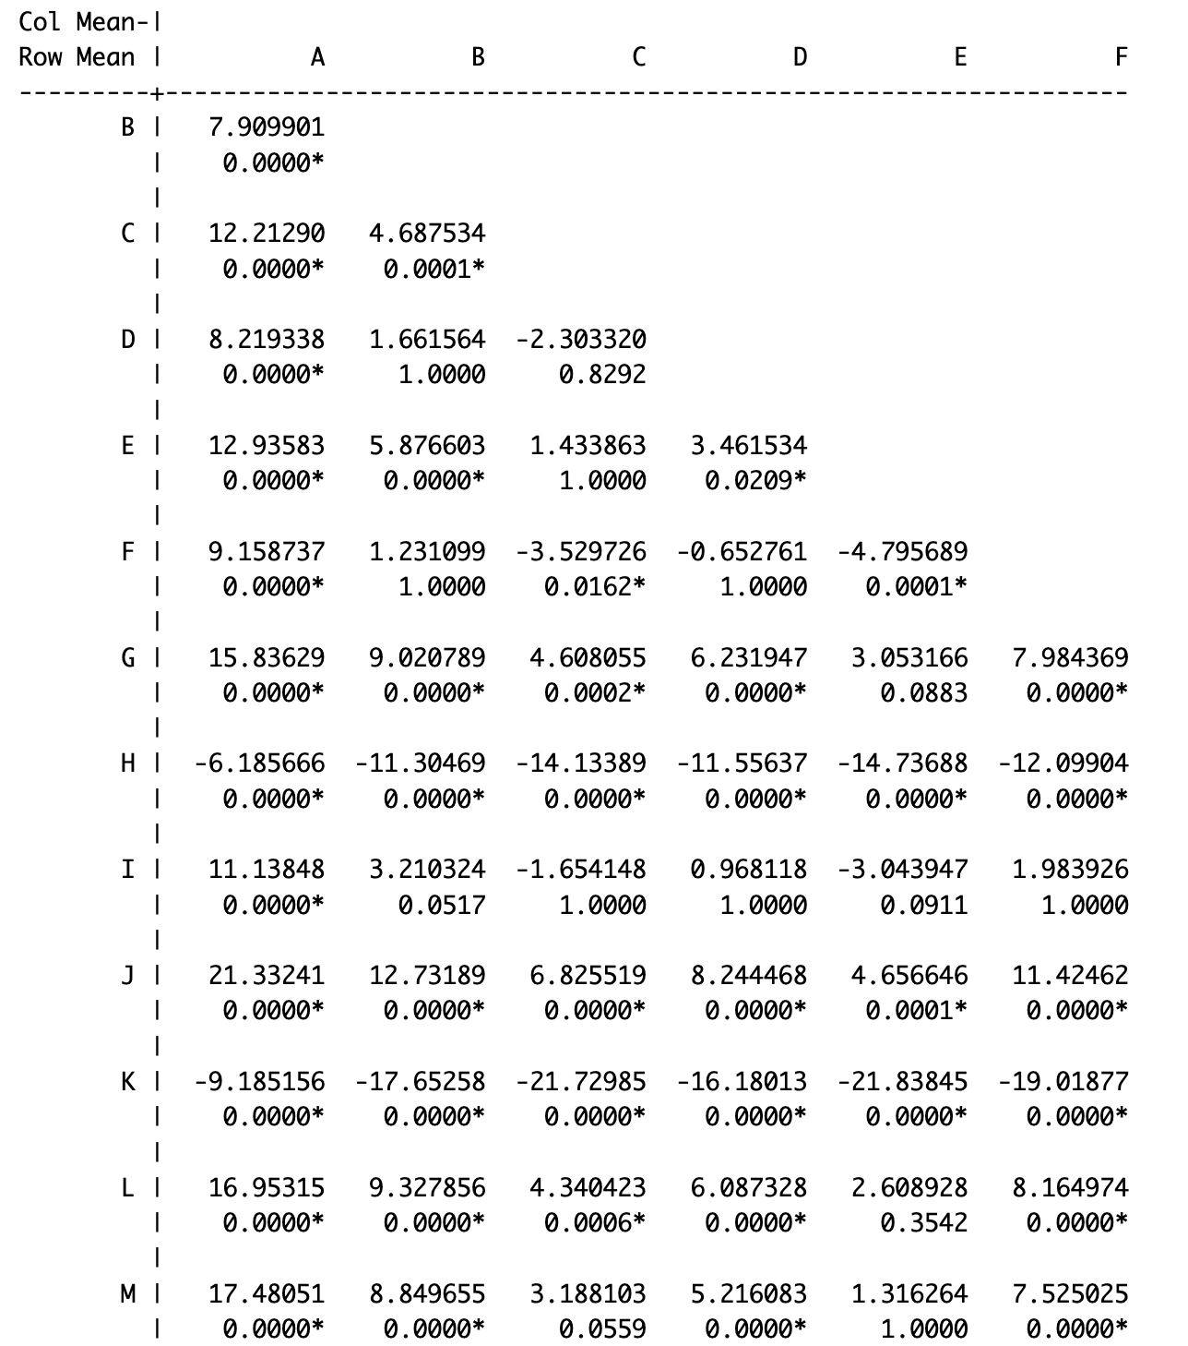
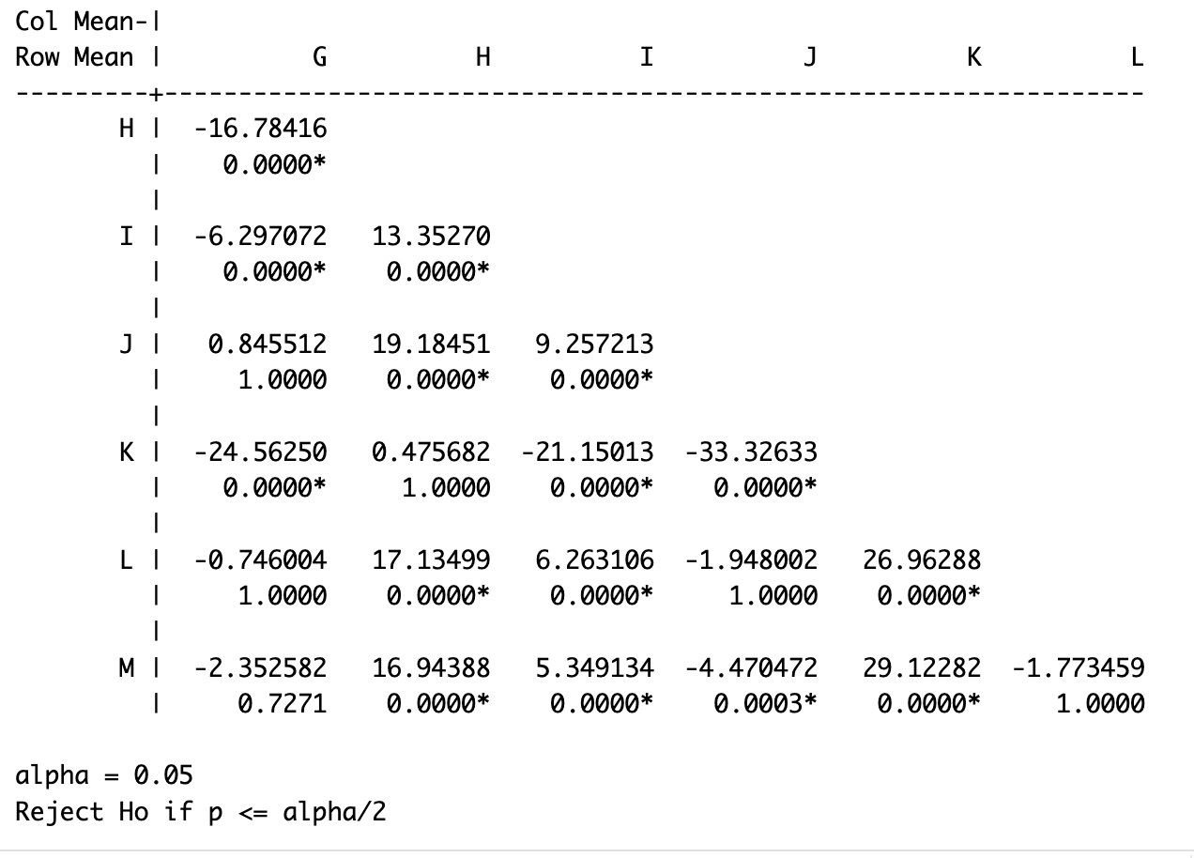
S-7 - Paragraph examples on the association between EBPs and stigma:

EBP MOUD and Stigma:
We also have an ad in Spanish to reach another target population from Campaign One. That was a portion of the paid media produced in collaboration with 105.5 The Beat and other partners. The next slide shows a snippet of our events and press releases, as well as billboards from early January. This concludes Campaign One—thank you for the support as we continue.
Now, onto Campaign Two, focusing on Medication for Opioid Use Disorder (MOUD). The goal is to raise awareness and knowledge of MOUD and reduce stigma. We need an all-hands-on-deck approach to disseminate campaign materials and social media posts. Here are the key tasks and dates: Our communications workgroup is developing our dissemination plan, customizing material, and has other tasks on the horizon. The goal is to increase knowledge of MOUD availability and reduce stigma, ultimately increasing access to and demand for MOUD. We’ve assigned SMART objectives to these goals.

EBP OEND and Stigma
We had a NaloxBox request from Ulta—this was the first big, huge business retailer request for a NaloxBox, and McNamara can give some background as to why they made this request. McNamara: “Chat, we have up to 270 days so far, yes.”

So, Ulta actually called the Department of Health, and I received the voicemail. Unfortunately, they experienced an overdose in the parking lot. Fortunately, someone had Narcan on them, and they ran out and saved that person’s life. As a result, the general manager called the Department of Health, let us know, and they requested staff training. One person happened to have Narcan, but it wasn’t because of an institutional decision—they were lucky. So, they wanted to make sure that moving forward, they could respond to these incidents more effectively.

We connected them to an OOPP (Opioid Overdose Prevention Program) provider, and I believe HVCS is handling that. They’re going to be doing a staff training, and I offered a NaloxBox, which they were more than happy to accept. It’s very exciting and really incredible. This wasn’t the result of any legwork we were doing; it was the community reaching out to us. And that’s something to be so, so proud of, to know that the stigma is decreasing through all the work that’s happening out there.

EBP Safer prescribing and Stigma:
And, you know, your little safer prescribing group is like—I love hearing about the ideas that are generated because they are innovative. Um, and, you know, funeral homes—I, when you first, she said it to me, and I was like, “What?” You know? And, you know, but it really is so many other areas that we can look at.

It was unfortunate with pharmacies that they pulled out, and we’ve talked a lot about this. We recognize that there might still be quite a bit of stigma out there for pharmacies in this space. So, we are starting to think internally about how we can begin to reduce stigma in pharmacies and with pharmacists, and how we can break down barriers, because we feel like that’s key. Initially, we just thought, well, maybe they just aren’t interested. But the more we, the more we, um, the more time that went on, the more we started to let this percolate, we started to recognize that it very well could be much more than that.

Um, so we’re going to figure out ways to address it. Your safer prescribing group still has more work to do—always. But I consider the safer prescribing group to be the little engine that could. Yeah, there’s only a few of us, but we’re pushing forward. That’s it. We definitely are.

S-8 - Sentence examples for EBP types, race, and stigma separately.

EBP’s:

EBP Type | Sample Sentences | Summary Descriptions for all sentences (via chatGPT)
EBP-MOUD | - Has volunteered to be a liaison because they have chaired the MOUD workgroup for the last couple of years.  - MOUD enhancements have evolved, with ongoing project support. They are currently implementing various enhancements and expansions.  - Check it out here: https://sites.google.com/view/uc-moud-list/home. No further details provided.  - The next grouping with voting results was the MOUD.  - We will be organizing discussions and planning for the MOUD workgroup, incorporating this into our existing workgroup to continue making progress. | The discussion centers on updates and strategies related to MOUD (Medication for Opioid Use Disorder) within various workgroups. The agenda involves expanding access to MOUD, increasing the number of trained and waiver-certified providers, and improving retention in treatment through strategies such as telemedicine and peer support. Numerous initiatives, such as maintaining a live MOUD provider list, utilizing telehealth, and addressing stigma associated with MOUD, are highlighted, with ongoing efforts to enhance community engagement and data collection to improve treatment outcomes.
EBP-OEND | - The state has authorized a protocol for first responders to start treatment for overdoses on the spot, without needing to go to the emergency room.  - There are cases where law enforcement labels a death as a fatal overdose without it being finalized.  - Around 400 care packages have been created.  - A quick review of Narcan strategies and data collection methods is provided.  - During incarceration, individuals are trained by classification officers to recognize overdose signs and respond with naloxone. | The discussion primarily revolves around the initiatives and challenges associated with Naloxone (Narcan) distribution and training efforts aimed at combating opioid overdoses, both nationally and within specific communities. Topics include the strategic placement of Naloxone kits, training for individuals (especially those on probation), the integration of Naloxone education into various environments such as jails and schools, engagement with community organizations and businesses, and monitoring overdose data to inform ongoing and future strategies. Additionally, the broader context of harm reduction and the importance of community engagement and education in addressing the opioid crisis are emphasized.
EBP-safer prescribing | - Your safer prescribing group generates innovative ideas. When it was first mentioned, I was surprised, especially with the involvement of funeral homes.  - I’ve been discussing with our pharmacy champion about their involvement post-study.  - A couple of weeks ago during our biweekly safer prescribing meeting, I mentioned this presentation.  - The approach in our curriculum teaches pharmacists to provide tools and resources to patients, helping them understand local services and becoming part of the solution.  - Their practice includes five or six prescribers serving the community. | The discussion heavily revolves around strategies to improve safer prescribing and medication disposal practices, especially in collaboration with local pharmacies. The main focus is on involving independent pharmacies in a voucher program and expanding the role of pharmacists through education and harm reduction strategies. Regular meetings and conferences are planned to train pharmacists and prescribers on safer prescribing practices, with efforts to distribute educational materials and medication disposal packets via various community channels, including pharmacies and other high-risk population contacts.
Non-EBP | - So there’s my report for this month.  - I think we’ve got everybody.  - Yeah, I mean, we certainly don’t want to tell people.  - I just want to say quickly that we, and I, have had a lot of back and forth about this.  - Those reach measures are listed in the appendix, which can be shown as well. | The dialogue covers a range of discussions about program updates, strategy planning, and logistical concerns related to healthcare and community initiatives. Key points include the need for training and transportation for clients, program appreciation, data collection challenges, and sustainability planning. The settings are diverse, involving healthcare providers, community agencies, and government partners, all working towards improving healthcare services and community support systems.

Individual Topics:

Topic | Sample Sentences | Summary Descriptions (via chatGPT)
Race and Ethnicity | - Again, looking at race and gender for 2022, primarily Caucasian males.  - We have Hispanic, white, black, and other categories located on the dashboard.  - The adults were hesitant to come out, some due to being undocumented.  - There was a slight increase in the Hispanic population, but it was very small.  - The data you’re looking at here are more complete forms, showing the breakdown by race and ethnicity. | The discussion focuses on analyzing demographic data, particularly race and ethnicity, to understand social and economic trends, disparities, and outcomes in specific towns or communities. Key points include the importance of accurately recording and visualizing race and ethnicity data to tailor responses, the challenge of collecting complete data, and the observed disparities in outcomes like overdoses and fatalities among different racial groups. The goal is to enhance data quality and representation to better serve minority populations and address systemic inequities.
Addressing Stigma | - I would suggest including St. John Fisher School of Pharmacy in your anti-stigma campaign.  - Feedback may not be recognized or taken seriously, which is part of the stigma of being dismissed or not heard.  - Attitudes and stigma around this strategy need to be addressed among staff, supervisors, leadership, and within this group.  - I appreciate your support; this is part of breaking the stigma.  - We want to discuss stigma and the barriers to operating. | The sentences primarily focuses on addressing and breaking the stigma associated with various social and healthcare issues. It highlights the pervasive nature of stigma across different sectors, including healthcare, workplaces, and communities, and emphasizes the importance of community efforts, education, and campaigns to reduce this stigma. The conversation illustrates multiple approaches, such as stigma reduction training, community outreach, and supportive messaging, to foster more inclusive and supportive environments for affected individuals.

S-9 - Sentence examples for the intersection of topics using context windows.

Topics | Sample sentences | Text around via context window
Stigma and Race | There’s been a positive shift locally, but there’s still room for improvement. | May I interject for a moment? I agree that exploring non-pharmaceutical approaches is necessary, but we also need to acknowledge situations where patients are unjustly denied medication due to stigma, which is sometimes linked to race. For example, I was denied a few days’ worth of painkillers during a chronic sinus infection, and I eventually had to visit the ER, where I was given a full week’s worth of medication—far more than I needed. So, while there’s a need for non-pharmaceutical strategies, there are situations where strong pain medication is absolutely required. It’s crucial to educate people about alternative treatments. There’s been a positive shift locally, but there’s still room for improvement. For instance, after a tooth extraction, I was offered a prescription for painkillers that I didn’t even need. It can go both ways. I wasn’t informed about the medication, including the fact that it was a controlled substance and highly addictive. So, I believe more education around prescribing is essential. And I just wanted to quickly add that point.
 | Some of the speculations as to why we might be seeing this now are due to disproportionate access to treatment. | What we’re trying to understand now is why this rise is occurring. Historically, when we look back to the beginning of the opioid crisis, we didn’t see this pattern. Some research has shown that the opioid crisis initially had a more significant impact on the white population. This was thought to be a consequence of prescribing practices, where opioids were prescribed more frequently to white individuals, while Black individuals were less likely to be prescribed opioids for pain management. One of the key drivers of the opioid crisis was overprescribing, which primarily affected the white population.  At the time, we weren’t seeing a proportional rise in opioid overdose deaths among Black individuals. Now, some speculations as to why we might be seeing this rise include disproportionate access to treatment. Dr. [name], the director of NIDA, mentioned in a recent NPR article that Black Americans with opioid use disorder are significantly less likely to be prescribed medications for opioid use disorder. This lack of parity in treatment access between Black individuals and other ethnic or racial groups seems to be a factor.  Additionally, stigma in the medical community has played a role. There’s stigma around viewing opioid use in the Black population as a criminal issue rather than a medical one. As a result, treatment isn’t being provided at the same level, and many individuals are not seeking treatment either. This combination of disproportionate access to treatment, provider stigma, and differing perceptions of opioid use is contributing to the disparities we are seeing.

S-10 - Contingency tables

S-10.1 EBP_types vs sentences related to Stigma for each county.

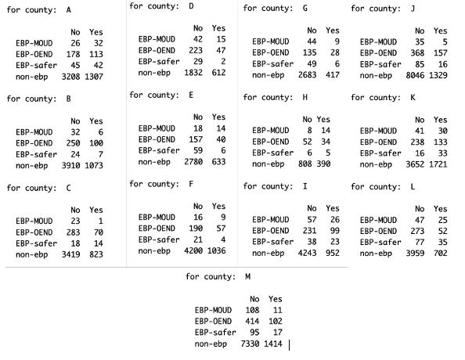

S-10.2 Sentences related to Race vs Sentences related to stigma

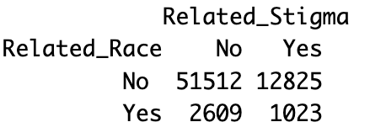

S-10.3 Amount of sentences that discussed 0 (no topics), 1 (at least 1 topic from race or stigma) and 2 (both topics) by county.

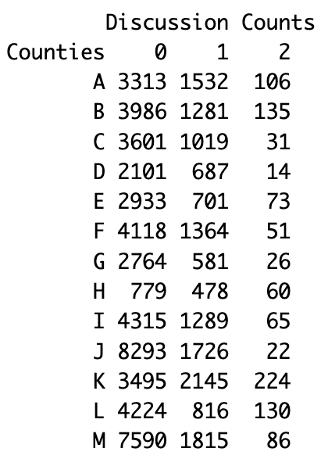

S-11 - Comparisons summaries about stigma and race between counties:
The following summaries are comparisons between two counties with a statistically significant p-value produced by the Dunn test performed in the analysis. The summary explores the similarities and differences related to stigma and race.

County A vs County B:

Similarities:

Both A and B counties are addressing issues related to racial and ethnic demographics and the stigma associated with certain populations or behaviors. Both locales are actively engaged in discussions about overcoming stigma, particularly in healthcare and social services. There is an evident emphasis on gathering data to better understand and address disparities among different racial and ethnic groups. Additionally, both regions highlight the importance of breaking down stigma and promoting non-judgmental and inclusive conversations to foster better community health outcomes.

Differences:

In A County, there is a more explicit focus on various racial demographics such as Black, Hispanic, and multiracial populations, with references to specific challenges in data accessibility and representation. The discourse in A also appears to emphasize legislative and community challenges related to stigma. Conversely, B County centers heavily on the ethics of combating stigma and includes specific data metrics on interventions like Narcan administration and MOUD (Medication for Opioid Use Disorder) initiatives. B further highlights the barriers faced by minority populations, such as the perceived neglect in data collection due to their smaller population size, which is less emphasized in the A context.

County A vs County C:

Similarities:

Both A and C counties actively discuss stigma and its impact on their communities, with a particular focus on race and ethnicity. In both lists, there is a clear emphasis on the need for stigma reduction in terms of substance use, as well as the importance of addressing bias and ensuring open and nonjudgmental dialogue. Additionally, both sets of sentences mention the use of data and surveys to measure and understand the prevalence and effects of stigma within their populations.

Differences:

While A puts considerable emphasis on specific demographic information and the prevalence of particular ethnic groups like Hispanic and Black communities, C appears more focused on the qualitative aspects and perceptions related to stigma. C’s discussion often revolves around training and community engagement to reduce bias and improve harm reduction practices. Conversely, A’s conversation includes more references to legislative challenges and real-life initiatives, such as community meetings aimed at addressing stigma.

County B vs County C:

Similarities:

Both B and C counties discuss themes of stigma, race, and ethnicity in relation to various social issues. Both highlight the importance of data collection and awareness in addressing these topics. The counties also touch on community response, indicating a shared focus on reducing stigma and fostering inclusivity. Additionally, there is an acknowledgment of the role professionals play in combating stigma, with mentions of ethical imperatives and diversity considerations.

Differences:

There are notable differences in the focus and depth of the discussions. B’s conversations are more oriented towards practical data collection methods and treatment outcomes, with specific statistics on demographic participation and various community settings. C’s narrative, in contrast, shows a strong emphasis on internalized stigma and broad community initiatives, like stigma buster teams and community surveys. Furthermore, C appears to have a more pronounced concern about specific marginalized groups, including the LGBTQ community, showcasing a broader scope in addressing disparities.

County A vs County D:

Similarities:

Both A and D counties are actively addressing the issues of stigma in their communities. They recognize stigma as a barrier to effective community engagement and the provision of services. Both counties have mentioned efforts to reduce stigma, such as media campaigns and legislative challenges, highlighting the importance of creating supportive environments for all community members. Additionally, there are shared concerns about the impact stigma has on accessing services and the reluctance to engage due to fear of judgment or dismissal.

Differences:

While A County mentions a more diverse array of demographics and explicitly highlights the challenges associated with different racial and ethnic groups, D focuses more on the structural and procedural aspects of combating stigma. A discusses specific racial and ethnic populations, such as Black, Hispanic, and multiracial communities, and the lack of race-based data availability. In contrast, D emphasizes the role of stigma in agency relationships and community trust. A’s approach includes mentions of legislative actions and community-led efforts, while D appears to be more focused on policy development, cultural norms, and designated roles like a ‘communication champion’ for anti-stigma campaigns.

County A vs County E:

Similarities:

Both A and E counties emphasize the significance of addressing stigma within their communities. Each highlights the persistence of stigma in various contexts, including healthcare, substance use, and community interactions. They both recognize the importance of community initiatives such as town hall meetings and public forums to reduce stigma. Additionally, both counties acknowledge the need for respectful and appropriate language when discussing stigmatized issues.

Differences:

A County’s discourse is more focused on the demographics, explicitly mentioning racial and ethnic breakdowns and the challenges in accessing race-based data. There’s a distinct emphasis on legislative challenges and interactions with community leaders to address stigma. In contrast, E County prominently features community organizations like Just Kings and communication initiatives such as public events and mobile units to address stigma. Furthermore, E delves into the stigma within recovery communities and specific barriers to medication-assisted treatment in their discussions.

County B vs County E:

Similarities:

Both B and E counties focus on the critical issue of stigma surrounding substance use and the efforts to address it. There is a common emphasis on overcoming stigma by increasing community awareness and education, as well as the importance of involving various stakeholders, including medical providers and community organizations. Both counties recognize the detrimental impact of stigma on individuals seeking treatment and the need to break down these barriers to improve overall health outcomes. Additionally, both highlight the need for accurate data and representation, particularly when discussing racial and ethnic disparities related to substance use and treatment.

Differences:

B County places a strong emphasis on collecting comprehensive data on race and ethnicity to better understand and serve minority populations, while E County acknowledges the increasing diversity but focuses more on general efforts to break down stigma through various initiatives. B discusses specific data points and the demographic breakdown of clients, whereas E seems more focused on the general approach to stigma reduction through public forums, community events, and language de-stigmatization tactics. Moreover, B includes specific concerns and strategies for ensuring minority populations are not overlooked, whereas E discusses the role of community organizations such as Just Kings in addressing issues affecting people of color.

County D vs County E:

Similarities:

Both D and E emphasize the significant role stigma plays as a barrier in their respective communities, particularly in the contexts of healthcare and community engagement. Each county discusses the importance of anti-stigma campaigns and community education as strategies to mitigate this issue, indicating a recognition of the need for proactive measures to change negative perceptions and foster inclusivity. Both sets of sentences highlight the presence of stigma within their communities, affecting not only public attitudes but also professional practices and policies.

Differences:

While D’s discussions appear to focus broadly on community engagement and the general cultural and procedural changes required to address stigma, E’s narratives are more specific, involving references to ethnic groups, the role of medical providers, and detailed strategies like public forums and neutral locations for meetings. D seems more concerned with the relational and trust-building aspects of overcoming stigma, whereas E points out specific community initiatives and organizations by name, and has a specific emphasis on the impact of stigma on people of different races, ages, and genders. This distinction showcases D’s broader, systemic approach versus E’s targeted, community-specific interventions.

County A vs County F:

Similarities:

Both A and F counties make consistent references to the issues of stigma and demographic diversity within their discussions. In both counties, there is a clear effort to address and reduce stigma, with multiple mentions of the challenges and barriers posed by stigmatizing attitudes, particularly in relation to accessing services and community support. Additionally, both lists mention the racial and ethnic composition of their communities, highlighting efforts to understand and address disparities and communication barriers with different demographic groups.

Differences:

The emphasis in each county appears to diverge slightly. A County’s discussions seem to focus more on legislative challenges and the need for community leaders to address stigma, particularly around substance use and service provider attitudes. In contrast, F County explicitly addresses the impact of systemic and structural racism, linking it to broader social issues such as mass incarceration and unemployment within communities of color. Additionally, F County mentions specific initiatives, such as public service announcements and campaigns addressing medication-assisted treatment stigma, reflecting a more structured approach to these challenges compared to the more general observations and efforts noted in A County.

County C vs County F:

Similarities:

Both C and F counties emphasize the pervasive issue of stigma within their communities, particularly relating to health and substance use. Each set of sentences discusses the importance of addressing stigma to improve service provision and community engagement. Both lists also touch upon the role of racial and ethnic disparities, highlighting the need for inclusive and culturally sensitive approaches to effectively address these issues. Additionally, there is a recurring theme in both counties about using data and targeted interventions to measure and reduce stigma.

Differences:

While C’s discussion includes a broader range of topics including LGBTQ issues and specific data measurements on race and age disparities connected to overdose and other health outcomes, F’s focus is more tightly centered on racial stigma and systemic issues stemming from historical injustices like mass incarceration. C’s sentences reference the internalization of stigma and community-level surveys, whereas F’s context places emphasis on specific groups, such as Black and Indigenous people, and the necessity of culturally empathetic providers. Moreover, F references efforts to humanize and offer support to those transitioning from incarceration—a point not directly discussed in C’s sentences.

County E vs County F:

Similarities:

The sentences from both E and F counties demonstrate a strong focus on addressing stigma, with particular attention to race, ethnicity, and systemic disparities. Both sets highlight the importance of community initiatives, public education, and strategic communication in reducing stigma. They also emphasize the need for supportive environments and culturally sensitive interventions, recognizing the role of diverse representation among providers and community leaders. Additionally, both counties show a concern for the intersections of stigma with other issues like mental health, substance use, and social justice.

Differences:

There are notable differences in the specifics of their focus. E appears more concentrated on stigma related to medication-assisted treatment and substance use, discussing community outreach events and the reluctance of individuals to seek certain types of treatment due to stigma. In contrast, F addresses broader systemic issues such as structural racism and mass incarceration more explicitly, and highlights the disproportionate impact these have on communities of color. F also seems to place a stronger emphasis on discussing racial identity and representation, referencing terms like BIPOC and discussing racial demographics and disparities more frequently.

County A vs County G:

Similarities:

Both A and G counties explicitly mention stigma in relation to community engagement and interventions. Both highlight the challenges posed by stigma in addressing issues within their communities, emphasizing the importance of reducing it to improve overall outcomes. Additionally, both counties recognize the role of outreach and educational campaigns in mitigating stigma.

Differences:

A County’s discussions are more extensive and encompass a wider range of demographic details, such as race and ethnicity, noting specific community breakdowns by racial categories. Their focus expands to include systemic issues like data access and legislative challenges related to stigma. In contrast, G County’s discussions are more focused on specific community interventions, such as placing NaloxBoxes and conducting campaigns to directly target stigma reduction, and seem less concerned with broader demographic data or legislative aspects.

County B vs County G:

Similarities:

Both B and G counties recognize the importance of addressing stigma related to health and social issues, emphasizing the need for community intervention and widespread awareness. They aim to break down social barriers and promote understanding and acceptance, whether through data collection in B or community campaigns in G. Both counties also acknowledge the critical role of ethical and professional conduct in contending with stigma and promoting equitable treatment for all individuals.

Differences:

However, the differences lie in the specific focus and implementation strategies. B’s dialogue includes a strong emphasis on racial and ethnic disparities, data collection, and targeted treatment initiatives for minority populations, reflecting a detailed and structured approach to addressing diversity and inclusion within their health interventions. In contrast, G County’s efforts appear more general, focusing on broader community engagement and initial interventions to reduce stigma without explicitly mentioning racial or ethnic disparities. This suggests that while both counties prioritize stigma reduction, B takes a more data-driven and demographic-specific angle, whereas G adopts a community-centered, broad-spectrum approach.

County C vs County G:

Similarities:

Both C and G are actively working to address stigma related to race, ethnicity, and drug use in their communities. They emphasize the importance of community engagement and seeking accurate data to inform their initiatives. Both counties also mention incorporating feedback from various stakeholders, such as professionals, family members, and board members, to better understand and combat stigma. Additionally, both communities recognize the role of stigma in hindering effective outreach and service utilization, and they are taking steps to incorporate stigma reduction strategies into their broader public health efforts.

Differences:

C seems more focused on addressing a broader range of stigmas, including those related to internalized feelings among marginalized communities such as people of color and LGBTQ populations. They also discuss the importance of training and onboarding staff to handle their biases, and implementation of harm reduction strategies. In contrast, G is more focused on specific interventions like the deployment of NaloxBoxes and the effectiveness of community campaigns to reduce stigma. Additionally, G expresses skepticism that has shifted towards validation regarding the impact of stigma reduction efforts, whereas C discusses detailed strategies and the need for precise measurement and evaluation of these efforts.

County D vs County G:

Similarities:

Both D and G counties are actively addressing stigma within their communities through various initiatives and interventions. Key strategies mentioned in both lists include community engagement, media campaigns, and educational efforts aimed at reducing stigma. Both counties recognize the importance of these efforts in ensuring the effectiveness of their broader public health and social service programs, stressing the need for specific campaigns and champions to tackle stigma. In addition, there is a clear acknowledgment from both lists that addressing stigma is essential for fostering trust and participation in community programs.

Differences:

D’s focus seems to be more on comprehensive policy development and cultural change within agencies, with an emphasis on trust-building and long-term procedural reforms. The county also highlights the difficulties individuals face navigating existing stigmas and the feedback mechanisms that may not always take their concerns seriously. On the other hand, G appears to concentrate more on the practical aspects of stigma reduction by getting interventions like NaloxBoxes into community spaces and tracking the tangible outcomes of their campaigns. G also displays an initial skepticism about the effectiveness of their stigma-reduction efforts but recognizes their overall positive impact over time.

County F vs County G:

Similarities:

Both F and G counties actively address stigma in their efforts to improve community well-being. Both sets of sentences mention interventions and campaigns designed to reduce stigma, particularly around racial and social issues. They each emphasize the importance of community involvement and understanding in order to make significant progress, as well as the need for thoughtful presentation and communication of these issues. Additionally, both counties recognize the barriers and challenges that stigma creates, making it clear that systemic and structural issues must be tackled to achieve meaningful change.

Differences:

The discussions in F County are more focused on the intersection of racial stigma, systemic racism, and disparities in various services and outcomes. F’s sentences highlight complex issues like the impact of systemic racism, the importance of representation among providers, and specific disparities faced by people of color in areas like incarceration and healthcare. In contrast, G County’s sentences are less detailed and more concentrated on the general challenge of addressing stigma through community-based interventions, specifically mentioning efforts like placing NaloxBoxes and launching various public awareness campaigns. While both counties address stigma, F goes deeper into ethnic and racial disparities, whereas G tends to focus on the implementation of broader anti-stigma initiatives.

County A vs County H:

Similarities:

Both A and H counties are actively addressing issues related to stigma, particularly in the context of race, ethnicity, and healthcare. They recognize the barriers stigma creates and are conducting campaigns and training programs aimed at reducing it. Each county mentions collaboration with various community partners and emphasizes the importance of open dialogue and education to combat stigma, such as engaging healthcare providers and first responders.

Differences:

While A County’s discussion appears broader, addressing demographic data, racial breakdowns, and specific challenges surrounding stigma in various communities, H County’s efforts are more focused on structured anti-stigma campaigns and training initiatives. A mentions the impact of stigma in legislative and community contexts and its effect on conversations and data access, whereas H emphasizes specific campaigns, partnering with local organizations like the New York Recovery Alliance and educational institutions to roll out anti-stigma training. Additionally, H’s communication strategies appear more advanced, utilizing tools like social media and community radio to reach specific populations, particularly the Latino community.

County B vs County H:

Similarities:

Both B and H Counties’ discussions highlight a strong focus on combating stigma, particularly in response to substance use disorders and the associated community awareness and training. Both counties emphasize the ethical importance of reducing stigma and discuss efforts related to data collection and reaching out to marginalized populations. Each has initiatives aimed at improving engagement with minority communities and healthcare providers, indicating a shared recognition of the broader impacts of stigma on public health and disparities.

Differences:

Contrastingly, B County’s dialogue includes extensive mentions of specific data collection efforts related to racial and ethnic demographics in the context of substance use treatment, conveying a data-driven approach. There’s a detailed focus on the breakdown of service recipients by race and ethnicity, indicating targeted efforts to address disparities. H County, on the other hand, features more discussion on anti-stigma campaigns, including detailed plans to integrate these initiatives within community services and educational programs. H’s efforts include specific mentions of first responder training and community partnerships to drive those anti-stigma messages.

County C vs County H:

Similarities:

Both C and H counties strongly emphasize the need to address stigma in their communities, specifically concerning health disparities and marginalized groups. They recognize that stigma serves as a significant barrier to effective care and communication, necessitating targeted anti-stigma campaigns and training programs. Additionally, both counties are engaging in outreach efforts to educate and shift perceptions in their communities, whether through direct interventions like training healthcare providers or broader public awareness campaigns.

Differences:

C County’s discussion appears broader and more qualitative, focusing on gathering community-level insights about stigma and the demographics affected, including Black males and LGBTQ communities. Their strategy involves understanding internal biases among service providers and addressing them through onboarding and harm reduction approaches. Meanwhile, H County places a stronger emphasis on structured anti-stigma campaigns and specific training, incorporating partnerships with organizations such as the Recovery Alliance and targeting professional audiences like first responders and healthcare students. H also highlights interventions tailored to its Latino population, suggesting a more segmented and focused approach.

County D vs County H:

Similarities:

Both D and H are actively engaged in combating stigma within their communities, prioritizing anti-stigma initiatives as a significant component of their strategies. They utilize community engagement and media campaigns to spread awareness and reduce stigma, focusing on partnership and community-friendly approaches. Additionally, both counties are working towards training and empowering specific groups and individuals, such as communication champions and first responders, to effectively address stigma. The use of updated and positive messaging in campaigns is also a common effort seen in both locales to enhance community acceptance and participation.

Differences:

While D emphasizes building trust and developing policy and cultural norms to foster an ongoing commitment to stigma reduction, H focuses heavily on structured training programs, especially targeting first responders and healthcare providers, to institutionalize anti-stigma efforts. H highlights specific partnerships, such as with Recovery Alliance and educational institutions like St. John Fisher School of Pharmacy, to extend the reach of their campaigns. In contrast, D’s discussions appear more centered on general community engagement and the emotional and social navigation of stigma, rather than specific partnerships or targeted training programs. H also explicitly mentions engaging the Latino community through dedicated media channels, indicating a tailored approach to cultural considerations.

County E vs County H:

Similarities:

Both E and H counties are actively engaged in initiatives to address and reduce stigma, particularly in the context of drug use and recovery. They emphasize the importance of community involvement, with E mentioning public events and H focusing on social media campaigns and community feedback. Additionally, both counties recognize the need for training and educating various stakeholders, such as medical providers and community trainers, to foster a more stigma-aware culture. There is also a shared recognition that stigma is a significant barrier that needs ongoing efforts to overcome.

Differences:

The focus of the stigma reduction approaches in each county differs somewhat. E tends to address stigma more directly within the community, emphasizing public forums, town hall meetings, and mobile units to engage with the public. H, on the other hand, appears to concentrate more on structured programs and partnerships, such as their collaboration with Recovery Alliance and working with first responders and healthcare providers through anti-stigma training sessions. Furthermore, H highlights targeting specific ethnic groups like the Latino population through ethnic media outlets, which is not explicitly mentioned in the E list.

County F vs County H:

Similarities:

Both F and H focus extensively on addressing the issue of stigma within their respective communities. They recognize stigma as a substantial barrier that affects the effectiveness of social programs and healthcare interventions. Both counties emphasize the involvement and training of community stakeholders—including frontline workers, healthcare providers, and community leaders—to combat stigma. Additionally, each has dedicated efforts to instill anti-stigma campaigns and incorporate community feedback to make their messages more impactful and relevant.

Differences:

F appears to take a broader, more inclusive approach by tackling both stigma and various racial, ethnic, and social disparities. It highlights specific racial groups such as Black, Hispanic, Asian, and Indigenous people and focuses on systemic issues like mass incarceration and structural racism. On the other hand, H’s approach is more targeted towards anti-stigma campaigns, particularly with respect to healthcare and first responders, without delving as deeply into the broader context of racial and ethnic disparities. H also appears to have more emphasis on practical implementations, such as training for primary care providers and partnership with local organizations like New York Recovery Alliance and the involvement of educational institutions.

County G vs County H:

Similarities:

Both G and H are actively engaged in addressing stigma within their communities. They focus on community engagement and education as key strategies, emphasizing the importance of reducing stigma to make their interventions more effective. Furthermore, both counties highlight the involvement of multiple stakeholders and community members in their efforts to combat stigma. Education and training on anti-stigma practices are central to their campaigns, indicating a shared understanding of the importance of informed, stigma-free community interactions.

Differences:

G County appears to concentrate more on initial, cautious steps to introduce interventions within community locations, prefacing broader rollouts with targeted campaigns to mitigate stigma. In contrast, H County is more advanced in operationalizing its anti-stigma efforts, incorporating specific programs like first responder leave-behind initiatives and partnerships with educational institutions for broader anti-stigma training. H also deals with delays and logistical challenges, such as contracting delays, indicating a larger and possibly more complex framework in their anti-stigma campaigns. Additionally, H County shows a particular focus on engaging specific ethnic communities like the Latino population, while G County’s efforts are described in a more general community context.

County A vs County I:

Similarities:

Both A and I counties address the issues of race, ethnicity, and stigma in their discussions. In both contexts, there is a focus on the challenges faced by Hispanic and multiracial populations as well as acknowledging the demographic diversity concerning race. Stigma, particularly in relation to access to services and substance use, is a prominent concern in both counties, with discussions around strategies to reduce stigma and improve engagement with marginalized communities. Additionally, both counties emphasize the need for better data and methodologies to understand the nuances of racial and ethnic disparities.

Differences:

While A County’s discussions reflect a relatively higher proportion of white population and less availability of race-specific data, I County provides more detailed demographic breakdowns, including specific percentages for different racial groups. A indicates a stronger emphasis on legislative and community challenges related to stigma, including working with community leaders and legislative bodies, whereas I County mentions specific campaigns and interventions targeting stigma reduction, like anti-stigma campaigns and community efforts. I discussions also delve into the resistance encountered when addressing stigma and the impact of stigma on specific populations, such as MOUD (Medication for Opioid Use Disorder) recipients and the African American community, highlighting variations in how stigma impacts different groups.

County G vs County I:

Similarities:

Both G and I counties are actively engaged in discussions to address stigma within their communities. They acknowledge the detrimental impact stigma has on public health interventions and emphasize the importance of community engagement and campaigns to mitigate these effects. Both lists highlight the significant effort being invested in reducing stigma, particularly in the context of substance use disorders and the implementation of harm reduction tools.

Differences:

G County’s discussions are more focused on the strategic deployment of NaloxBoxes in community locations and the initial skepticism about the influence of stigma on these efforts. In contrast, I County’s conversations delve deeply into the demographic breakdown of service recipients, addressing racial and ethnic disparities, and resistance based on stigma. I County’s narrative includes detailed statistics regarding race and ethnicity, highlighting a multi-dimensional approach to understanding how stigma interacts with racial disparities in healthcare access and outcomes.

County H vs County I:

Similarities:

Both H and I counties exhibit a keen awareness and proactive efforts to address stigma, particularly in the context of health disparities. Both regions have anti-stigma campaigns in place, targeting different facets of their communities. H is heavily focused on integrating anti-stigma training into medical education and first responders’ practices, and also engaging community members through social media. Similarly, I is leveraging communication campaigns to tackle stigma, discussing the potential impacts of stigma within their population, and noting specific connections made through ongoing anti-stigma work.

Differences:

H County’s efforts are centered around public health initiatives, with a major emphasis on anti-stigma training for healthcare providers and first responders, and it’s highly engaged with Latino media outlets to reach specific demographic groups. Conversely, I County pays more attention to the demographics and the racial and ethnic breakdown of individuals receiving MOUD. This county highlights changes in racial and ethnic populations and their respective stigma-related experiences more frequently. Unlike H, which integrates anti-stigma campaigns into broader health frameworks and educational settings, I takes a direct approach by addressing specific racial disparities and the unique stigma challenges faced by different demographic groups.

County A vs County J:

Similarities:

Both A and J counties engage in discussions about stigma reduction, reflecting a shared concern for addressing social issues related to race, ethnicity, and marginalized populations. Both counties also emphasize awareness campaigns as a crucial step in combating stigma, involving community events and collaboration with various stakeholders. Additionally, there is a focus on leveraging support from community leaders and local groups to raise awareness and promote inclusiveness.

Differences:

A County’s discourse heavily focuses on racial and ethnic demographics and their impact on stigma, often mentioning specific racial groups like Hispanic, Black/African American, and multiracial communities. They also express concerns about the lack of detailed demographic data to address these issues effectively. In contrast, J County’s discussions are more centered around actions taken to reduce stigma, such as lighting up landmarks with purple bulbs and conducting high-visibility campaigns. J’s conversations appear more solution-oriented, focusing on tangible actions and community engagement initiatives to combat stigma.

County B vs County J:

Similarities:

Both B and J counties emphasize the importance of addressing stigma and raising awareness around race, ethnicity, and disparities in their respective communities. They both identify stigma as a significant barrier and propose community-oriented approaches to tackle it. Initiatives in both counties focus on education, destigmatization, and the dissemination of information to ensure broader community engagement and support. These shared goals reflect a unified understanding of the importance of reducing stigma to better address racial and ethnic disparities.

Differences:

B County’s discourse is heavily data-oriented, focusing on demographic statistics and the need to collect racial and ethnic data to track progress and target interventions effectively. They also underscore the inclusion of minority populations in treatment plans and services. In contrast, J County’s efforts are more campaign-focused and event-driven, aiming at high-visibility initiatives such as lighting up purple to raise awareness and normalize conversations around stigma. J seems less focused on granular demographic data and more on broad community participation and visibility.

County C vs County J:

Similarities:

Both C and J counties are actively engaged in efforts to address stigma related to public health issues, particularly substance use and mental health. Both lists reflect a keen interest in implementing community-level interventions and raising awareness to reduce stigma. Each county utilizes discussions, surveys, and campaigns as tools to understand and mitigate stigma, suggesting an emphasis on both qualitative and quantitative approaches. Additionally, the idea of running awareness events and distributing materials, such as surveys or purple bulbs, is a shared strategy to engage and educate the public.

Differences:

The discussions in C County emphasize a deeper focus on internalized stigma and its impact on particular demographic groups such as African Americans and LGBTQ+ communities. C also uses more structured tools like stigma buster teams and campaign evaluation questionnaires. In contrast, J County appears to concentrate more on visible, community-wide stigma reduction efforts like lighting up buildings in purple and distributing awareness materials. The tone in J is more about high-visibility initiatives and normalization of these issues, whereas C’s approach seems more data-driven and concerned with understanding how stigma affects specific groups within the community.

County D vs County J:

Similarities

Both D and J emphasize the importance of reducing stigma related to mental health and other issues within their communities. They both highlight the role of community campaigns and engagement efforts as methods to tackle stigma and increase awareness. Media campaigns, events, and the support of local organizations are recognized as critical strategies in both counties. Additionally, both areas acknowledge the challenges of overcoming stigma and the need for continuous effort to foster trust and normalize discussions around these topics.

Differences

D seems to focus on the interpersonal and systemic barriers associated with stigma, emphasizing long-term relationship-building and policy development. Their approach includes specific references to trust, cultural norms, and the emotional experience of stigma. On the other hand, J’s discourse is more action-oriented, discussing specific initiatives such as lighting up purple, distributing purple bulbs, and engaging local businesses to visibly support stigma reduction campaigns. J’s efforts appear more centralized around high-visibility awareness activities and coalitions working towards a unified goal, while D seems to address stigma within broader systemic and cultural contexts.

County E vs County J:

Similarities:

The lists for E and J reveal a common emphasis on addressing stigma, particularly around issues of mental health, substance use, and ethnic disparities. Both counties actively seek ways to reduce stigma through community engagement, events, and educational efforts. The discussions in both lists highlight the importance of raising awareness and normalizing conversations around these topics, demonstrating a shared commitment to creating supportive environments for affected individuals.

Differences:

There are notable differences in their approaches and focal points. E’s list includes specific references to racial and ethnic disparities, with mentions of organizations like Just Kings and data on increasing diversity. It also notes various initiatives to address stigma among medical providers and within the recovery community itself. In contrast, J’s efforts are more focused on visual and community-wide campaigns, such as lighting buildings purple and partnering with local businesses to distribute awareness materials. The J list highlights the use of high-visibility strategies and community receptiveness, whereas E seems to emphasize a broader spectrum of educational and public forum activities.

County F vs County J:

Similarities

Both F and J counties are actively engaged in addressing and reducing stigma within their communities. They both recognize the importance of tackling stigma to improve the effectiveness of their services and interventions. For instance, F County mentions stigma reduction efforts within the DSS system and community, while J County focuses on awareness campaigns and events to normalize certain issues and reduce stigma. Both counties appear to be employing multi-faceted approaches that involve outreach, education, and community engagement as essential components of their strategies to combat stigma.

Differences

While both counties aim to address stigma, their focal points and methods exhibit distinctions. F County’s conversations expand more broadly into issues of racial stigma, cultural empathy, and systemic disparities, reflecting a deeper engagement with structural and racial contexts. Discussions in F also include a variety of stakeholders, such as DSS workers and criminal justice system participants. In contrast, J County’s efforts are primarily centered around community events and visible campaigns aimed at raising awareness and normalizing issues. J’s strategy involves pragmatic actions like distributing materials and engaging local businesses to foster stigma reduction in a more direct community-focused manner.

County H vs County J:

Similarities:

Both H and J counties are actively engaged in efforts to reduce and address stigma within their communities. Each county has initiated campaigns and programs aimed at raising awareness and promoting anti-stigma messaging through various channels, such as social media, public events, and training for specific groups like first responders and healthcare providers. Additionally, both counties emphasize communal involvement, encouraging local organizations and businesses to participate in spreading the anti-stigma message, thereby fostering a community-wide effort to combat stigma.

Differences:

While H focuses on integrating anti-stigma training into existing professional development programs for providers, students, and first responders, J’s efforts seem more geared toward public visibility and awareness through symbolic gestures like lighting up purple and distributing items to increase awareness. H’s strategy appears to be more structured, with specific goals such as having 75 primary care providers complete training, whereas J emphasizes community engagement and high visibility to challenge and normalize the conversation around stigma. Lastly, H includes considerations for specific populations like the Latino community, whereas J’s approach centers more broadly on reducing stigma through community-wide activities and visibility campaigns.

County I vs County J:

Similarities:

Both I and J counties are actively engaged in efforts to address and reduce stigma within their communities. Discussions in both locales emphasize the significance of awareness campaigns, often highlighting the need for more visibility and communication to tackle stigma associated with specific issues. In both counties, there is a sense of communal involvement and a willingness to adopt new strategies, including campaigns and data analysis, to mitigate discriminatory attitudes and foster a more inclusive environment.

Differences:

I County places a strong focus on race and ethnicity, frequently referencing specific racial demographics and their interactions with the systems in question, such as MOUD (Medications for Opioid Use Disorder). There is also a recurring theme about the stigmatization faced by diverse racial groups. On the other hand, J County’s discussions are more centered around stigma reduction events, such as lighting up purple to raise awareness, and the active involvement of local businesses. The conversations there seem to emphasize community events and high-visibility prevention strategies without a distinct focus on racial demographics.’

County A vs County K:

Similarities:

Both A and K counties’ lists emphasize the significant role that stigma plays in addressing community health issues, particularly in relation to race and ethnicity. The participants from both counties indicate that stigma serves as a barrier to outreach, treatment, and engagement within their communities. They also highlight ongoing efforts and discussions around reducing stigma among healthcare providers and within the broader community. Furthermore, both regions are concerned with incorporating accurate demographic data, including race and ethnicity, to better understand and address these issues.

Differences:

The key difference between A and K counties lies in the scope and focus of their discussions. A County appears to be more concerned with internal and community-based conversations about stigma, demographics, and efforts to reduce stigma through local events and legislative action. In contrast, K County’s discussions incorporate broader systemic issues, such as trust and rapport with service recipients, programmatic efficacy, and specific demographic breakdowns, including non-Hispanic Blacks and Hispanics, in multiple contexts. Additionally, K County’s dialogue includes more detailed discussions about overcoming stigmatization within various infrastructure and service models, including healthcare and community programs.

County B vs County K:

Similarities:

Both B and K counties are highly focused on addressing stigma associated with mental health and substance abuse, recognizing it as a significant barrier to care. Both counties engage in initiatives to overcome these stigmas, involving various stakeholders such as healthcare providers, community members, and organizations. Additionally, both counties collect detailed demographic data, including race and ethnicity, to better understand and address disparities in treatment and access to resources. Each county also expresses a commitment to inclusivity and equity, emphasizing the necessity of reaching minority populations and addressing unique challenges faced by these groups.

Differences:

B County’s discussions emphasize local demographics, data collection, and outreach efforts specific to race and ethnicity, including a notable component on the African American and Hispanic populations. The focus is also on community-wide responses and treatment pathways to prevent repeat incidents. In contrast, K County places a stronger emphasis on internal organizational readiness, willingness to address stigma, and the need for community and healthcare providers’ education. K seems more oriented towards structural changes and community engagement strategies to reduce stigma, whereas B appears more focused on immediate, practical data utilization and direct treatment impacts.

County C vs County K:

Similarities:

Both C and K counties highlight stigma as a significant barrier to addressing issues related to race, ethnicity, and disparities in healthcare. There is a common emphasis on the need for stigma reduction, community engagement, and improving the attitudes among healthcare providers. Both counties stress the importance of gathering data and measuring stigma to better understand and tackle the underlying issues. Additionally, both areas express a need for targeted communication strategies to change public perceptions and encourage broader community involvement.

Differences:

C’s discussion includes a broader focus on internalized stigma and its impact on individuals’ willingness to seek help, with mentions of specific demographic groups like African American males and LGBTQ+ communities. K places significant weight on systemic issues such as the challenges faced by healthcare providers and the impact of stigma on various ethnic groups, particularly highlighting the Hispanic and Black communities. K provides more detailed demographic information and emphasizes the need to address stigma in emergency care and mental health contexts, whereas C’s dialogue incorporates a broader community-level perspective, including harm reduction strategies.

County D vs County K:

Similarities:

Both D and K are actively addressing stigma as a crucial barrier to effective community engagement and healthcare. Each county recognizes the importance of media campaigns and community outreach to combat stigma and build trust. In both cases, there are evident efforts to educate and involve local communities, healthcare providers, and other stakeholders to reduce the stigma associated with mental health, substance abuse, and other societal issues.

Differences:

While D’s discussions primarily center around general community engagement and policy development to address stigma broadly, K emphasizes racial and ethnic disparities more prominently within their analysis. K’s conversations include detailed demographic data breakdowns, identifying and addressing the unique impacts on Black and Hispanic communities. Additionally, K places a significant focus on the role of race and ethnicity in shaping access to care and the stigma experienced within medical and social service settings, highlighting a targeted approach to addressing equity issues.

County E vs County K:

Similarities:

Both E and K counties are actively addressing issues related to stigma, race, and disparities in their respective communities. The discussions in both areas emphasize the significant challenges posed by stigma, particularly in relation to healthcare and treatment services. Both counties recognize the importance of community education and engagement in reducing stigma and are considering various outreach and public event strategies to tackle these issues. Additionally, there is a shared understanding that stigma not only affects the general public but also pervades among healthcare providers, which hinders effective treatment and support for marginalized groups.

Differences:

E’s conversations seem more focused on breaking the stigma around medication-assisted treatment for substance use disorder, with multiple mentions of trying to de-stigmatize related to addiction and recovery. In contrast, K’s discussions highlight a broader range of stigmatized issues, including race, ethnicity, and mental health, alongside substance use. K also appears more data-oriented, with a greater emphasis on analyzing racial and ethnic demographics to inform their interventions, whereas E seems more focused on community initiatives and practical steps to reduce stigma through public forums and direct community engagement. K’s dialogue also reflects a more diverse context, considering multiple racial and ethnic groups and specific challenges within those communities.

County F vs County K:

Similarities:

Both F and K counties’ sentences reflect a strong emphasis on addressing stigma, particularly in the context of racial and ethnic disparities. Both lists frequently mention the need to combat stigma within communities, among providers, and within systems such as healthcare and social services. Discussions emphasize the importance of inclusive representation and understanding of diverse cultural backgrounds, highlighting the challenges faced by Black, Hispanic, and other communities of color. Efforts to address structural and systemic issues, such as racism and unequal access to services, are consistently featured in both sets of dialogues.

Differences:

While F County sentences appear to focus more on the historical context of systemic racism and the specific impact on certain communities, K County’s sentences provide more detailed data analysis and demographic segmentation. K County places a larger emphasis on the specific challenges faced in engaging various community sectors, such as businesses and healthcare providers, and highlights the practical steps being taken to address these issues. Additionally, F County discusses broader social issues such as mass incarceration and its resulting socio-economic impacts, whereas K County delves into programmatic and statistical methodologies to understand and address disparities.

County G vs County K:

Similarities:

Both G and K counties address the pervasive issue of stigma, particularly in the context of healthcare and community interventions. In G, reducing stigma is seen as essential to deploying public health interventions like NaloxBoxes and engaging community locations. Similarly, K’s discourse emphasizes the significant barrier stigma poses in accessing care, whether due to systemic bias among healthcare providers or societal attitudes. Both counties recognize the importance of community outreach and narrative shifting to mitigate the negative impacts of stigma, indicating a shared understanding of its critical role in public health initiatives.

Differences:

The key differences between the discussions in G and K lie in their focal points and demographic considerations. G primarily emphasizes community engagement and intervention strategies, like placing NaloxBoxes and discussing the impact of stigma on community acceptance. In contrast, K extends the conversation to include race and ethnicity, underscoring the compounded challenges faced by minority groups, especially in healthcare settings. This county also delves deeper into the structural aspects of stigma, such as its intersection with race and ethnicity data, illustrating a broader, more systemic approach to addressing disparities beyond stigma alone.

County I vs County K:

Similarities:

Both I and K counties exhibit a preoccupation with the challenges of stigma and how it impacts different racial and ethnic communities. Each list refers to issues related to non-Hispanic whites, Blacks, Hispanics, and other racial groups such as American Indian or Alaska Native populations. The language across both lists indicates a shared understanding that stigma acts as a barrier to care and requires concerted effort to mitigate its effects, especially among healthcare providers and community members.

Differences:

Differences between the two counties can be observed in the contexts and details provided. I County’s list places a significant emphasis on statistical data regarding race and ethnicity and mentions specific percentage breakdowns of racial groups. Additionally, I County appears to frequently discuss the integration of anti-stigma campaigns within various community programs. In contrast, the K County list tends to focus more on anecdotal experiences and general challenges related to stigma, including its impact on healthcare delivery, mental health awareness, and outreach programs. K places a stronger emphasis on practical strategies for overcoming stigma, demonstrating efforts to engage community members and providers alike.

County J vs County K:

Similarities:

Both J and K counties emphasize the critical issue of stigma and its reduction, especially in the context of health and community well-being. In both lists, numerous efforts and campaigns are noted that aim to raise awareness and normalize discussions around stigmatized topics. The discussions also highlight the need for collective action, whether through community events like lighting up spaces in purple or engaging local businesses and providers in combating stigma. Furthermore, the importance of education and outreach efforts to dispel myths and encourage a more accepting attitude towards affected individuals is a common thread in both counties.

Differences:

While J County primarily focuses on stigma reduction concerning general awareness and preventive measures within the community, K County extends the conversation to include race, ethnicity, and healthcare disparities. K’s dialogue highlights specific issues related to the Hispanic and Black communities, detailing demographic data and challenges in accessing equitable healthcare. Additionally, K County places a significant emphasis on overcoming stigma in healthcare settings and among healthcare providers, which is less explicitly discussed in J’s list. The inclusion of race and ethnicity data in K’s discussions indicates a broader and more nuanced approach to addressing disparities and stigma in the county.

County A vs County L:

Similarities:

Both A and L counties grapple with issues related to stigma, particularly in the context of race, ethnicity, and healthcare. They both recognize the need to address stigma within their communities and emphasize the importance of targeted efforts and conversations to reduce it. Additionally, both counties touch on the demographics of their populations, with references to predominantly white communities and the presence of Hispanic and Black/African American populations.

Differences:

A County’s discussions seem to focus more on the challenges and legislative efforts to combat stigma, including specific community initiatives and personal anecdotes. There’s a stronger emphasis on the difficulty of obtaining race-based data and fostering discussions among healthcare providers. In contrast, L County’s discourse is more centered around practical solutions, offering training and technical assistance to address stigma and highlighting the unjust denial of medication to patients due to stigma, sometimes tied to race. L also appears to concentrate more on the procedural aspects and the impact of stigma in the healthcare system.

County B vs County L:

Similarities:

Both B and L counties emphasize the importance of addressing stigma associated with healthcare and treatment disparities, particularly in the context of race and ethnicity. In both lists, there is a clear focus on breaking down barriers created by stigma and finding ways to engage minority populations more effectively in treatment programs. Both sets of sentences also show a recognition of the need for data collection that is mindful of racial and ethnic disparities, reflecting a commitment to targeted and inclusive approaches. Additionally, both counties mention the importance of training and technical assistance to tackle stigma within healthcare providers and broader communities.

Differences:

B County’s sentences are more narrative and personalized, reflecting detailed and specific instances of how stigma affects treatment and demographic disparities. The focus in B is more on real-time data collection and specific initiatives like the use of Narcan and racial data in MOUD programs. On the other hand, L County’s sentences are more structured and appear to focus on general guidelines, research statements, and training programs aimed at combating stigma. While B offers real-time demographic data and analyses, L’s approach is more about conceptual frameworks and preparatory steps to address stigma and racial disparities in a broader context.

County C vs County L:

Similarities:

Both C and L counties emphasize the critical role of addressing stigma in their efforts to combat various health and social issues. Each county recognizes the intersectionality of stigma with race and ethnicity, and both have incorporated stigma reduction strategies within their broader community and healthcare initiatives. Training, technical assistance, and community engagement efforts are highlighted as vital components in reducing stigma in both regions. Additionally, both sets of sentences reflect an ongoing dialogue about effective measures and the need for continuous improvement in tackling stigma-related issues.

Differences:

C County’s discourse shows a notable focus on internal community dynamics, such as family members and friends dealing with internalized stigma and the broader implications of biases among healthcare providers. The discussions also mention specific demographic data, highlighting concerns about inclusivity and the representation of people of color and LGBTQ individuals in service utilization. In contrast, L County’s discussions lean more towards structural and institutional approaches, such as clearer guidelines, demographic targeting, and building competencies within healthcare systems to drive change. Moreover, L’s sentences reflect specific feedback and initiatives to expand and enhance current efforts against stigma, particularly in healthcare settings, including issues related to pain management and treatment duration misconceptions.

County D vs County L:

Similarities:

Both D and L exhibit a strong commitment to addressing stigma, particularly in healthcare and community settings. Each county includes discussions on engaging community members and developing campaigns to combat stigma, indicating a proactive approach to fostering more inclusive environments. Additionally, both lists mention training and technical assistance related to stigma, suggesting an understanding of the need for capacity building within different sectors, such as healthcare providers and community organizations. Furthermore, both emphasize the importance of evidence-based strategies and ongoing work, highlighting a forward-thinking mindset towards managing and mitigating stigma.

Differences:

D focuses heavily on the practical aspects of engagement and campaign management to address stigma, with multiple mentions of building trust and relationships over time. In contrast, L’s list incorporates more explicit discussions around race and ethnicity, identifying these as key factors intersecting with stigma. L also references demographic data and feedback mechanisms as part of their approach, showing a data-driven and inclusive strategy to address these issues. Additionally, while D’s sentences often revolve around individual and community engagement, L’s discussions include broader themes such as policy development and structural competencies, suggesting a more systemic approach to addressing stigma-related challenges.

County F vs County L:

Similarities:

Both F and L counties actively address issues related to stigma, particularly focusing on racial and health disparities. Both counties emphasize the need for community engagement and training to mitigate stigma within healthcare providers and the broader community. They also highlight the impact of systemic racism and the necessity of culturally competent interventions for communities of color. Additionally, both regions recognize the importance of communicating effectively to reduce stigma and build awareness.

Differences:

F County’s discussions are more explicit about the historical context of racial disparities, referencing systemic and structural racism, mass incarceration, and the need for providers who empathize with women of color. In contrast, L County’s approach includes more specific strategies, such as clearer guidelines to prevent personal interpretation that could perpetuate stigma and a focus on non-pharmaceutical treatment options. F also seems to focus more on demographic disparities within data collection, while L highlights the challenges of engaging underserved populations such as undocumented adults and addresses stigma in pain management specific to race.

County H vs County L:

Similarities:

Both H and L counties are actively engaged in addressing stigma related to health disparities, race, and ethnicity. Each county emphasizes anti-stigma campaigns as part of their broader public health initiatives, with H focusing on community-friendly messaging and engaging healthcare providers and students, while L mentions training and technical assistance for providers and organizations. Both counties note the impact of stigma within the Latino and broader community, recognizing it as a significant barrier in healthcare communications and equitable treatment.

Differences:

H’s initiatives include specific partnerships, such as with Recovery Alliance and educational institutions, to institutionalize anti-stigma training, and they are particularly focused on building relationships with first responders. Conversely, L’s efforts highlight the role of clearer guidelines and demographic analysis to address stigma and racial disparities, suggesting a structural and data-driven approach. Additionally, L places a noted emphasis on the intersection of stigma with race, particularly concerning the denial of pain management, and has cited the demographic specifics and hesitation among vulnerable populations, such as undocumented individuals.

County I vs County L:

Similarities:

Both I and L counties discuss the pervasive issue of stigma and its intersection with race and ethnicity. They emphasize the need for targeted efforts and strategies to address stigma within their communities. Both sets of sentences highlight specific racial and ethnic demographics, with an emphasis on how certain populations, particularly non-Hispanic whites, Hispanics, and Blacks, are affected. There’s also a common theme of seeking to understand and mitigate the role of stigma in accessing healthcare and other support services.

Differences:

I County’s discussion delves more into detailed demographic statistics and the representation of various racial and ethnic groups, while also touching upon the impact of stigma in specific operational aspects like resistance to certain initiatives and data collection concerns. On the other hand, L County’s focus is more on the structural and systemic aspects of addressing stigma, such as the importance of clear guidelines and training, and the broad impact of stigma associated with race on healthcare practices. L also notes the issue of undocumented individuals and their reluctance to seek help, which is not mentioned in I’s discussion.

County K vs County L:

Similarities:

Both K and L counties’ lists highlight the significant concern around stigma and its impact on various communities, including healthcare settings. In both lists, there is an emphasis on the critical need to address stigma, build competencies to combat it, and engage in outreach and education to promote better understanding and care. Both regions acknowledge the intersection of stigma with race, ethnicity, and other demographic factors, showing an awareness that cultural and systemic issues perpetuate this barrier to care.

Differences:

The sentences from K County demonstrate a broader and more detailed engagement with racial and ethnic demographics, such as specific references to Hispanic, Black, and non-Hispanic populations. K’s list includes more varied contexts where stigma is being addressed, from healthcare to community and program implementation. Conversely, L County’s sentences succinctly target the impact of stigma within healthcare and also point out the need for clearer guidelines and educational efforts among providers, without delving deeply into the demographic specifics or broader community applications that are evident in K’s analysis.

County A vs County M:

Similarities:

Both A and M counties appear to be grappling with issues related to stigma and racial disparities. In both cases, there is a significant emphasis on demographic data, particularly focusing on race and ethnicity. They each acknowledge the predominance of white individuals in their respective regions while noting the presence and challenges faced by other racial and ethnic groups. Additionally, both counties highlight the ongoing efforts to reduce stigma and enhance community support systems, indicating a shared commitment to addressing these social issues.

Differences:

A County’s discussions seem more focused on acknowledging and combating stigma within the community and healthcare providers, as well as recognizing the demographic diversity beyond just the white population. There’s also an emphasis on data gaps and efforts to engage community leaders in stigma reduction strategies. In contrast, M County’s discussions concentrate more on disparities and the demographic distribution concerning fatalities, with a particular focus on race and gender. M also mentions specific anti-racism workgroups and detailed data-driven approaches to identifying and mitigating stigma, including the integration of culturally responsive care, indicating a possibly more structured and holistic approach to addressing these issues.

County B vs County M:

Similarities:

Both B and M counties demonstrate a commitment to addressing stigma and race, ethnicity, and disparities. In both sets of sentences, a strong emphasis is placed on breaking down stigma and highlighting the importance of collecting accurate demographic data, particularly related to race and ethnicity. Both counties also show an awareness of the need to address disparities through community actions and improving data reporting and collection practices. Furthermore, both indicate efforts to include marginalized populations in their health interventions and studies.

Differences:

There are notable differences in the specifics of their approaches and focus areas. B’s sentences emphasize a more direct approach in community response and treatment protocols, with specific reference to Narcan distribution and the racial breakdown of clients and participants. M, on the other hand, appears to have a more structured approach focusing on anti-racism workgroups, integrated care, and specific workshops aimed at reducing stigma through culturally responsive strategies. M also discusses disparities in fatalities and demographic variations over time, suggesting a deeper dive into systemic and longitudinal data, something less apparent in B’s provided sentences.

County D vs County M:

Similarities:
Both D and M emphasize the importance of community engagement and media campaigns to tackle stigma. They recognize the need for building trust and developing policies, procedures, and cultural norms to support marginalized groups. Both also acknowledge the role of data reporting and analysis in addressing racial disparities and improving community awareness and outreach efforts.
Differences:
D’s list primarily focuses on managing anti-stigma campaigns and fostering a supportive environment where individuals feel less stigmatized and more heard. The language revolves around overcoming barriers and building relationships. In contrast, M’s list delves deeper into the specifics of racial and gender disparities, citing concrete examples such as the predominance of Caucasian males in certain statistics. M also mentions anti-racism workgroups and a holistic approach to inclusive, culturally responsive care. Furthermore, M emphasizes the need to improve data reporting to better reflect racial identities and address unconscious biases in practice, indicating a structurally systemic approach to these issues.

County F vs County M:

Similarities:
Both F and M counties actively engage in discussions about stigma, race, ethnicity, and disparities in their communities. Both regions acknowledge the importance of addressing stigma, whether it is related to race, health, or social determinants of health, and work towards mitigating its effects. There is a focus on reducing stigma through community efforts and improving cultural competence among providers to better serve marginalized and racially diverse populations. Additionally, both counties recognize disparities in health outcomes and stress the need for accurate and comprehensive data to better understand and address these issues.
Differences:
F County places a significant emphasis on the systemic and structural roots of racial disparities, referencing specific issues like mass incarceration and systemic racism. This county explicitly discusses the impact of historical and ongoing systemic challenges on communities of color and highlights the importance of having culturally competent providers. In contrast, M County seems more focused on the practical steps taken to reduce stigma within community services and health agencies. M’s discussion includes specifics on race and gender statistics, particularly pointing out a higher representation of Caucasian males in their data, and expresses a strong proactive stance on improving data collection to better reflect racial identities.

County H vs County M:

Similarities:

Both H and M counties are actively engaged in addressing stigma within their communities, with a particular focus on reducing barriers and improving relationships through targeted campaigns and training programs. Both counties highlight the importance of utilizing social media and community engagement to spread their anti-stigma messages. Additionally, both have taken steps to integrate education and training on stigma reduction into various professional fields, including healthcare providers and first responders. Finally, both regions emphasize the significance of collaborative efforts and community involvement in their strategies to combat stigma.
Differences:
H County’s focus appears to be more on the integration of anti-stigma efforts into healthcare training and first responder programs, with an emphasis on reaching specific professional groups such as nursing and medical students. They also highlight their collaboration with specific organizations like the New York Recovery Alliance. In contrast, M County places a stronger emphasis on addressing disparities related to race and ethnicity, highlighting the importance of data accuracy and the challenges of differential treatment and unconscious bias. M also demonstrates active efforts in anti-racism initiatives and culturally responsive care, indicating a broader scope in tackling stigma beyond just healthcare and first responders.

County I vs County M:

Similarities:

Both I and M counties discuss the issues of stigma and race/ethnicity disparities in their respective contexts. In both lists, there is a focus on analyzing the demographic breakdown of populations affected by various issues, with an emphasis on predominantly white demographics. Additionally, both areas mention the challenges and efforts related to confronting and reducing stigma, with specific initiatives and community actions highlighted. Overall, both counties are dealing with similar challenges regarding racial disparities and stigma in their populations.

Differences:
I County’s sentences provide more detailed demographic breakdowns, including specific racial and ethnic groups such as non-Hispanic Black, Hispanic, and Native American populations, as well as small numbers of Asian and Pacific Islanders. I also discuss the impact of stigma on access to services and care managers. In contrast, M County is more focused on trends and disparities over time, often highlighting primarily Caucasian males in their data and addressing systemic issues like anti-racism workgroups and improving data reporting. M also places significant emphasis on culturally responsive care and strategies to mitigate bias in healthcare services.

County J vs County M:

Similarities:
Both J and M counties show a clear commitment to reducing stigma and raising awareness within their communities. The conversations in both lists demonstrate the importance of community involvement and collaboration in achieving these goals, mentioning specific efforts like distributing purple bulbs in J and engaging businesses for support in M. Both counties recognize the value of high-visibility campaigns and utilize data and reports to measure their progress and adjust strategies. Moreover, both lists exhibit a sense of pride and encouragement from the community’s participation and the positive steps taken so far.

Differences:

While J County primarily focuses on efforts to reduce stigma related to prevention through various community activities and campaigns, M County’s discussions are more centered around addressing disparities in race, ethnicity, and gender within their data collection and broader community initiatives. M’s conversations emphasize the significance of integrating culturally responsive care and addressing unconscious bias to improve services for marginalized communities, whereas J’s focus is more on general stigma reduction through visible actions. Additionally, M highlights specific challenges in data reporting and the need for more accurate representation of race and ethnicity, a concern less explicitly detailed in the J list.

County K vs County M:

Similarities:

Both K and M counties are addressing issues related to race, ethnicity, and stigma, particularly in the context of socioeconomic well-being and healthcare. Both regions recognize the significant impact of stigma on marginalized communities, with substantial efforts being made to educate and reduce stigma among healthcare providers and the broader community. Additionally, both counties are utilizing demographic data to analyze disparities and improve targeted outreach, emphasizing the importance of inclusive and culturally responsive care.

Differences:

K County’s dialogues are highly detailed and focused on a broad range of demographic variables, discussing the impact of stigma across various subgroups and settings, including workplace environments and healthcare systems. In contrast, M County’s discussions are more streamlined, with a notable emphasis on racial disparities, particularly highlighting issues faced by white males and people of color in the context of fatality statistics. Furthermore, M appears to focus more on community involvement and success stories in reducing stigma, while K emphasizes analytic rigor and specific challenges in addressing stigma among healthcare providers.

