Project1, Arrival time part

Fig 1

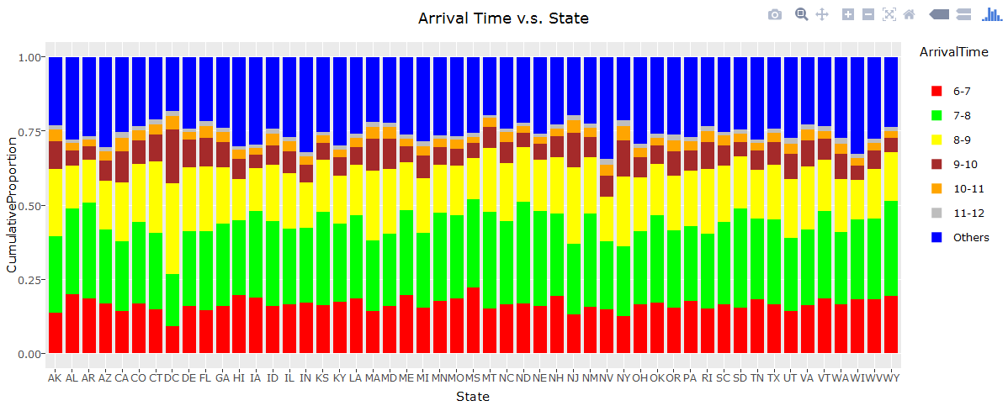

We can see clearly from the plot that most of people arrive at work from 6 to10, no matter which state they are working in. More specifically, in most of the states, people arrive at work between 6 to 8, but In DC, unexpectedly, large amounts of people arrive at 8-10. So basically, if you want to sleep more and get to work a little late, you may choose DC as your ideal place.

Fig 2

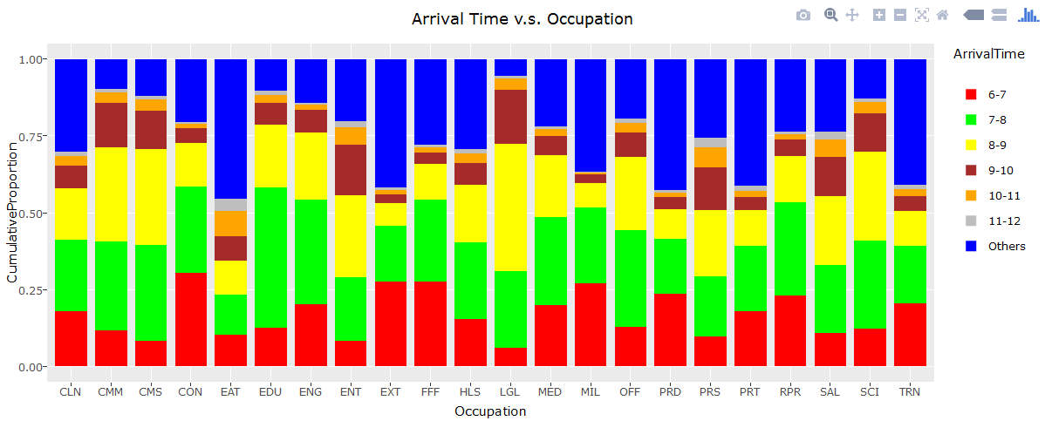

From this plot, we can see arrival time is totally different due to many choices of occupations. Most of occupations have arrival time focus on 6-12, for example LGL, SCI, etc. But thinking about the occupation EAT, like chefs or waiters, they always have their work time beginning after 12.

Fig 3

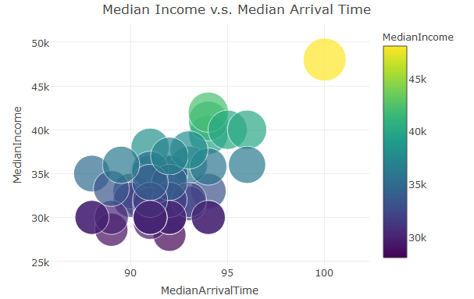

And this Fig is another proof that DC is a good place for work, since it shows that the people working in DC have latest median arrival time and highest median income. Moreover, there is an obvious distinction between DC and other states. This is an interesting point and we will talk about it in the following parts.

Fig 4

. 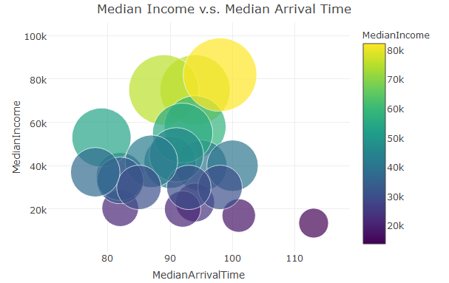

As we have mentioned, EAT has latest arriving time in general, but it is also at a low level for salary. Meanwhile, people work as LGL, like lawyers or judges, they earn more but work earlier comparing to EAT. So for arriving-time opinion, there is no so-called “perfect” occupation. We have to make a choice, high salary or get up late?

Part comment: Most of states have their arrival time at regular interval, but DC is different from others and it is suggested at the first level in the job selection based on arrival time. If we consider both arrival time and income factors, DC is also a good choice. For occupational suggestion, LGL, such as lawyers and judges, may be some ideal occupations, based on highest income and top 5 latest arrival time.