Project1, Arrival time part

Fig 1

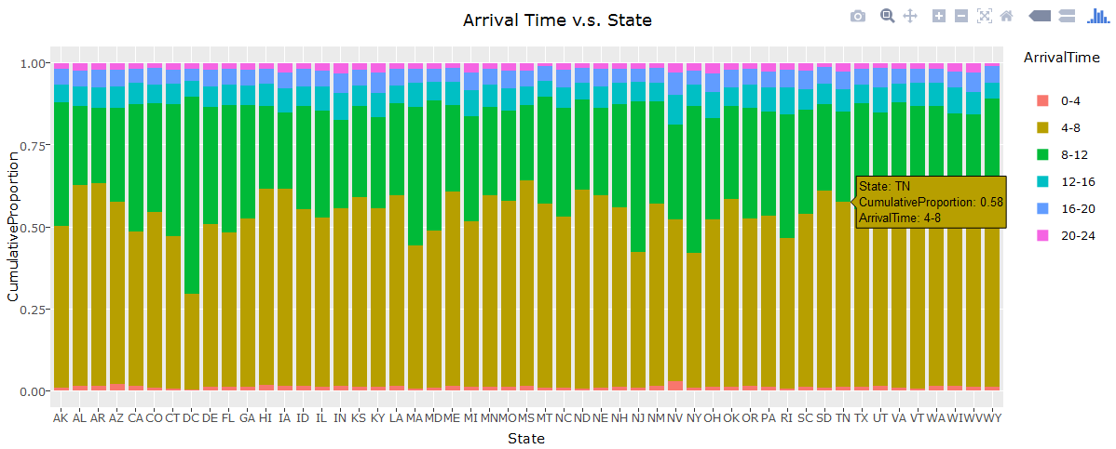

We can see clearly from the plot that most of people in most of the state arrive at work at 4-8, but In DC, unexpectedly, most of people arrive at 8-12. So basically, if you want to sleep more and get to work late, you can choose DC as your ideal place to work.

Fig 2

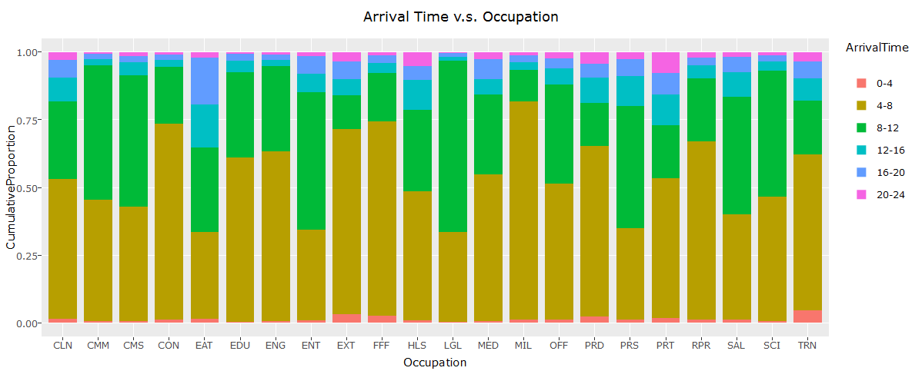

From this plot, we can see arrival time is different due to many choice of occupations. Most of occupations have arrival time focus on 4-12. Think about the occupation EAT, like chefs or waiters, they have their work time beginning after noon. And it not to understand for that fact.

Fig 3

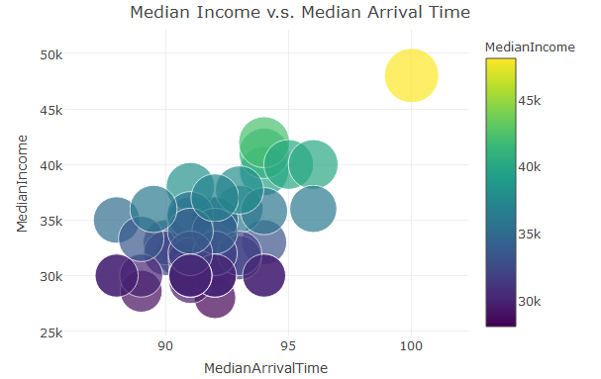

And this Fig is another proof that DC is a good place for work, since it shows that the people work in DC have latest arriving time and highest income. So in my opinion, I suggest DC as a great state to find jobs

Fig 4

. 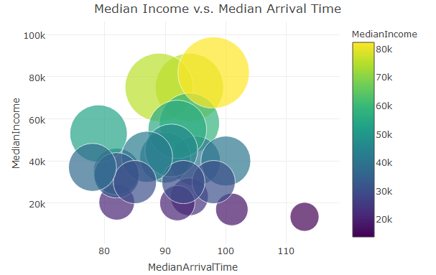

As we have mentioned, although EAT has latest arriving time, it also at a low level for salary. Meanwhile, people work as LGL, like lawyers or judges, they earn more but work earlier than others. So we need to make a choice, high salary or get up late?