**1. Our Objective**

In this part of analysis, we want to know how STEM jobs has changed along with the announcement of the STEM policy. Two data sets are being used: data of 2007, which is the last year before STEM policy, and data of 2014, the latest obtainable under-STEM-policy data. For each data set, we categorize our data into two classes: STEM-job data and non-STEM-job data. By doing the separations, we can look at the differences of STEM and non-STEM jobs before and after STEM policy went out.

#### ****2. Our Concerns****

1. Will the STEM/non-STEM job allocation change?
2. Among STEM/non-STEM jobs, will gender proportion and class of work be influenced by the STEM policy?
3. How did the working conditions, such as wage and working hours change?
4. Will the STEM policy further influence people’s immigration behavior?

Findings:

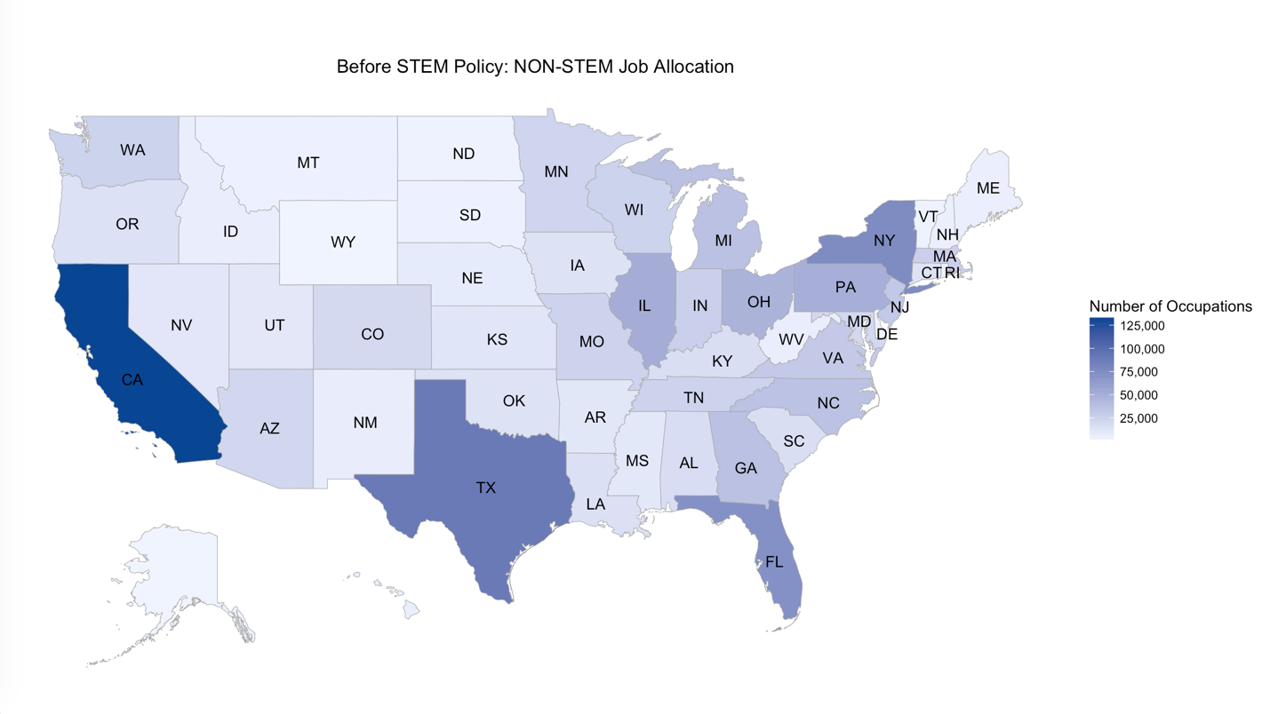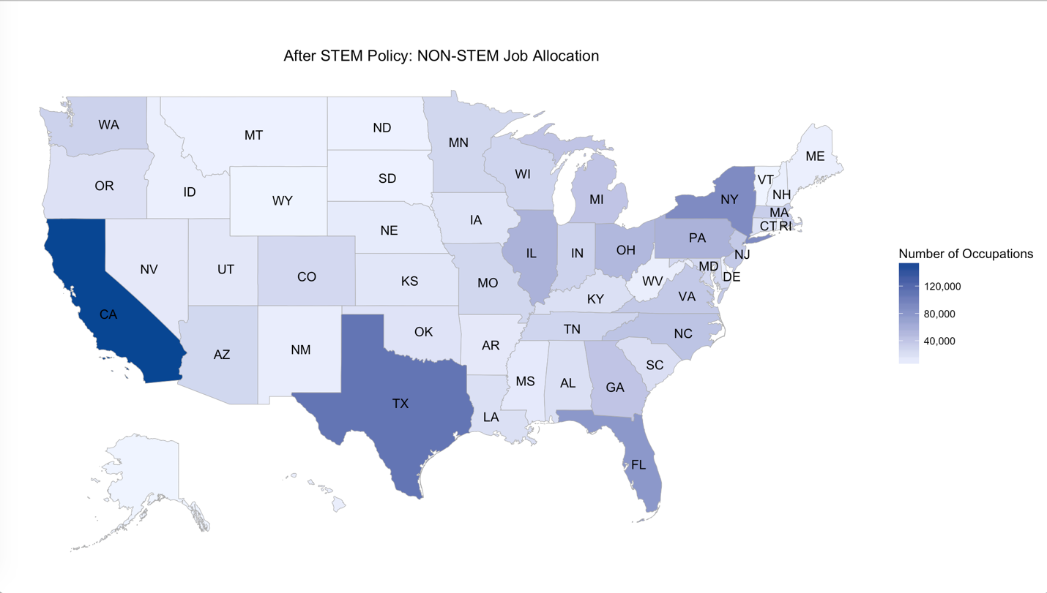

According to these two figures, we can see that the geographical allocation of non-stem jobs barely changed after STEM policy went out.

However, if we have a close look at STEM jobs,

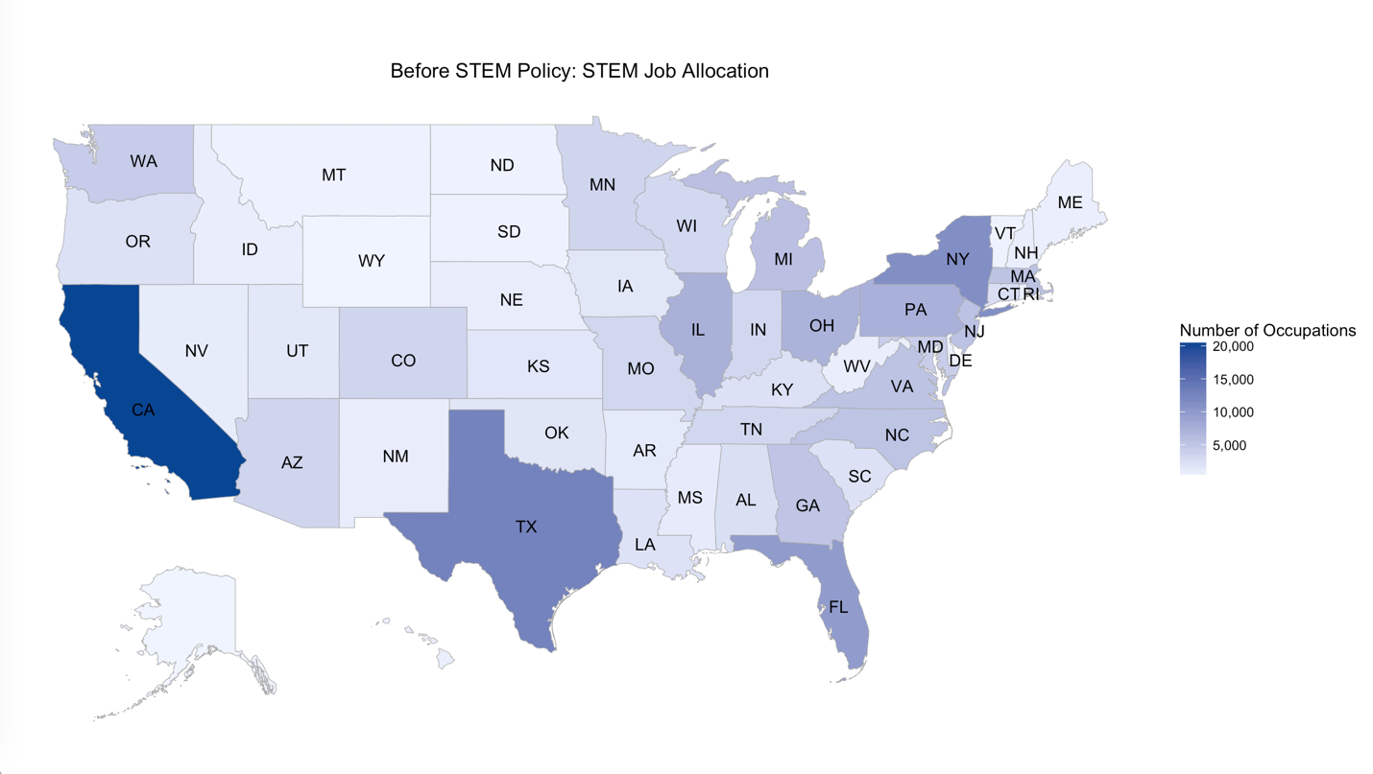

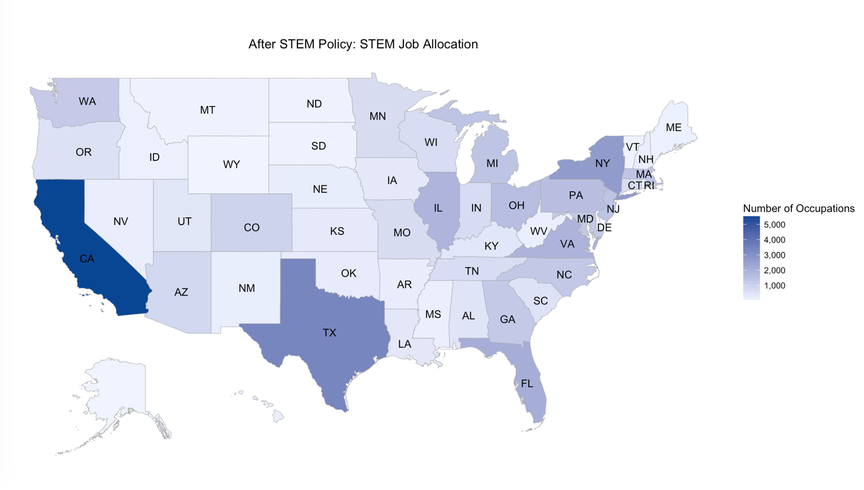

we realized that relevant jobs in NY an FL tended to diffuse towards neighboring states.

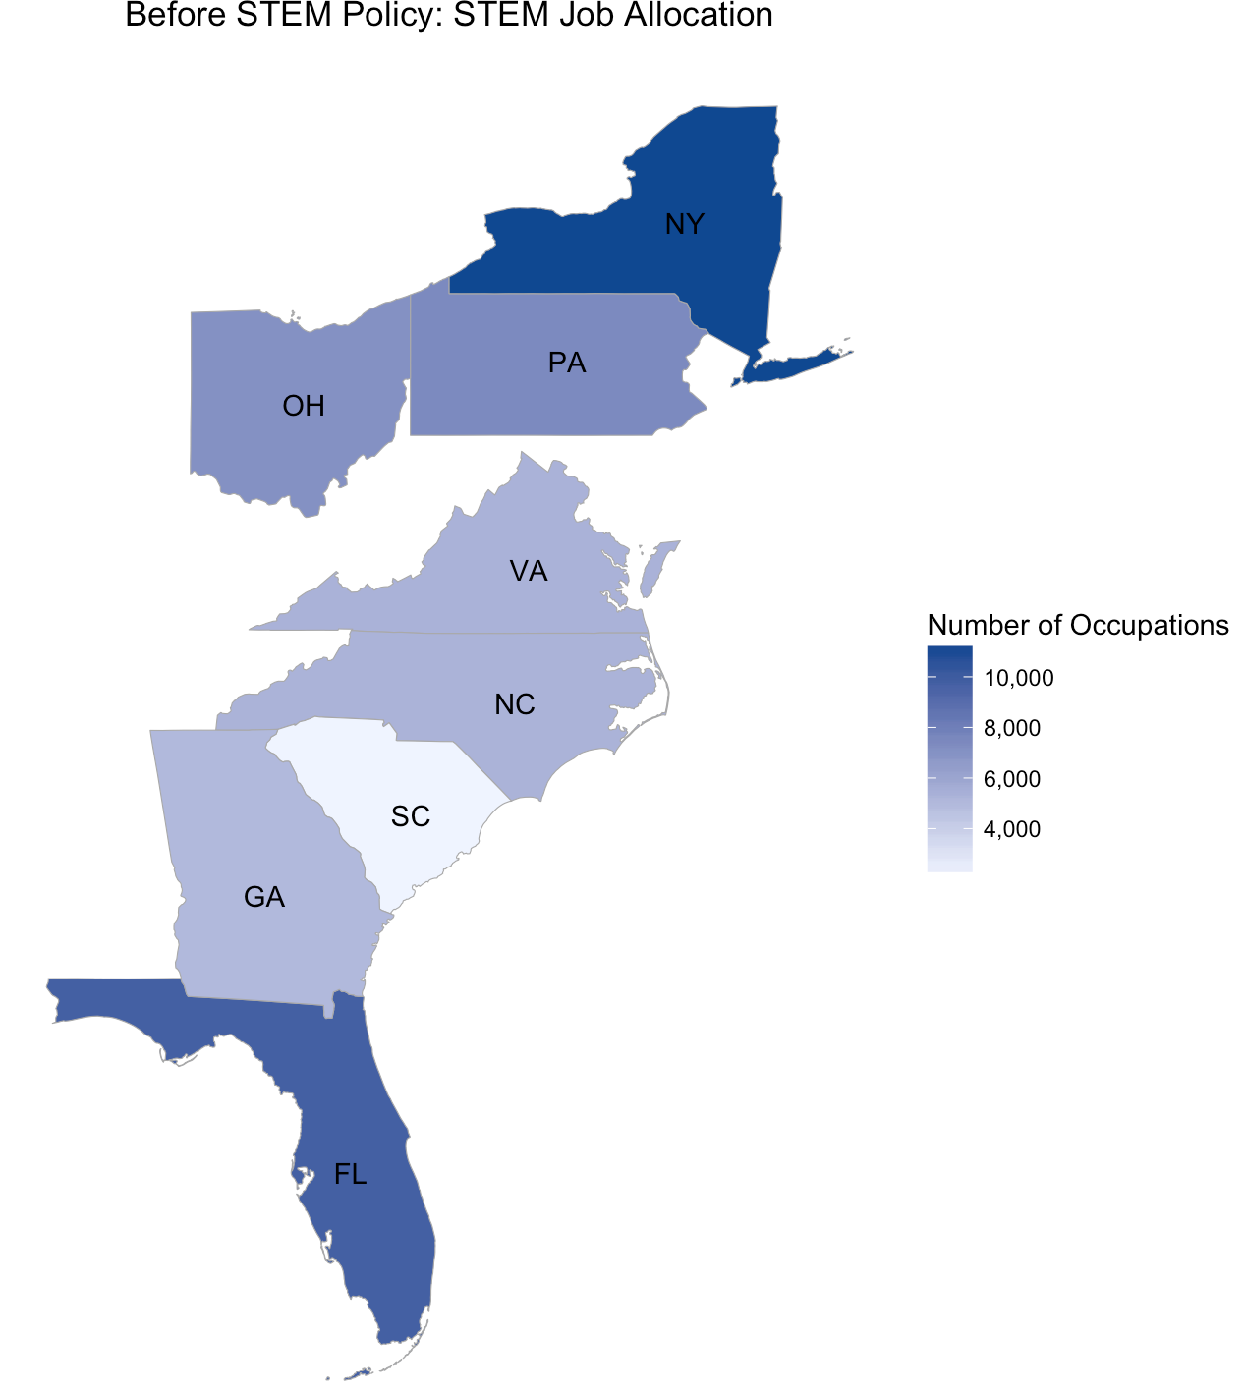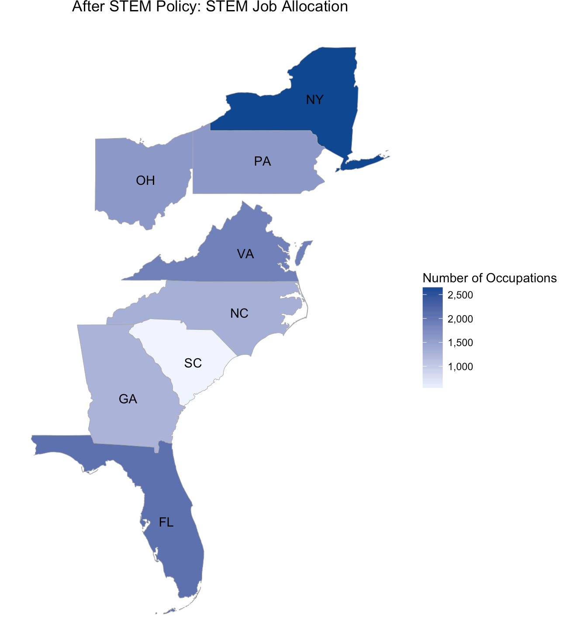

Among these states, VA has the most significant increase in the amount of STEM jobs.

In general, the state allocation of jobs didn’t change dramatically after the STEM policy went out. It could be plausible since STEM policy is in effect for foreign students while the job allocation depends more on the locational choices of different companies.

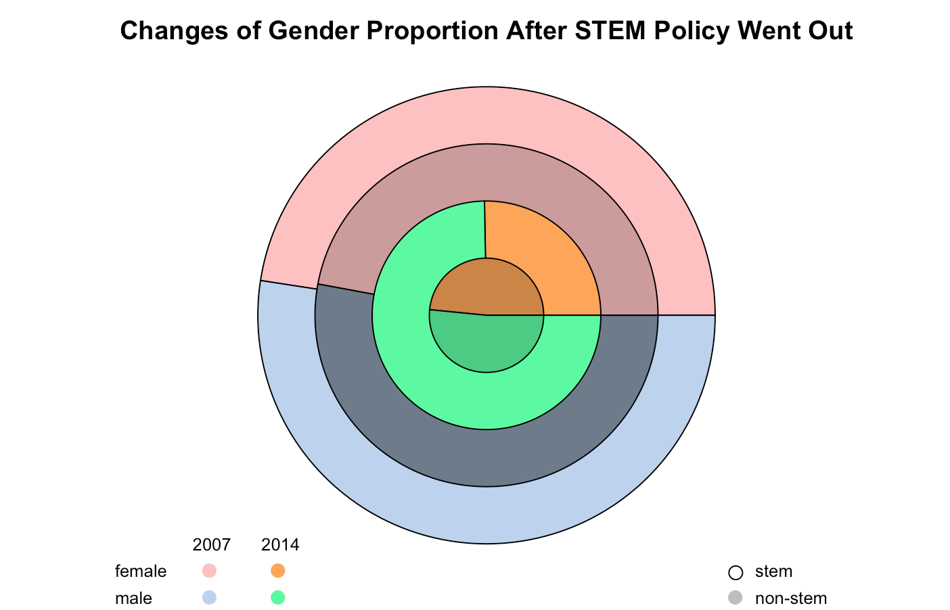

If we try to address the gender proportion in jobs, we get some more interesting findings. First of all, the gender equality seems to be quite tenable in non-stem jobs. However, when speaking of stem jobs, the percentage of female employees dropped significantly after STEM policy went out. What could the potential reasons be? If it is relevant to STEM policy, does this mean that STEM policy is more appealing to male foreign students compared to female? Yet, if we consider the fact that the proportion of non-US-born employees in the STEM industries is actually not that big, we should realize that STEM policy could not be the major cause. In other words, there’re some other factors that are currently influencing the gender structure in STEM industries, and we should pay attention to this huge gender gap.

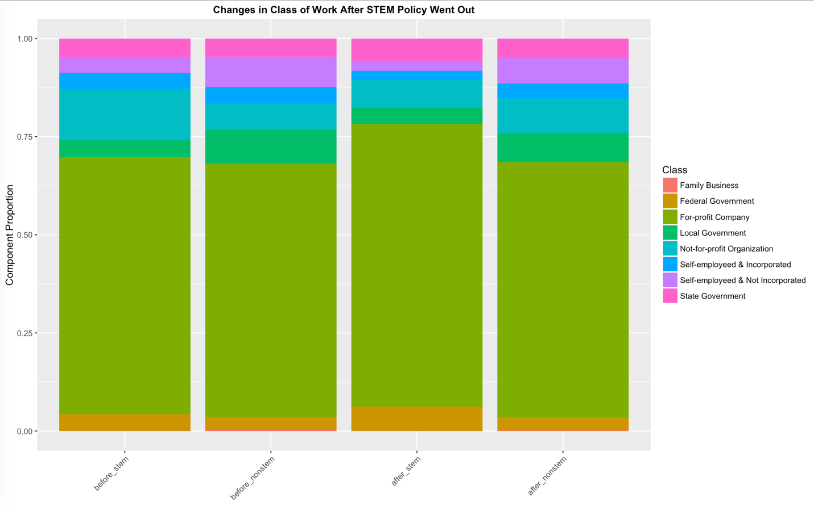

While the structure of class of work remains almost the same after STEM policy went out, we could tell the difference between STEM industry structures with and without STEM policy. Compared to non-stem industries, less jobs are of self-employed or for Not-for-profit organizations. Instead, STEM people tend to stay at for-profit companies. This change could be relevant to both the structure change of the STEM industries and the thought conversion of STEM people. It’s likely that for these people, for-profit company is the option which stands for self-fulfillment.

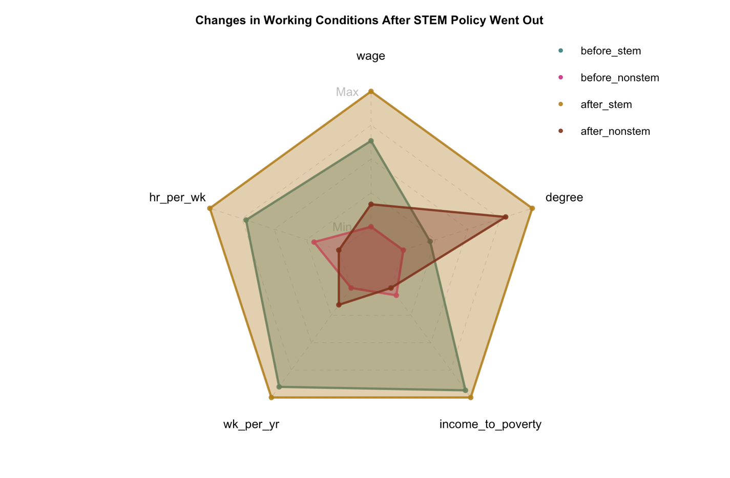

STEM jobs used to be kind of jobs in which you need to pay more in order to get more. The good thing was, you didn’t need to have an advanced degree to get such kind of jobs.

After STEM policy went out, the requirement of degree in STEM jobs raised sharply. Though it’s actually the same case in non-STEM jobs, STEM jobs are still the group which requires the highest average degree attainment.

We can also read more information from this figure, such as, currently, the better wage/degree performance appears to STEM jobs instead of non-STEM jobs and the gap is quite obvious. However, speaking of wage/working hours, the answer could be the opposite. But this doesn’t mean that non-STEM job is a better choice since you are not the one who decides how many hours you work.

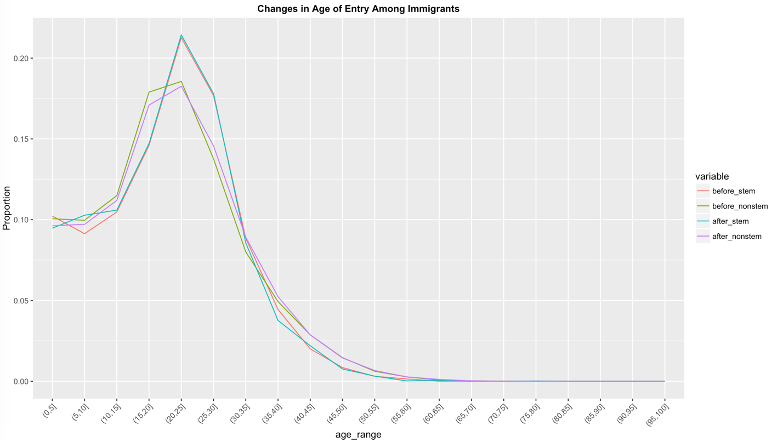

If we assume the STEM policy does attract a lot of foreign students to come and study in US, does it mean that this policy will further influence them to stay in US permanently?

From the figure above, we know the answer is NO. The figure generally presents the distribution of age of entry among immigrants to US. We can see from the plot that the proportion of immigrants who came to US during their age of schooling didn’t change much as the STEM policy was published, either for STEM or non-STEM people.