# God, women, and emotions: How present are referenced in the most prominent schools of philosophy?

### *Rodrigo Zarate / Applied Data Science @ Columbia University / Fall 2021*

## Introduction

Have you ever wondered how present God’s concept is in primary texts in the history of philosophy? In what schools of philosophy are more recurrent references to God? What about the presence of words referencing women? What are the schools of philosophy that most recurrent mention words describing women? How is the balance between men’s and women’s words? How is the balance of words referencing logic and emotions? A unique and fascinating data set allowed us to explore the great texts in the history of philosophy.

The **Philosophy Data Project** (see <http://philosophydata.com/index.html>) is a data science project that explores the history of philosophy through the primary schools of thought. This fascinating data set allows us a data-driven exploration of philosophical texts.

## Context

The dataset contains 13 schools of philosophy which give a broad overview of different ideas about the world, representing more or less the entire history of philosophy.

kable(table.schools)

|  |
| --- |
| school |
| plato |
| aristotle |
| empiricism |
| rationalism |
| analytic |
| continental |
| phenomenology |
| german_idealism |
| communism |
| capitalism |
| stoicism |
| nietzsche |
| feminism |

For each school of thought, there are specific philosophical texts chosen to represent the intellectual tradition.

kable(table.summary)

|  |  |  |
| --- | --- | --- |
| school | author | title |
| plato | Plato | Plato - Complete Works |
| aristotle | Aristotle | Aristotle - Complete Works |
| empiricism | Locke | Second Treatise On Government |
| empiricism | Locke | Essay Concerning Human Understanding |
| empiricism | Hume | A Treatise Of Human Nature |
| empiricism | Hume | Dialogues Concerning Natural Religion |
| empiricism | Berkeley | Three Dialogues |
| empiricism | Berkeley | A Treatise Concerning The Principles Of Human Knowledge |
| rationalism | Spinoza | Ethics |
| rationalism | Spinoza | On The Improvement Of Understanding |
| rationalism | Leibniz | Theodicy |
| rationalism | Descartes | Discourse On Method |
| rationalism | Descartes | Meditations On First Philosophy |
| rationalism | Malebranche | The Search After Truth |
| analytic | Russell | The Analysis Of Mind |
| analytic | Russell | The Problems Of Philosophy |
| analytic | Moore | Philosophical Studies |
| analytic | Wittgenstein | Philosophical Investigations |
| analytic | Wittgenstein | Tractatus Logico-Philosophicus |
| analytic | Lewis | Lewis - Papers |
| analytic | Quine | Quintessence |
| analytic | Popper | The Logic Of Scientific Discovery |
| analytic | Kripke | Naming And Necessity |
| analytic | Kripke | Philosophical Troubles |
| analytic | Wittgenstein | On Certainty |
| continental | Foucault | The Birth Of The Clinic |
| continental | Foucault | History Of Madness |
| continental | Foucault | The Order Of Things |
| continental | Derrida | Writing And Difference |
| continental | Deleuze | Difference And Repetition |
| continental | Deleuze | Anti-Oedipus |
| phenomenology | Merleau-Ponty | The Phenomenology Of Perception |
| phenomenology | Husserl | The Crisis Of The European Sciences And Phenomenology |
| phenomenology | Husserl | The Idea Of Phenomenology |
| phenomenology | Heidegger | Being And Time |
| phenomenology | Heidegger | Off The Beaten Track |
| german_idealism | Kant | Critique Of Practical Reason |
| german_idealism | Kant | Critique Of Judgement |
| german_idealism | Kant | Critique Of Pure Reason |
| german_idealism | Fichte | The System Of Ethics |
| german_idealism | Hegel | Science Of Logic |
| german_idealism | Hegel | The Phenomenology Of Spirit |
| german_idealism | Hegel | Elements Of The Philosophy Of Right |
| communism | Marx | Capital |
| communism | Marx | The Communist Manifesto |
| communism | Lenin | Essential Works Of Lenin |
| capitalism | Smith | The Wealth Of Nations |
| capitalism | Ricardo | On The Principles Of Political Economy And Taxation |
| capitalism | Keynes | A General Theory Of Employment, Interest, And Money |
| stoicism | Epictetus | Enchiridion |
| stoicism | Marcus Aurelius | Meditations |
| nietzsche | Nietzsche | The Antichrist |
| nietzsche | Nietzsche | Beyond Good And Evil |
| nietzsche | Nietzsche | Ecce Homo |
| nietzsche | Nietzsche | Twilight Of The Idols |
| nietzsche | Nietzsche | Thus Spake Zarathustra |
| feminism | Wollstonecraft | Vindication Of The Rights Of Woman |
| feminism | Beauvoir | The Second Sex |
| feminism | Davis | Women, Race, And Class |

## Data Exploration

Before starting the analysis of specific concepts present in each school of thought, I will give you a quick summary of the most prominent terms for each philosophical tradition though word clouds.

### Word clouds

A word cloud is a collection, or cluster, of words depicted in different sizes. The bigger and bolder the word appears, the more often it’s mentioned within a given text and the more important it is.

**Analytic**

## Warning in wordcloud(d$word, d$freq, random.order = FALSE, rot.per = 0.3, :  
## general could not be fit on page. It will not be plotted.

## Warning in wordcloud(d$word, d$freq, random.order = FALSE, rot.per = 0.3, :  
## probability could not be fit on page. It will not be plotted.

## Warning in wordcloud(d$word, d$freq, random.order = FALSE, rot.per = 0.3, :  
## however could not be fit on page. It will not be plotted.

## Warning in wordcloud(d$word, d$freq, random.order = FALSE, rot.per = 0.3, :  
## present could not be fit on page. It will not be plotted.

## Warning in wordcloud(d$word, d$freq, random.order = FALSE, rot.per = 0.3, :  
## believe could not be fit on page. It will not be plotted.

## Warning in wordcloud(d$word, d$freq, random.order = FALSE, rot.per = 0.3, :  
## therefore could not be fit on page. It will not be plotted.

## Warning in wordcloud(d$word, d$freq, random.order = FALSE, rot.per = 0.3, : many  
## could not be fit on page. It will not be plotted.

## Warning in wordcloud(d$word, d$freq, random.order = FALSE, rot.per = 0.3, :  
## logic could not be fit on page. It will not be plotted.

## Warning in wordcloud(d$word, d$freq, random.order = FALSE, rot.per = 0.3, :  
## names could not be fit on page. It will not be plotted.

## Warning in wordcloud(d$word, d$freq, random.order = FALSE, rot.per = 0.3, :  
## course could not be fit on page. It will not be plotted.

## Warning in wordcloud(d$word, d$freq, random.order = FALSE, rot.per = 0.3, :  
## problem could not be fit on page. It will not be plotted.

## Warning in wordcloud(d$word, d$freq, random.order = FALSE, rot.per = 0.3, :  
## propositions could not be fit on page. It will not be plotted.

## Warning in wordcloud(d$word, d$freq, random.order = FALSE, rot.per = 0.3, :  
## someone could not be fit on page. It will not be plotted.

## Warning in wordcloud(d$word, d$freq, random.order = FALSE, rot.per = 0.3, :  
## every could not be fit on page. It will not be plotted.

## Warning in wordcloud(d$word, d$freq, random.order = FALSE, rot.per = 0.3, :  
## rather could not be fit on page. It will not be plotted.

## Warning in wordcloud(d$word, d$freq, random.order = FALSE, rot.per = 0.3, : give  
## could not be fit on page. It will not be plotted.

## Warning in wordcloud(d$word, d$freq, random.order = FALSE, rot.per = 0.3, :  
## reference could not be fit on page. It will not be plotted.

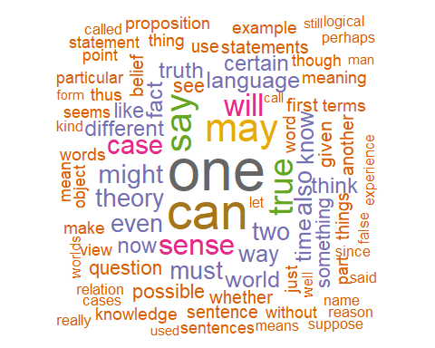

**Aristotle**

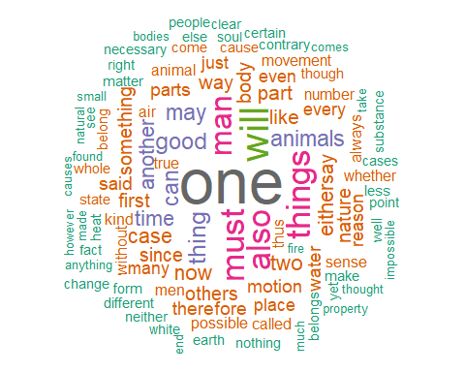

**Capitalism**

## Warning in wordcloud(d$word, d$freq, random.order = FALSE, rot.per = 0.3, :  
## proportion could not be fit on page. It will not be plotted.

## Warning in wordcloud(d$word, d$freq, random.order = FALSE, rot.per = 0.3, :  
## commodities could not be fit on page. It will not be plotted.

## Warning in wordcloud(d$word, d$freq, random.order = FALSE, rot.per = 0.3, :  
## revenue could not be fit on page. It will not be plotted.

## Warning in wordcloud(d$word, d$freq, random.order = FALSE, rot.per = 0.3, :  
## employed could not be fit on page. It will not be plotted.

## Warning in wordcloud(d$word, d$freq, random.order = FALSE, rot.per = 0.3, :  
## countries could not be fit on page. It will not be plotted.

## Warning in wordcloud(d$word, d$freq, random.order = FALSE, rot.per = 0.3, :  
## particular could not be fit on page. It will not be plotted.

## Warning in wordcloud(d$word, d$freq, random.order = FALSE, rot.per = 0.3, :  
## without could not be fit on page. It will not be plotted.

## Warning in wordcloud(d$word, d$freq, random.order = FALSE, rot.per = 0.3, :  
## equal could not be fit on page. It will not be plotted.

## Warning in wordcloud(d$word, d$freq, random.order = FALSE, rot.per = 0.3, :  
## consumption could not be fit on page. It will not be plotted.

## Warning in wordcloud(d$word, d$freq, random.order = FALSE, rot.per = 0.3, :  
## present could not be fit on page. It will not be plotted.

## Warning in wordcloud(d$word, d$freq, random.order = FALSE, rot.per = 0.3, :  
## necessary could not be fit on page. It will not be plotted.

## Warning in wordcloud(d$word, d$freq, random.order = FALSE, rot.per = 0.3, :  
## england could not be fit on page. It will not be plotted.

## Warning in wordcloud(d$word, d$freq, random.order = FALSE, rot.per = 0.3, :  
## investment could not be fit on page. It will not be plotted.

## Warning in wordcloud(d$word, d$freq, random.order = FALSE, rot.per = 0.3, :  
## perhaps could not be fit on page. It will not be plotted.

## Warning in wordcloud(d$word, d$freq, random.order = FALSE, rot.per = 0.3, :  
## general could not be fit on page. It will not be plotted.

## Warning in wordcloud(d$word, d$freq, random.order = FALSE, rot.per = 0.3, :  
## industry could not be fit on page. It will not be plotted.

## Warning in wordcloud(d$word, d$freq, random.order = FALSE, rot.per = 0.3, :  
## years could not be fit on page. It will not be plotted.

## Warning in wordcloud(d$word, d$freq, random.order = FALSE, rot.per = 0.3, :  
## public could not be fit on page. It will not be plotted.

## Warning in wordcloud(d$word, d$freq, random.order = FALSE, rot.per = 0.3, :  
## necessarily could not be fit on page. It will not be plotted.

## Warning in wordcloud(d$word, d$freq, random.order = FALSE, rot.per = 0.3, : many  
## could not be fit on page. It will not be plotted.

## Warning in wordcloud(d$word, d$freq, random.order = FALSE, rot.per = 0.3, :  
## given could not be fit on page. It will not be plotted.

## Warning in wordcloud(d$word, d$freq, random.order = FALSE, rot.per = 0.3, : made  
## could not be fit on page. It will not be plotted.

## Warning in wordcloud(d$word, d$freq, random.order = FALSE, rot.per = 0.3, :  
## percent could not be fit on page. It will not be plotted.

## Warning in wordcloud(d$word, d$freq, random.order = FALSE, rot.per = 0.3, :  
## another could not be fit on page. It will not be plotted.

## Warning in wordcloud(d$word, d$freq, random.order = FALSE, rot.per = 0.3, :  
## increased could not be fit on page. It will not be plotted.

## Warning in wordcloud(d$word, d$freq, random.order = FALSE, rot.per = 0.3, :  
## sometimes could not be fit on page. It will not be plotted.

## Warning in wordcloud(d$word, d$freq, random.order = FALSE, rot.per = 0.3, : well  
## could not be fit on page. It will not be plotted.

## Warning in wordcloud(d$word, d$freq, random.order = FALSE, rot.per = 0.3, :  
## natural could not be fit on page. It will not be plotted.

## Warning in wordcloud(d$word, d$freq, random.order = FALSE, rot.per = 0.3, :  
## supply could not be fit on page. It will not be plotted.

## Warning in wordcloud(d$word, d$freq, random.order = FALSE, rot.per = 0.3, :  
## income could not be fit on page. It will not be plotted.

## Warning in wordcloud(d$word, d$freq, random.order = FALSE, rot.per = 0.3, :  
## number could not be fit on page. It will not be plotted.

## Warning in wordcloud(d$word, d$freq, random.order = FALSE, rot.per = 0.3, :  
## society could not be fit on page. It will not be plotted.

## Warning in wordcloud(d$word, d$freq, random.order = FALSE, rot.per = 0.3, : case  
## could not be fit on page. It will not be plotted.

## Warning in wordcloud(d$word, d$freq, random.order = FALSE, rot.per = 0.3, :  
## manner could not be fit on page. It will not be plotted.

## Warning in wordcloud(d$word, d$freq, random.order = FALSE, rot.per = 0.3, :  
## europe could not be fit on page. It will not be plotted.

## Warning in wordcloud(d$word, d$freq, random.order = FALSE, rot.per = 0.3, :  
## certain could not be fit on page. It will not be plotted.

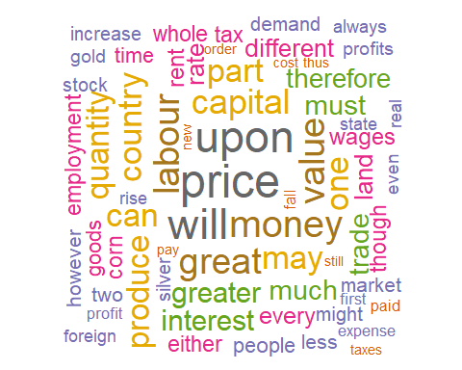

**Communism**

## Warning in wordcloud(d$word, d$freq, random.order = FALSE, rot.per = 0.3, :  
## england could not be fit on page. It will not be plotted.

## Warning in wordcloud(d$word, d$freq, random.order = FALSE, rot.per = 0.3, :  
## country could not be fit on page. It will not be plotted.

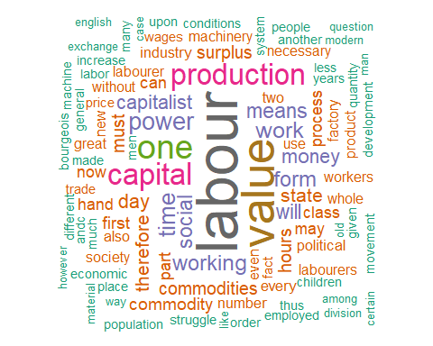

**Continental**

## Warning in wordcloud(d$word, d$freq, random.order = FALSE, rot.per = 0.3, :  
## experience could not be fit on page. It will not be plotted.

## Warning in wordcloud(d$word, d$freq, random.order = FALSE, rot.per = 0.3, :  
## structure could not be fit on page. It will not be plotted.

## Warning in wordcloud(d$word, d$freq, random.order = FALSE, rot.per = 0.3, : made  
## could not be fit on page. It will not be plotted.

## Warning in wordcloud(d$word, d$freq, random.order = FALSE, rot.per = 0.3, :  
## nothing could not be fit on page. It will not be plotted.

## Warning in wordcloud(d$word, d$freq, random.order = FALSE, rot.per = 0.3, :  
## already could not be fit on page. It will not be plotted.

## Warning in wordcloud(d$word, d$freq, random.order = FALSE, rot.per = 0.3, :  
## classical could not be fit on page. It will not be plotted.

## Warning in wordcloud(d$word, d$freq, random.order = FALSE, rot.per = 0.3, :  
## great could not be fit on page. It will not be plotted.

## Warning in wordcloud(d$word, d$freq, random.order = FALSE, rot.per = 0.3, :  
## power could not be fit on page. It will not be plotted.

## Warning in wordcloud(d$word, d$freq, random.order = FALSE, rot.per = 0.3, :  
## elements could not be fit on page. It will not be plotted.

## Warning in wordcloud(d$word, d$freq, random.order = FALSE, rot.per = 0.3, :  
## present could not be fit on page. It will not be plotted.

## Warning in wordcloud(d$word, d$freq, random.order = FALSE, rot.per = 0.3, :  
## subject could not be fit on page. It will not be plotted.

## Warning in wordcloud(d$word, d$freq, random.order = FALSE, rot.per = 0.3, :  
## whose could not be fit on page. It will not be plotted.

## Warning in wordcloud(d$word, d$freq, random.order = FALSE, rot.per = 0.3, :  
## state could not be fit on page. It will not be plotted.

## Warning in wordcloud(d$word, d$freq, random.order = FALSE, rot.per = 0.3, :  
## oedipus could not be fit on page. It will not be plotted.

## Warning in wordcloud(d$word, d$freq, random.order = FALSE, rot.per = 0.3, :  
## become could not be fit on page. It will not be plotted.

## Warning in wordcloud(d$word, d$freq, random.order = FALSE, rot.per = 0.3, :  
## every could not be fit on page. It will not be plotted.

## Warning in wordcloud(d$word, d$freq, random.order = FALSE, rot.per = 0.3, :  
## given could not be fit on page. It will not be plotted.

## Warning in wordcloud(d$word, d$freq, random.order = FALSE, rot.per = 0.3, :  
## discourse could not be fit on page. It will not be plotted.

## Warning in wordcloud(d$word, d$freq, random.order = FALSE, rot.per = 0.3, : idea  
## could not be fit on page. It will not be plotted.

## Warning in wordcloud(d$word, d$freq, random.order = FALSE, rot.per = 0.3, :  
## process could not be fit on page. It will not be plotted.

## Warning in wordcloud(d$word, d$freq, random.order = FALSE, rot.per = 0.3, :  
## analysis could not be fit on page. It will not be plotted.

## Warning in wordcloud(d$word, d$freq, random.order = FALSE, rot.per = 0.3, : real  
## could not be fit on page. It will not be plotted.

## Warning in wordcloud(d$word, d$freq, random.order = FALSE, rot.per = 0.3, :  
## however could not be fit on page. It will not be plotted.

## Warning in wordcloud(d$word, d$freq, random.order = FALSE, rot.per = 0.3, : pure  
## could not be fit on page. It will not be plotted.

## Warning in wordcloud(d$word, d$freq, random.order = FALSE, rot.per = 0.3, :  
## problem could not be fit on page. It will not be plotted.

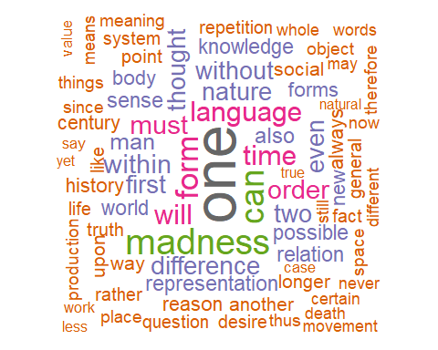

**Empiricism**

## Warning in wordcloud(d$word, d$freq, random.order = FALSE, rot.per = 0.3, :  
## relation could not be fit on page. It will not be plotted.

## Warning in wordcloud(d$word, d$freq, random.order = FALSE, rot.per = 0.3, :  
## principles could not be fit on page. It will not be plotted.

## Warning in wordcloud(d$word, d$freq, random.order = FALSE, rot.per = 0.3, :  
## thought could not be fit on page. It will not be plotted.

## Warning in wordcloud(d$word, d$freq, random.order = FALSE, rot.per = 0.3, :  
## common could not be fit on page. It will not be plotted.

## Warning in wordcloud(d$word, d$freq, random.order = FALSE, rot.per = 0.3, : good  
## could not be fit on page. It will not be plotted.

## Warning in wordcloud(d$word, d$freq, random.order = FALSE, rot.per = 0.3, :  
## sense could not be fit on page. It will not be plotted.

## Warning in wordcloud(d$word, d$freq, random.order = FALSE, rot.per = 0.3, : even  
## could not be fit on page. It will not be plotted.

## Warning in wordcloud(d$word, d$freq, random.order = FALSE, rot.per = 0.3, :  
## evident could not be fit on page. It will not be plotted.

## Warning in wordcloud(d$word, d$freq, random.order = FALSE, rot.per = 0.3, : give  
## could not be fit on page. It will not be plotted.

## Warning in wordcloud(d$word, d$freq, random.order = FALSE, rot.per = 0.3, :  
## always could not be fit on page. It will not be plotted.

## Warning in wordcloud(d$word, d$freq, random.order = FALSE, rot.per = 0.3, :  
## right could not be fit on page. It will not be plotted.

## Warning in wordcloud(d$word, d$freq, random.order = FALSE, rot.per = 0.3, :  
## human could not be fit on page. It will not be plotted.

## Warning in wordcloud(d$word, d$freq, random.order = FALSE, rot.per = 0.3, : thus  
## could not be fit on page. It will not be plotted.

## Warning in wordcloud(d$word, d$freq, random.order = FALSE, rot.per = 0.3, : many  
## could not be fit on page. It will not be plotted.

## Warning in wordcloud(d$word, d$freq, random.order = FALSE, rot.per = 0.3, : name  
## could not be fit on page. It will not be plotted.

## Warning in wordcloud(d$word, d$freq, random.order = FALSE, rot.per = 0.3, :  
## concerning could not be fit on page. It will not be plotted.

## Warning in wordcloud(d$word, d$freq, random.order = FALSE, rot.per = 0.3, :  
## consider could not be fit on page. It will not be plotted.

## Warning in wordcloud(d$word, d$freq, random.order = FALSE, rot.per = 0.3, :  
## causes could not be fit on page. It will not be plotted.

## Warning in wordcloud(d$word, d$freq, random.order = FALSE, rot.per = 0.3, :  
## manner could not be fit on page. It will not be plotted.

## Warning in wordcloud(d$word, d$freq, random.order = FALSE, rot.per = 0.3, :  
## pleasure could not be fit on page. It will not be plotted.

## Warning in wordcloud(d$word, d$freq, random.order = FALSE, rot.per = 0.3, :  
## species could not be fit on page. It will not be plotted.

## Warning in wordcloud(d$word, d$freq, random.order = FALSE, rot.per = 0.3, : way  
## could not be fit on page. It will not be plotted.

## Warning in wordcloud(d$word, d$freq, random.order = FALSE, rot.per = 0.3, :  
## bodies could not be fit on page. It will not be plotted.

## Warning in wordcloud(d$word, d$freq, random.order = FALSE, rot.per = 0.3, : now  
## could not be fit on page. It will not be plotted.

## Warning in wordcloud(d$word, d$freq, random.order = FALSE, rot.per = 0.3, : new  
## could not be fit on page. It will not be plotted.

## Warning in wordcloud(d$word, d$freq, random.order = FALSE, rot.per = 0.3, :  
## force could not be fit on page. It will not be plotted.

## Warning in wordcloud(d$word, d$freq, random.order = FALSE, rot.per = 0.3, :  
## place could not be fit on page. It will not be plotted.

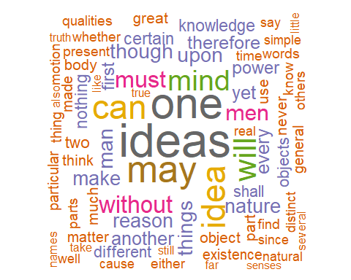

**Feminism**

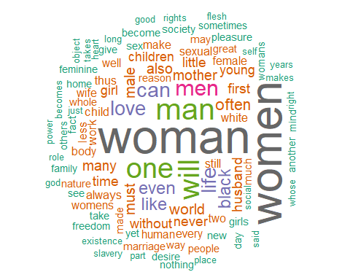

**German Idealism**

## Warning in wordcloud(d$word, d$freq, random.order = FALSE, rot.per = 0.3, :  
## necessary could not be fit on page. It will not be plotted.

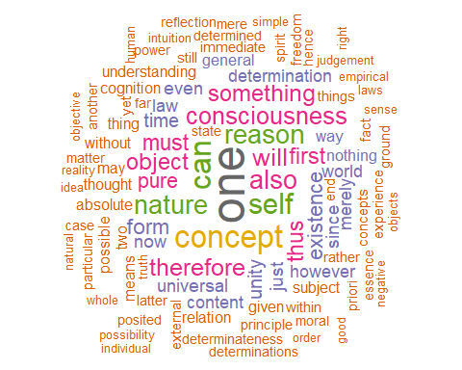

**Nietzsche**

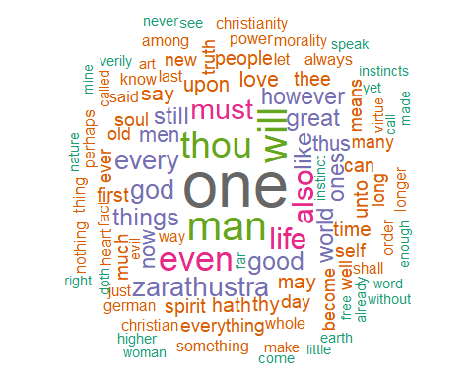

**Phenomenology**

## Warning in wordcloud(d$word, d$freq, random.order = FALSE, rot.per = 0.3, :  
## interpretation could not be fit on page. It will not be plotted.

## Warning in wordcloud(d$word, d$freq, random.order = FALSE, rot.per = 0.3, :  
## nothing could not be fit on page. It will not be plotted.

## Warning in wordcloud(d$word, d$freq, random.order = FALSE, rot.per = 0.3, :  
## absolute could not be fit on page. It will not be plotted.

## Warning in wordcloud(d$word, d$freq, random.order = FALSE, rot.per = 0.3, :  
## ontological could not be fit on page. It will not be plotted.

## Warning in wordcloud(d$word, d$freq, random.order = FALSE, rot.per = 0.3, : pure  
## could not be fit on page. It will not be plotted.

## Warning in wordcloud(d$word, d$freq, random.order = FALSE, rot.per = 0.3, :  
## history could not be fit on page. It will not be plotted.

## Warning in wordcloud(d$word, d$freq, random.order = FALSE, rot.per = 0.3, :  
## objects could not be fit on page. It will not be plotted.

## Warning in wordcloud(d$word, d$freq, random.order = FALSE, rot.per = 0.3, : just  
## could not be fit on page. It will not be plotted.

## Warning in wordcloud(d$word, d$freq, random.order = FALSE, rot.per = 0.3, : real  
## could not be fit on page. It will not be plotted.

## Warning in wordcloud(d$word, d$freq, random.order = FALSE, rot.per = 0.3, :  
## becomes could not be fit on page. It will not be plotted.

## Warning in wordcloud(d$word, d$freq, random.order = FALSE, rot.per = 0.3, :  
## thinking could not be fit on page. It will not be plotted.

## Warning in wordcloud(d$word, d$freq, random.order = FALSE, rot.per = 0.3, :  
## terms could not be fit on page. It will not be plotted.

## Warning in wordcloud(d$word, d$freq, random.order = FALSE, rot.per = 0.3, :  
## place could not be fit on page. It will not be plotted.

## Warning in wordcloud(d$word, d$freq, random.order = FALSE, rot.per = 0.3, :  
## together could not be fit on page. It will not be plotted.

## Warning in wordcloud(d$word, d$freq, random.order = FALSE, rot.per = 0.3, :  
## relation could not be fit on page. It will not be plotted.

## Warning in wordcloud(d$word, d$freq, random.order = FALSE, rot.per = 0.3, :  
## structure could not be fit on page. It will not be plotted.

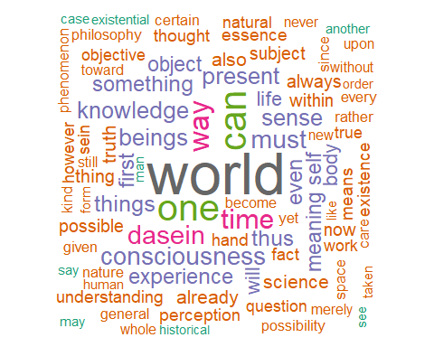

**Plato**

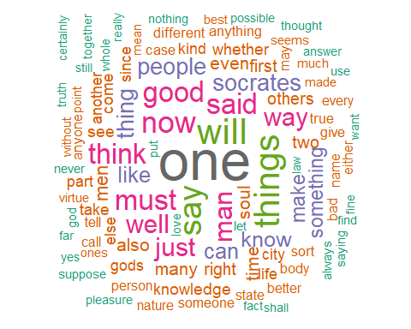

**Rationalism**

## Warning in wordcloud(d$word, d$freq, random.order = FALSE, rot.per = 0.3, :  
## knowledge could not be fit on page. It will not be plotted.

## Warning in wordcloud(d$word, d$freq, random.order = FALSE, rot.per = 0.3, :  
## objects could not be fit on page. It will not be plotted.

## Warning in wordcloud(d$word, d$freq, random.order = FALSE, rot.per = 0.3, :  
## pleasure could not be fit on page. It will not be plotted.

## Warning in wordcloud(d$word, d$freq, random.order = FALSE, rot.per = 0.3, :  
## object could not be fit on page. It will not be plotted.

## Warning in wordcloud(d$word, d$freq, random.order = FALSE, rot.per = 0.3, : upon  
## could not be fit on page. It will not be plotted.

## Warning in wordcloud(d$word, d$freq, random.order = FALSE, rot.per = 0.3, :  
## parts could not be fit on page. It will not be plotted.

## Warning in wordcloud(d$word, d$freq, random.order = FALSE, rot.per = 0.3, : part  
## could not be fit on page. It will not be plotted.

## Warning in wordcloud(d$word, d$freq, random.order = FALSE, rot.per = 0.3, : well  
## could not be fit on page. It will not be plotted.

## Warning in wordcloud(d$word, d$freq, random.order = FALSE, rot.per = 0.3, :  
## natural could not be fit on page. It will not be plotted.

## Warning in wordcloud(d$word, d$freq, random.order = FALSE, rot.per = 0.3, :  
## causes could not be fit on page. It will not be plotted.

## Warning in wordcloud(d$word, d$freq, random.order = FALSE, rot.per = 0.3, :  
## general could not be fit on page. It will not be plotted.

## Warning in wordcloud(d$word, d$freq, random.order = FALSE, rot.per = 0.3, :  
## clear could not be fit on page. It will not be plotted.

## Warning in wordcloud(d$word, d$freq, random.order = FALSE, rot.per = 0.3, :  
## given could not be fit on page. It will not be plotted.

## Warning in wordcloud(d$word, d$freq, random.order = FALSE, rot.per = 0.3, :  
## although could not be fit on page. It will not be plotted.

## Warning in wordcloud(d$word, d$freq, random.order = FALSE, rot.per = 0.3, :  
## senses could not be fit on page. It will not be plotted.

## Warning in wordcloud(d$word, d$freq, random.order = FALSE, rot.per = 0.3, :  
## something could not be fit on page. It will not be plotted.

## Warning in wordcloud(d$word, d$freq, random.order = FALSE, rot.per = 0.3, :  
## believe could not be fit on page. It will not be plotted.

## Warning in wordcloud(d$word, d$freq, random.order = FALSE, rot.per = 0.3, :  
## never could not be fit on page. It will not be plotted.

## Warning in wordcloud(d$word, d$freq, random.order = FALSE, rot.per = 0.3, :  
## infinite could not be fit on page. It will not be plotted.

## Warning in wordcloud(d$word, d$freq, random.order = FALSE, rot.per = 0.3, :  
## clearly could not be fit on page. It will not be plotted.

## Warning in wordcloud(d$word, d$freq, random.order = FALSE, rot.per = 0.3, :  
## human could not be fit on page. It will not be plotted.

## Warning in wordcloud(d$word, d$freq, random.order = FALSE, rot.per = 0.3, :  
## people could not be fit on page. It will not be plotted.

## Warning in wordcloud(d$word, d$freq, random.order = FALSE, rot.per = 0.3, :  
## existence could not be fit on page. It will not be plotted.

## Warning in wordcloud(d$word, d$freq, random.order = FALSE, rot.per = 0.3, :  
## passions could not be fit on page. It will not be plotted.

## Warning in wordcloud(d$word, d$freq, random.order = FALSE, rot.per = 0.3, :  
## imagination could not be fit on page. It will not be plotted.

## Warning in wordcloud(d$word, d$freq, random.order = FALSE, rot.per = 0.3, :  
## particular could not be fit on page. It will not be plotted.

## Warning in wordcloud(d$word, d$freq, random.order = FALSE, rot.per = 0.3, :  
## spirits could not be fit on page. It will not be plotted.

## Warning in wordcloud(d$word, d$freq, random.order = FALSE, rot.per = 0.3, :  
## rather could not be fit on page. It will not be plotted.

## Warning in wordcloud(d$word, d$freq, random.order = FALSE, rot.per = 0.3, :  
## brain could not be fit on page. It will not be plotted.

## Warning in wordcloud(d$word, d$freq, random.order = FALSE, rot.per = 0.3, :  
## often could not be fit on page. It will not be plotted.

## Warning in wordcloud(d$word, d$freq, random.order = FALSE, rot.per = 0.3, :  
## relation could not be fit on page. It will not be plotted.

## Warning in wordcloud(d$word, d$freq, random.order = FALSE, rot.per = 0.3, :  
## whether could not be fit on page. It will not be plotted.

## Warning in wordcloud(d$word, d$freq, random.order = FALSE, rot.per = 0.3, :  
## greater could not be fit on page. It will not be plotted.

## Warning in wordcloud(d$word, d$freq, random.order = FALSE, rot.per = 0.3, :  
## capable could not be fit on page. It will not be plotted.

## Warning in wordcloud(d$word, d$freq, random.order = FALSE, rot.per = 0.3, :  
## thought could not be fit on page. It will not be plotted.

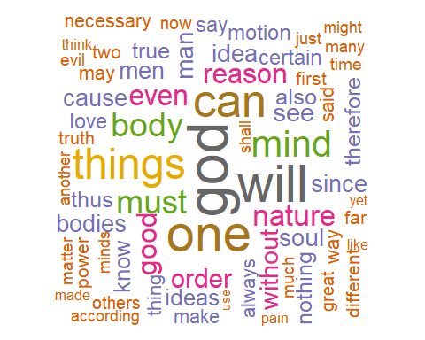

**Stoicism**

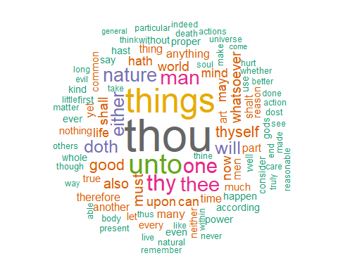

## Logic versus Emotions

Logic and emotion are the two elements that make for perfect persuasion. We can be persuasive using only logic or emotion, but the effect will be short-term and unbalanced. In this analysis, I will show you what is the proportion of words referring to both concepts for every school of philosophy.

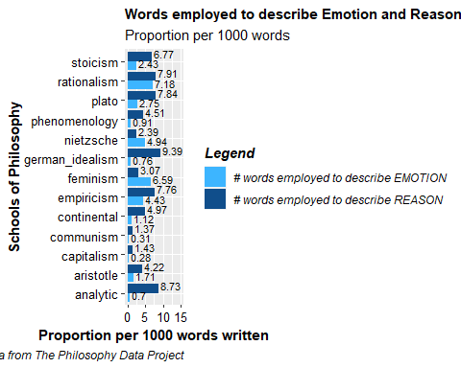

Surprisingly, **rationalism** is the school of thought in which the proportion of words referring to emotions and reasons is more similar (7.18 vs. 7.91 words per 1000, respectively). This similarity could be related to the fact that rationalism is a theory in which the criterion of the truth is not sensory but intellectual and deductive. Thus, its texts discuss emotions and feelings to disregard them and then base its theory on pure logic. On the other hand, the **analytic** school of philosophy is the thought in which the proportion of words describing emotions and reasons is more different, being the ratio of logic words 12.47 times than that of emotional expressions.

## Prominence of women

This analysis measures the proportion of words referring to women in the central philosophy books and compares this number to the ratio of terms employed to describe men.

In the early to mid-twentieth century, women were experiencing a transformation in their role in society. With the suffragette movement and the advent of females in the workforce during the war, the role of women in society was expanding. Thus, this analysis can help us understand which schools of thought were most closely related to this phenomenon.

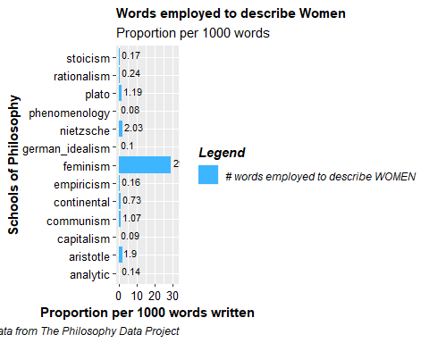

It is no surprise that **feminism** is the school of philosophy in which women’s words are most prominent. On the other hand, **phenomenology**, the philosophical study of the structures of experience and consciousness, is the one with the lowest proportion of words describing women.

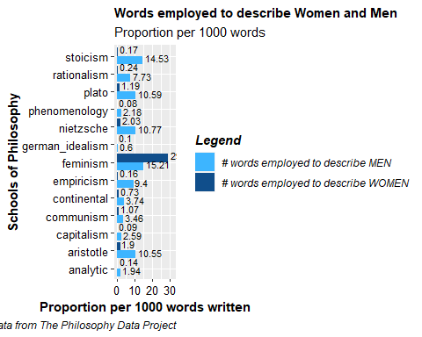

Comparing women and men proportions, it is interesting to highlight that **feminism** is also the one with the highest proportion of men’s words

## God presence

Finally, I will study references to God and divinity in the data set. This analysis is fascinating because references to God in the different schools reflect the culture and identity the beliefs of each one of the authors.

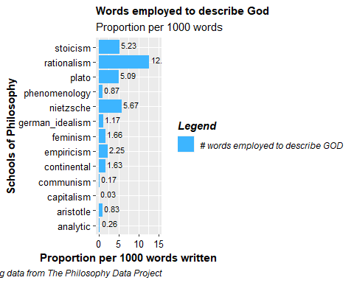

**Rationalism** is the school of thought with the highest proportion of words describing God. Nevertheless, this effect is caused by the fact that some of the books spanning this philosophy are dedicated to arguing against God’s existence (see <https://plato.stanford.edu/entries/spinoza/>).

Finally, **capitalism** is the school of philosophy with the lowest proportion of words referring to God (0.03 per 1000 words).