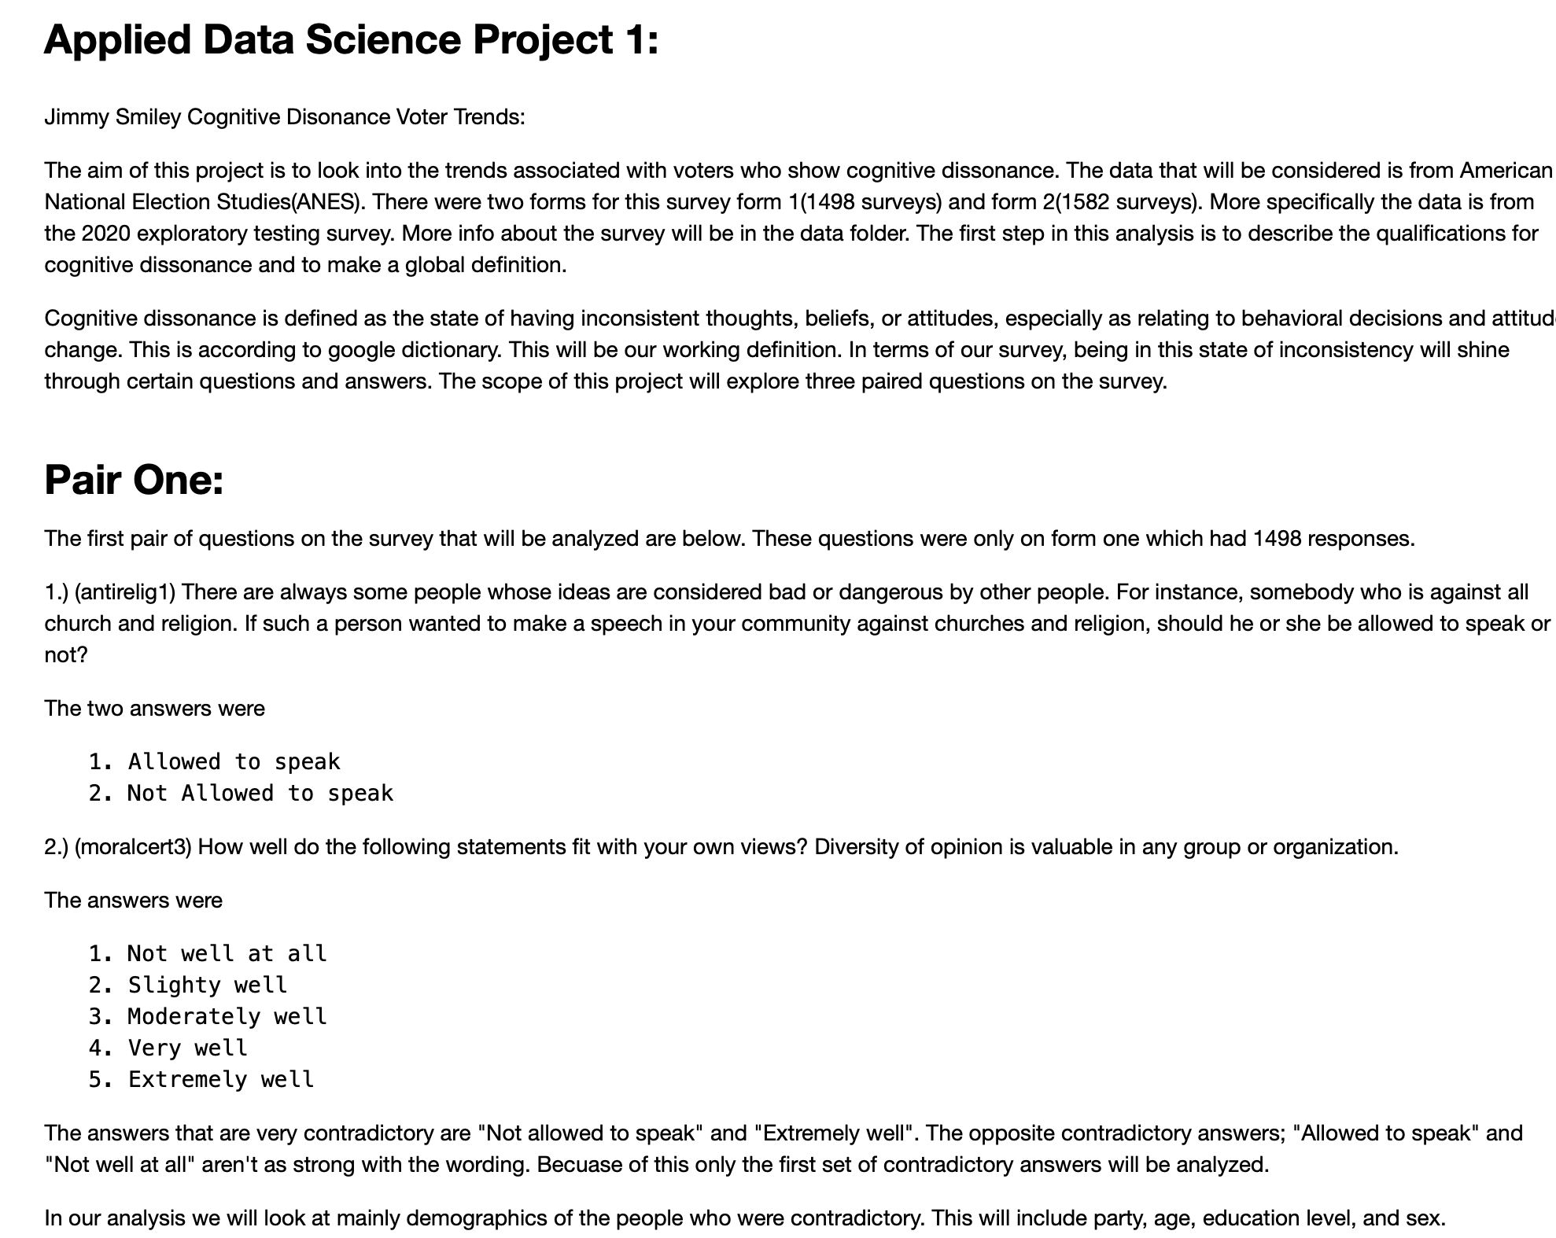

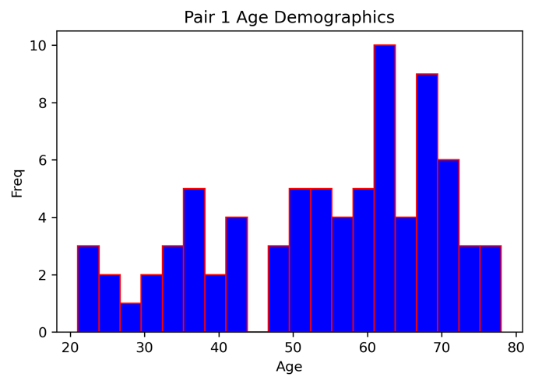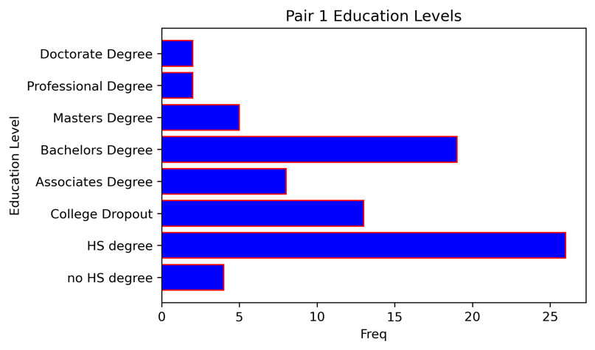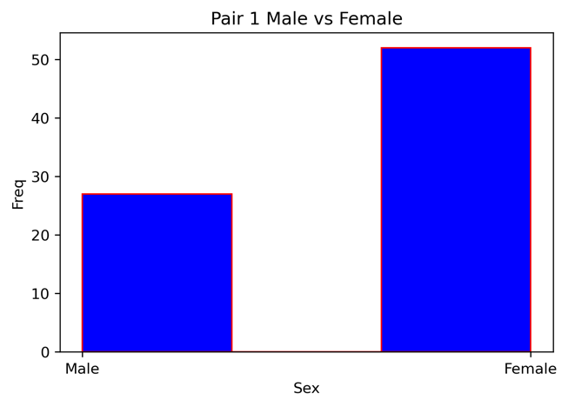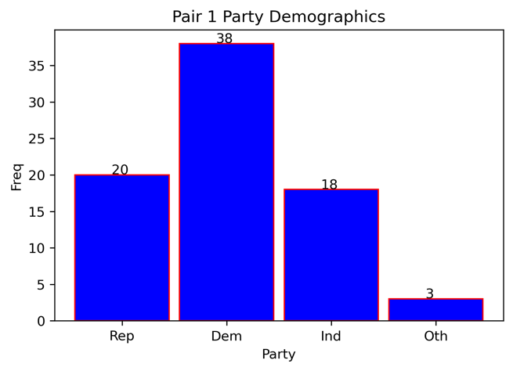

This Pair was only in form 1. Out of 1498 surveys, 5.3 % (79) of the surveys were contradictory.

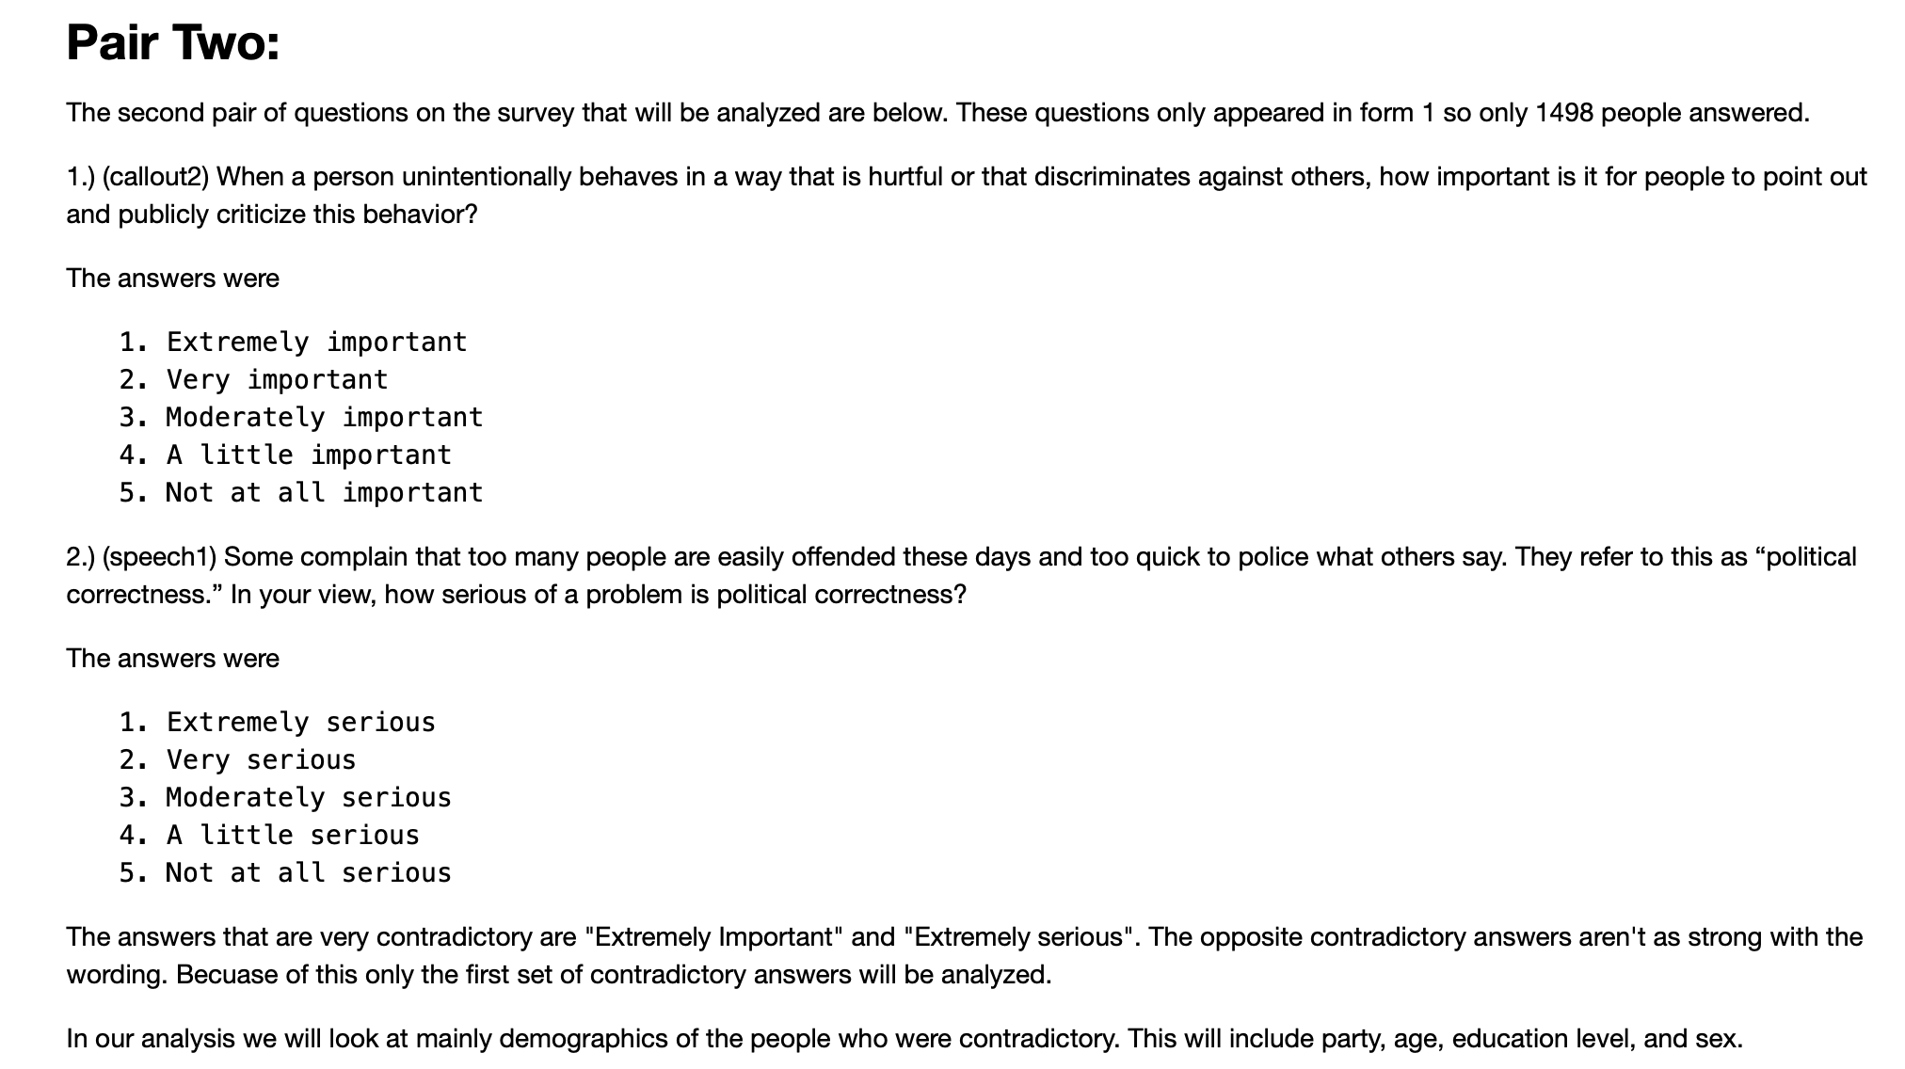

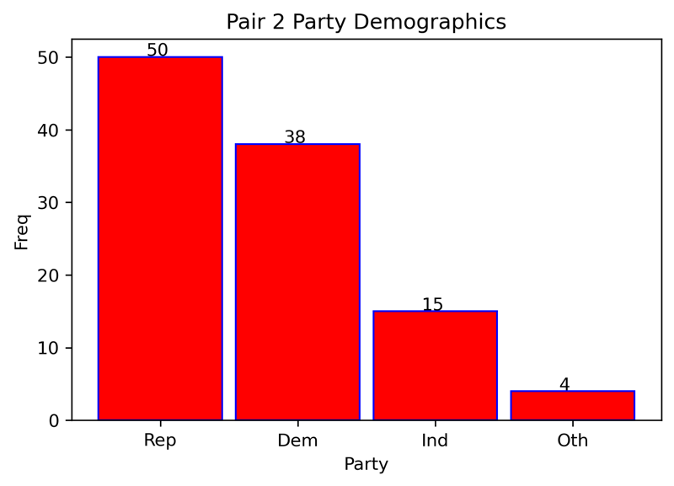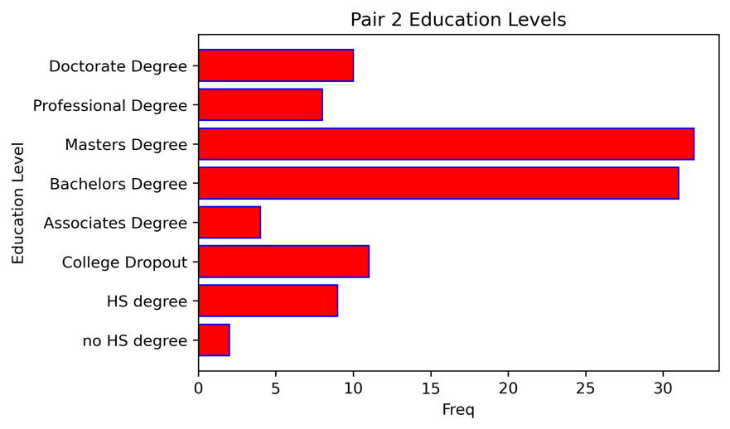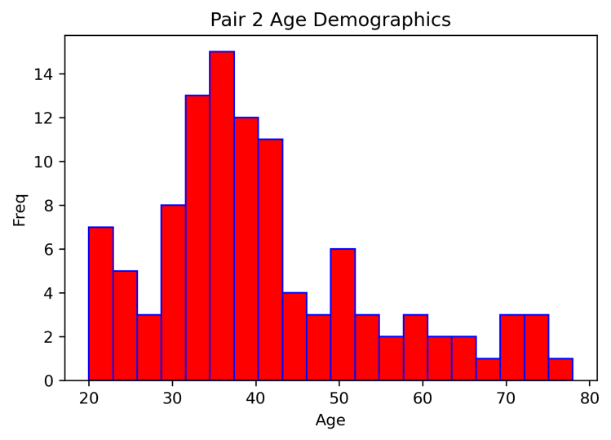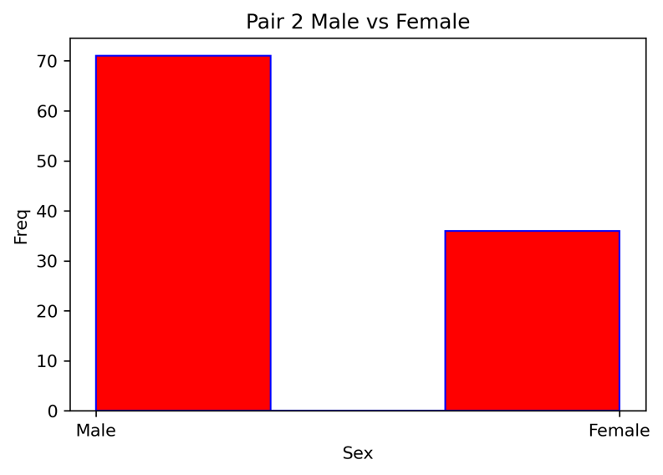

This Pair was only in form 1. Out of 1498 surveys, 7.14 % (107) of the surveys were contradictory.

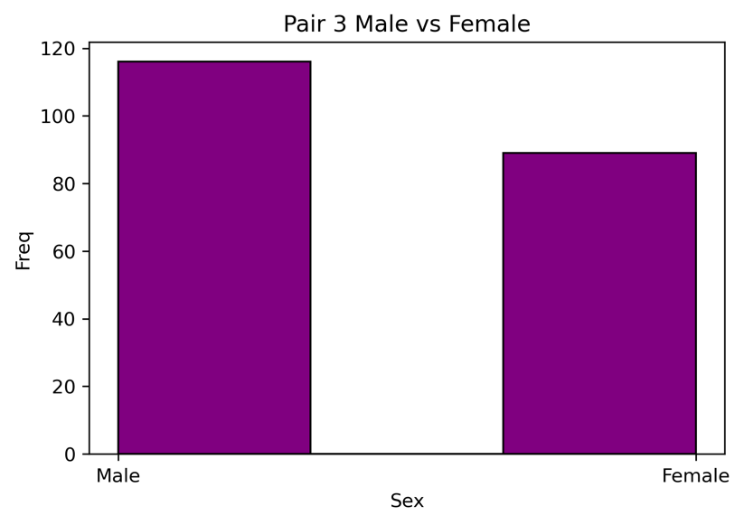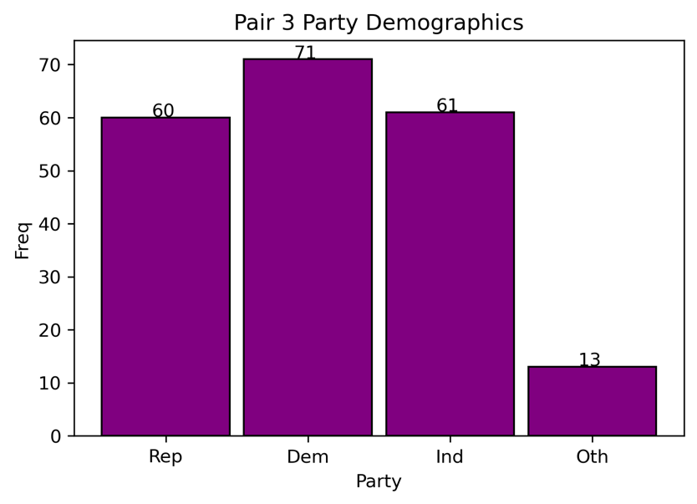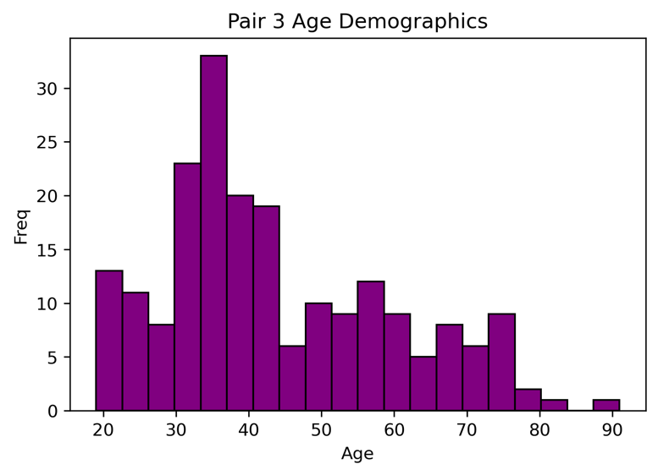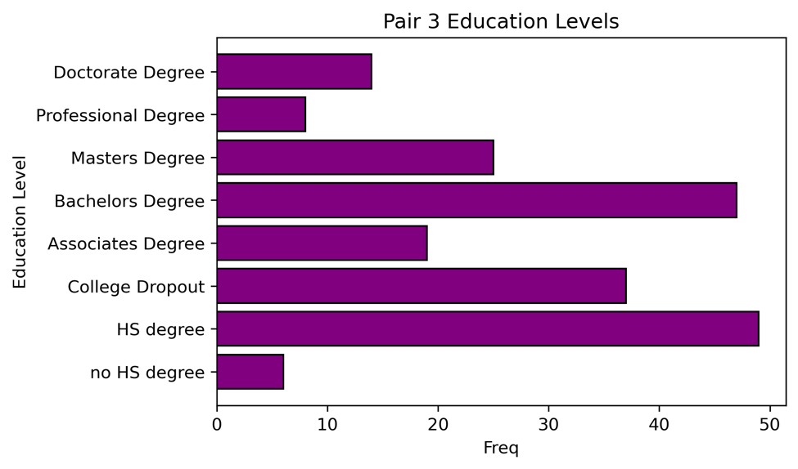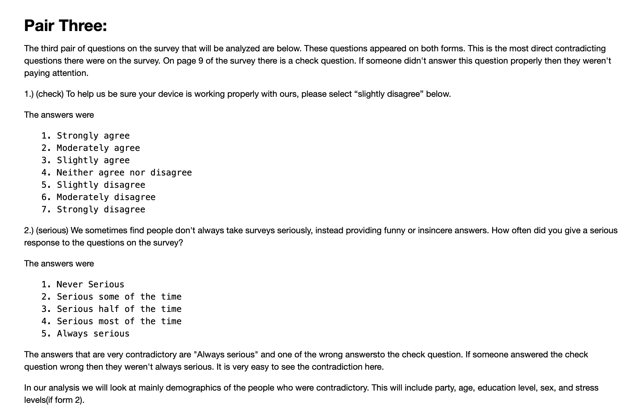

This Pair was on both forms. Out of 3080 surveys, 6.7 % (205) of the surveys were contradictory.

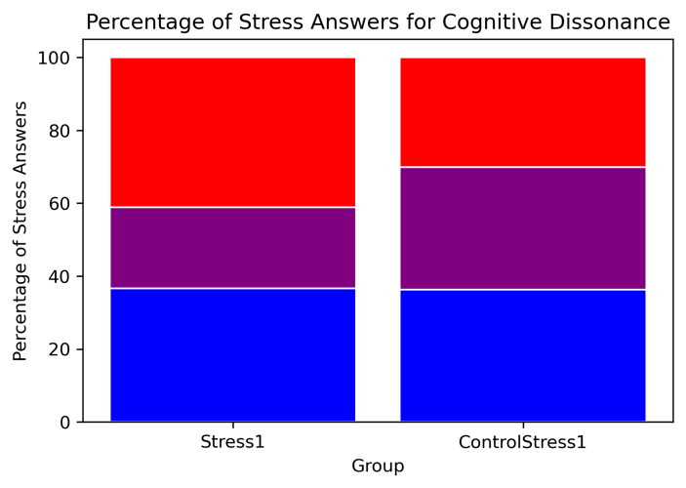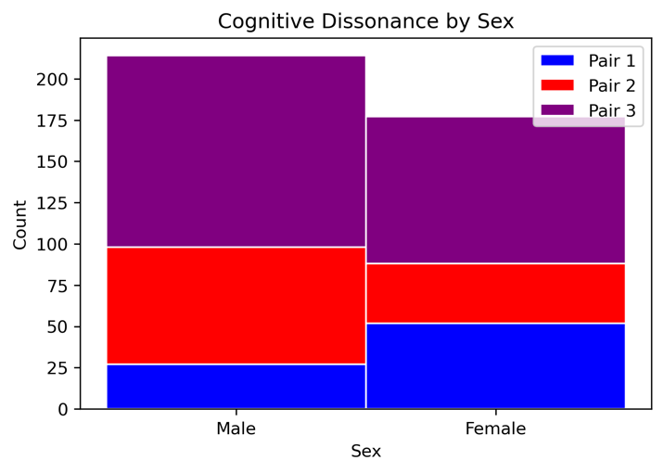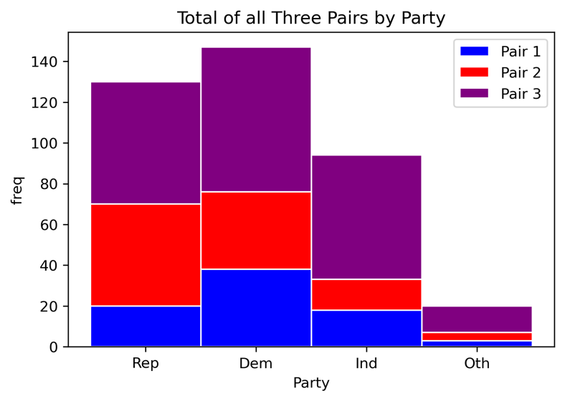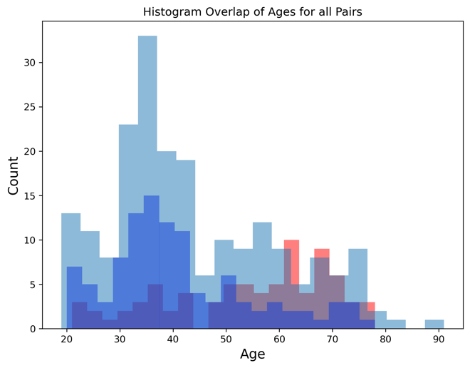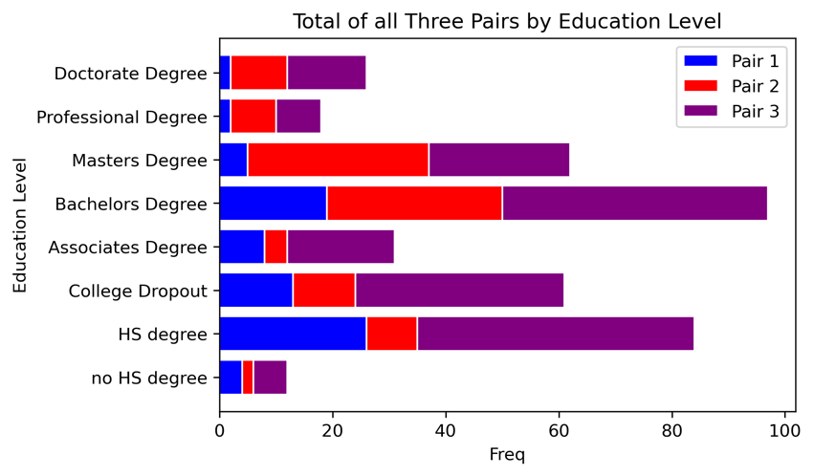

**Conclusion:**

Below are the aggregated numbers for various demographics for the people who answered with contradicting viewpoints. As you can see males tend to do it more often than females. In terms of party, it’s too close to make a conclusion on it. When it comes to education this analysis is short sighted in the fact that it should be tested against the percentages of the US populations’ education level to fully understand if this cognitive dissonance group has a substantial percentage of one or more demographics. The same should be done with age. For example, I would assume most of the people that took this survey had just a bachelors degree and were in the 30-40 year old age range. This would push the frequency of these people in the cognitive dissonance group higher. This was a mistake and will be noted for future analysis.

**Side note:**

One of the questions in the survey asked how often a person was able to control important things in their life. This was part of the stress portion of the survey. To the right are the answers from people who showed cognitive dissonance (stress1) and from the whole group (Controlstress1). Red represents the answers of often and all the time. Blue represents the answers of never and rarely. This shows that people who show conflicting political beliefs tend to be more stressed about their life.