IF TIME GOES BACK WITH NO COVID-19,WILL TRUMP WIN?

Weiwei Song

1/22/2021

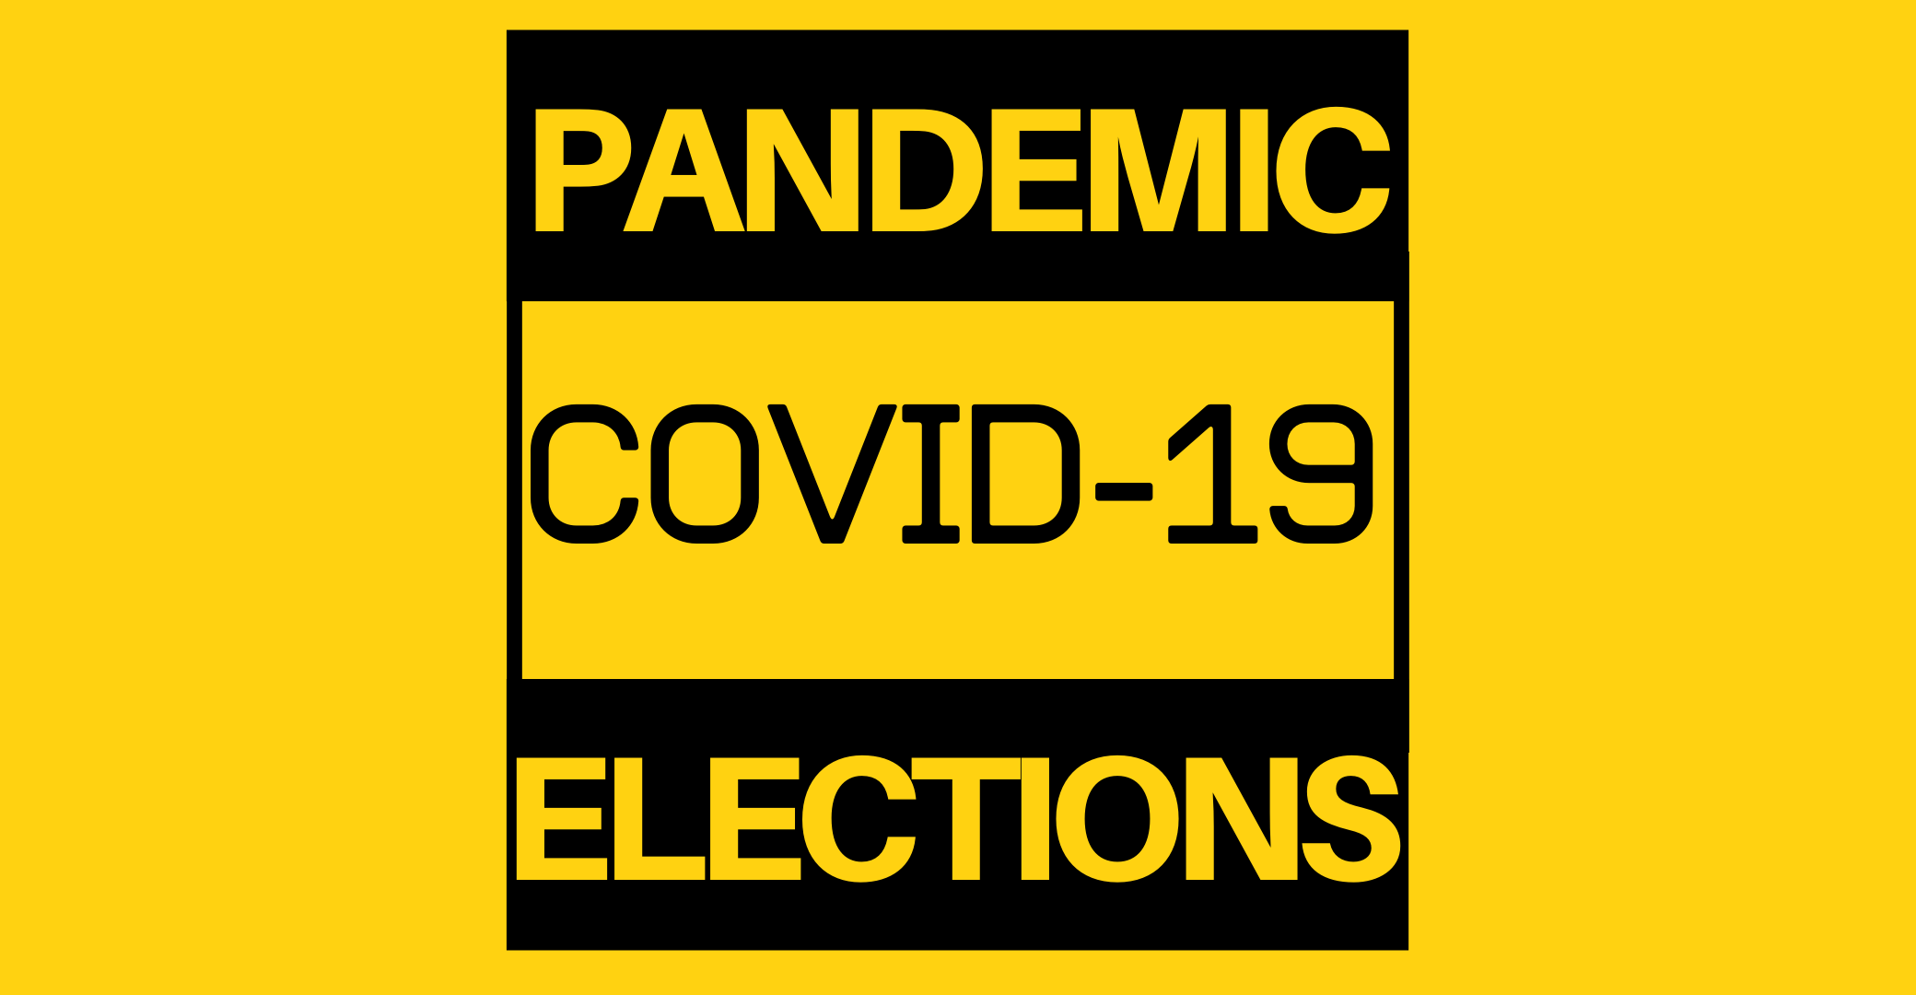

Back in February of 2020, the world situation is completely different. At that time, the unemployment rate in the United States was the lowest in decades, the stock market repeatedly hit record highs, and the situation of President Trump’s re-election was very good. However, the COVID-19 pandemic changed this situation dramatically. Many people say that Trump’s response to Coronavirus is one of the main reason he failed in the election. Is that true? This report is based on the ANES 2020 Exploratory Testing Survey conducted between April 10, 2020 and April 18, 2020. For more information, please visit <https://electionstudies.org/data-center/2020-exploratory-testing-survey/>

### Question 1: Is Trump’policy cope with Covid-19 is an important reason why people disapprove his job?

This questionare have two Form in the Trump Job Approval category.

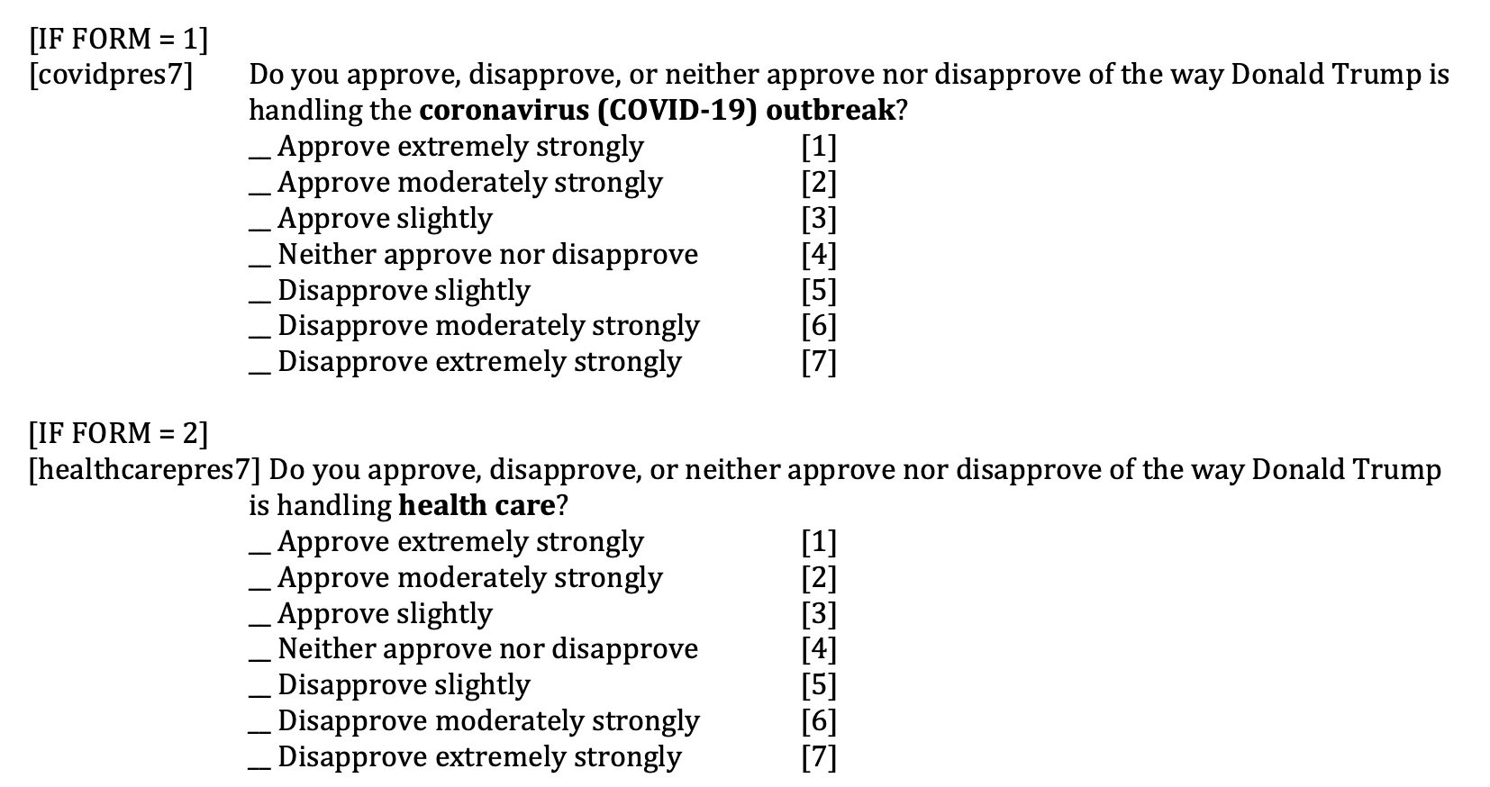

Should health care and coronavirus(COVID-19) be merged as one variable? Let’s see the distribution of people’s answers iterms of this question.

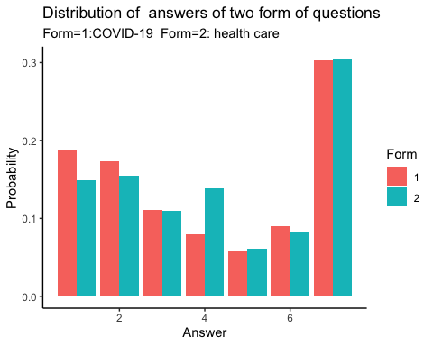

From the plot, people are more likely to hold an approval attitude towards Trump’s job handling COVID-19 than health care. Overall, difference is not big, except for the case that answer is “Neither approve or Disapprove”.

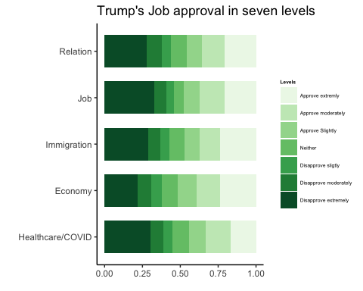

People who disapprove are mostly extremely disapprove.

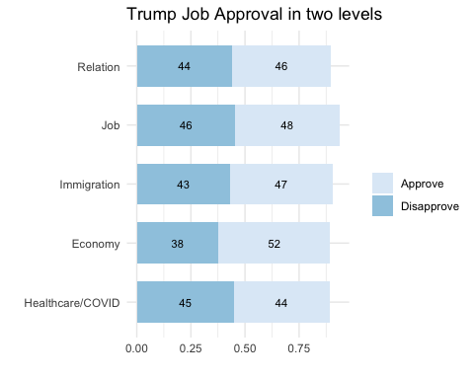

The approval rate of Trump’s Job in the field of economy is really high. But look at the bar of Healthcare/COVID, the difference actually really small.

### Question 2: If the economy quickly declines as one of the common effects of the pendamic, will the disapproval ratio in the COVID/HEALTHCARE increase? How about the job approval rate?

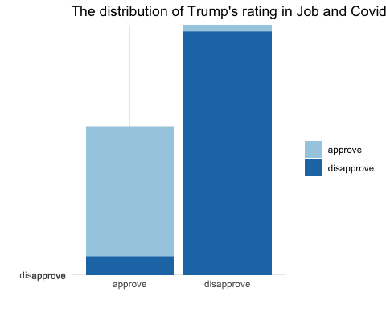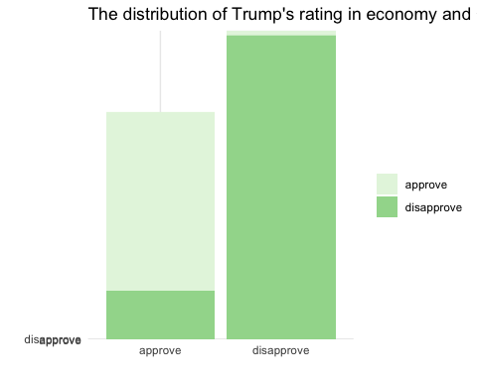

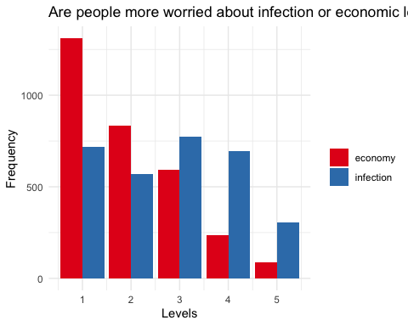

High consitency in the people’s view in the Job approval rating and healthcare/covid approval rating

People are more concerned about the economy decline as an important effect of pandemic.

It is possible if the outbreak of COVID-19 can’t get controlled, TRUMP’s disapproval rate will be increasing.

### Question 3: Gender, Age,Education difference in Trump’s Job Approval handling COVID-19. Who is the ideal candidate(Trump or Biden) in April 2020 for those people concern about the coronavirus?

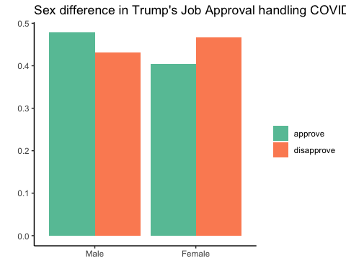

Clearly, women generally disapprove with trump’s response.

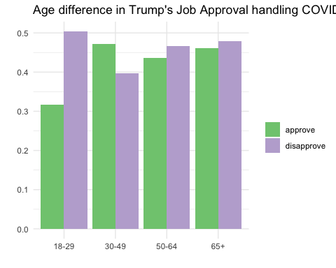

Young generation seems to disapprove it more, maybe the use of social media.

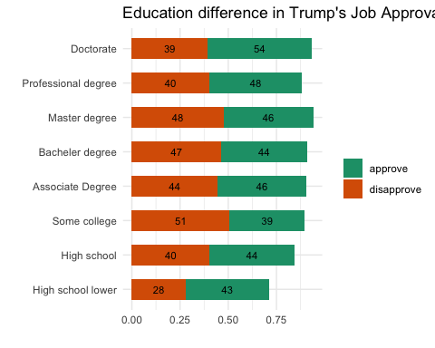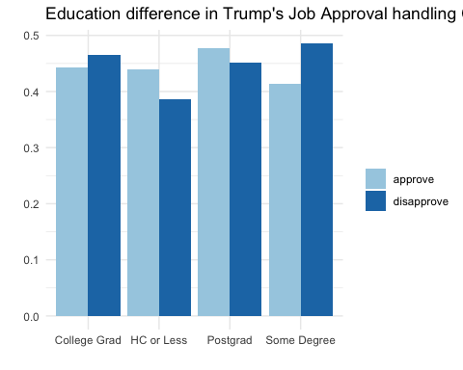

The differences is not so clear in the education level.

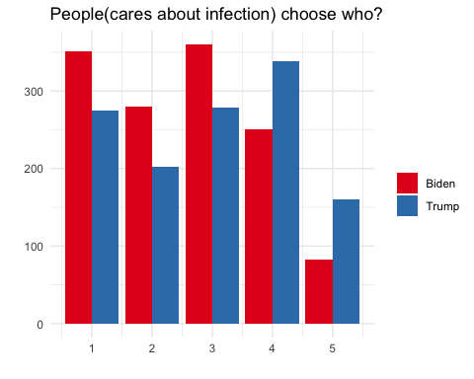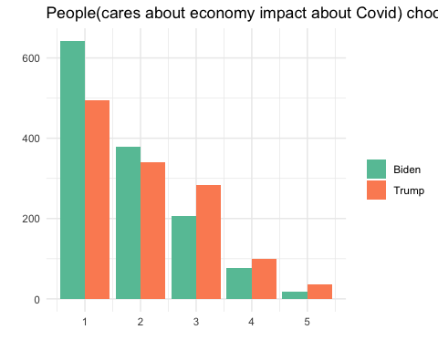

Degree=1 indicates extremely worried.The trend is obvious,the more people getting worried, the more they will choose Biden instead Trump. And this is unavoidable because American lose th leader role at the beginning of the outbreak. When people see the number of increase and death getting bigger and bigger in the news everyday, they begin to worry about this pedamic more.

## Conclusion

1. In April 2020, Trump’s job approval actually is not as bad now. The outbreak of COVID-19 hasn’t make people to be very disappointed with Trump at that time. On th other side, Trump earned some supports in the approval rating because of economic growth.

2.On the whole,there is high consistency in people’s choice in the Economy, Covid and Job approval ratings.Compared with the potential danger of getting infected, people are more concerned about economic impact of the coronavirus. It is possible if the outbreak of COVID-19 couldn’t get controlled, Trump’s disapproval rate will be increasing at least in the economy and health care fields.

1. The more people worried about COVID-19, the more likely Trump will lose.