Question 1, do the happy moments for elders different with youngers?

Of course yes! Basically we can to check what are the differents between two age groups, I split the data in to two groups, the one with age less than 25 and the one with age larger than 35. We try to analysis the proportion of frequency that each keyword or text appear in happy moments.

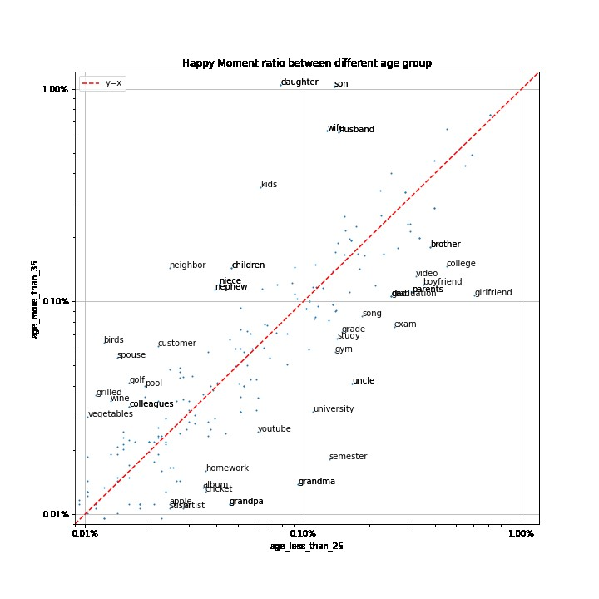Based on the plot above, the keywords about family appears for both dataset, elders cares more about wife, husband, children, kids while younger cares more about grandma and grandpa. However, the keywords about school never appears in the plot for elders dataset, while “semester”,”homework”,”university”,”exam”,”college” appears in the youngers dataset.

It looks like teenagers are more happy in the school!

We can also check this by looking at the word cloud.

Dataset for age more than 35

Dataset for age less than 25

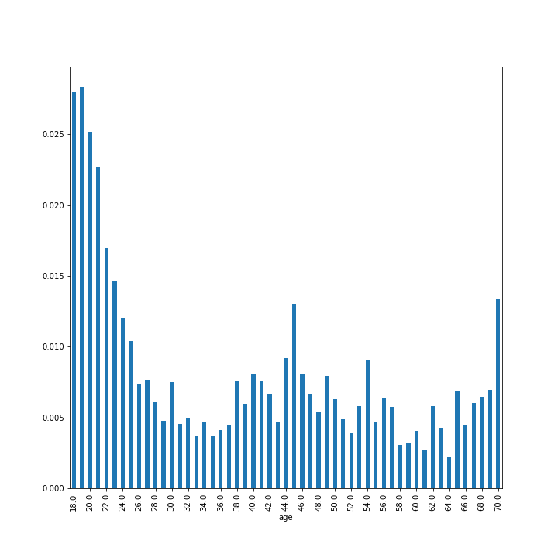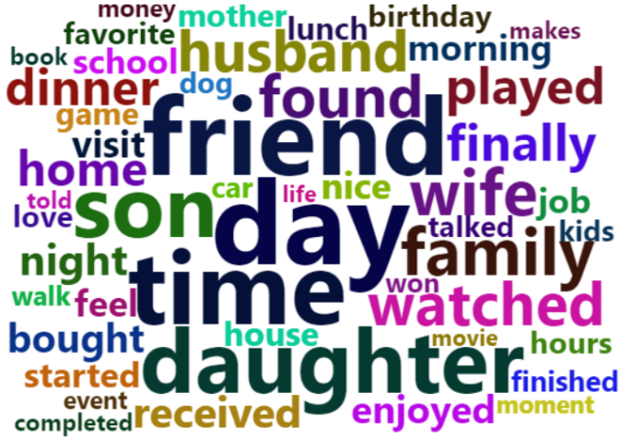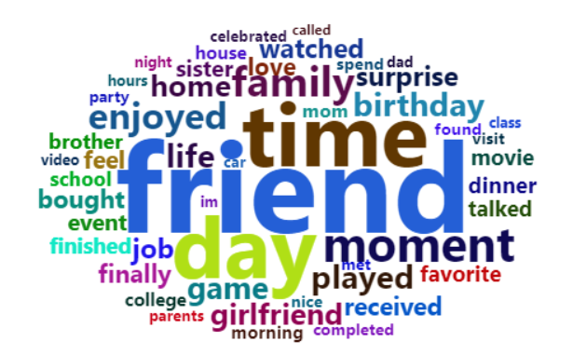

Q2: Does the ratio of happy moments related to school decreases as age get larger?

To address this problem, we need to divide the dataset for each age, and calculate the frequency of keywords related to school for happy moments.

The result if contrary to intuition, the frequency is the highest near 18-20, then it decreases, however, the tendency start to increase at age 35 for a while, then decrease at 45. It is partly because the kids of people from age 35 to 45 start to go to school, so the happy moments about school for those parents increases at that time. I do wish to see if the same tendency appears when people’s grandson and granddaughter go to school and the answer is yes! The tendency for frequency start to increase again at age 65.

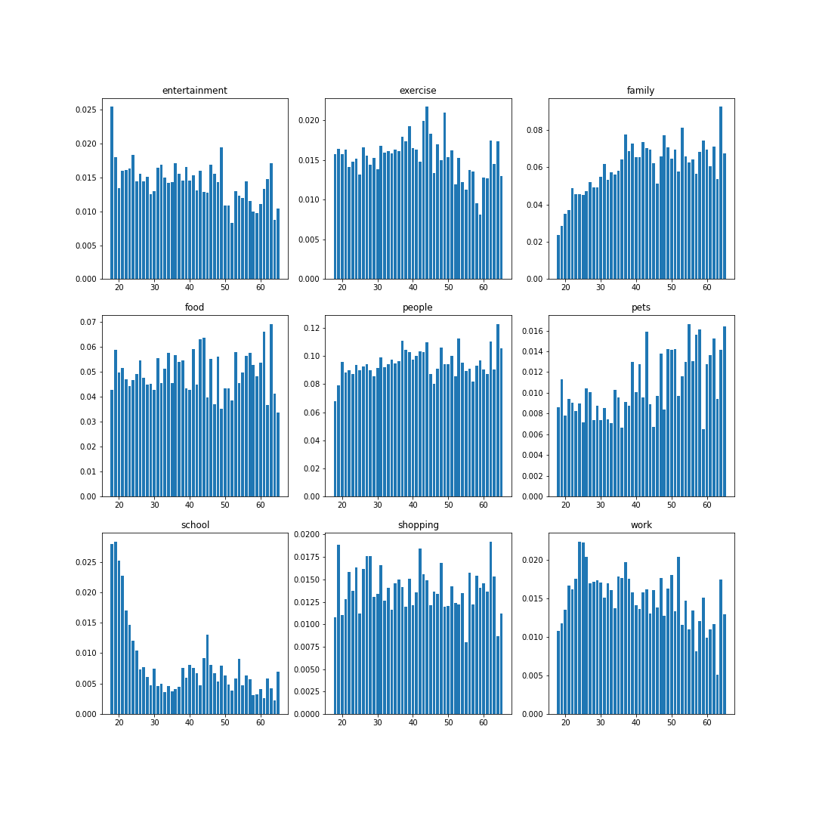

Q3: There are nine different topic, what about other topic?

I did the same thing I do in Q2 to other eight topic, and here is the result

Indeed the tendency for school is the most interesting, the frequency of family keep increasing as age gets larger, the pets one increases significantly at about age 35. For topic of work, the frequency increases from age 18 to 25, then decrease, but is also experience a liitle increase start from age 55, maybe because their son and daughter start go to work? For other topic, the frequency are almost the same among all age. But for entertainment, it is likely for kids, the frequency will be larger than other age, however, I have not enough dataset to show that.

Conclusion:

Q1: for different age group, the happy moments are different.

Q2: The tendency not strictly decreases as age gets larger, between when people’s children and grandchildren go to school , the frequency will increase.

Q3: For some topic, the frequency for happy moments remains almost the same, but for school, work, and pets, it depends.