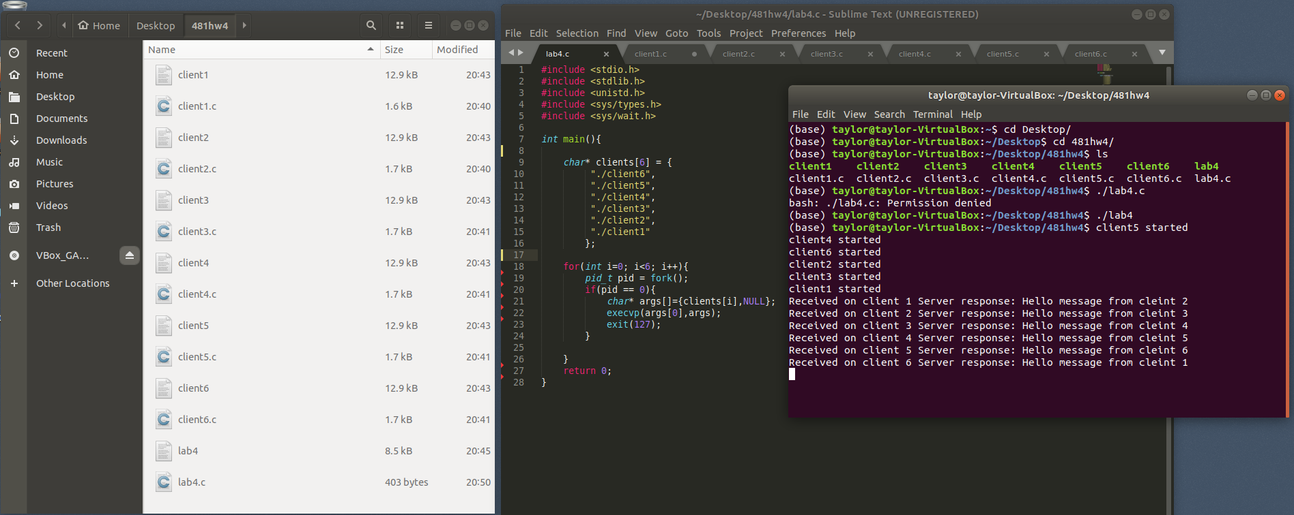

I created an individual client1-6.c file for each of the six required clients, each containing a port to listen on as-well as a port to send traffic to other clients on. In order to run each of the clients in an organized manner I created a program that implements fork() to create new processes and run the 6 clients all at once.