HW1 Solution by Tianze Wang
USCID:3993275888

Q1(a):
Number of heads: 34
Longest run of heads: 7
Q1(b):
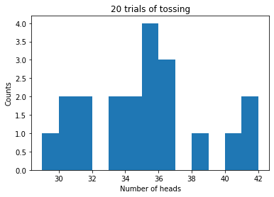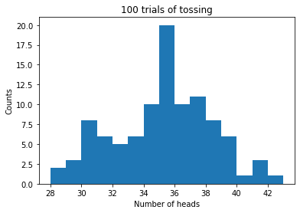
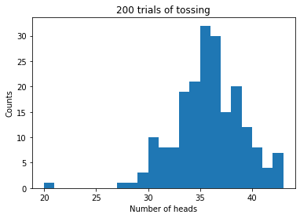
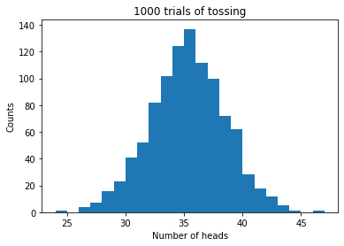
With the increament of experiment time, the histogram looks more like Gaussian Distribution with expectation of 35.
Q1(c):
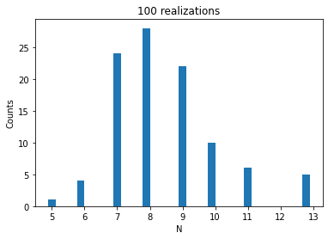
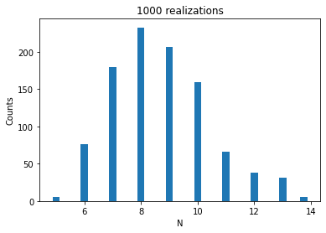
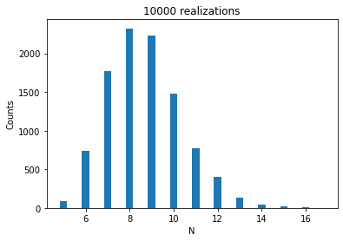
E[N] = 4 / (1/2*(1-0)) = 8

Q3:
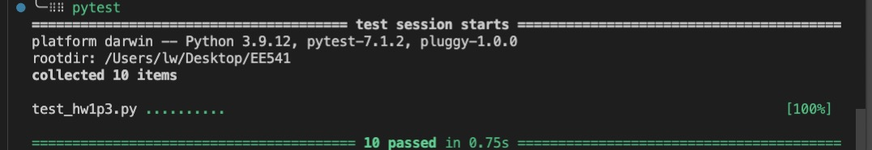

Code
Q1:
import matplotlib.pyplot as plt
import random

def toss():
if random.random() < 0.7:
return "Head"
return "Tail"

count = 0
longest_run = 0
cur_longest = 0
for i in range(50):
if toss() == "Head":
count=count+1
cur_longest = cur_longest + 1
else:
cur_longest = 0
longest_run = max(longest_run, cur_longest)

print("Number of heads: " + str(count))
print("Longest run of heads: " + str(longest_run))

def toss2():
if random.random() < 0.7:
return 1
return 0

def q1b(num):
result = [0] * num
for i in range(num):
cur_case = []
for n in range(50):
cur_case.append(toss2())
result[i] = sum(cur_case)
return result

plt.figure()
plt.title("20 trials of tossing")
plt.xlabel("Number of heads")
plt.ylabel("Counts")
res = q1b(20)
edge_left = min(res)
edge_right = max(res)
num_bins = edge_right - edge_left
trial_20 = plt.hist(res, bins = num_bins)
plt.figure()
plt.title("100 trials of tossing")
plt.xlabel("Number of heads")
plt.ylabel("Counts")
res = q1b(100)
edge_left = min(res)
edge_right = max(res)
num_bins = edge_right - edge_left
trial_50 = plt.hist(res, bins = num_bins)
plt.figure()
plt.title("200 trials of tossing")
plt.xlabel("Number of heads")
plt.ylabel("Counts")
res = q1b(200)
edge_left = min(res)
edge_right = max(res)
num_bins = edge_right - edge_left
trial_200 = plt.hist(res, bins = num_bins)
plt.figure()
plt.title("1000 trials of tossing")
plt.xlabel("Number of heads")
plt.ylabel("Counts")
res = q1b(1000)
edge_left = min(res)
edge_right = max(res)
num_bins = edge_right - edge_left
trial_1000 = plt.hist(res, bins = num_bins)

def q1c(num):
result = []
for i in range(num):
cur_longest = 0
for n in range(50):
if toss2() == 1:
cur_longest = cur_longest + 1
else:
if cur_longest != 0:
result.append(cur_longest)
cur_longest = 0
return result

plt.figure()
plt.title("500 trials of tossing")
plt.xlabel("Longest head run")
plt.ylabel("Counts")
res = q1c(500)
edge_left = min(res)
edge_right = max(res)
num_bins = edge_right - edge_left
trial_500 = plt.hist(res, bins = num_bins)
Q2:
import matplotlib.pyplot as plt
import random

def q2(num):
result = [0]*num
for i in range(num):
N = 0
cur_sum = 0
while cur_sum <= 4:
cur_sum = cur_sum + random.random()
N = N + 1
result[i] = N
edge_left = min(res)
edge_right = max(res)
num_bins = edge_right - edge_left + 1
plt.figure()
plt.title(str(num) + " realizations")
plt.xlabel("N")
plt.ylabel("Counts")
trial = plt.hist(result, bins = num_bins,align = 'left')

q2(100)
q2(1000)
q2(10000)
Q3:
from func import f
import sys

a = sys.argv[1]
b = sys.argv[2]

# Prerequisite check
try:
float(a)
float(b)
except:
sys.stderr.write("Range error\n")
# print('Range error', file=sys.stderr)
sys.exit()
else:
a = float(a)
b = float(b)

if a >= b:
sys.stderr.write("Range error\n")
# print('Range error', file=sys.stderr)
sys.exit()
if f(a)*f(b) >= 0:
sys.stderr.write("Range error\n")
# print('Range error', file=sys.stderr)
sys.exit()

#Secant inplementation
CONV_CRIT = 1e-10

x0 = a
x1 = b
N = 0
while True:
x2 = x1 - f(x1)*(x1-x0)/(f(x1) - f(x0))
N += 1
if(abs(x2 - x1) < CONV_CRIT):
print(str(N), file=sys.stdout)
print(str(x0), file=sys.stdout)
print(str(x1), file=sys.stdout)
print(str(x2), file=sys.stdout)
sys.exit()
x0 = x1
x1 = x2

