***AMERICAN INTERNATIONAL UNIVERSITY OF BANGLADESH***

PROJECT: COFFE SHOP MANAGEMENT

COURSE: INTRODUCTION TO DATABASE

COURSE TEACHER: SIFAT RAHMAN AHONA

GROUP MEMBERS: ID

1.Md.Tohidul Alam Anik 18-37450-1

2.Md. Mostak Jakaria Sohan 18-38543-2

3.Istiuq Ahmad 18-38590-2

4.Md. Nabil Hossain 18-38585-2

Introduction:

A database management system (DBMS) is a system software for creating and managing

databases. The DBMS provides users and programmers with a systematic way to create,

retrieve, update and manage data. A DBMS makes it possible for end users to create, read,

update and delete data in a database.

In our project (Coffee Shop Management System) was created by the concept of DBMS.

Case Study:

In a coffee shop management system a coffee shop can have one or many owners and also owners can have one or many coffee shop. Owners are identified by owner nid. Shop also stores owners name, email, city, country . The shop is identified by shop license. System also stores coffee shop name, coffee shop address . Coffee shop can have one or many customers at a time . Customers are identified by customer id . System also stores customer name. A coffee shop can have many branches but branches belongs to one coffee shop. Branches are identified by branch id. System also stores branch name, branch address . Branch has employees. Branch can have one or many employees but employees can work in one shop . Employees are identified by employee id . System also stores employee name, gender, phone number, salary, city, country . A branch of a coffee shop can have one or many managers and a manager can work in one shop . Managers are identified by manager id. System also stores manager name, phone number, hire date, salary . One manager controls many chefs but chefs works under only one manager . Chefs are identified by chefs id. System also stores chefs name, salary, phone number .

ER-DIAGRAM:

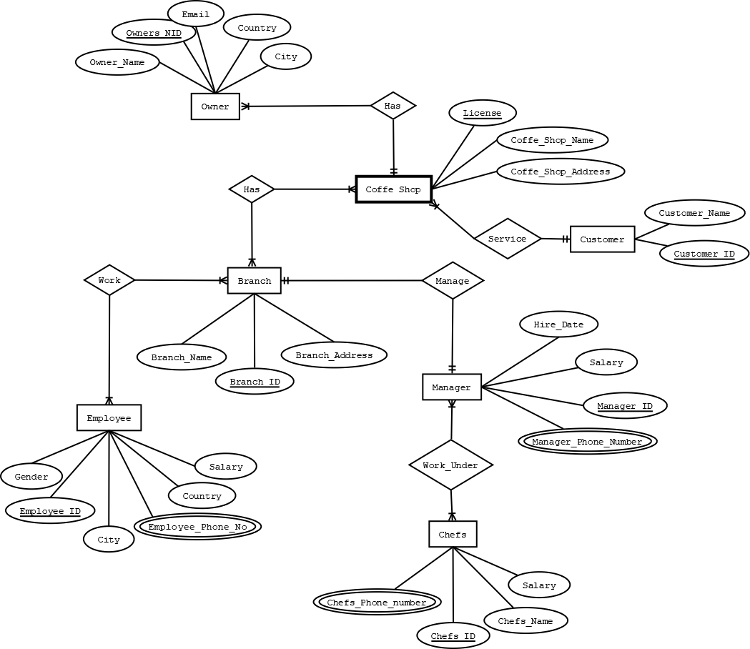

Normalization:

Has (Owners_NID,Owners_Name,Email,Country,City,License,Coffe_Shop_Name,

Coffe_Shop_Address)

1NF: No multivalued attribute

2NF: Owners_NID,Owners­_Name,Email,City,Country

License,Coffe_Shop_Name,Coffe_Shop_Addres

Ol_ID,Owners_NID,License

3NF: Owners_NID,Owners­_Name,Email,~~City,Country~~,Cc_ID

License,Coffe_Shop_Name,Coffe_Shop_Addres

Ol_ID,Owners_NID,License

Cc_ID,Country,City

TABLE:

1. Owners_NID,Owners­_Name,Email,Cc_ID

2.License,Coffe_Shop_Name,Coffe_Shop_Addres

3.Ol_ID,Owners_NID,License

4.Cc_ID,Country,City

Service (Customer_Name,Customer_ID,License,Coffe_Shop_Name,

Coffe_Shop_Address)

1NF: No multivalued attribute

2NF: Customer_ID,Customer_Name

License,Coffe_Shop_Name,Coffe_Shop_Address,Customer_ID

3NF: No Transitive Dependency

TABLE:  
 1. Customer_ID,Customer_Name

2.License,Coffe_Shop_Name,Coffe_Shop_Address,Customer_ID

Has (License,Coffe_Shop_Name,Coffe_Shop_Address,Branch_ID,Branch_Address,

Branch_Name)

1NF: No multivalued attribute

2NF: License,Coffe_Shop_Name,Coffe_Shop_Addree

Branch_ID,Branch_Address,Branch_Name

Lb_ID,License,Branch_ID

3NF: No Transitive Dependency

TABLE:

1. License,Coffe_Shop_Name,Coffe_Shop_Addree

2. Branch_ID,Branch_Address,Branch_Name

3.Lb_ID,License,Branch_ID

Work (Branch_ID,Branch_Address,Branch_Name,Employee_ID,Salary,Gender,

Employee_Phone_Number,City,Country)

1NF: Employee_Phone_Number multivalued attribute

2NF: Branch_ID,Branch_Address,Branch_Name

Employee_ID,Salary,Gender,Employee_phone_Number,City,Country

Be_ID,Branch_ID,Employee_ID

3NF: Branch_ID,Branch_Address,Branch_Name

Employee_ID,Salary,Gender,Employee_phone_Number,~~City,Country~~,Cc_ID

Be_ID,Branch_ID,Employee_ID

Cc_ID,City,Country

TABLE:

1. Branch_ID,Branch_Address,Branch_Name

2.Employee_ID,Salary,Gender,Employee_phone_Number,Cc_ID

3.Be_ID,Branch_ID,Employee_ID

4.Cc_ID,City,Country

Manage (Manager_ID,Hire_Date,Salary,Manager_Phone_Number,Branch_ID,

Branch_Address,Branch_Name)

1NF: Manager_Phone_Number multivalued attribute

2NF: Manager_ID,Hire_Date,Salary,Manager_Phone_Number

Branch_ID,Branch_Address,Branch_Name,Manager_ID

3NF: No Transitive Dependency

TABLE:

1.Manager_ID,Hire_Date,Salary,Manager_Phone_Number

2.Branch_ID,Branch_Address,Branch_Name,Manager_ID

Work Under (Manager_ID,Hire_Date,Salary,Manager_Phone_Number,Chefs_ID,

Salary,Chefs_Name,Chefs_Phone_Number)

1NF: Manager_Phone_Number,Chefs_Phone_Nmuber are multivalued attribute

2NF: Manager_ID,Hire_Date,Salary,Manager_Phone_Number

Chefs_ID,Salary,Chefs_name,Chefs_Phone_Number

Mc_ID,Manager_ID,Chefs_ID

3NF: No Transitive Dependency

TABLE:

1.Manager_ID,Hire_Date,Salary,Manager_Phone_Number

2.Chefs_ID,Salary,Chefs_name,Chefs_Phone_Number

3.Mc_ID,Manager_ID,Chefs_ID

TOTAL TABLE:

1.Owners_NID,Owners­_Name,Email,Cc_ID

2.~~License,Coffe_Shop_Name,Coffe_Shop_Addres~~

3.Ol_ID,Owners_NID,License

4.Cc_ID,Country,City

5.Customer_ID,Customer_Name

6.License,Coffe_Shop_Name,Coffe_Shop_Address,Customer_ID

7.~~License,Coffe_Shop_Name,Coffe_Shop_Addree~~

8.Branch_ID,Branch_Address,Branch_Name

9.Lb_ID,License,Branch_ID

10.~~Branch_ID,Branch_Address,Branch_Name~~

11.Employee_ID,Salary,Gender,Employee_phone_Number,Cc_ID

12.Be_ID,Branch_ID,Employee_ID

13.~~Cc_ID,City,Country~~

14.Manager_ID,Hire_Date,Salary,Manager_Phone_Number

15.Branch_ID,Branch_Address,Branch_Name,Manager_ID

16.~~Manager_ID,Hire_Date,Salary,Manager_Phone_Number~~

17.Chefs_ID,Salary,Chefs_name,Chefs_Phone_Number

18.Mc_ID,Manager_ID,Chefs_ID

FINAL TABLE:

1.Owners_NID,Owners­_Name,Email,Cc_ID

2.Ol_ID,Owners_NID,License

3.Cc_ID,Country,City

4.Customer_ID,Customer_Name

5.License,Coffe_Shop_Name,Coffe_Shop_Address,Customer_ID

6.Branch_ID,Branch_Address,Branch_Name

7.Lb_ID,License,Branch_ID

8.Employee_ID,Salary,Gender,Employee_phone_Number,Cc_ID

9.Be_ID,Branch_ID,Employee_ID

10.Manager_ID,Hire_Date,Salary,Manager_Phone_Number

11.Branch_ID,Branch_Address,Branch_Name,Manager_ID

12.Chefs_ID,Salary,Chefs_name,Chefs_Phone_Number

13.Mc_ID,Manager_ID,Chefs_ID

Table Creation :

*create table owner*

(owner_Nid number(5) constraint owner_onid_pk primary key,

owner_name varchar2(25) not null,

owner_email varchar2(25) not null,

owner_city varchar2(10) unique,

owner_country varchar2(10) unique

)

desc owner

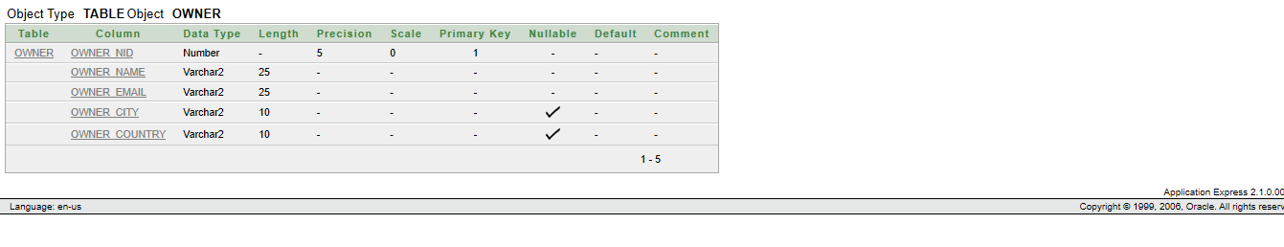

create table customer

(customer_id number(20) constraint customer_cid_pk primary key,

customer_name varchar2(10) unique)

Desc customer

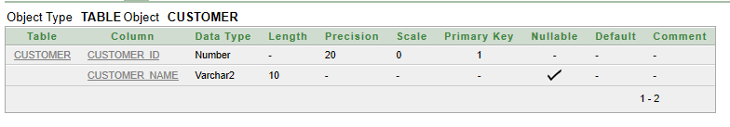

create table coffee_shop

(coffee_license varchar2(20) not null,

coffee_name varchar2(10)unique,

coffee_address varchar2(10)not null)

desc coffee_shop

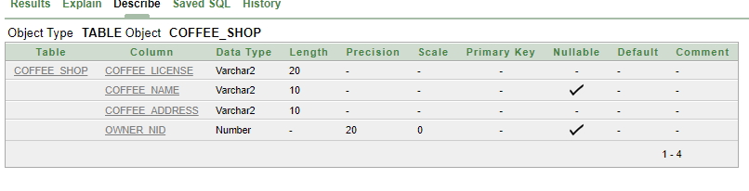

Create table branch

(

branch_id number(20) default 1,

branch_name varchar2(20) constraint branch_bname_pk primary key,

branch_address varchar2(10) not null

)

desc branch

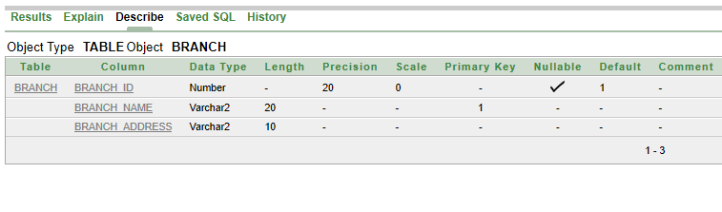

create table employee

(e_id varchar2(5) constraint employee_eid_pk primary key,

salary number(6) constraint employee_salary_ck check(salary<2000),

e_gender varchar2(2) not null,

e_pnumber number(15) default 100,

e_city varchar2(10) not null,

e_country varchar2(10) not null)

desc employee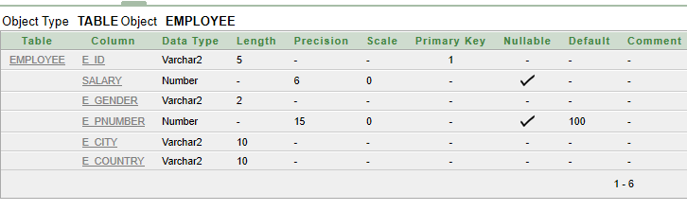 create table manager

(m_id number(10) not null,

salary number(10) constraint manager_msalary_pk primary key,

m_hire_date varchar2(20) unique,

m_pnumber number(10) default 300,

e_id number(10) not null)

desc manager

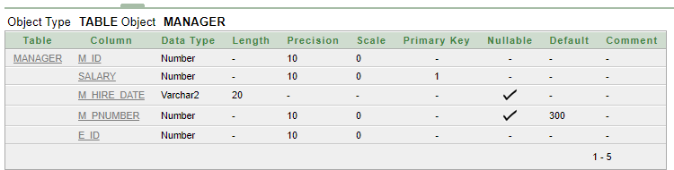

create table chefs

(chef_id number(20) constraint chefs_cid_pk primary key,

salary number(8) constraint chefs_salary_ck check(salary>1000),

chef_name varchar2(20) not null,

chef_pnumber number(10) unique)

desc chefs

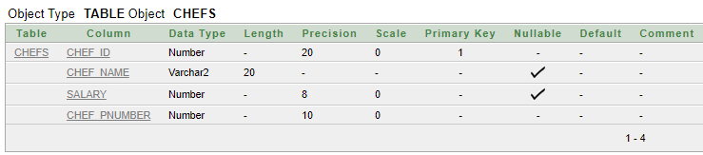

Insertion :

insert into owner

(owner_Nid,owner_name,owner_email,owner_city,owner_country)values(101,'Anik','taanik13@gmail.com','chittagong','bangladesh')

insert into owner(owner_Nid,owner_name,owner_email,owner_city,owner_country)values(102,'tanim','tanim@gmail.com','feni','london')

insert into owner(owner_Nid,owner_name,owner_email,owner_city,owner_country)values(103,'Alex','Alex@gmail.com','toronto','canada')

insert into owner(owner_Nid,owner_name,owner_email,owner_city,owner_country)values(104,'john','john@gmail.com','regina','UK')

insert into owner(owner_Nid,owner_name,owner_email,owner_city,owner_country)values(105,'Bob','bob@gmail.com','manitoba','USA')

select * from owner

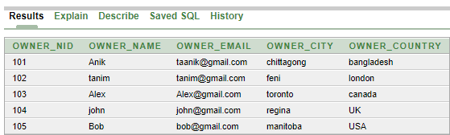

insert into customer

(customer_id,customer_name)values(1,'Anik')

insert into customer(customer_id,customer_name)values(2,'Tanim')

insert into customer(customer_id,customer_name)values(3,'Nabil')

insert into customer(customer_id,customer_name)values(4,'Jakaria')

insert into customer(customer_id,customer_name)values(5,'Joy')

select * from customer

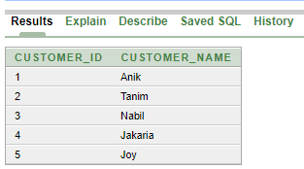

insert into coffee_shop

(coffee_license,coffee_name,coffee_address,owner_Nid)values(123,'Khanas','Dhaka',101)

insert into coffee_shop

(coffee_license,coffee_name,coffee_address,owner_Nid)values(111,'Bachelors','banani',102)

insert into coffee_shop(coffee_license,coffee_name,coffee_address,owner_Nid)values(243,'gulshan','Dhanmondi',103)

insert into

coffee_shop(coffee_license,coffee_name,coffee_address,owner_Nid)values(546,'Sultans','Nikunjo2',104)

insert into coffee_shop(coffee_license,coffee_name,coffee_address,owner_Nid)values(786,'cafeteria','mirpur',105)

select * from coffee_shop

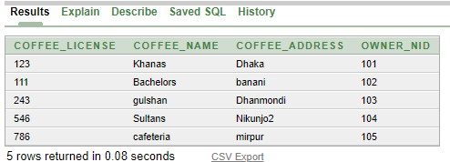

insert into branch(branch_id,branch_name,branch_address)values(101,'Nikkunjo','Khilkhet')

insert into branch(branch_id,branch_name,branch_address)values(102,'Moghol','Uttara')

insert into branch(branch_id,branch_name,branch_address)values(103,'Chilies','Banani')

insert into branch(branch_id,branch_name,branch_address)values(104,'Foodies','Rajshahi')

insert into branch(branch_id,branch_name,branch_address)values(105,'Gulshan','Nilkhet')

select * from branch

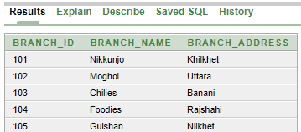

insert into employee(e_id,salary,e_gender,e_pnumber,e_city,e_country)values

(01,10000,'Male',01635942353,'mirpur' , 'Dhaka')

insert into employee(e_id,salary,e_gender,e_pnumber,e_city,e_country)values

(02,15000,'Male',01634672353,'Dhanmondi' , 'Dhaka')

insert into employee(e_id,salary,e_gender,e_pnumber,e_city,e_country)values

(03,20000,'female',01633842353,'uttara' , 'Dhaka')

insert into employee(e_id,salary,e_gender,e_pnumber,e_city,e_country)values

(04,25000,'female',01735942353,'Gulshan' , 'Dhaka')

insert into employee(e_id,salary,e_gender,e_pnumber,e_city,e_country)values

(05,50000,'Male',01835942353,'Banani' , 'Dhaka')

select * from employee

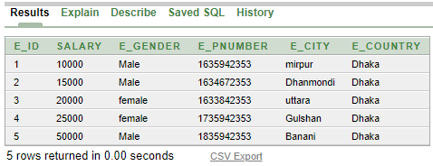

insert into manager(m_id,salary,m_hire_date,m_pnumber,e_id)values(111,10000,'10 jan 2010',485465,1)

insert into manager(m_id,salary,m_hire_date,m_pnumber,e_id)values(222,15000,'15 feb 2011',4845465,2)

insert into manager(m_id,salary,m_hire_date,m_pnumber,e_id)values(333,20000,'12 may 2010',485485,3)

insert into manager(m_id,salary,m_hire_date,m_pnumber,e_id)values(444,18000,'03 jan 2012',42346,4)

insert into manager(m_id,salary,m_hire_date,m_pnumber,e_id)values(555,14000,'25 april 2013',485675,5)

select *from manager

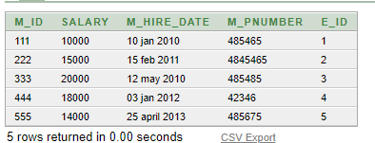

insert into chefs(chef_id,salary,chef_name,chef_pnumber)values(01,5000,'Tohidul',01748739)

insert into chefs(chef_id,salary,chef_name,chef_pnumber)values(02,6000,'Istiaq',01848739)

insert into chefs(chef_id,salary,chef_name,chef_pnumber)values(03,7000,'Hossain',01948739)

insert into chefs(chef_id,salary,chef_name,chef_pnumber)values(04,8000,'Sohan',02648739)

insert into chefs(chef_id,salary,chef_name,chef_pnumber)values(05,9000,'Monowar',016748739)

select * from chefs

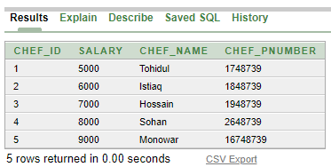

Query Writing:(Subquery)

1 Write a query to display the employee id and salary whose salary is greater than employee id = 3 ?

Ans:

select e_id,salary from employee

where salary > (select salary from employee where e_id = 3)

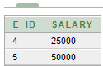

2. Write a query to display the employee id and salary for all employees who earn more than the minimum salary (Employees table)

Ans:

select e_id,salary from employee where salary > (select min(salary) from employee )

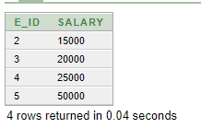

3. Write a query to display the customer name?

Ans:

select customer_name from customer where customer_id in(select customer_id from customer)

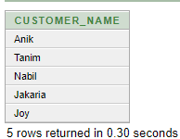

Join Query :

1. Write a query to display the owner name,Nid,coffeeshop name from coffee shop table?

Ans: select o.owner_name,o.owner_Nid,c.coffee_name from owner o , coffee_shop c where o.owner_Nid = c.owner_Nid

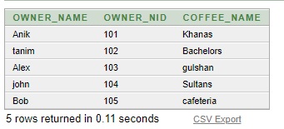

2. Write a query to display the employee id , employee salary , manager id , manager salary from manager table?

Ans: select e.e_id ,e.salary, m.m_id ,m.salary from employee e , manager m where e.e_id = m.e_id

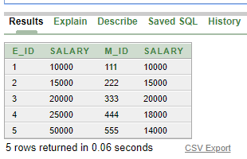

3. Write a query to display the employee id , city,country,manager hiredate,phone number from manager table?

Ans: select e.e_id ,e.e_city, e.e_country,m.m_hire_date,m.m_pnumber from employee e , manager m

where e.e_id = m.e_id

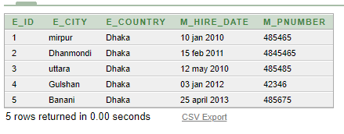

Group Function

1. Write a query to display average salary, maximum salary, minimum salary, sum of salary for

employee table?

select avg(salary),max(salary),min(salary),sum(salary) from employee

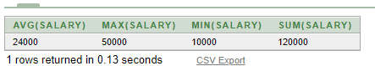

2. Write a query to display the row number from employee?

select count(*) from employee

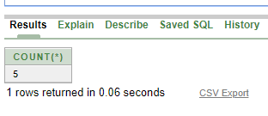

Single row function:

1.Write a single row function?

Ans : select e_id,concat(salary,e_gender)from employee

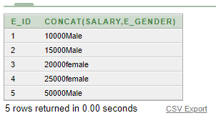

View:

create or replace view emp90vu

as

select e_id,salary,e_gender from employee

where e_id = 4

select * from emp90vu

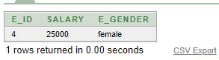

Conclusion:

THIS PROJECT IS ABOUT ON A COFEEE SHOP MANAGEMENT SYSTERM .THIS IS NOT AN ONLINE BASED SYSTEM. THIS SYSTEM IS CREATE FOR MANAGING A LOCAL COFFEE SHOP WHERE COFFEE SHOP , OWNER MANAGER ,EMPLOYEE DETAILS ARE INCLUDED AND CUSTOMER ACTIVITIES ARE RECORDER . THIS SYSTEM CAN BE USEFUL FOR A LOCAL COFFEE SHOP WHO WANTS TO RECORD THEIR DAILYS ACTIVITIES.