Assignment 2 report:

CPTS 427

Hongqi Guo

Question #1—Decode this simple cipher, which is the title of a book:

ACVLQDMZ

Answer is : **sundiver**

**This problem I used the Caesar Cipher to solve, I do this by changing the Shift value.**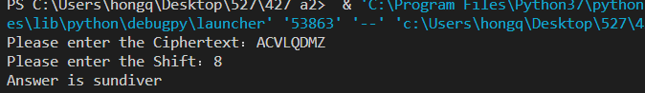

Question #2

Answer in **question2new.txt book name is <alice’s adventures in wonderland>**

This problem has consumed me for a long time. I originally decided to use **Caesar Cipher** to solve this problem, but the results were not satisfactory. I learned from the book that I can use **substitution cipher**.

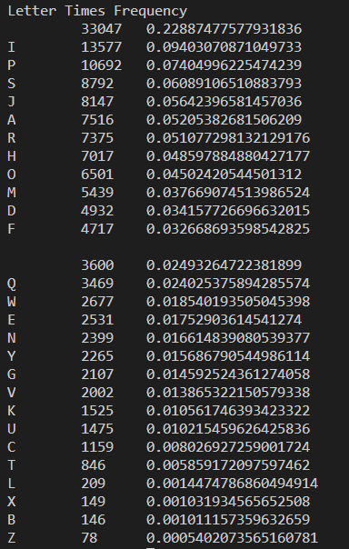I first get the frequency of all the letters.

Then I matched them against the English character frequency table in the book. The results were bad. I realized that it would take a lot of testing to get all the correct comparison tables, so I used a [decompiler](https://www.boxentriq.com/code-breaking/cryptogram). I get all the keys from the decompiler and use Python to decipher the encrypted file.

Question #3—Decode this cipher (which has a connection to the plaintext in question #2) using the keyword from question2.txt (which has a connection to the keyword in question #1 and #2): YSFKFMEOE

Answer is : **EDUCATION**

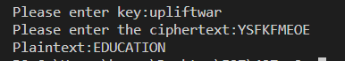

This part did not take me too long. I used the **Vigenere cipher**, and the key value appears in the last line of the second question. I need to plug in the key value and ciphertext, and the final answer is' **EDUCATION** '.

Question #4—What is in the question4.txt file? Use the keyword from question #3 to unzip question4.zip.

Answer**: The keyword is THUNDERCASTLE.**