Exercise 2.7:

The result is the same as the POST method but with the GET method, we can see the transferred data appended to the URL so the GET method is not secured

Exercise 2.9:

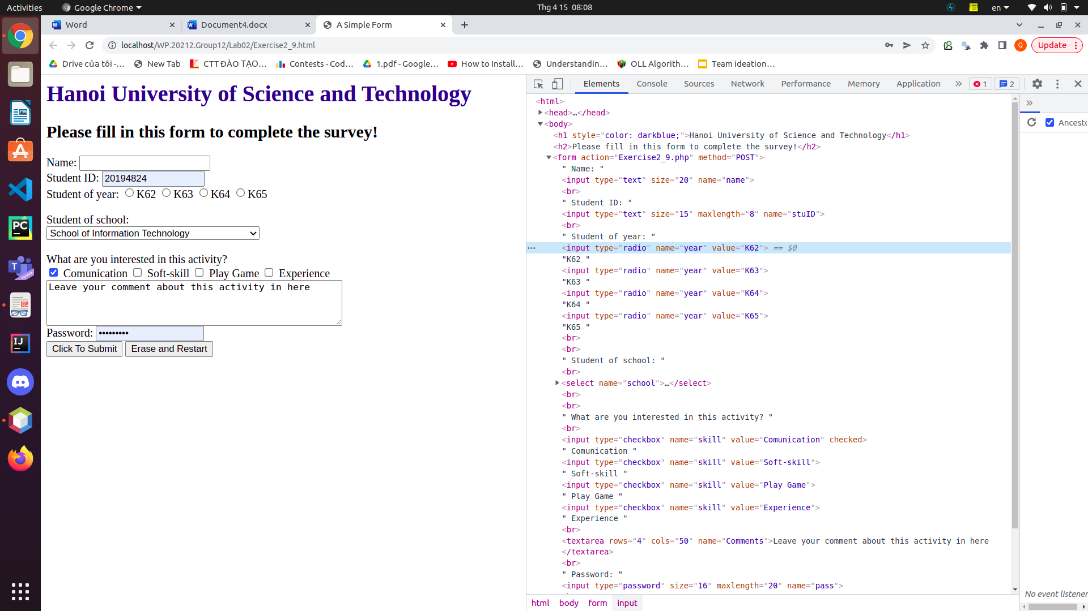

* In this picture, we use DOM inspector to show the hierachical structure of this HTML document. For example, when we inspect the radio button with the value “K62”, the DOM inspector shows the structure as follow: html > body > form > input

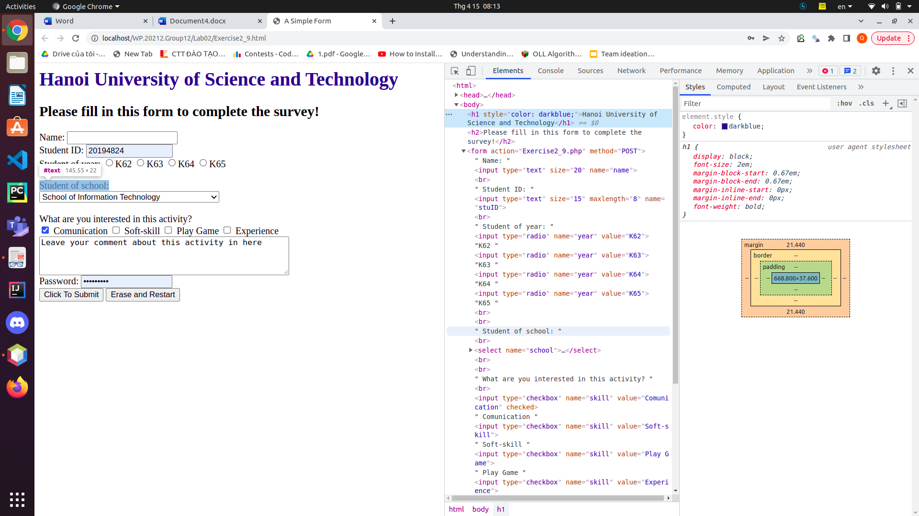

* Not only the structure, we can also see the CSS style applied to specific elements. For example, we can see element.style value of the “Hanoi University of Science and Technology” element is “darkblue”

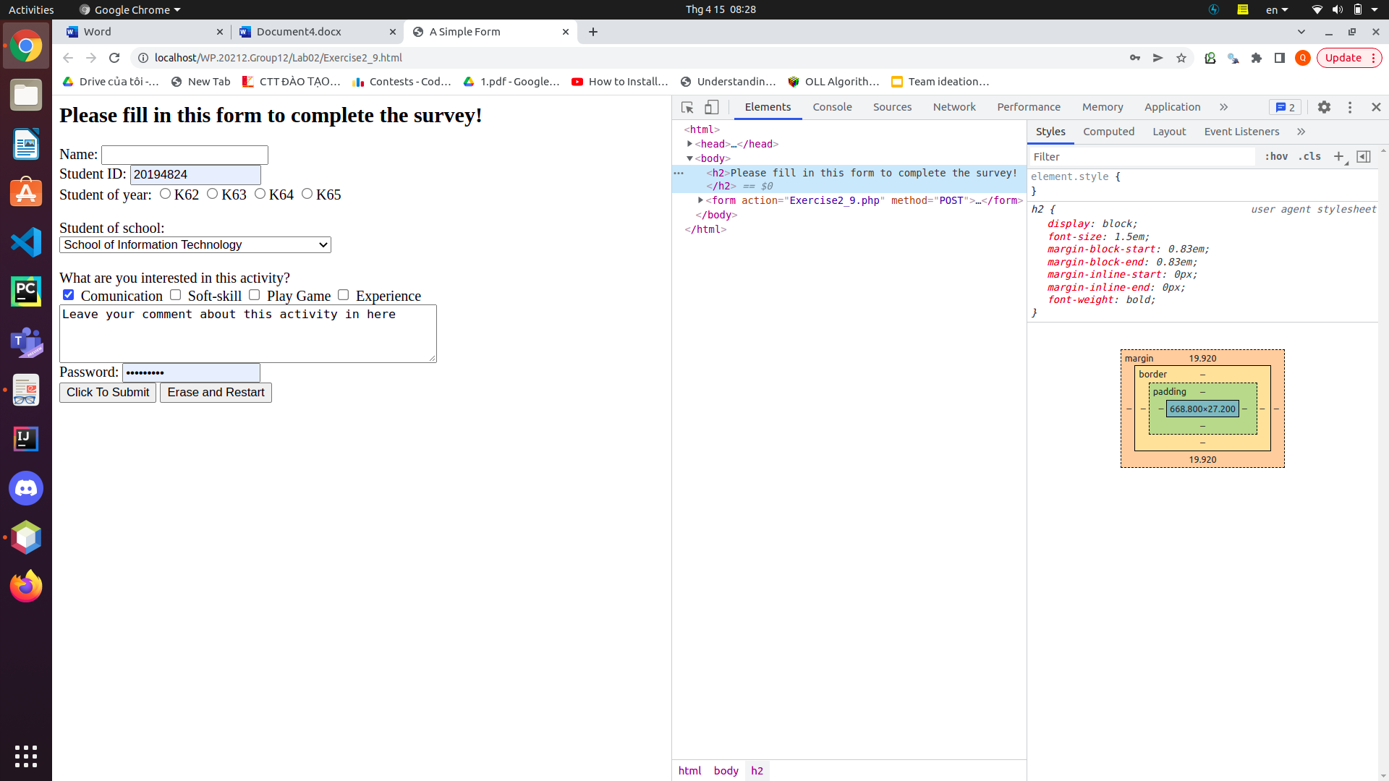

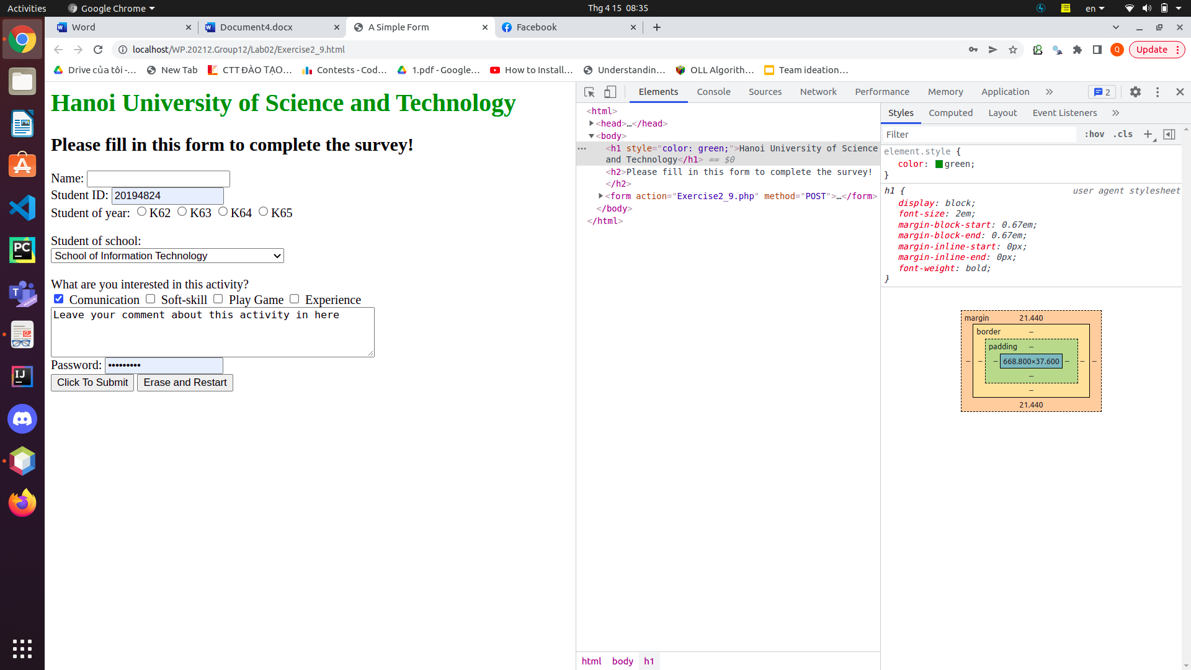

* And we can also edit the HTML sources as I deleted the “Hanoi University of Science and Technology” element or change the element attribute value as the two above pictures