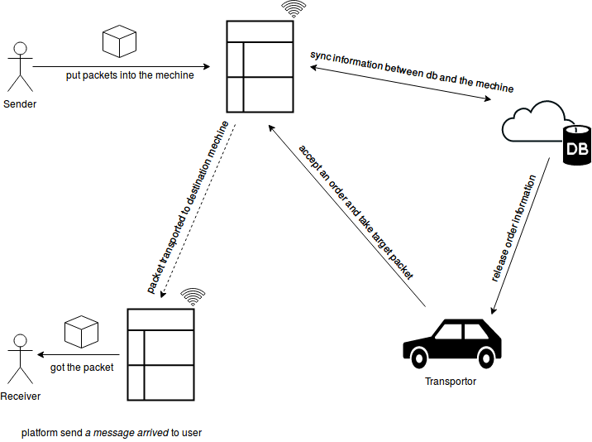

Figure 1: Design diagram of xxx system

// The detail I will send to u tomorrow :-p