**ROP-Hunt：在应用程序中检测返回导向编程(ROP)攻击**

摘要:

Return-oriented Programming (ROP) is a new exploitation technique that can perform arbitrary unintended operations by constructing a gadget chain reusing existing small code sequences.

返回导向编程(ROP) 是一种新型漏洞利用技术，该技术通过重复使用已有的小代码序列(gadget)构造出一条gadget链，从而执行任意的非法操作。

Although many defense mechanisms have been proposed, some new variants of ROP attack can easily circumvent them.

尽管很多防御机制已经被提出，但是一些新的ROP攻击的变种能够轻易绕过这些机制防御。

In this paper, we present a new tool, ROP-Hunt, that can defend against ROP attacks based on the differences between normal program and ROP malicious code.

在本文中，我们将介绍一个新工具ROP-Hunt，它能依据正常程序与恶意ROP代码间的差异来防御ROP攻击。

ROP-Hunt leverages instrumentation technique and detects ROP attack at runtime.

ROP-Hunt利用**插桩检测**(instrumentation)技术并在程序运行时检测ROP攻击。

In our experiment, ROP-Hunt can detect all types of ROP attack from real-world examples.

在我们的实验中，ROP-Hunt可以在众多实例程序中检测出所有类型的ROP攻击。

We use several unmodified SPEC2006 benchmarks to test the performance and the result shows that it has a zero false positive rate and an acceptable overhead.

我们使用了几个原版的SPEC2006标准来测试ROP-Hunt的性能，结果表明它具有零误报率和可接受的系统开销。

Keywords: Return-oriented Programming · Buffer overflow Detection · Code reuse attack · Binary instrumentation

关键词：返回导向编程、缓冲区溢出、检测、代码复用攻击、二进制插桩检测

1 Introduction

一、引言

Since the widespread adoption of data execution prevention (DEP) [1], which ensures that all writable pages in memory are non-executable, it's hard for attackers to redirect the hijacked control flow to their own injected malicious code.

由于数据执行保护（DEP）[1]的广泛采用，确保了内存中的所有可写页面都是不可执行的，因此攻击者很难将被劫持的控制流重定向到他们自行注入的恶意代码。

To bypass DEP mechanism, code reuse attack (CRA) techniques are proposed and have become attacker's powerful tools.

为了绕过DEP机制，代码复用攻击（CRA）被提出并成为了攻击者们的利器。

Instead of injection code, they reuse instructions already residing in the attacked vulnerable process to induce malicious behaviors.

攻击者们不再注入代码，而是通过复用被攻击的漏洞进程中的现有指令来构造恶意行为。

Return-into-libc technique [37] is one simple practice of it, in which the attacker uses a buffer overflow to overwrite the return address stored in the stack to the address of the library function chosen to be executed.

Return-into-libc技术[37]是代码复用攻击的一种简单应用，攻击者利用缓冲区溢出漏洞，将位于栈中的返回地址覆写为攻击者挑选出的将要被执行的库函数地址。

Traditional return-into-libc attack leverages libc functions and cannot support arbitrary computation on the victim machine.

传统的return-into-libc攻击利用libc函数，并不支持在受害计算机上的执行任意操作。

Return-oriented Programming (ROP) is another code reuse attack technique, which executes short instruction sequences called gadgets instead of an entire function.

返回导向编程（ROP）是另一种代码复用攻击技术，它执行称为gadgets的短指令序列，而不是执行一整个函数。

ROP was first demonstrated by Shacham [35] for the x86 platform,and was subsequently extended to other architectures [13,16,23,26].

ROP最初由Shacham[35]提出并应用于x86平台，随后被拓展到其他体系结构[13,16,23,26]。

It has been proved that ROP can perform Turing-complete computation [36].

ROP可实现图灵完备计算已被证明[36]。

Some tools have been developed that allow attackers to construct arbitrary malicious programs using ROP automatically [22,24,33,34].

一些允许攻击者使用ROP自动构造任意恶意程序的工具已被开发[22,24,33,34]。

In the last few years, a number of software and hardware defenses have been proposed to mitigate ROP-based attacks.

在过去几年中，许多用于减缓基于ROP攻击的软件或硬件防御方法已被提出。

For example, DROP [17] and DynIMA [20] will trigger an alarm if the small instruction sequences each ending with a ret instruction are executed consecutively.

例如，如果连续执行以ret指令为结尾的小指令序列，DROP [17]和DynIMA [20]将触发警报。

ROPdefender [21] maintains a shadow stack and verifies all return addresses.

ROPdefender [21]则维护一个影子栈，并验证所有返回地址。

Li et al. [27] proposed a compiler for the x86 platform that avoids issuing "0xc3" bytes that can be used as unintended return instructions. Further more, it replaces intended call and return instructions with an indirect call mechanism. However, these mechanisms only focus on the ROP gadgets ending with return instructions and can not defeat other types of ROP-like attacks that capture gadgets without return instructions.

李等人[27]提出了一个用于x86平台的编译器，它能避免生成可用作恶意返回指令的“0xc3”字节。此外，它使用间接调用机制替换了预期的调用和返回指令。但这些机制只关注了以返回指令为结尾的gadget，并不能防御其他类型，即不以返回指令为结尾的gadget的类ROP攻击。

CFLocking [11] and G-Free [30] aim to defend against all types of ROP attacks, but they require the source code which is often unavailable to the end users in the real world.

CFLocking [11]和G-Free [30]旨在防御所有类型的ROP攻击，但它们需要源代码，对于实际的终端用户而言，这些源代码通常难以取得的。

KBouncer [32] covers all ROP attack types, requires no side information and achieves good runtime efficiency. However, it only monitors the application execution flow on selected critical paths, e.g., system APIs. It inevitably misses the ROP attacks that do not use those paths.

KBouncer [32]涵盖了所有ROP攻击类型，且不需要辅助信息，并实现不错的运行时效率。然而，它只是监视目标关键路径上的应用程序执行流，例如系统API。如此，它不可避免地漏掉了那些不使用这些路径的ROP攻击。

ROP attack chains gadgets together to perform complex computations and has its own features: the length of gadget is short, contiguous gadgets are not in the same routine and they all execute system calls in somewhere.

ROP攻击组合gadget成链，以执行复杂的操作，它具有如下特征：gadget长度很短；连续的gadget并不在同一个例程中，并且它们都在某个地方执行系统调用。

Based on these features, we design and implement a tool named ROP-Hunt, which dynamically detects all types of ROP attack by checking whether the execution behavior has these matched features. In ROP-Hunt, based on the hazard degree, we divide the ROP report into two categories: *Warning* and *Attack.*

基于这些特征，我们设计并实现了一个名为ROP-Hunt的工具，该工具通过检查程序执行的行为是否与这些特征匹配，从而对所有类型的ROP攻击进行动态检测。在ROP-Hunt中，基于危害程度，我们将ROP报告分为两类：*警告*和*攻击*。

In summary, the main contributions of our work are:

总的来说，我们工作的主要贡献是：

- We statistically analyze a number of normal applications and latest ROP malicious code, and extract features of the ROP attack.

- 我们统计分析了大量正常的应用程序和最新的ROP恶意代码，并提取了ROP攻击的特征。

- We propose a novel approach to protecting legacy applications from all types of ROP attacks without accessing to source code.

- 我们提出了一种新方法，可以在不访问源代码的情况下保护传统应用程序免受所有类型的ROP攻击。

- We design and implement a prototype, ROP-Hunt, on x86-based Linux platform and evaluate its security effectiveness and performance overhead.

- 我们在x86框架的Linux平台上，设计并实现一台样机，即ROP-Hunt，并评估了其安全有效性和性能开销。

The remainder of the paper is organized as follows: In Sects. 2 and 3, we describe the ROP attacks and analyze the features of them. The design and implementation of ROP-Hunt are illustrated at Sect. 4. Sections 5 and 6 discuss the parameter selections and delay gadget respectively. Section 7 presents the security and performance evaluation of ROP-Hunt. Section 8 examines its limitations. Finally, we conclude this paper and discuss the future work in Sect. 9.

本文的其余部分安排如下：在第二、三部分中，我们描述了ROP攻击并分析了它们的特征。 ROP-Hunt的设计和实现在第四部分介绍。第五部分和第六部分，分别讨论了参数选取和特殊的延迟gadget。第七部分介绍了ROP-Hunt的安全性和性能评估。第八部分研究了它的局限性。最后，我们在第九部分总结全文并讨论有待完成的工作。

2 ROP Attack

二、ROP攻击

Without injecting new code into the programs address space, ROP attacks consist of short instruction sequences, which are called gadgets.

在不向程序地址空间注入新代码的情况下，ROP攻击由称为gadget的短指令序列组成。

Each gadget performs some small computation, such as adding two registers or loading a value to memory, and ends with return instruction. We can chain gadgets together and transfer the control flow from one gadget to another by writing appropriate values over the stack.

每个gadget执行一些小的计算操作，例如将两个寄存器相加或将某个值加载到内存，并以返回指令为结尾。我们可以将这些gadget链接在一起，并通过在堆栈上写入适当的值，使控制流从一个gadget转至另一个gadget。

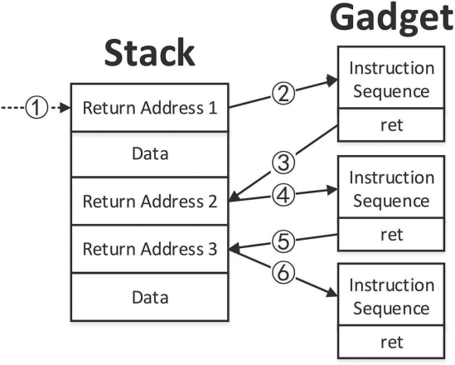

Fig. 1. A general ROP attack

图1 一般的ROP攻击

Figure 1 illustrates a general ROP attack workflow. In step 1, the attacker exploits a memory-related vulnerability of a specific program, e.g., a buffer overflow, and moves the stack pointer (ESP) to the first return address.

图1说明了一般的ROP攻击流程。第一步，攻击者利用漏洞程序的如缓冲区溢出这类的与内存相关的漏洞，将堆栈指针（ESP）移至第一个返回地址所在位置。

For example, Aleph in [31] uses stack smashing techniques to overwrite the return address of a function. Return address 1 is injected at the place where the original return address was located, and the value of ESP will be automatically changed to this point.

例如，Aleph在[31]这篇文章中，通过栈溢出覆写了函数返回地址。由于返回地址1覆盖了原返回地址所在位置，ESP的值将自动改为此点。

In step 2, execution is redirected to the first gadget by popping return address 1 from the stack.

第二步，通过pop栈中的返回地址1，程序执行流被重定向至第一个gadget。

The gadget is terminated by another return instruction which pops return address 2 from the stack (step 3) and redirects execution to the next gadget (step 4).

该gadget以另一个返回指令为终止，该指令pop栈中的返回地址2（第三歩）并将程序执行流重定向至下一个gadget（第四歩）。

Each gadget is executed one by one in this way until the attacker attains his goal.

每个gadget通过这种方式逐个执行，直到攻击者达到目标。

Recently, some new variants of ROP attack without using ret instructions were proposed.

最近，一些不使用ret指令的ROP攻击新变种被提出。

Checkoway et al. [15] found it is possible to perform return-oriented programming by looking for a pop instruction followed by an indirect jump (e.g., pop edx ; jmp [edx ]).

Checkoway等人[15]发现可以通过搜寻尾随有间接跳转的pop指令（例如*pop edx; jmp [edx]*）来进行返回导向编程。

This instruction sequence behaves like returns, and can be used to chain useful gadgets together.

这种指令序列的行为类似于返回指令，亦可用作gadget的链接。

Jump-Oriented Programming (JOP) [12] is another variant of ROP attack which uses register-indirect jumps instead of returns.

跳转导向编程（Jump-Oriented Programming, JOP）[12]是ROP攻击的另一种变体，它使用寄存器间接跳转代替了返回指令。

JOP uses a dispatcher table to hold gadget addresses. Each gadget must be followed by a dispatcher, which is an instruction sequence that can govern the control flow.

which is an instruction sequence that can govern the control flow.

JOP使用调度程序表来保存gadget的地址。每个gadget对应一个调度程序，调度程序是一段可以控制程序控制流的指令序列。

The dispatcher is used as a virtual program counter and translates the control flow to an entry in the dispatch table, which is the address of a particular jump-oriented functional gadget.

调度程序用作虚拟程序计数器(PC)，将程序控制流转换为调度表中存储的地址条目，这些地址是特殊的、具有跳转导向功能的gadget的地址。

At the end of a functional gadget, the attacker uses an indirect jump back to the dispatcher.

在这些gadget的结尾，攻击者通过间接跳使程序控制流回归调度程序。

Then, the dispatcher advances the pointer to the next functional gadget. A simple case of dispatcher is add edx, 4; jmp [edx ].

随后，调度程序将指针指向下一个gadget。一个简单的调度程序如下：add edx,4; jmp [edx]。

Call Oriented Programming (COP) [14] was introduced by Nicholas Carlini and David Wagner in 2014.

调用导向编程（Call Oriented Programming, COP）[14]由Nicholas Carlini和David Wagner于2014年推出。

Instead of using gadgets that end in returns, the attacker uses gadgets that end with indirect calls.

攻击者用以间接调用指令为结尾的gadget代替以返回指令为结尾的gadget。

COP attack does not require a dispatcher gadget and gadgets are chained together by pointing the memory-indirect locations to the next gadget in sequence.

COP攻击不需要调度程序，它通过依次地将内存间接位置指向下一个gadget的方法，来将gadget链接在一起。

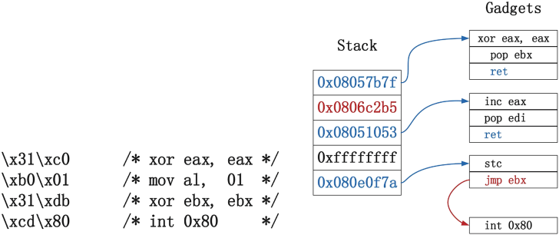

(a) Traditional Shellcode (b) ROP Malicious Code

(a) 传统shellcode (b)ROP恶意代码

Fig. 2. A simple mixed ROP attack

图2 简单混合式ROP攻击

To evade current protection mechanisms, attackers prefer to use combinational gadgets.

为了绕过现有的保护机制，攻击者更喜欢使用组合型gadget。

Figure 2 shows a very simple mixed ROP attack constructed by only 4 short gadgets.

图2展示了一个仅由4个gadget构成的非常简单的混合式ROP攻击。

It is derived from a traditional shellcode [3] which exits the running process on x86 architecture.

它是由传统shellcode [3]派生出的，在x86架构下，用于关闭正在运行的进程。

We used exit(n) (n represents a non-zero integer) system call instead of exit(0) for convenience. The system call number is stored in eax and the parameter is stored in ebx.

为方便起见，我们使用系统调用exit(n)（n表示非零整数）代替exit(0)。其中，寄存器eax中存储系统调用号，ebx中存储参数。

DROP [17] and DynIMA [20] only detect contiguous ret-based gadgets and the attacker can leverage this simple ROP malicious code to evade these two defense mechanisms.

由于DROP [17]和DynIMA [20]只检测连续的基于ret的gadget，攻击者可以利用上述简单的ROP恶意代码来绕过这两种防御机制。

3 Features of ROP Attack

三、ROP攻击特征

The key to ROP attack detection is finding the differences between ROP malicious code and normal programs. One of the important factors in ROP is the gadget length. [20] found that instruction sequences used in ROP attacks range from two to five instructions. DROP [17] found that the number of the instructions in the gadget is no more than 5. Kayaalp et al. [25] extracted gadgets from standard C library and conducted studies on average gadget lengths. The result showed that as the gadget length grew the number of side effects grew linearly making them increasingly more difficult to use.

ROP攻击检测的关键是找出ROP恶意代码和普通程序代码间的差异。ROP中的一个重要因素是gadget的长度。 在[20]这篇文章中，研究者们发现ROP攻击中使用的指令序列长度为2到5个指令。DROP [17]也指出gadget中的指令数不超过5条。Kayaalp等人[25]从libc标准库中提取了所有gadget，并对平均gadget长度进行了研究。结果表明，随着gadget长度的增加，副作用的数量呈线性增长，使得它们越来越难以被利用。

There are also some other factors being considered in present detecting mechanisms. DynIMA [20] reports a ROP attack if three of small instruction sequences were executed one after another. Fan Yao et al. [38] found that it is relatively hard to find gadgets within short distances.

在目前的检测机制中还需要考虑了一些其他因素。如果三个小指令序列一个接一个地被执行，DynIMA [20]将报告一次ROP攻击。Fan Yao等人[38]发现很少有两地址相离较近的gadget存在。

Based on the experience of writing ROP malicious code, we find out other two features. First, contiguous gadgets, no matter ending with jump or call instructions, do not locate in the same routine. Second, shellcodes always leverage system call to transfer the flow of control to the kernel mode.

基于编写ROP恶意代码的经验，我们发现了另外两个特性。其一，无论是以跳转还是调用指令为结尾，连续的gadget都不会位于同一个例程中。其二，shellcode总是利用系统调用将控制流从用户态转移至内核态。

In computer programming, routine is a sequence of code that is intended to be called and used repeatedly during the execution of a program. In high-level languages, many commonly-needed routines are packaged as functions. In the traditional ROP attacks, each gadget ends with the return instruction. At most time, they are not in the same routine except recursive returns. We extract gadgets from glibc by ROPGadget [8], which is an open source tool to search gadgets, and construct some JOP malicious code with the algorithm proposed by [12]. We find that it is extremely hard to use contiguous gadgets that are in the same routine.

在计算机编程中，**例程**是一串代码序列，被用于在程序执行期间重复调用和使用。在高级语言中，许多常用的例程被打包为函数。在传统的ROP攻击中，每个gadget都以返回指令为结尾，除了递归返回，在大多数情况下，它们不在同一个例程中。ROPGadget [8]是一个开源的gadget搜索工具，我们用它从glibc中提取gadget，并使用文章[12]中提出的算法构造几段JOP恶意代码。我们发现相同例程中的连续的gadget极难被利用。

ROP malicious code is the derivation of shellcode and bases on the traditional shellcode to construct gadgets. We analyze all 247 shellcodes from [5] and find that 212 of them invoke system call at least once. However, to evade the IDs detecting mechanisms, other shellcodes encrypt or self-modify payloads and do not use "int 0x80" directly to avoid containing sensitive data (e.g., cd 80). But anyway they will invoke system call at runtime to get higher privilege. [2] invokes kernel vsyscall function that uses sysenter instruction to transfer the control flow from user mode running at privilege level 3 to operating system. However, sysenter instruction provides a fast entry to the kernel and also can be considered as another kind of system call.

ROP恶意代码由shellcode派生而出，基于传统的shellcode来构建gadget。我们分析了文章[5]中全部247个shellcode，发现其中212个至少调用了一次系统调用。其他的shellcode为了绕过特征检测机制，使用了加密或自修改payload的方式，于是“int 0x80”不被直接使用，避免敏感数据（如cd 80）的出现。但无论如何，为了获得更高的权限，他们终将在runtime调用系统调用。 文章[2]中调用了内核vsyscall函数，该函数使用sysenter指令，将控制流从在第3特权级运行的用户态转移至操作系统。但是，sysenter指令提供了对内核的快速访问方式，也可以被视为另一种系统调用。

We consider the (i) small gadget size, (ii) the execution of system call and (iii) contiguous candidate gadgets are not in the same routine as the ROP attack's most representative characteristics. Based on these three differences between ROP malicious code and normal programs, we develop a tool named ROP-Hunt, which dynamically detects ROP attack by checking whether the execution trace deviates from the normal execution route. We will show the design of ROP-Hunt in the next section.

我们认为（1）gadget的大小；（2）系统调用的执行；（3）连续的候选gadget不在同一程序中，这三点可以作为ROP攻击最具代表性的特征。我们基于ROP恶意代码和普通程序之间存在的这三种差异，开发了一个名为ROP-Hunt的工具，它通过检查程序运行轨迹是否偏离正常运行路径来动态检测ROP攻击。我们将在下一部分中展示ROP-Hunt的设计。

4 ROP-Hunt Design and Implementation

四、ROP-Hunt设计与实现

Based on the features of ROP attack, we propose our approach to efficiently detect ROP attacks. Since we assume no access to source code, we make use of instrumentation technique that allows to add extra code to a program to observe and debug the program's behavior [29].

基于ROP攻击的特征，我们提出了能够有效地检测ROP攻击的方法。由于我们设想的是无法访问源代码的情况，因此我们使用了允许向程序添加额外代码以观察、调试其行为[29]的插桩检测技术。

4.1 Assumptions and Definitions

4.1假设及定义

In this paper, we define the number of instructions in a gadget as G_size. Candidate gadget refers to the gadget that G_size is greater than the threshold T0. The length of contiguous candidate gadget sequence is defined as S_length, and Max(S_length) represents the maximum values of S_length.

在本文中，我们将gadget中的指令数定义为G_size。候选gadget是指G_size大于阈值T0的gadget。连续的候选gadget序列的长度定义为S_length，Max(S_length)代表S_length的最大值。

In order to simulate the real environment, we make the following assumptions:

为了模拟真实环境，我们做出如下假设：

1. We assume that the underlying system supports DEP [1] model that prohibits writing to executable memory. In this case, code injection based attacks are impossible. Modern processors and operating systems already enable DEP by default.

1.我们假设底层系统支持DEP[1]模型，该模型禁止了可执行内存的写权限。在这种情况下，基于代码注入的攻击是不可行的。现代处理器和操作系统默认启用DEP。

2. We assume that the attacker is able to perform a buffer overflow [19,31,39], a string formatting attack or a non-local jump buffer (using *setjmp* and *longjmp* [4]) to mount a ROP attack.

2.我们假设攻击者能够通过缓冲区溢出[19,31,39]、字符串格式化攻击或非本地跳转缓冲区（使用*setjmp*和*longjmp* [4]）来发起ROP攻击。

3. We assume that the attacker operates in the user mode and the vulnerability exploited to initiate the attack does not lead to a privilege escalation.

3.我们假设攻击者在用户态下进行操作，并且利用漏洞发起的攻击不会导致权限提升。

4. We assume that we have no access to source code.

4.我们假设我们无法访问源代码。

4.2 System Overview

4.2系统概述

Figure 3 shows the flow chart of ROP-Hunt. According to the features of ROP that we have analyzed in Sect. 3, ROP-Hunt monitors the program dynamically, intercepts the system call instruction and three control flow sensitive instructions: call, jmp and ret. There are two categories of ROP report: Warning and Attack. Warning indicates that there is a serious risk that the process is under a ROP attack. Since it have not invoked a system call to visit the underlying system sources, we believe that it is not ready to do any meaningful attack. If the statistic values break the thresholds and a system call is being invoked, ROP-Hunt will kill the process appending with an Attack report.

图3展示了ROP-Hunt的流程图。根据我们在第三部分中分析的ROP的特征，ROP-Hunt动态地监视程序，并截取系统调用指令和三个控制流敏感指令：call，jmp和ret。ROP报告分为两类：*警告*和*攻击*。*警告*表示该进程存在严重的被ROP攻击风险，但是由于它没有调用系统调用来访问底层系统源，我们认为攻击者无法利用其进行任何有意义的攻击。如果**统计值越过阈值**且**有调用系统被调用**，ROP-Hunt将终止进程并反馈攻击报告。

* *Report Warning*: When ROP-Hunt recognizes these three instructions (call, indirect jump and return), it checks whether the length of instruction sequence is greater than T0. If not, it extracts the target address and the current instruction address. Especially for ret instruction, the target address will be popped from the stack. Then ROP-Hunt checks whether the two addresses locate in the same routine. If not, we record the instruction sequence as a candidate gadget. Next, we count the maximum length of contiguous candidate gadgets S_length. If S length is less than or equal to T1, we will set the potential attack flag to True and raise a Warning.
* *报告警告*：当ROP-Hunt识别到这三种指令（调用、间接跳转和返回指令）时，它会检查指令序列的长度是否大于阈值T0。若非，则提取目标地址和当前指令地址，尤应重视ret指令，因为ret指令会将目标地址pop出栈。随后，ROP-Hunt会检查这两个地址是否位于同一例程中。若非，我们便将该指令序列记录为候选gadget。接下来，我们统计连续候选gadget的最大长度S_length。如果S_length小于或等于阈值T1，我们便将**潜在攻击**标志置为*True*并发出*警告*。
* *Report Attack*: System call is the only way to transfer the flow of control from user space to kernel space. When a system call instruction is recognized, ROP-Hunt checks whether the potential attack flag is True. If the condition is satisfied, ROP-Hunt will report an Attack and terminate the process.
* *报告攻击*：系统调用是将控制流从用户空间转移至内核空间的唯一途径。故当识别出系统调用指令时，ROP-Hunt检查**潜在攻击**标志是否为True。若是，ROP-Hunt将报告*攻击*并终止该进程。

4.3 Implementation Details

4.3实现细则

To demonstrate the effectiveness and evaluate the performance of our approach, we have developed a prototype implementation for the x86 32-bit version of Ubuntu 14.04 with kernel 3.19. For our prototype, ROP-Hunt, we used the binary instrumentation framework Pin [28] (version 2.14).

为了证明我们的方法的有效性并对其进行性能评估，我们开发了一个内核版本3.19的x86 32位版的Ubuntu 14.04样机。我们在样机ROP-Hunt中，使用了二进制插桩检测框架Pin [28]（版本2.14）。

We incorporated ROP-Hunt directly into the Pin Framework. Pin is a tool for the instrumentation of programs and instruments all instructions that are actually executed. There are two kinds of working mode in Pin, probe mode and just-in-time (JIT) mode. In JIT mode, Pin can intercept each instruction before it is executed by the processor, even if the instruction was not intended by the programmer.

我们将ROP-Hunt直接整合到Pin框架中。 Pin是程序插桩检测的工具，能检测所有实际执行的指令。Pin有两种工作模式：探针模式和即时（JIT）模式。在JIT模式下，Pin能够在处理器执行每条指令前将其拦截，包括那些程序员“意想不到”的指令。

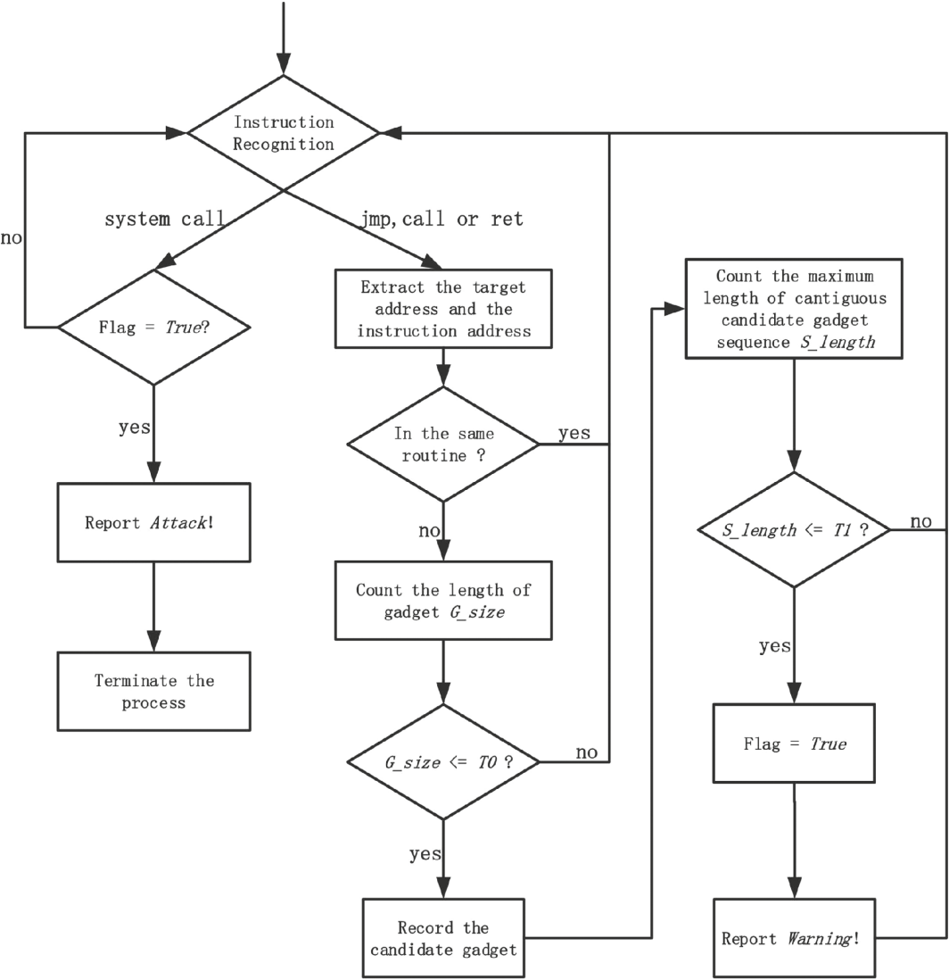

Fig. 3. Work flow of ROP-Hunt

图3 ROP-Hunt的工作流程

To instrument a binary at runtime, we have to determine where code is inserted and what code to execute at insertion points. Pin provides instrumentation tools which are called Pintools. Pintools are written in the C/C++ programming language using Pin's rich API and allow to specify your own instrumentation code. We designed and implemented our own Pintool to detect ROP attacks in the Pin framework.

要想在runtime检测二进制文件，我们必须确定代码被插入在什么位置以及在插入点处执行了什么代码。 Pin提供了名为Pintools的插桩检测工具。Pintools以C/C++语言编写，在使用Pin提供的丰富API的同时，用户还可以自定义插桩检测代码。我们设计并实现了自己的Pintool来在Pin框架下检测ROP攻击。

The overall architecture of the runtime system is depicted in Fig. 4. Our architecture consists of the Pin Framework and the Pintool ROP-Hunt. Pin is the engine that jits and instruments the program binary. Pin itself consists of a virtual machine (VM), a code cache, and instrumentation APIs invoked by Pintools. The VM consists of a JIT compiler, an emulator and a dispatcher. When a program is started, the JIT compiles and instruments instructions, which are then launched by the dispatcher. The compiled instructions are stored in the code cache in order to reduce performance overhead if code pieces are invoked multiple times. The emulator interprets instructions that cannot be executed directly.

runtime系统的总体架构如图4所示。我们的架构由Pin框架和Pintool，即ROP-Hunt组成。Pin是用于即时(JIT)调试及检测二进制程序的引擎。Pin框架包含一台虚拟机（VM）、代码缓存和供Pintools调用的API。其中，**虚拟机**包含JIT编译器、模拟器和调度程序。当程序开始运行时，各条指令先经JIT**编译**并检测，再交由**调度程序**激活并执行。经过编译的指令存储在**代码缓存**中，以便在多次调用代码段时降低性能开销。**模拟器**用于解释无法被直接执行的指令。

Our Pintool, ROP-Hunt, consists of a record unit and a detection unit which contains instrumentation routines and analysis routines. The detection unit leverages instrumentation APIs to communicate with Pin and the record unit just stores the statistic values at runtime.

我们的Pintool，即ROP-Hunt，由记录单元和检测单元组成，检测单元包含**插桩检测例程**和**分析例程**。检测单元利用各插桩检测API与Pin进行通信，记录单元仅用于存储runtime中的一些统计值。

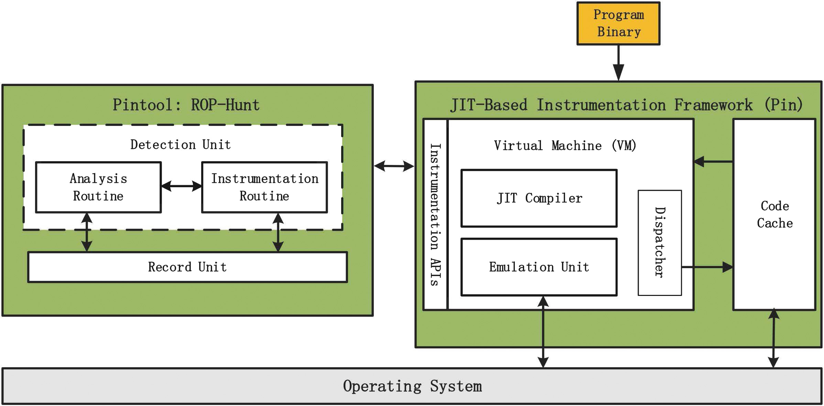

Fig. 4. Implementation of ROP-Hunt within pin framework

图4 在Pin框架下实现的ROP-Hunt

4.4 Instrumentation and Analysis Routines

4.4插桩检测和分析例程

As mentioned in Sect. 4.1, one of the key points is to recognize the instruction types. The instrumentation routines of our ROP-Hunt use the inspection functions INS_IsSyscall(INS ins), INS_IsSysenter(INS ins) provided by the Pin APIs to determine whether the current instruction is a system call or a system enter, and use INS_IsIndirectBranchOrCall(INS ins) to determine whether the current instruction is a branch instruction. If the current instruction is an indirect jump, call or return instruction, then we invoke an analysis function that extracts the addresses of both the current instruction and the target.

据4.1小节中所述内容，识别指令类型是关键点之一。ROP-Hunt的插桩检测例程通过Pin API提供的检查函数INS_IsSyscall(INS ins)和INS_IsSysenter(INS ins)来确定当前指令是否为*syscall*或*sysenter*，并通过INS_IsIndirectBranchOrCall(INS ins)来确定当前指令是否为跳转指令。如果当前指令是间接跳转、调用或返回指令，我们将调用分析函数来提取当前指令地址以及目标地址。

ROP-Hunt assigns each routine an ID. The ID is globally unique, i.e., an ID will not appear in two images. If the same routine name exists in two different images (i.e., they are in different addresses), each will have a different ID. If an image is unloaded and then reloaded, the routines within it will most likely have different IDs than before. ROP-Hunt leverages the function PIN_InitSymbols() to initialize the symbol table and read symbols from the binary. Since then, we can get the routine ID by the address.

ROP-Hunt为每个例程分配一个ID，该ID全局唯一，即同一个ID不会出现在两个内存镜像中。如果有同名例程存在于两个不同的内存镜像中（即它们在不同的地址中），那么每个例程将被分配不同的ID。如果内存镜像被卸载然后重载，那么其中的例程ID极有可能与以前ID不同。ROP-Hunt使用PIN_InitSymbols()来函数初始化符号表并从二进制文件中读取符号。由此，我们可以通过地址来获取例程ID。

The record unit allocates data space to each thread respectively. We use the thread local storage (TLS) from the Pin APIs to avoid that one thread accesses the record of another thread.

记录单元分别为每个线程分配数据空间。我们使用Pin API中的**线程本地存储**（TLS）来避免一个线程访问另一个线程记录的情况。

5 Parameter Selections

5参数选择

We have to determine the thresholds of the two factors which represent the features of ROP: the number of instructions in the gadget (G_size), the length of contiguous candidate gadget sequence (S_length).

我们必须确定能够代表ROP特征的两个因素的阈值，即gadget中的指令数（G_size）和连续候选gadget序列的长度（S_length）。

The gadget size threshold (T0) affects the detection accuracy. Bigger threshold generally incurs higher false positive. To find T0, we used two well-know gadget search tools, ROPGadget [8] and Ropper [9], to measure the sizes of gadgets from many normal applications, which include 22 popular Linux tools (e.g., ls, grep, and find) under directory /bin and /usr/bin, and 3 large binaries (Apache web server httpd 2.4.20, mysql 5.6 and python 2.7). We collected 282341 gadgets totally, 125605 from ROPGadget and 156736 from Ropper.

用于检测gadget大小的阈值（T0）会影响检测的准确度，较大的阈值通常会导致误报率较高。为寻找T0，我们使用了两个知名的gadget搜索工具ROPGadget[8]和Ropper[9]测量了大量正常程序中的gadget大小。这些程序包括/bin和/usr/bin目录下的22种Linux常用工具（例如ls、grep和find），以及3个大型二进制文件（Apache Web服务器httpd 2.4.20、mysql 5.6和python 2.7）。我们总共收集了282341个gadget，其中125605个来自ROPGadget，156736个来自Ropper。

As shown in Fig. 5, the largest gadget size is 10 and nearly all gadgets size is less than 8. In the gadget set generated by Ropper, the largest size is 6. We also measured the ROP malicious code collected from the real world ROP attacks, and no gadget size is greater than 6. Based on the above results, we can safely choose 7 as the gadget size threshold (T0 ). If the length of an instruction sequence is not greater than 7, it will be treated as a candidate gadget by ROP-Hunt.

如图5所示，最大的gadget大小为10，且近乎所有gadget的大小都小于8。在Ropper收集的gadget中，最大的大小为6。我们还测量了实际ROP攻击中ROP恶意代码，并没有发现大小超过6的gadget。根据上述结果，我们可以安全地选择7作为gadget大小的阈值（T0）。如果指令序列的长度不超过7，ROP-Hunt将会视其为候选gadget。

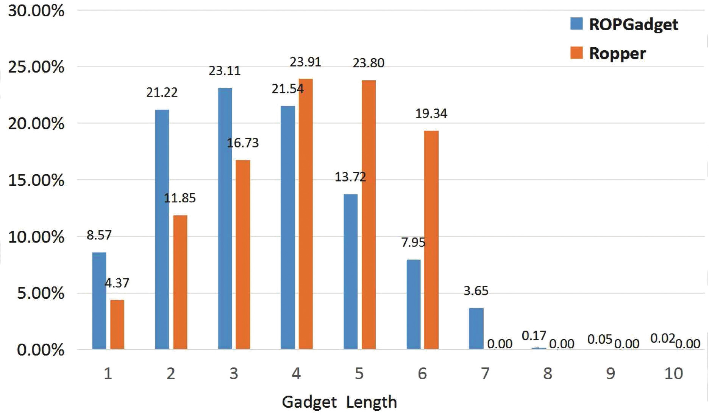

Fig. 5. The size of gadget measurement results

图5.gadget测量结果的大小

In ROP attack, the attacker chains a few gadgets together to complete an intended operation. To construct a system call operation, the attacker has to use at least 3 gadgets to place the correct parameters in the argument registers and jump to the system call entry. We believe an attacker can not do any meaningful attacks by just using 3 or less gadgets. So we set the T1 to 3, that is to say, ROP-Hunt checks whether there are more than 3 contiguous gadgets.

在ROP攻击中，攻击者将一些gadget链接在一起以完成预期的操作。为了构造一次系统调用操作，攻击者至少要用3个gadget才能将正确的参数放入参数寄存器并跳转至系统调用程序入口。我们认为，攻击者只用3个或更少的gadget无法进行任何有意义的攻击。所以，我们将阈值T1设置为3，也就是说，ROP-Hunt会检查连续的gadget是否超过3个。

6 Delay Gadget

6延迟gadget

ROP-Hunt is effective under the assumption that usable gadgets are short allowing us to distinguish attacks from normal programs. However, smart attackers may be able to tolerate some of the side-effects in a long gadget and use it in the middle of the attack to evade the detection. Mehmet Kyaalp et al. [25] introduced delay gadget that was long enough to reset the gadget counter used by the signature detector. They made a call to a function that resulted in executing a larger number of instructions. By convention, when a function returns, many registers such as ebx, esi, edi, esp, and ebp are saved. That is to say, delay gadget can reduce side-effect greatly.

正因为我们假设可用的gadget很短，我们才能够从正常程序中区分出攻击代码，ROP-Hunt才能起作用。然而，高明的攻击者为了在攻击过程中绕过检测机制，可能会使用长gadget并容忍其带来的一些副作用。Mehmet Kyaalp等人[25]引入了延迟gadget，其长度足以重置长度特征检测器中的gadget计数器。他们构造一个函数调用，该调用将导致大量指令被执行。按照惯例，当函数返回时会保存许多寄存器的值，例如ebx、esi、edi、esp和ebp。如此说来，延迟gadget的副作用可被大大地降低。

The purpose of a delay gadget is to avoid detection by signature-based detectors. It neither executes any part of the attack code or corrupts the machine state needed by the attack. It is impossible to conduct ROP attack only by delay gadgets. So when the previous gadget ending with a call invokes a function and the gadgets is longer than the threshold T0, ROP-Hunt just ignores this gadget and does not reset the counter. But if the gadget size does not break the threshold T0, the counter is still added by one.

延迟gadget的目的是绕过基于长度特征检测器的检测，它既不执行任何的攻击代码，也不会破坏攻击所需的机器状态。仅通过延迟gadget进行ROP攻击是不可能的。因此，当上一个gadget以调用为结尾调用了一个函数时，若该gadget的大小超过了阈值T0，ROP-Hunt将忽略此gadget，并不会重置计数器。但若其大小没有超过阈值T0，计数器仍会加1。

———————————DASH———正月十五———DASH————————————

7 Evaluation

7评估

In this section, we evaluated the security effectiveness and the performance overhead of ROP-Hunt. All experiments were performed on a computer with the following specifications: Intel Core i3 2370M CPU, 4 GB RAM, 32-bit Ubuntu with kernel version 3.19. For the security evaluation, we verify our approach with two real-world ROP attacks and a small program that has a simple stack buffer overflow triggered by a long input parameter. For the performance evaluation, we used 18 C and C++ SPEC CPU2006 [10] benchmarks for our experiments. The benchmarks were compiled using gcc-4.8.3 compiler.

在本节中，我们评估了ROP-Hunt的安全有效性和性能开销。所有实验均在具有以下规格的计算机上进行：Intel Core i3 2370M CPU，4 GB RAM，32位Ubuntu，内核版本3.19。对于安全性评估，我们使用两个真实的ROP攻击和一个由长输入参数触发的简单堆栈缓冲区溢出的小程序来验证我们的方法。对于性能评估，我们在实验中使用了18 C和C ++ SPEC CPU2006 [10]基准测试。基准测试使用gcc-4.8.3编译器编译。

To further assess ROP-Hunt detection capabilities, we used a simple target program that had a strcpy vulnerability (demonstrated in [31]). The program were compiled by gcc-4.8.4 and linked with glibc-2.3.5. We used ROPGadget [8] to analyze the program and generate usable gadgets. We manually chained candidate gadgets together to rewrite 30 representative shellcode from the Shell-Storm Linux shellcode repository [5]. These shellcodes were composed of combinational gadgets which ending with ret, jmp or call instructions. Gadgets longer than 7 instructions were extremely difficult to incorporate due to side effects. The most simple attack required 4 gadgets (greater than T1 ). As we have analyzed in Sect. 3, all shellcodes used system calls to complete attacks. The experimental result showed that ROP-Hunt could detect all these ROP attacks without false positive.

为了进一步评估ROP-Hunt检测功能，我们使用了一个具有严重漏洞的简单目标程序（在[31]中进行了演示）。该程序由gcc-4.8.4编译并与glibc-2.3.5链接。我们使用ROPGadget [8]来分析程序并生成可用的gadget。我们手动将候选gadget链接在一起，从Shell-Storm Linux shellcode存储库[5]重写30个代表性的shellcode。这些shellcode由组合gadget组成，以ret，jmp或call指令结尾。由于副作用，超过7条指令的gadget极难加入。最简单的攻击需要4个gadget（大于T1）。正如我们在Sect中所分析的那样。 3，所有shellcode使用系统调用来完成攻击。实验结果表明，ROP-Hunt可以检测到所有这些ROP攻击而没有误报。

7.2 Performance Overhead

7.2性能开销

We chose the benchmark tool SPEC CPU2006 benchmark suite [10] to measure the performance of ROP-Hunt. Specifically, we ran the testing suits with and without ROP-Hunt. The results are illustrated in Fig. 6, which shows that applications under protection of ROP-Hunt run on average 1.75x. The slowdown for benchmarks ranges from 1.05x to 2.41x. We compared ROP-Hunt with other ROP detectors based on instrumentation technique. According to the results in [17,21], applications running under ROPdefender and DROP are 2.17x and 5.3x. [18] causes an average slowdown of 3.5x.

我们选择基准工具SPEC CPU2006基准套件[10]来衡量ROP-Hunt的性能。具体来说，我们在有和没有ROP-Hunt的情况下运行测试服。结果如图6所示，表明在ROP-Hunt保护下的应用平均运行1.75倍。基准测试的放缓范围为1.05x至2.41x。我们将ROP-Hunt与其他基于仪器技术的ROP探测器进行了比较。根据[17,21]的结果，在ROPdefender和DROP下运行的应用程序分别为2.17x和5.3x。 [18]导致平均减速3.5倍。

Fig. 6. SPEC CPU2006 benchmark results

图6. SPEC CPU2006基准测试结果

The result shows that the Pin framework itself also induces an average slowdown of 1.66x. We believe the performance of ROP-Hunt will be continuously improved with the optimization of Pin Framework.

结果表明Pin框架本身也导致1.66x的平均减速。我们相信，随着Pin Framework的优化，ROP-Hunt的性能将不断提高。

8 Discussion

8讨论

We design and implement ROP-Hunt to detect ROP attacks at runtime, and currently ROP-Hunt is based on dynamic binary instrumentation tool Pin. Although ROP-Hunt is effective detecting ROP attacks, there are some limitations. First, ROP-Hunt only detects ROP malicious code on x86 architecture. However, malicious code can be rewritten on other architectures by ROP technique. We believe that our approach can be deployed to other architectures. Second, ROP-Hunt detects ROP attack with the assumption that all ROP malicious codes meet the thresholds discussed in Sect. 5. Although it is extremely hard, there is a theoretical possibility that some ROP attacks may break this assumption. Finally, ROP-Hunt is implemented by using the jit-based binary instrumentation framework Pin and causes an average slowdown of 1.75x. The performance overhead may be unacceptable for some time-critical applications.

我们设计并实现了ROP-Hunt以在运行时检测ROP攻击，目前ROP-Hunt基于动态二进制检测工具Pin。尽管ROP-Hunt可以有效地检测ROP攻击，但仍存在一些局限性。首先，ROP-Hunt仅检测x86架构上的ROP恶意代码。但是，恶意代码可以通过ROP技术在其他体系结构上重写。我们相信我们的方法可以部署到其他架构。其次，ROP-Hunt检测到ROP攻击，假设所有ROP恶意代码都满足Sect中讨论的阈值。虽然这是非常困难的，但理论上有可能一些ROP攻击可能会打破这种假设。最后，ROP-Hunt通过使用基于jit的二进制检测框架Pin实现，并导致平均减速1.75倍。对于某些对时间要求严格的应用程序而言，性能开销可能是不可接受的。

9 Conclusions

9结论

ROP is a very powerful exploitation technique used to bypass current security mechanisms. In this paper, we studied and extracted the features of the ROP malicious code. Based on the identification of distinctive attributes of ROP malicious code that are inherently exhibited during execution, we proposed a novel and practical approach for protecting against ROP attack without requiring access to source code. The experimental results showed that our prototype, ROP-Hunt, successfully detects all ROP attacks with no false positive. ROP-Hunt leverages instrumentation technique and adds a runtime overhead of 1.75x which is comparable to similar instrumentation-based ROP detection tools. As part of our future work, we plan to port our prototype implementation to other architectures.

ROP是一种非常强大的开发技术，用于绕过当前的安全机制。在本文中，我们研究并提取了ROP恶意代码的功能。基于对执行过程中固有展示的ROP恶意代码的独特属性的识别，我们提出了一种新颖实用的方法来防止ROP攻击，而无需访问源代码。实验结果表明，我们的原型ROP-Hunt成功检测到所有ROP攻击，没有误报。 ROP-Hunt利用仪器技术并增加了1.75x的运行时开销，这与类似的基于仪器的ROP检测工具相当。作为我们未来工作的一部分，我们计划将原型实现移植到其他架构。

Acknowledgments. We thank the anonymous reviewers for their constructive comments that guided the final version of this paper. We thank National University of Defense Technology for providing essential conditions to accomplish this paper. This work is supported by the NSFC under Grant 61103015, 61303191, 61402504 and 61303190.

致谢。我们感谢匿名审稿人的建设性意见，这些意见指导了本文的最终版本。我们感谢国防科技大学为完成本文提供必要条件。国家自然科学基金委员会在Grant 61103015,61303191,61402504和61303190的支持下开展了这项工作。