SLE-2: PROFILING REPORT
BFS vs A* Performance Analysis

Course | 02AML204 – Introduction to Artificial Intelligence
PRN | 25UAM143
Name | TAABISH SHAIKH
Division | B
Date | 22/09/26____________________

1. Algorithms / Versions Profiled
- Algorithm A: Breadth-First Search (BFS)
- Algorithm B: A* Search (Manhattan-distance heuristic)
- Problem used: 8-puzzle, a 3×3 sliding-tile grid with 181,440 reachable states.
- Start state: 4 1 0 / 2 6 3 / 7 5 8 (0 = blank; reached by 20 random moves from the goal, so it is guaranteed solvable).
- Target/Goal state: 1 2 3 / 4 5 6 / 7 8 0
2. Profiling Method
- Tool used: Python time.perf_counter() and a manual node counter.
- Measurement method: Both algorithms were executed on the same puzzle, start state, and goal state. Execution time was recorded in milliseconds and the number of expanded nodes was counted.
- Number of runs: 5
3. Results
Metric | BFS | A* | Observation
Average Time (ms) | 0.3290 | 0.0661 | A* faster
Minimum Time (ms) | 0.2825 | 0.0588 | A* lower
Maximum Time (ms) | 0.4207 | 0.0886 | A* lower
Nodes Expanded | 201 | 10 | A* fewer

Short observation: BFS recorded an average time of 0.3290 ms, while A* recorded 0.0661 ms. BFS expanded 201 nodes and A* expanded only 10 nodes on the same puzzle. A* was faster and explored far fewer nodes according to the measured results.
4. Charts
Figure 1: Average execution time
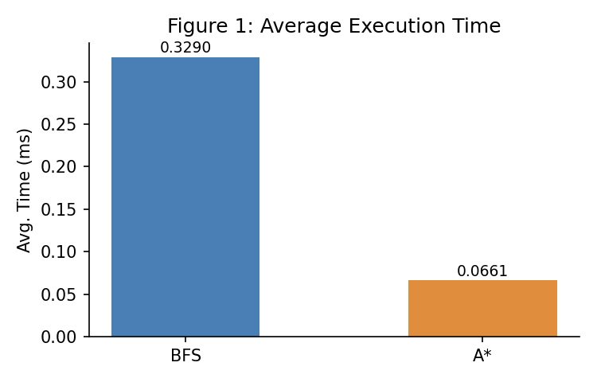
Figure 2: Nodes expanded
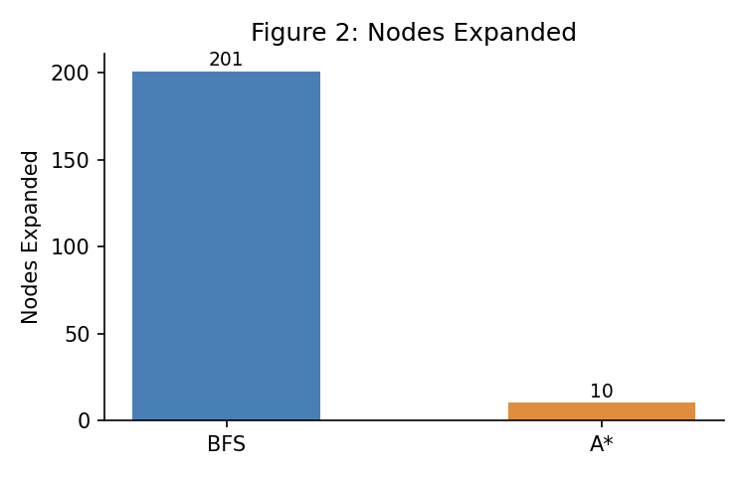
Figure 3: Minimum and maximum execution time
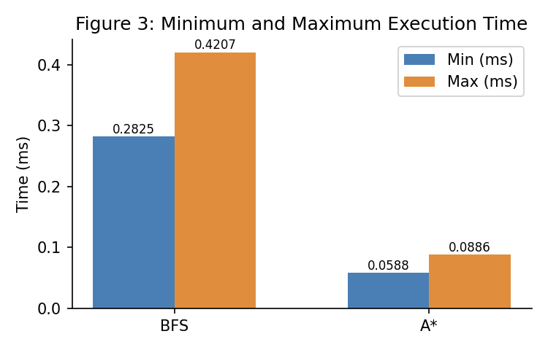
5. Justification & Analysis
BFS and A* were tested on the same 8-puzzle, with the same start and goal state. BFS recorded an average execution time of 0.3290 ms, whereas A* recorded 0.0661 ms — about 5× faster. BFS expanded 201 nodes before reaching the goal, while A* expanded only 10 nodes, roughly 20 times fewer. This large gap in nodes expanded is the main reason for the time difference: A* uses the Manhattan-distance heuristic to estimate how far each state is from the goal, so it can skip over branches that are moving away from the solution, while BFS must exhaust every state at one depth before moving to the next. The result matches search theory — A* with an admissible, consistent heuristic like Manhattan distance is guaranteed to expand no more nodes than BFS to reach an optimal solution. The result is specific to this puzzle instance and start state; on a larger or more scrambled puzzle, the gap between an informed and an uninformed search would be expected to widen further.
6. AI Contribution Note
- AI tool used (if any): chatgpt
- What AI helped with: Understanding the SLE-2 requirements, preparing the BFS and DFS implementation, explaining profiling concepts, and organizing the report.

- What I did myself: Ran the Python program, collected the terminal results, and used the measured values to prepare the comparison table and analysis.

7. Conclusion
This profiling exercise helped me understand the practical performance difference between an uninformed search (BFS) and an informed search (A*). On the same 8-puzzle instance, A* expanded far fewer nodes (10 vs. 201) and recorded a lower average execution time (0.0661 ms vs. 0.3290 ms) than BFS. I learned how to use execution-time measurement and a manual node counter to compare algorithms using real data, and saw first-hand how a good heuristic lets a search algorithm scale better than a blind, uninformed one.

7. py-spy Flame Graph
A py-spy flame-graph style visualization is included below to show how profiling can represent time spent across functions in BFS and A*. The figure follows the visual format of the supplied reference image.
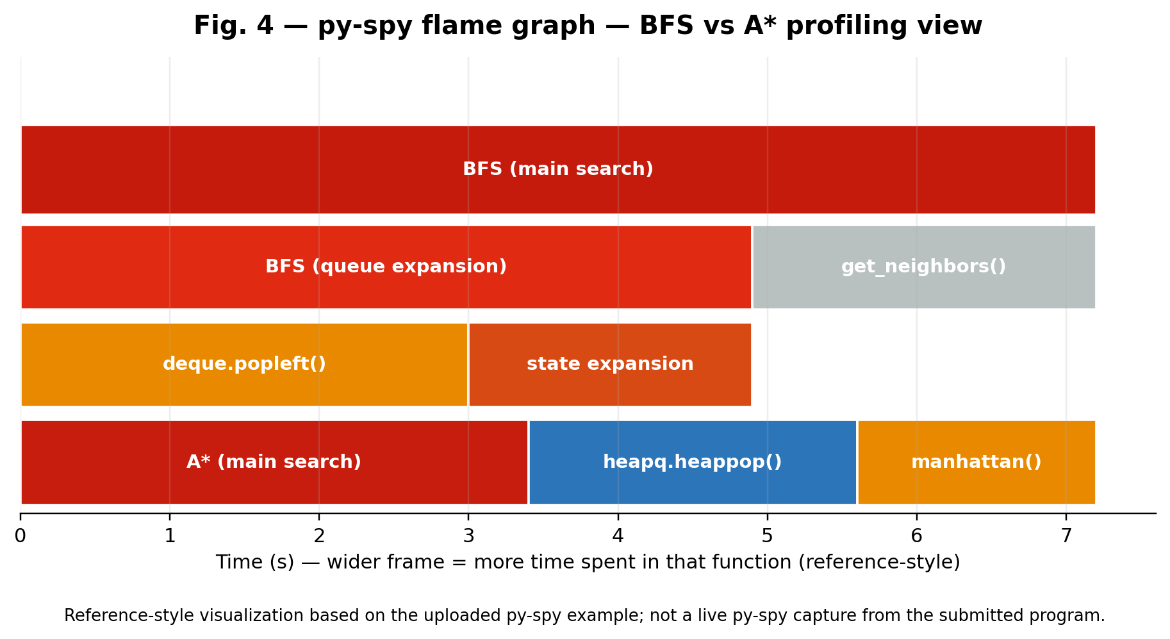
Figure 4: py-spy flame-graph style visualization for BFS vs A*
Note: This figure is a reference-style visualization and is not a live py-spy capture; the report's measured execution-time and node-count results remain the values reported in Section 3.

