**World-class chefs & sommeliers award 2,200 food & drink products for their superior taste**

**Brussels, May 25th, 2021**: the jury of the **International Taste Institute**, composed of some of the world’s best chefs and sommeliers, has awarded 2,218 food and drink products with the 2021 Superior Taste Award. Around the world, food and drink producers are investing enormously in the quality and taste of their products. 2021 showed an increase of 45% in the number of products submitted to our taste evaluation, with massive growth in the submission of health and sustainability-related products. This year more than 30 products from 10 companies in **Croatia** were awarded with the Superior Taste Award.

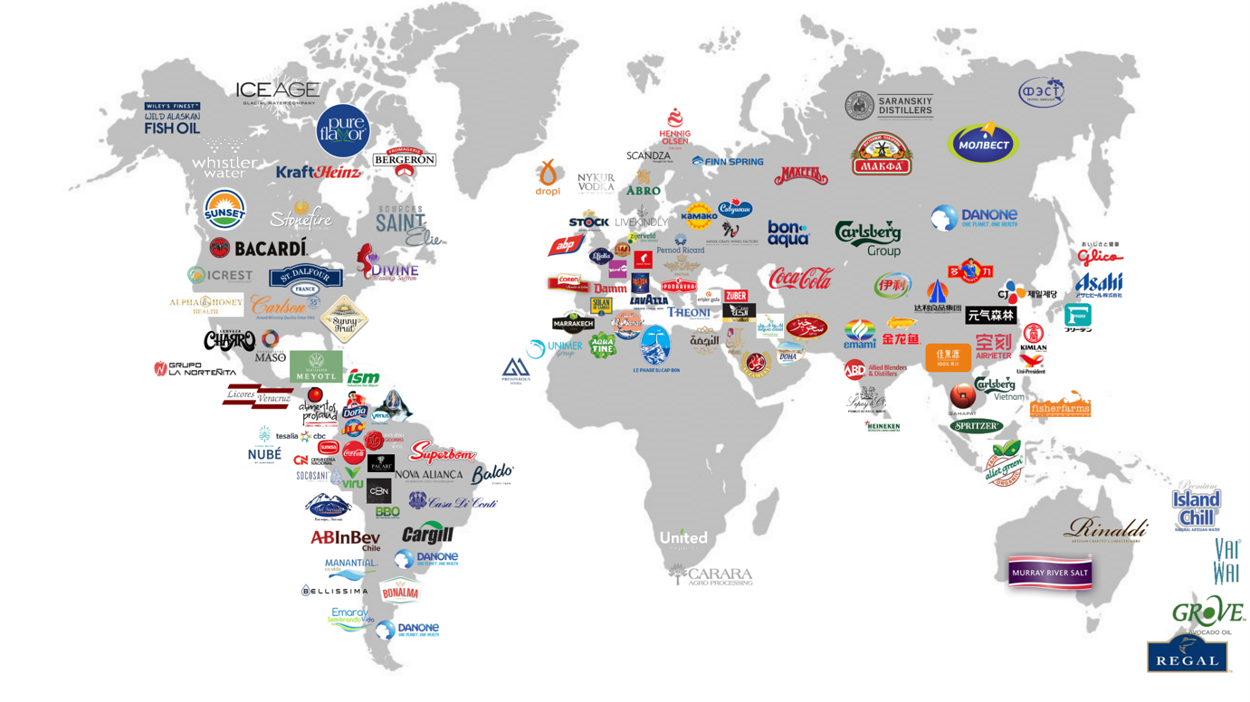

**Mastering taste is more crucial than ever**

**2,218 products received the Superior Taste Award**, a certification granted to products that meet or exceed (tasting score above 70%) the expectations of our chefs and sommeliers. Awarded products are well made, balanced and delicious. Every year, thousands of products are evaluated, while only very good products are awarded.

A list of 2021 awarded products can be found on the International Taste Institute’s website at www.taste-institute.com

**39 Prestige Awards**

The International Taste Institute recognises producers that demonstrate consistent exceptional product quality over several years. In 2021, we distributed:

29 Crystal Taste Awards, which are granted to products that have been awarded 3 stars for 3 years in a row.

10 Diamond Taste Awards, which are granted to products that have been awarded 3 stars 7 times over a period of 10 years.

Alan Coxon, president of the International Taste Institute chef jury: “The overall quality of products submitted in 2021 has been exceptionally high. We are delighted to witness that the industry is increasingly developing healthier products while keeping a strong focus on taste.”

**Making the world a tastier place**

Eric de Spoelberch, CEO of the International Taste Institute: “We are extremely proud that, despite the complicated global situation, we have been able to gather very high-level international chefs and sommeliers for the 2021 evaluations while maintaining strict hygiene measures.”

Some of the new jury members in 2021 include:

Bringing their experience from gastronomy to serve the food and beverage industry, our jury helps and encourages producers to step up the gustative quality of their products, contributing to our institute’s mission to make the world a tastier place.

**Health & sustainability in the spotlight**

In the first half of 2021, we have seen a massive growth in submission of health & sustainability related products.

For example, there has been a strong increase in plant-based meat and dairy alternatives (+240%), gluten-free products (+112%) and vegan products (+77%). The challenge with healthy and sustainable products lies in their image: consumers often think that these products are less tasty. Therefore, producers have every interest in changing that perception.

This ties in nicely with another trend: often influenced by nutritional rating systems such as the much-controverted European Nutri-Score scale, more and more producers are sending us products they have reformulated to modify their nutritional values. Here, too, taste is paramount. Improving the nutritional values of a product by using less salt, sugar or fat often has a major impact on taste, which has to be compensated for in innovative ways.

**About the International Taste Institute**

The International Taste Institute, founded in 2005 and based in Brussels, Belgium, evaluates and certifies the taste of foods and drinks from around the world. Its jury is composed of over 200 renowned chefs and sommeliers from 15 European culinary and sommelier associations.

Over the years, more than 18,000 products have been certified by the International Taste Institute’s jury, which features prestigious chefs and sommeliers such as Ferran Centelles (head sommelier at El Bulli Foundation), Manuel Jimenez (Best Sommelier of Spain 2017), Alain Nonnet (2 Michelin Stars for 36 years), Gaetano Raguni (winner of Italy Bocuse d'Or 2017), Alan Coxon (British Ambassador for Food/Drink and BBC TV chef presenter), and Cristina Figueira (1 Michelin Star), among many other accomplished Chefs and Sommeliers.

The International Taste Institute performs objective sensory evaluation: its jury follows a rigorous blind-tasting methodology in which product samples are anonymised to avoid any scoring biases. In addition to scoring product performance according to the 5 standard sensory criteria, the jury provides comments as well as suggestions for further product improvement and food pairing.

*The names of awarded products and producers are available at* *www.taste-institute.com**. For more information or for interviews, please contact Eric de Spoelberch at +32 2 372 34 22 or* *eric@taste-institute.com**.*