**Digital Gauge for Oil Pressure and Coolant Temperature Sensors** **V1**

*Author:*

*JULIAN TABASCIO*

*DATE: February 22ND, 2024*



**Abstract:**

This project aims to develop a digital gauge cluster for monitoring live oil pressure and coolant temperature in a 2003 Ford Mustang GT while preserving the functionality of the stock gauges. By integrating additional sensors and innovative design strategies, the project enables simultaneous readings on both the OEM gauge cluster and the new digital display without compromising stock functionality. Utilizing cost-effective components for this project offers a practical and accessible solution for automotive enthusiasts seeking to enhance their vehicle's instrumentation. The project's methodology, results, and implications are explored, providing understanding into the technical intricacies and practical considerations of creating a digital gauge cluster for the 2003 Ford Mustang GT.

**Introduction:**

The automotive industry continues to evolve rapidly, driven by advancements in technology and a growing demand for enhanced vehicle performance, safety, and monitoring capabilities. Digital gauge clusters have emerged as a key innovation, offering drivers real-time access to critical vehicle data such as oil pressure and coolant temperature. In this context, the development of a digital gauge cluster tailored for the 2003 Ford Mustang GT represents an important advancement in modernizing classic muscle cars while retaining their timeless appeal. This article aims to provide valuable insights into the realm of automotive customization and performance enhancement.

**Materials:**

1. **1/4” NPT Brass splitter fitting**: $10 (MAYBE)
   * Source: [Amazon](https://www.amazon.com/Anderson-Metals-Fitting-Forged-Street/dp/B006PKKZ4U/ref=sr_1_8?crid=8BDSOM6ZASMY&dib=eyJ2IjoiMSJ9.iUKqxpFY_FelKFzcRb0djKgfTAdpR0dki8DYf09slOPXuQzJKIlrAMSkD8SDZC324wxWwgA8txxlgQ1uIraL1BnzbDLVR64JnZKiRHY3wm2B0-RSKhfTUpNiUPRGoZ2cyQAqIiZsKK-nKBs2tysow7Z6uYqqOVHydNcic9Pdg77WqnuEqtadM6UqiFx6_v5bnqzrJbGWbakkramoxlpLIAW10OWKH7R6V0MIgapPhtE.PLSZQL3g_-W5JNQm2n0jO5YWI4Q4R8veVPXFMHitt9A&dib_tag=se&keywords=1%2F4+npt+tee&qid=1708594840&sprefix=1%2F4+npt+tee%2Caps%2C105&sr=8-8)
2. **1/8" NPT Pressure Transducer Sender Sensor with Connector 100 PSI:** $13
   * Source: [Amazon](https://www.amazon.com/gp/product/B07TLJNSV8/ref=ppx_yo_dt_b_asin_title_o00_s01?ie=UTF8&psc=1)
3. **1/4" NPT Male to 1/8" NPT Female Brass Reducer Bushing Forged Hex Head:** $6
   * Source: [Amazon](https://www.amazon.com/gp/product/B0747CJ2LV/ref=ppx_yo_dt_b_asin_title_o00_s00?ie=UTF8&th=1)
4. **3/8 NPT ECT Sensor from JUNKYARD**: $8 (GET PLUG AND WIRING)
   * Source: [UPullAndPay](https://www.upullandpay.com/auto-parts/parts-pricing/)
5. **3/8” NPT Brass splitter fitting**: $9
   * Source: [Amazon](https://www.amazon.com/gp/product/B006PKKXZ6/ref=ox_sc_act_title_2?smid=ATVPDKIKX0DER&psc=1)
6. **Arduino nano clone from AliExpress**: $5
   * Source: [AliExpress](https://www.aliexpress.us/item/3256805951350156.html?spm=a2g0o.order_list.order_list_main.17.1fb91802ncgzvC&gatewayAdapt=glo2usa)
7. **2.4 LCD Screen no touch from AliExpress**: $5
   * Source: [AliExpress](https://www.aliexpress.us/item/3256806137276331.html?spm=a2g0o.order_list.order_list_main.16.41b81802JLmNUY&gatewayAdapt=glo2usa)

**Total Cost: $56**

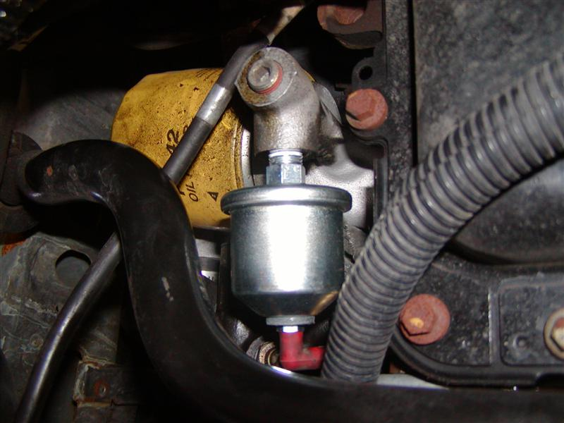2003 Ford Mustang GT: Oil Pressure Sensor location, next to oil filter.

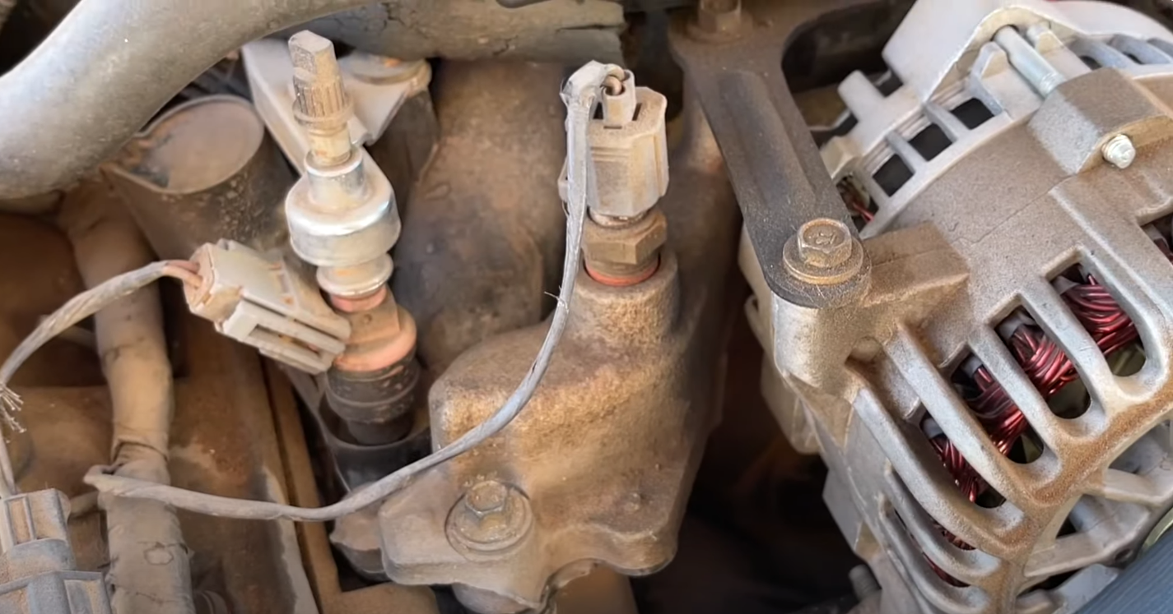2003 Ford Mustang GT: Coolant Temperature Sensor location, to the left of alternator.

**Procedure:**

**ECT Calibration:**

Calibrating sensors like the Engine Coolant Temperature (ECT) sensor is a crucial task that ensures accurate readings for optimal performance. These analog sensors, typically equipped with only two wires, require meticulous calibration procedures involving temperature-resistance measurements. The process entails measuring specific temperatures and their corresponding resistance values, typically gathering around ten data points. Statistical methods are then applied to interpolate values within this range, resulting in a comprehensive data table for accurate interpretation of temperature readings. Household environments, such as using a pot of water on a stove alongside a thermometer, provide practical settings for generating temperature-resistance data points.

Since the ECT sensor was sourced from a junkyard, it lacks the technical data necessary for calibration. As a result, the calibration process must be done manually, relying on empirical methods rather than pre-existing specifications. Manual calibration involves measuring specific temperatures and their corresponding resistance values, typically gathering data points through practical experimentation. Without access to manufacturer-provided calibration data, manual calibration becomes essential to ensure accurate sensor readings. This manual approach may involve methods such as immersing the sensor in known temperature environments and recording the resistance values observed. While more labor-intensive than calibration with technical data, manual calibration remains a viable option for achieving accurate sensor readings and optimal performance.

**Oil Pressure Calibration**:

The 100-psi pressure transducer comes equipped with a linear voltage output specification provided by the manufacturer. This linear voltage output feature ensures that the sensor produces a predictable and consistent voltage signal across the entire pressure range. Specifically, the output voltage varies linearly with changes in pressure, adhering to a precise relationship: 0 psi outputs 0.5V, 50 psi outputs 2.5V, and 100 psi outputs 4.5V.

Given this inherent linearity in the voltage output, traditional calibration procedures may not be necessary. The manufacturer's provided linear voltage output eliminates the need for complex calibration processes typically required to correct nonlinearities or inaccuracies in sensor readings.

Additionally, the wiring specifications provided by the manufacturer further simplify installation and operation. The wire colors are as follows: Red for +5V (power input), Black for ground, and Blue for signal output. These color codes ensure correct connection and functionality of the pressure transducer, streamlining the setup process for users.

Overall, the linear voltage output feature of the 100 psi pressure transducer, combined with clear wiring specifications, ensures accurate and consistent pressure measurements without the need for additional calibration, providing users with confidence in the sensor's performance across various applications.

ECT Data Points:

25C = 24 kiloohms

|  |  |
| --- | --- |
| Engine Coolant Temperature (1998 Ford) | |
| Temperature (C) | Resistance (ohms) |
| -18 | 245,000 |
| 3 | 87,000 |
| 25 | 24,000 |
|  |  |
|  |  |
|  |  |
|  |  |
|  |  |
|  |  |
|  |  |

Oil Pressure Data Points:

0 psi = 0.5v and 100 psi = 4.5v

|  |  |
| --- | --- |
| Oil Pressure Transducer (Amazon) | |
| Pressure (PSI) | Voltage (v) |
| 0 | 0.5 |
| 10 | 0.9 |
| 20 | 1.3 |
| 30 | 1.7 |
| 40 | 2.1 |
| 50 | 2.5 |
| 60 | 2.9 |
| 70 | 3.3 |
| 80 | 3.7 |
| 90 | 4.1 |
| 100 | 4.5 |