**Introduction:** A process model describes business processes—the activities that people do. Process models are developed for the as-is system and/or the to-be system. Data flow diagramming, one of the most commonly used process modeling techniques is described here.

**The Systems Development Life Cycle(SDLC) :** The systems development life cycle (SDLC) is a conceptual model used in project management that describes the stages involved in an information system development project, from an initial feasibility study through maintenance of the completed application. SDLC is also an abbreviation for Synchronous Data Link Control and software development life cycle.

1. Requirements Determinations

2. Requirements Specifications

3. Feasibility Analysis

4. Final Specifications

5. Hardware Study

6. System Design

7. System Implementation

8. System Evaluation

9. System Modification

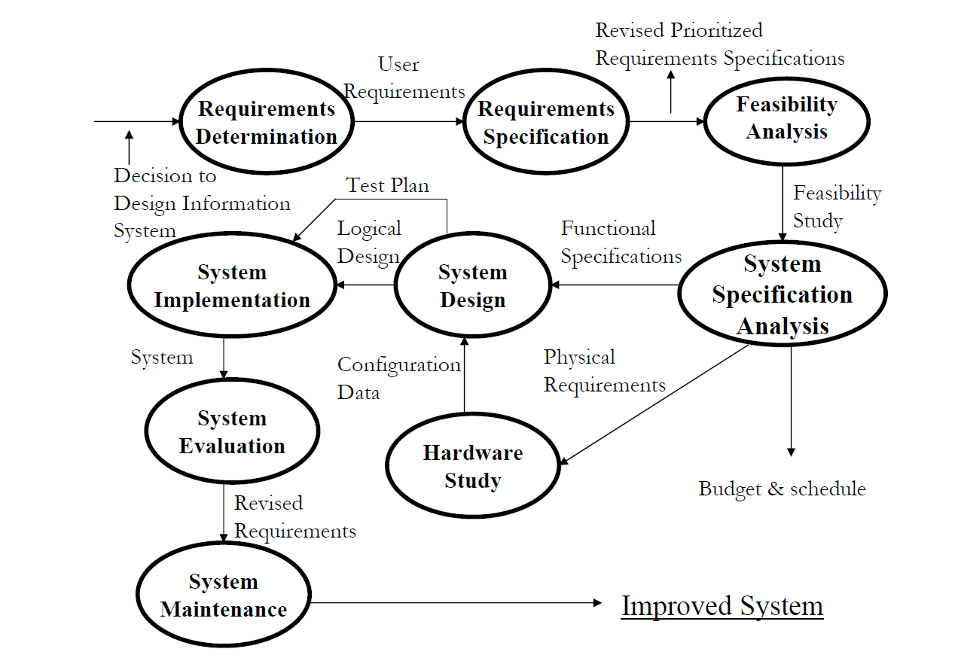

**Fig. 1:** System development life cycle

**Data Flow Diagram:** A data flow diagram (DFD) illustrates how data is processed by a system in terms of inputs and outputs. As its name indicates its focus is on the flow of information, where data comes from, where it goes and how it gets stored.

1. **Context Grammar:** The Context Diagram shows the system under consideration as a single high-level process and then shows the relationship that the system has with other external entities. A Context Diagram (and a DFD for that matter) provides no information about the timing, sequencing, or synchronization of processes such as which processes occur in sequence or in parallel.  Therefore, it should not be confused with a flowchart or process flow which can show these things.

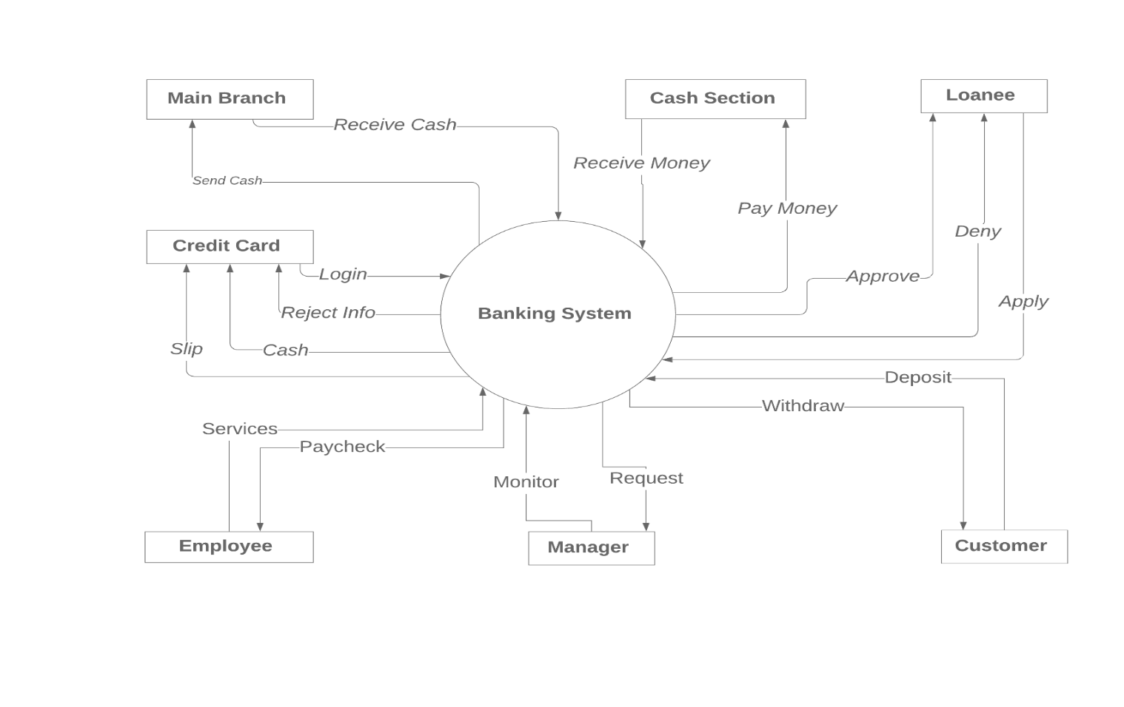

**Fig. 2:** Context Diagram of a banking system

1. **Logical and Physical DFDs:** A logical DFD focuses on the business and business activities, while a physical DFD looks at how a system is implemented. While any data flow diagram maps out the flow of information for a process or system, the logical diagram provides the “what” and the physical provides the “how.” The benefit of logical DFDs is that they tend to be more easily understandable to non-technical people. On the other hand, a physical DFD can depict a current system or show how a new system will be implemented.

**Physical DFD of Loan System :**

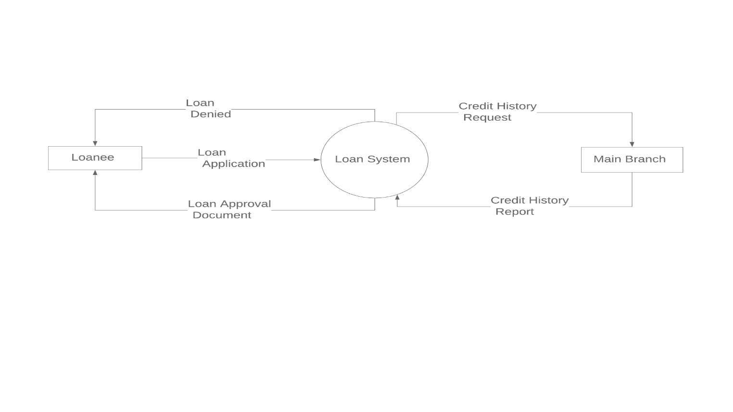

**Fig.3** : Physical DFD of Loan System

**Physical DFD of Clearing System :**

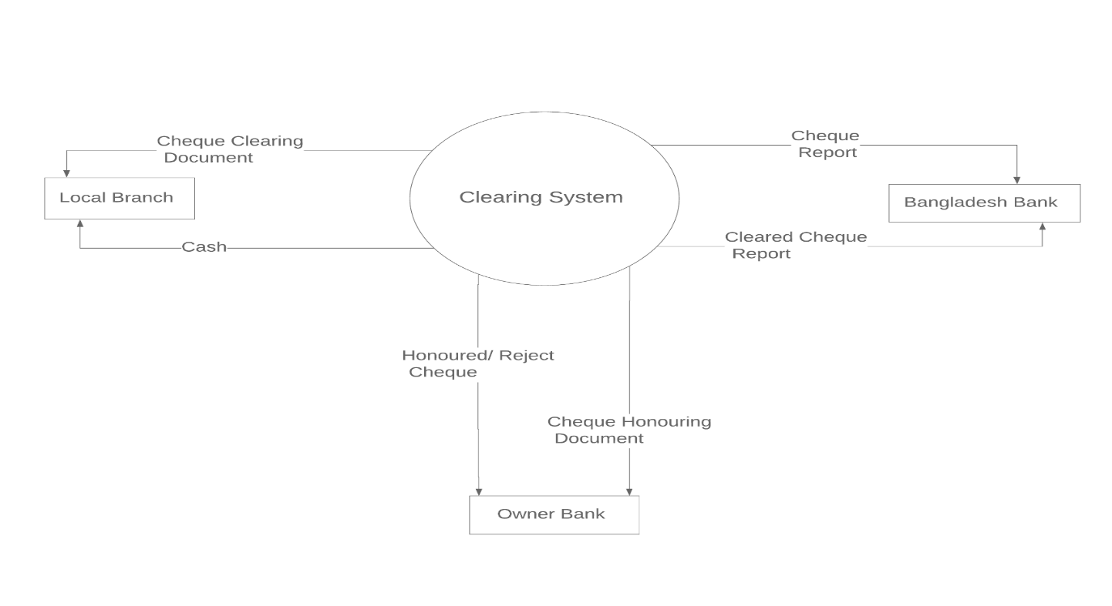

**Fig. 4:** Physical DFD of Clearing System

**Physical DFD of Transaction System:**

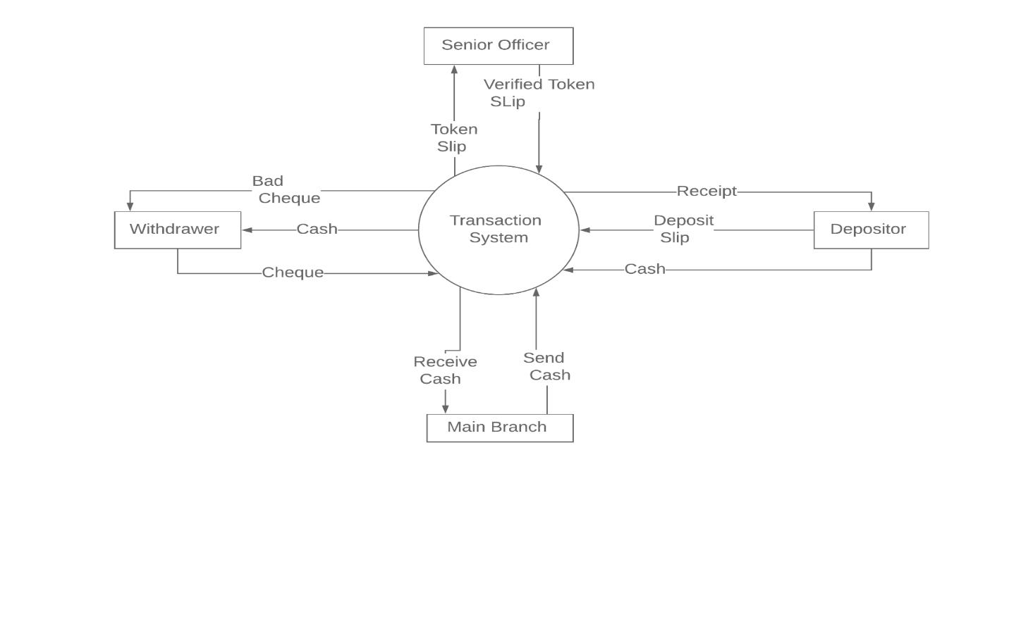

**Fig. 5:** Physical DFD of Transaction System

**Physical DFD of ATM System :**

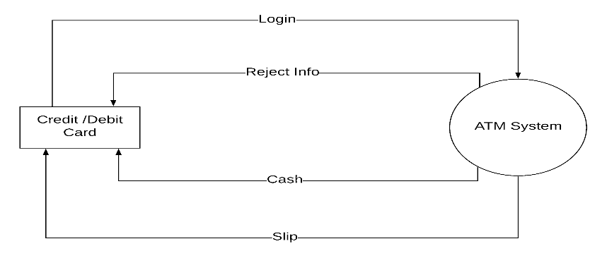**Fig. 6 :** Physical DFD of ATM System

**Logical DFD of Loan System:**

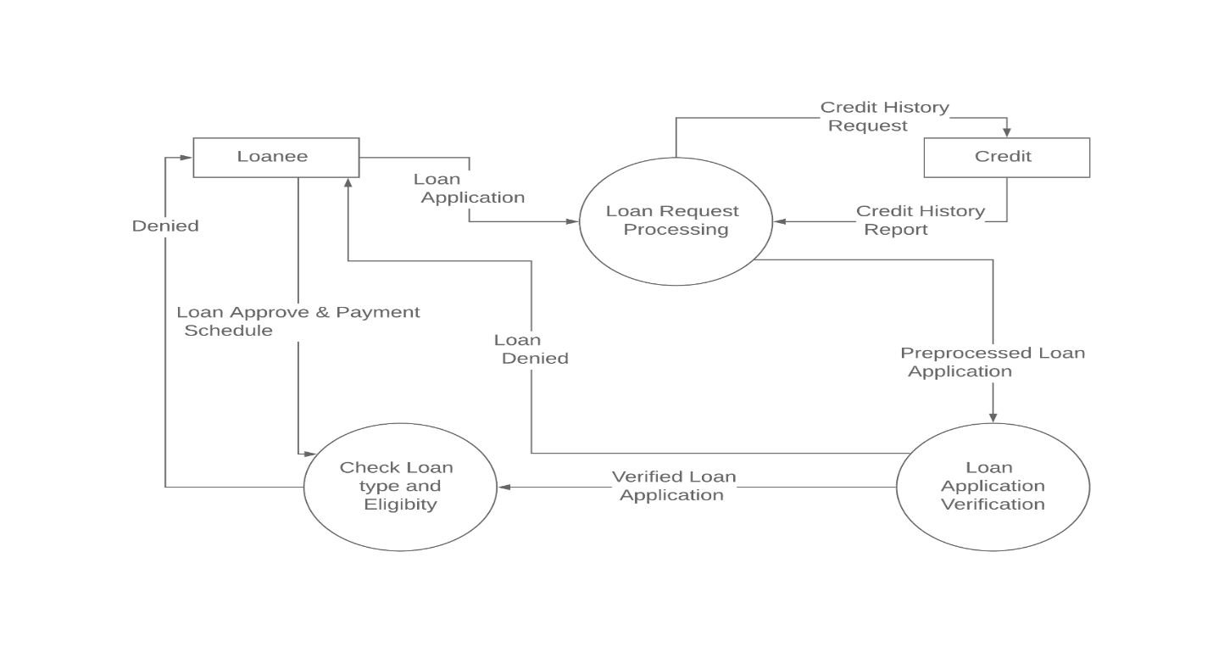

**Fig. 7:** Logical DFD of Loan System

**Logical DFD of Clearing System:**

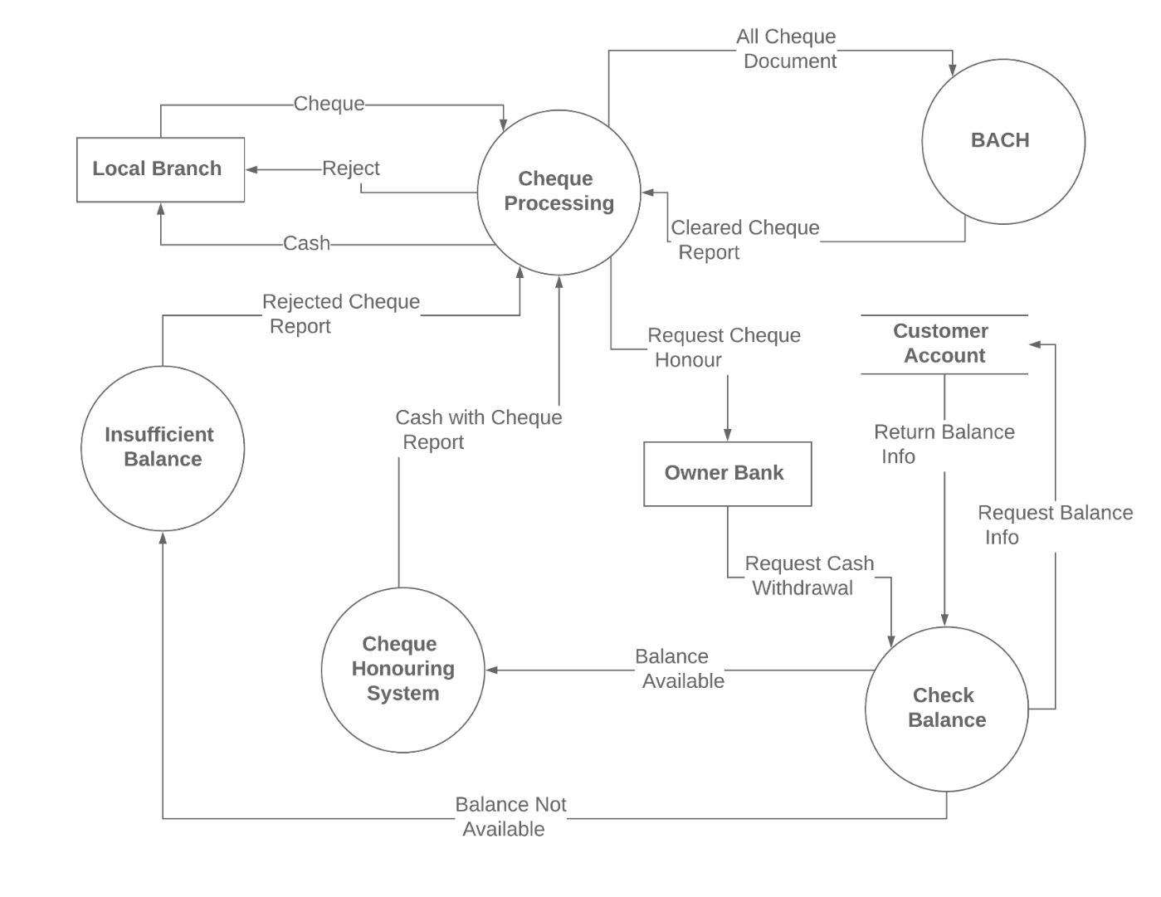

**Fig. 8:** Logical DFD of Clearing System

**Logical DFD of Transaction System:**

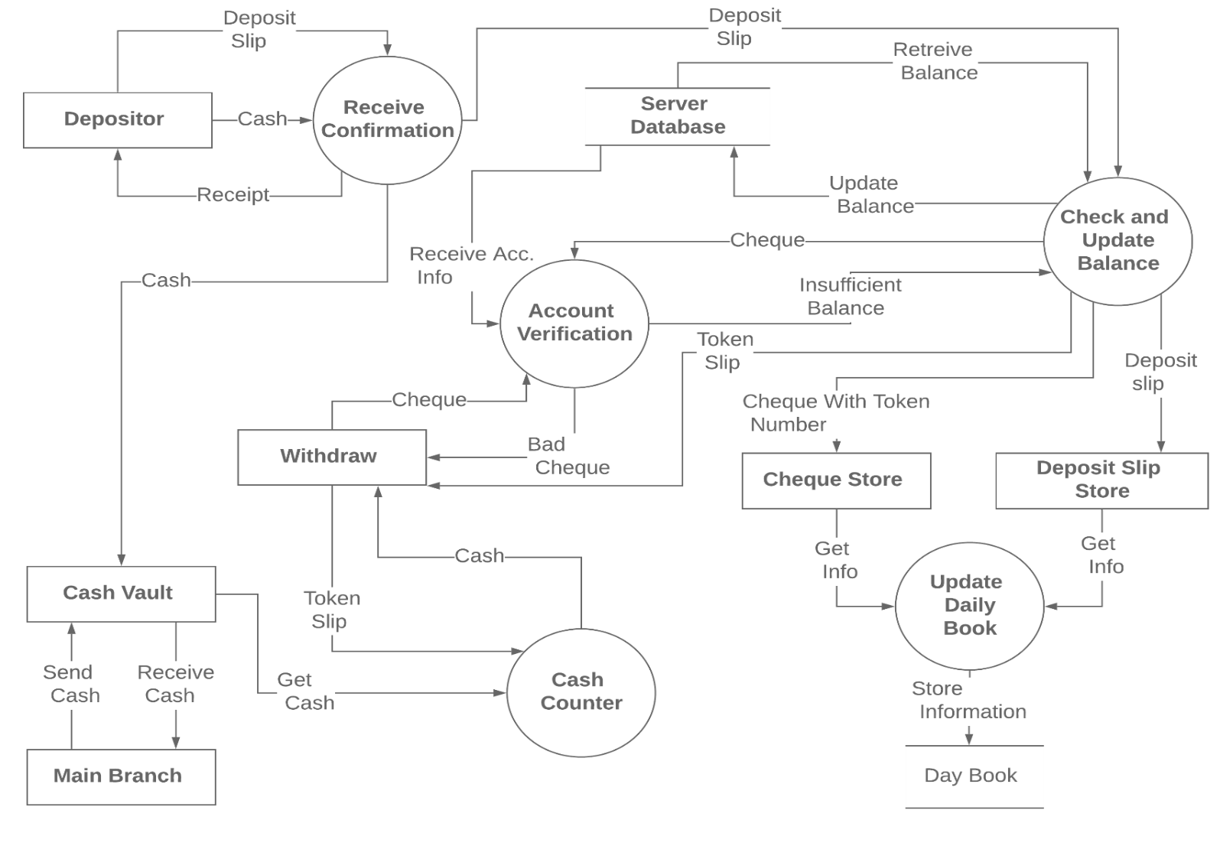

**Fig. 9 :** Logical DFD of Transaction System

**Logical DFD of ATM System :**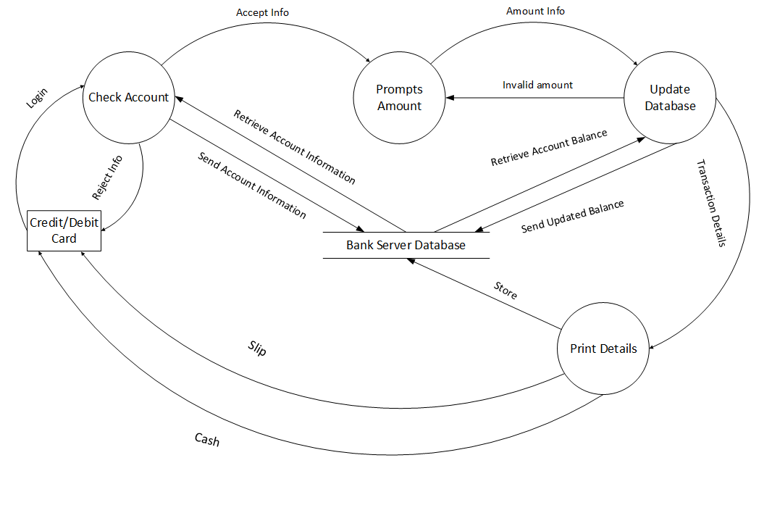

**Fig. 10 :** Logical DFD of ATM System

**Validating Data Flow Diagram:**

**Data can flow from:**

1. external entity to process
2. process to external entity
3. process to store and back
4. process to process

**Data cannot flow from:**

1. external entity to external entity
2. external entity to store
3. store to external entity
4. store to store

**Illegal Constructs in DFD:**

1. No loops are allowed in DFD
2. A single data flow should not be split into many flows with different labels

**Process Description :**

A process specification is a method used to document, analyze and explain the decision-making logic and formulas used to create output data from process input data. Its objective is to flow down and specify regulatory/engineering requirements and procedures. High-quality, consistent data requires clear and complete process specifications. **Process modeling** involves graphically representing the processes, or actions, that capture, manipulate, store, and distribute data between a system and its environment and among components within a system. A common form of a process model is a**data-flow diagram (DFD).** Although several different tools have been developed for process modeling, we focus solely on data-flow diagrams because they are useful tools for process modeling. Data-flow diagramming is one of several structured analysis techniques used to increase software development productivity.

**Conclusion :**