|  |  |
| --- | --- |
| ***Introduction To Database*** | **Project Fall**  **2019-20** |

**Project Name: Team Management System**

**Course Teacher: Kawser Irom Rushee**

**Group Members**

|  |  |
| --- | --- |
| Name | ID |
| Shahriar Islam Shaikat | 19-39972-1 |
| Nuzhut Tabassum | 19-39967-1 |
| Tajkia Faruk | 19-40009-1 |
| Shochi Akter | 19-40235-1 |

**Table of Contents**

**Part1:(Maximum 2 page)**

* **Scenario**
* **ER diagram**

**Part2: (Maximum 1 and half page)**

* **Normalization**

**Part3: (Maximum 6 page)**

* **Table Creation query with screenshot. (Table should include Constraints)**
* **Tables screenshot with data (Each Table should include 3 rows of data)**
* **Query with data screenshot (4 joining query (4 type of joining must be included),2 Sub query (1 subquery using group function),1 view)**
* **Enable, disable constraints of table with screenshot (1 query)**
* **Relational Algebra (2)**

**Scenario**

1. A club organized a football match. Two teams play that match. One team consist of many players. Many players play in a one team. Team has team unique license, team name, team location. Every player has a unique License, name, salary, class, email, nationality, Birthday. And every player has address city and country, multiple skill and phone. Players are trained by a coach. Many players trained a coach and also many players trained by many coaches. One team has many coaches and also many coaches are in one team. Each coach has a unique License, name, salary, nationality, Birthday. And every Coach has address city and country, multiple phone and skill. Team has also physician. Physician guide the player. Many players guided by an physician and also many physician guided many players. A team has an physician and also many physician are in a team. Physician has a unique License,

name, salary, class, email, nationality, Birthday. And every player has address city and country, multiple skill and phone.

**ER diagram**

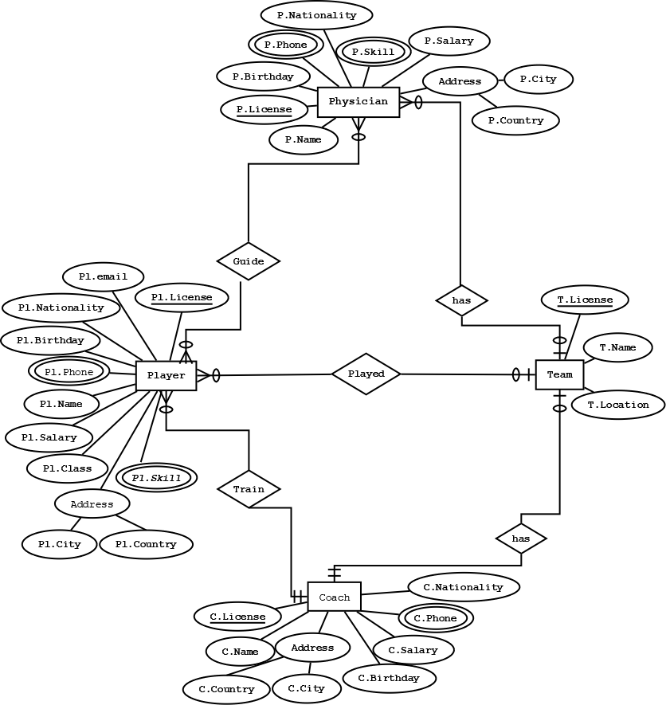

**Normalization**

**UNF:** (Player & Team)

pllicence , plname , plskill , plphn , plemail , plbirthday , plnationality , plclass , plsalary , plcity , plcountry , t.licence , t.name , location

**1NF :** (Player & Team)

pllicence , plname , plskill , plphn , plemail , plbirthday , plnationality , plclass , plsalary , plcity , plcountry , t.licence , t.name , location

**2NF :** (Player & Team)

**1st :** pllicence , plname , plphn , plemail , plbirthday , plnationality , plclass , plsalary , plcity , plcountry , t.licence

**2nd :** pllicence , plskill

**4th:** t.licence , t.name , location

**3NF :** (Player & Team)

**1st :** pllicence , plname , plphn , plemail , plbirthday , plnationality , plclass , plcity , t.licence

**2nd:** plclass , plsalary

**3rd:** plcity , plcountry

**4th :** pllicence , plskill

**5th:** t.licence , t.name , location

**UNF:** (Player & Physician)

pllicence , plname , plskill , plphn , plemail , plbirthday , plnationality , plclass , plsalary , plcity , plcountry , plicence , pname , pskill , pphn, pbirthday , pnationality , psalary , pcity , pcountry

**1NF :** (Player & Physician)

pllicence , plname , plskill , plphn , plemail , plbirthday , plnationality , plclass , plsalary , plcity , plcountry , plicence , pname , pskill , pphn, pbirthday , pnationality , psalary , pcity , pcountry

**2NF :** (Player & Physician)

**1st :** pllicence , plname ,plphn , plemail , plbirthday , plnationality , plclass , plsalary , plcity , plcountry

**2nd :** pllicence , plskill

**3th:** plicence , pname ,pphn , pbirthday , pnationality , psalary , pcity , pcountry

**4th:** plicence , pskill

**5th:** pllicence , plicence

**3NF :** (Player & Physician)

**1st :** pllicence , plname ,plphn , plemail , plbirthday , plnationality , plclass , plcity

**2nd:** plclass , plsalary

**3rd:** plcity , plcountry

**4th :** pllicence , plskill

**5th:** plicence , pname, pphn , pbirthday , pnationality , psalary , pcity

**6th:** plicence , pskill

**7th:** pcity , pcountry

**8th:** pllicence , plicence

**UNF:** (Player & Coach)

pllicence , plname , plskill , plphn , plemail , plbirthday , plnationality , plclass , plsalary , plcity , plcountry , clicence , cname , cphn , cbirthday , cnationality , csalary , ccity , ccountry

**1NF :** (Player & Coach)

pllicence , plname , plskill , plphn , plemail , plbirthday , plnationality , plclass , plsalary , plcity , plcountry , clicence , cname , cphn , cbirthday , cnationality , csalary , ccity , country

**2NF :** (Player & Coach)

**1st :** pllicence , plname , plphn , plemail , plbirthday , plnationality , plclass , plsalary , plcity , plcountry , clicence

**2nd :** pllicence , plskill

**3th:** clicence , cname ,cphn , cbirthday , cnationality , csalary , ccity , country

**3NF :** (Player & Coach)

**1st :** pllicence , plname ,plphn , plemail , plbirthday , plnationality , plclass , plcity , c.licence

**2nd:** plclass , plsalary

**3rd:** plcity , plcountry

**4th:** pllicence , plskill

**5th:** clicence , cname ,cphn , cbirthday , cnationality , csalary , ccity

**6th:** ccity , country

**UNF:** (Coach & Team)

clicence , cname , cphn , cbirthday , cnationality , csalary , ccity , ccountry , t.licence , t.name , location

**1NF :** (Coach & Team)

clicence , cname , cphn , cbirthday , cnationality , csalary , ccity , ccountry , t.licence , t.name , location

**2NF :** (Coach & Team)

**1st:** clicence , cname ,cphn , cbirthday , cnationality , csalary , ccity , country , t.licence

**2nd:** t.licence , t.name , location

**3NF :** (Coach & Team)

**1st:** clicence , cname ,cphn , cbirthday , cnationality , csalary , ccity , t.licence

**2nd:** ccity , country

**3rd:** t.licence , t.name , location

**UNF:** (Physician & Team)

plicence , pname , pskill , pphn, pbirthday , pnationality , psalary , pcity , pcountry , t.licence , t.name , location

**1NF :** (Physician & Team)

plicence , pname , pskill , pphn, pbirthday , pnationality , psalary , pcity , pcountry , t.licence , t.name , location

**2NF :** (Physician & Team)

**1st:** plicence , pname ,pphn , pbirthday , pnationality , psalary , pcity , pcountry ,tlicence

**2nd:** plicence , pskill

**3rd:** t.licence , t.name , location

**3NF :** (Physician & Team)

**1st:** plicence , pname ,pphn , pbirthday , pnationality , psalary , pcity , tlicence

**2nd:** plicence , pskill

**3rd:** pcity , pcountry

**5th:** t.licence , t.name , location

**TABLE**

|  |  |  |  |
| --- | --- | --- | --- |
| **No.** | **Table Name** | **Attribute** | **Constraint** |
| 1 | Team | t.licence , t.name , location | CONSTRAINT pk_team, CONSTRAINT u_team |
| 2 | Player | pllicence , plname ,plphn , plemail , plbirthday , plnationality , plclass , plcity , t.licence, c.licence | CONSTRAINT pk_Player, fk_Player, fk2_Player, fk3_Player, ck_Player_salary |
| 3 | Player_salary | plclass , plsalary | CONSTRAINT pk_Player_salary, ck_Player_salary |
| 4 | Player_skill | pllicence , plskill | CONSTRAINT pk_Player_skill |
| 5 | Physician | plicence , pname ,pphn , pbirthday , pnationality , psalary , pcity , tlicence | CONSTRAINT pk_Physician, fk_Physician, fk2_Physician |
| 6 | Physician_skill | plicence , pskill | CONSTRAINT pk_Physician_skill |
| 7 | Rel_player_ physician | pllicence , plicence | CONSTRAINT pk_Rel_player_physician |
| 8 | Coach | clicence , cname ,cphn , cbirthday , cnationality , csalary , ccity , t.licence | CONSTRAINT nnl_Coach, pk_Coach, fk_Coach, fk2_Coach |
| 9 | Address | city , country | CONSTRAINT pk_Address |

**Table create with inserted value**

**Team**

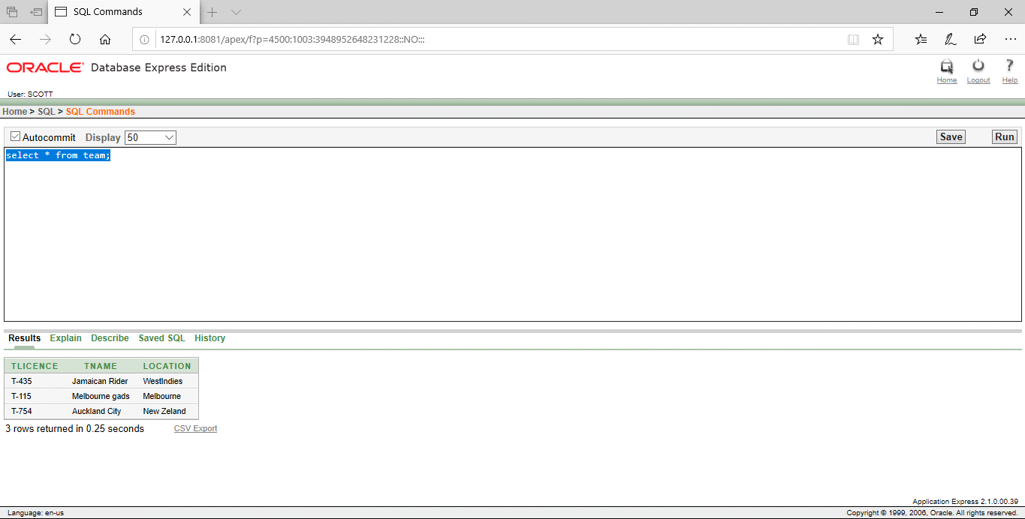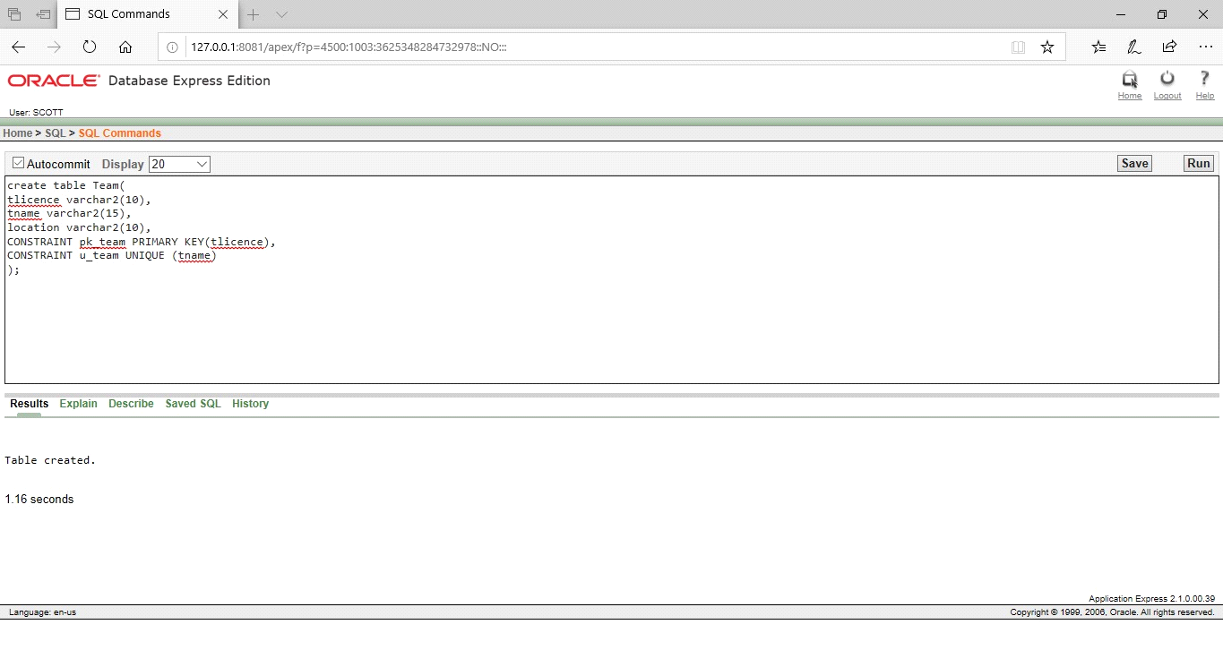

**Player**

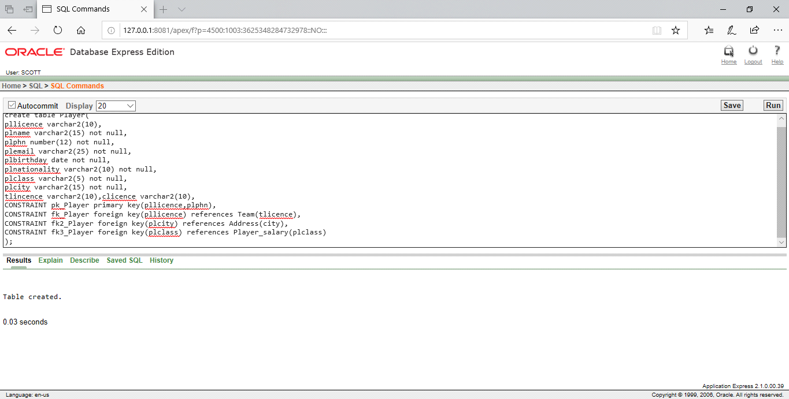

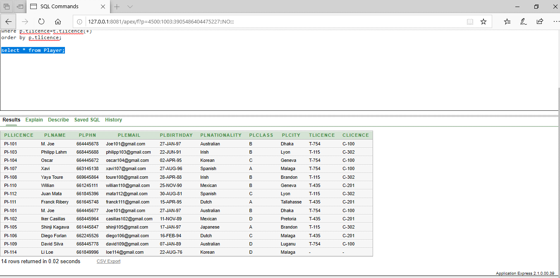

**Player_salary**

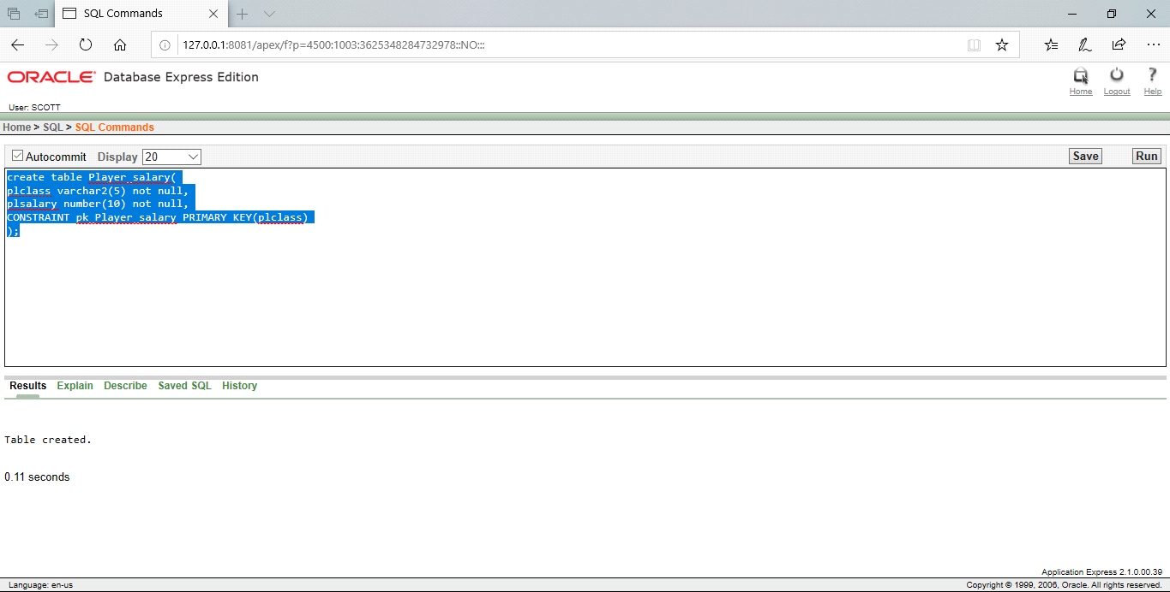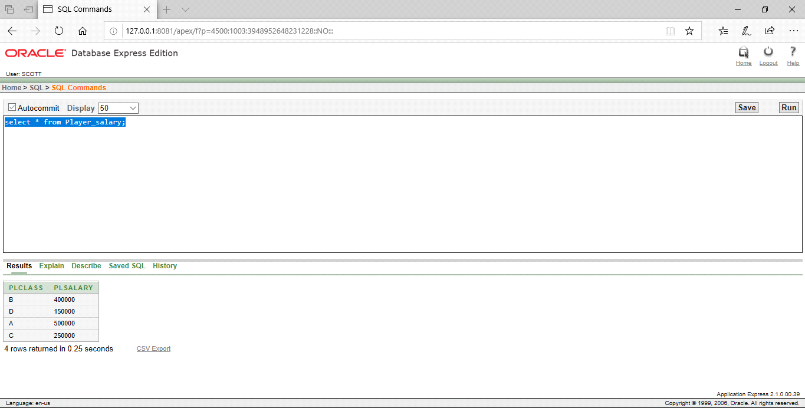

**Player_skill**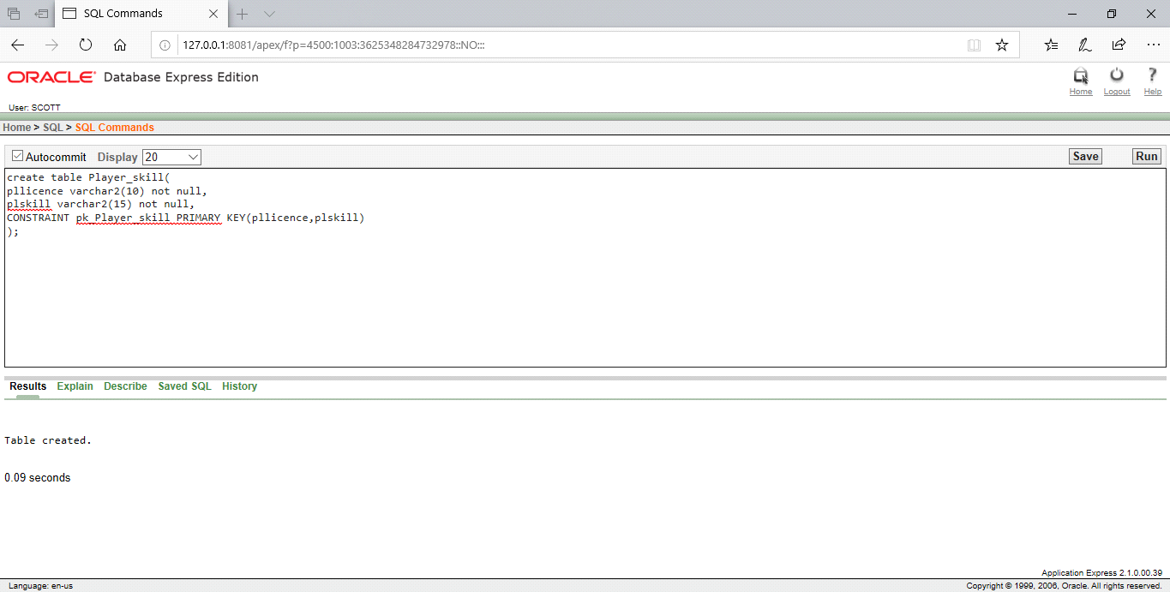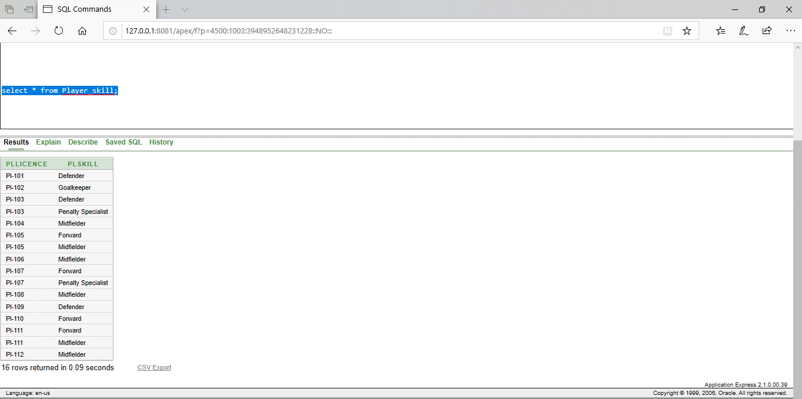

**Physician**

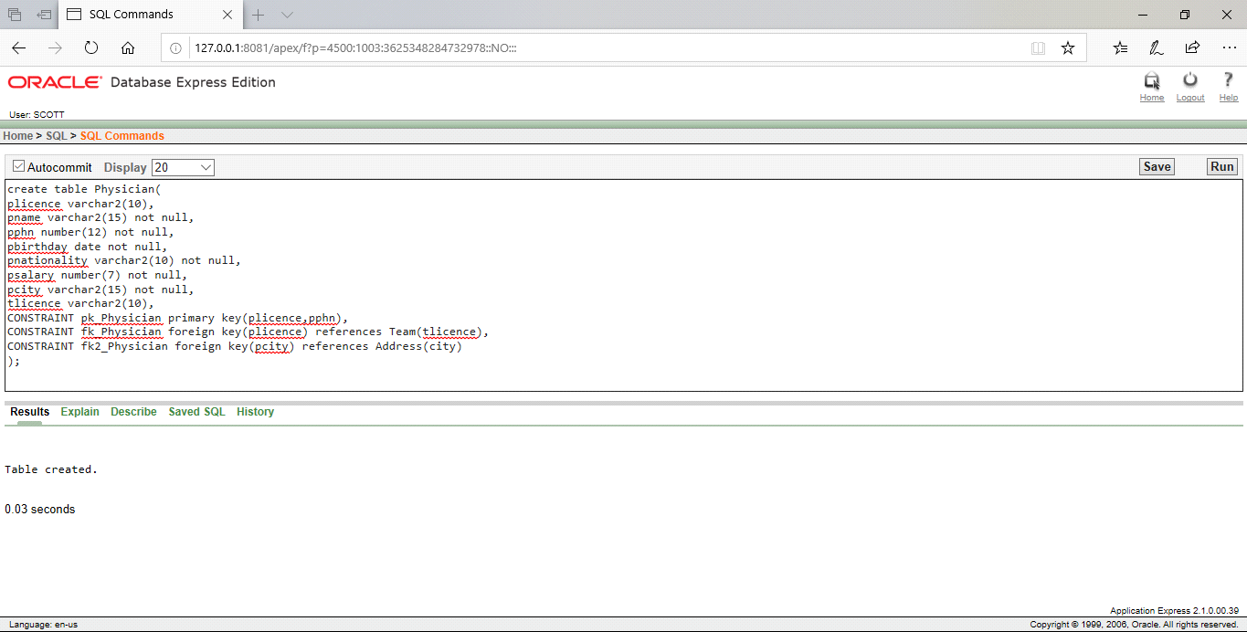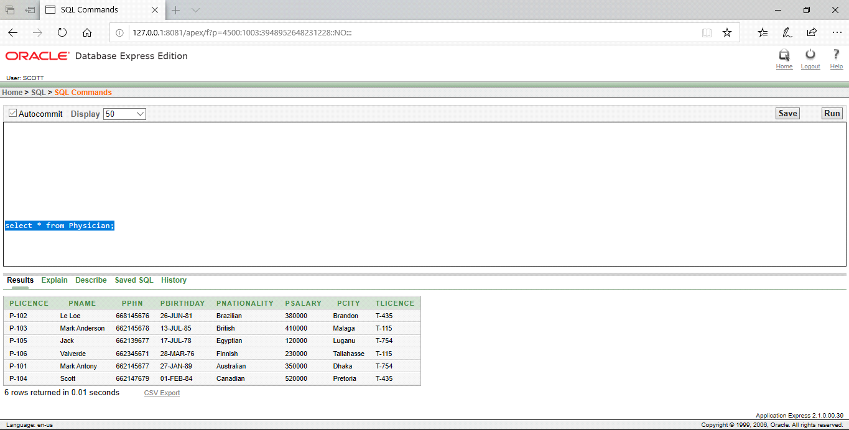

**Physician_skill**

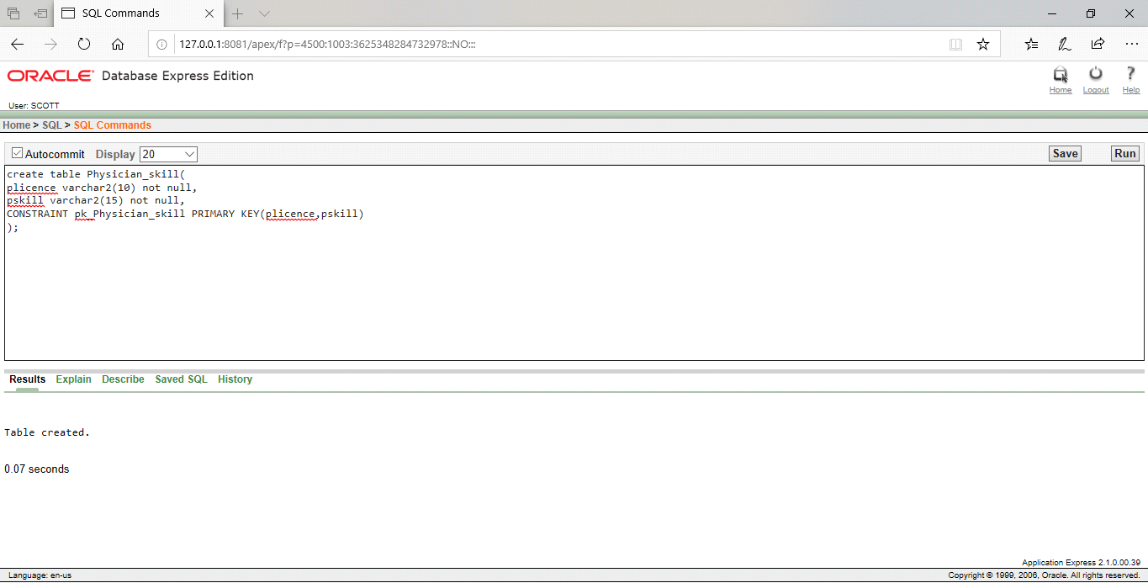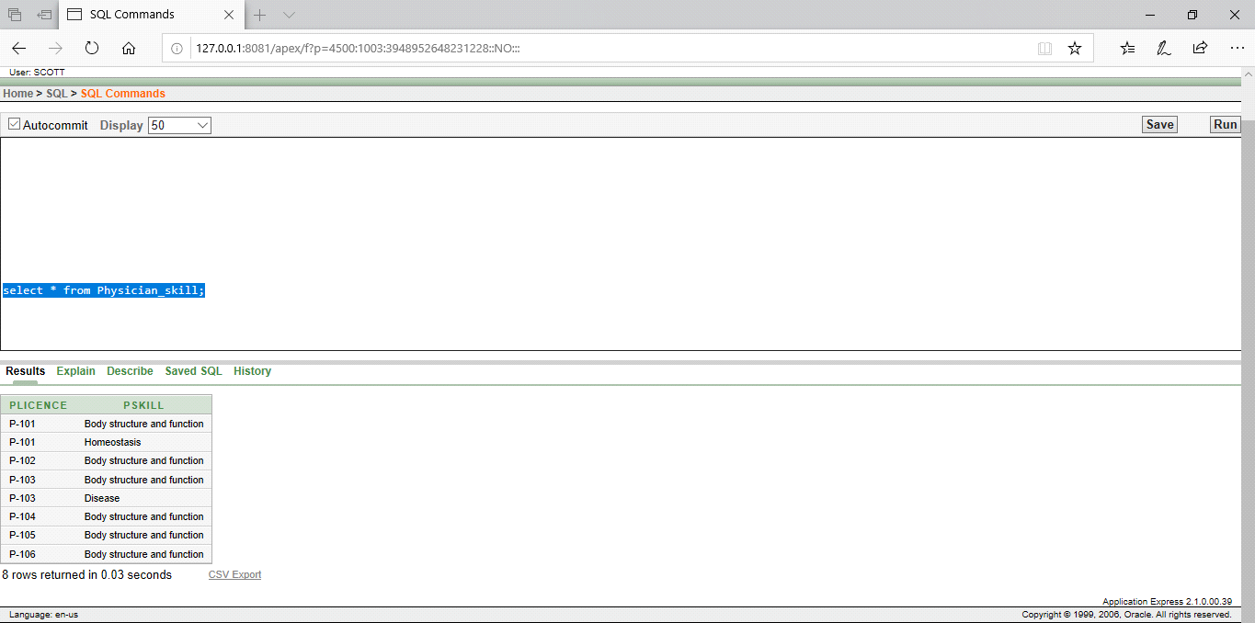

**Rel_player_ physician**

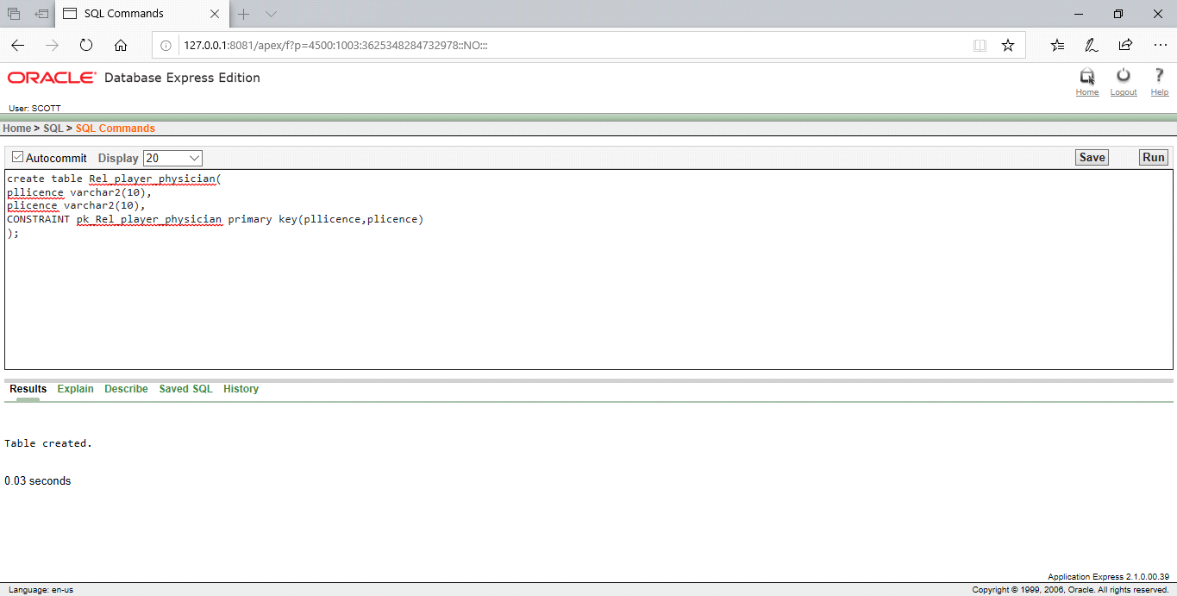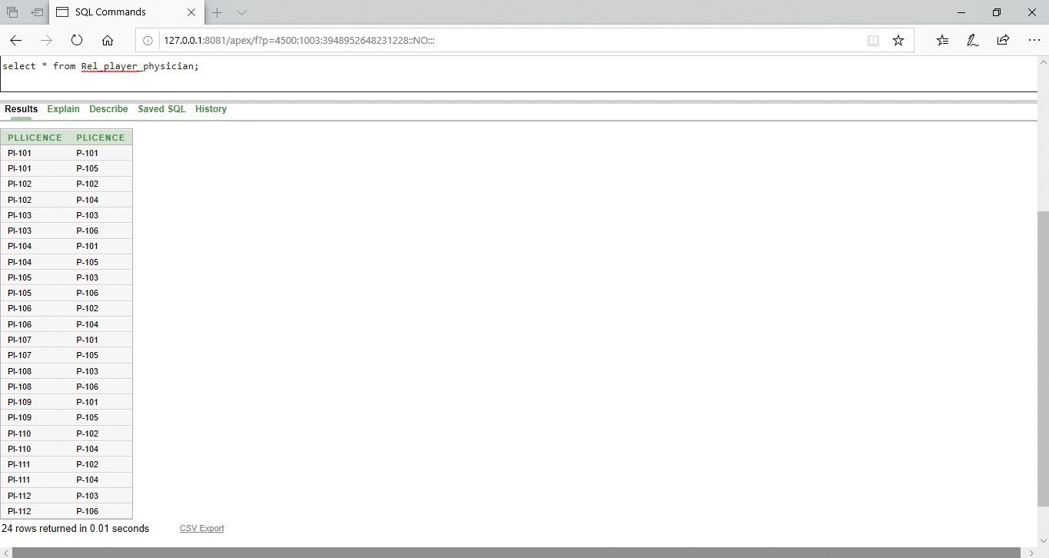

**Coach**

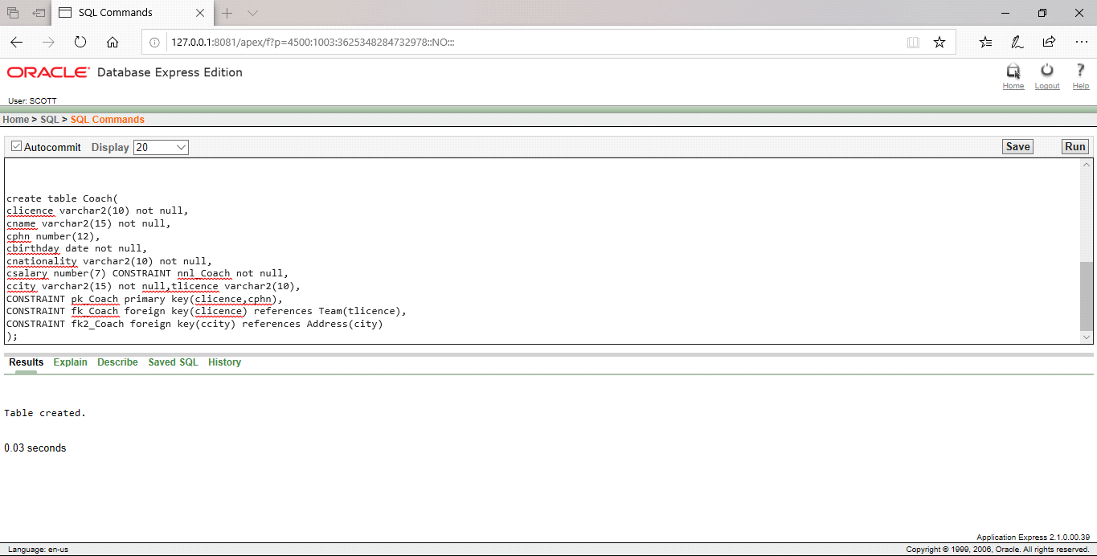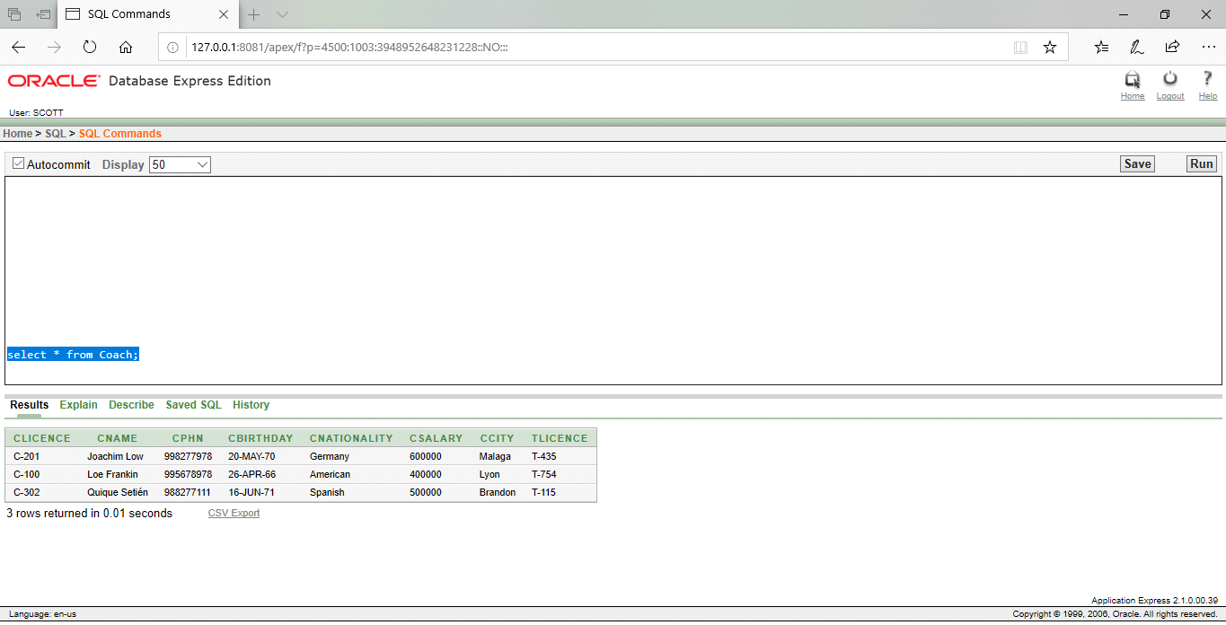

**Address**

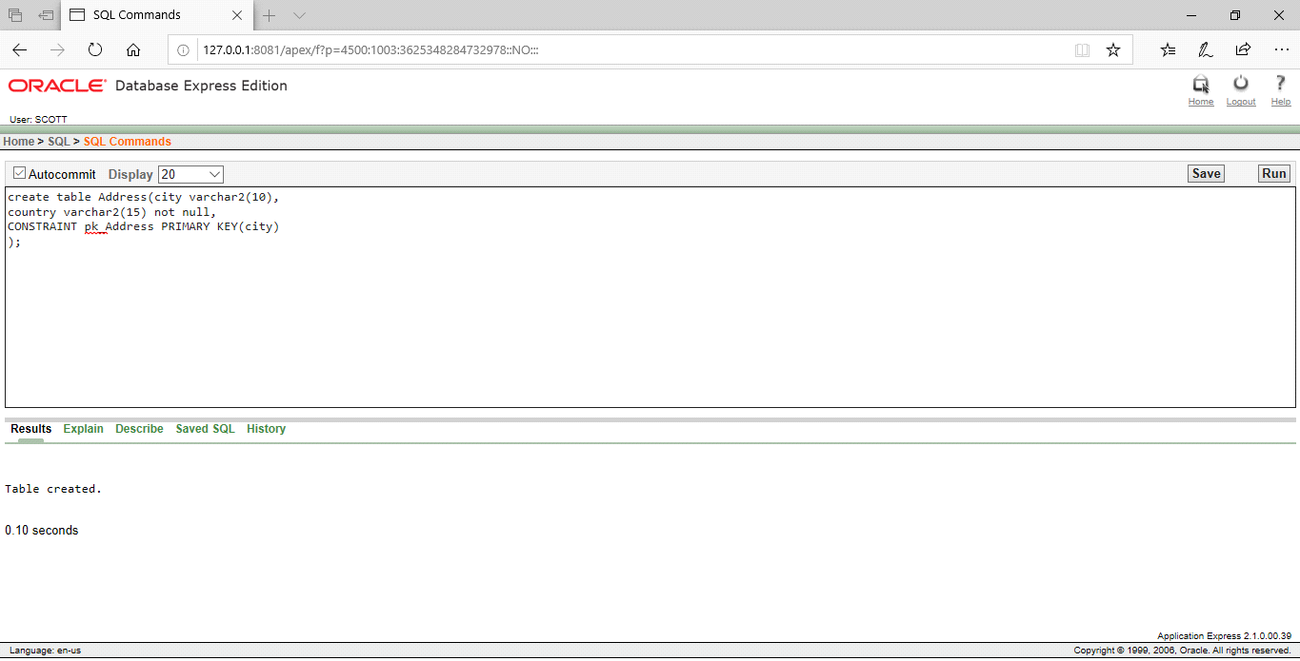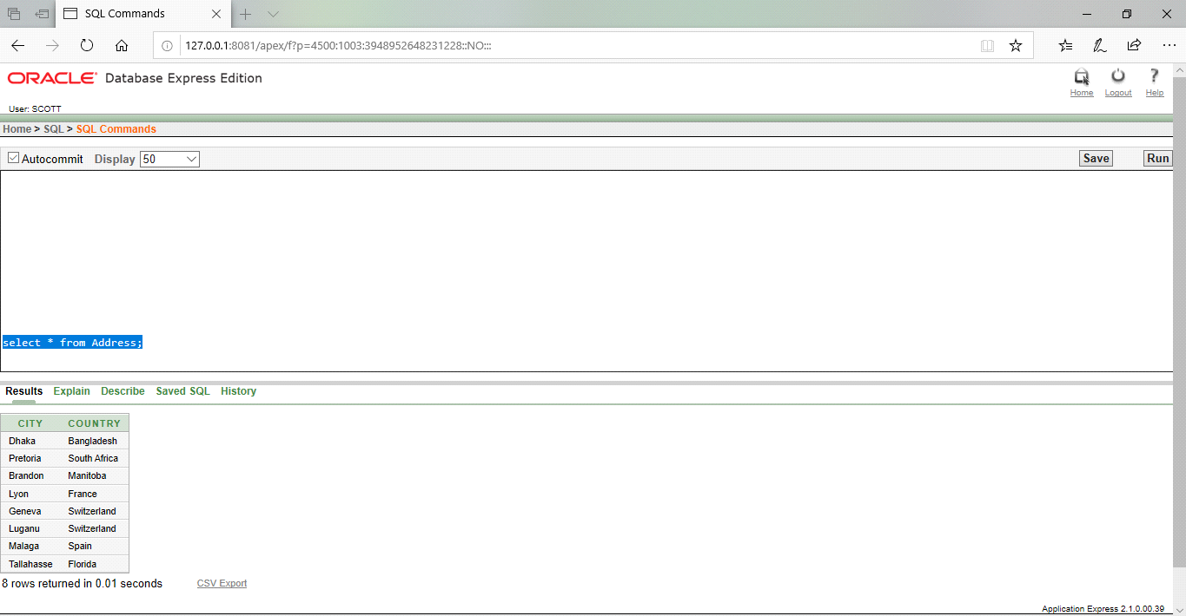

**Query question & Answer**

**1.**Display player licence,name,skill & salary where player age is more than 30. (Equijoin)

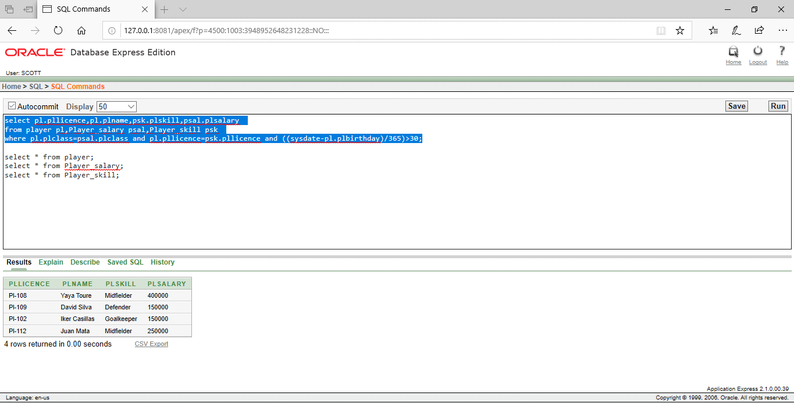

2. Display all player's licence,name and team information. (outer join)

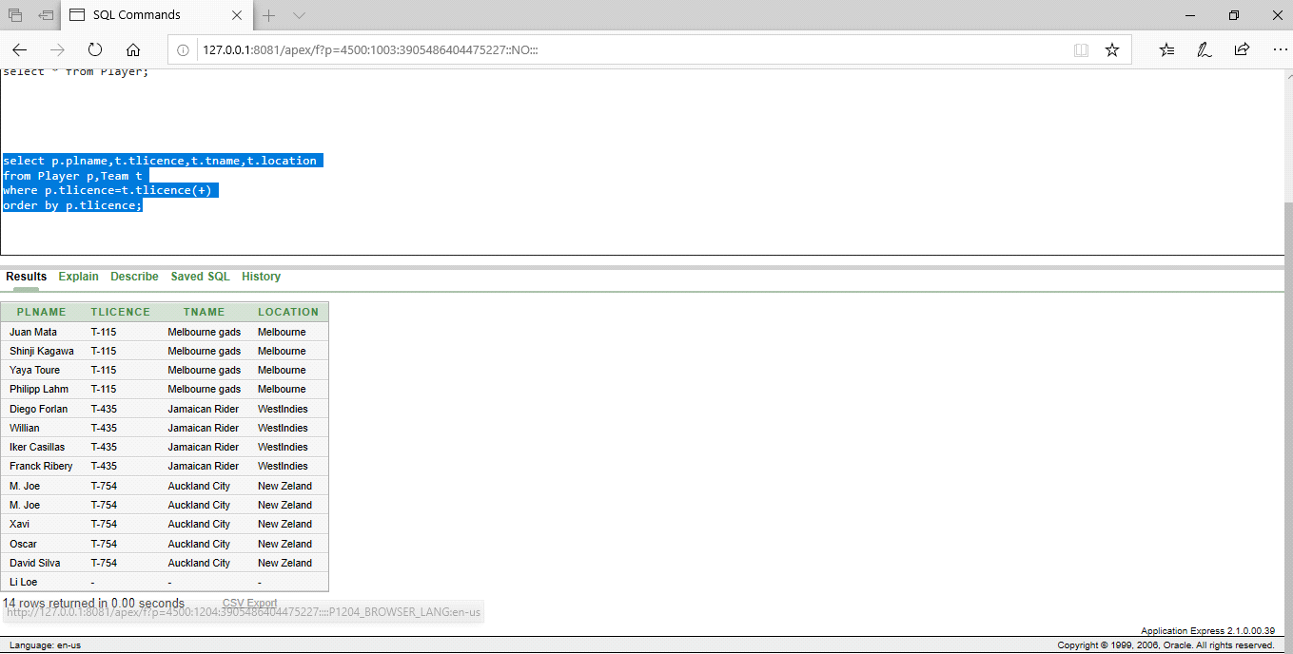

3.Display the coach information where their length of the word of their nationality is equal. (Self join)

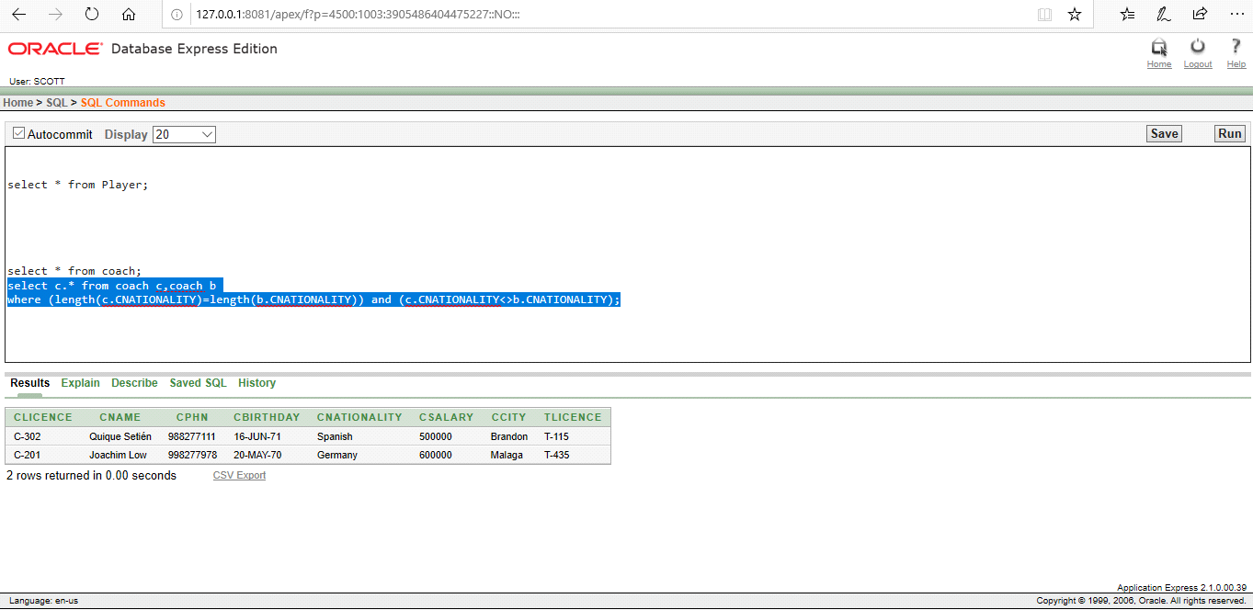

4.Find the third lowest salary and class name from Player’s salary table.

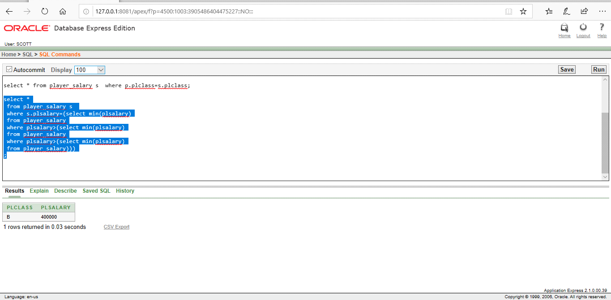

5.Find all of the players info, who are born after Franck Ribery.

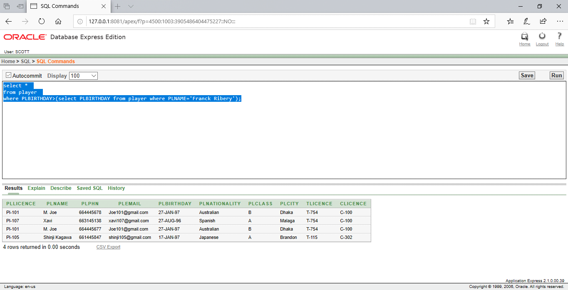

6.Create a view.(view_physician)

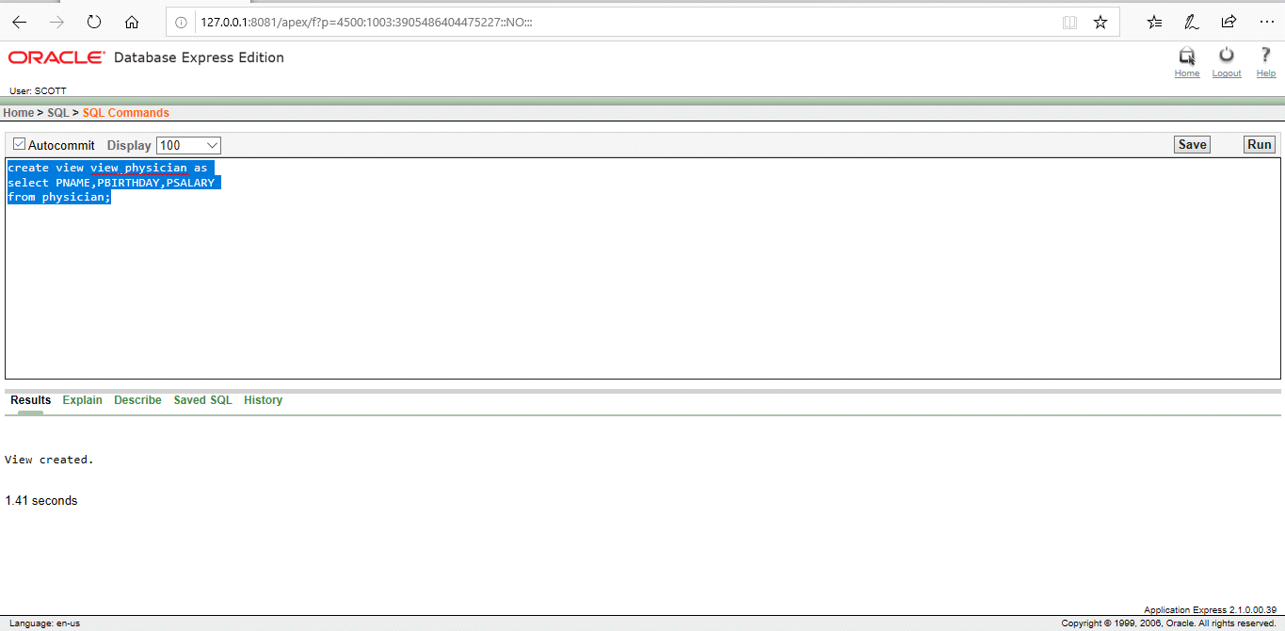

7.Enable, disable constraints of table:

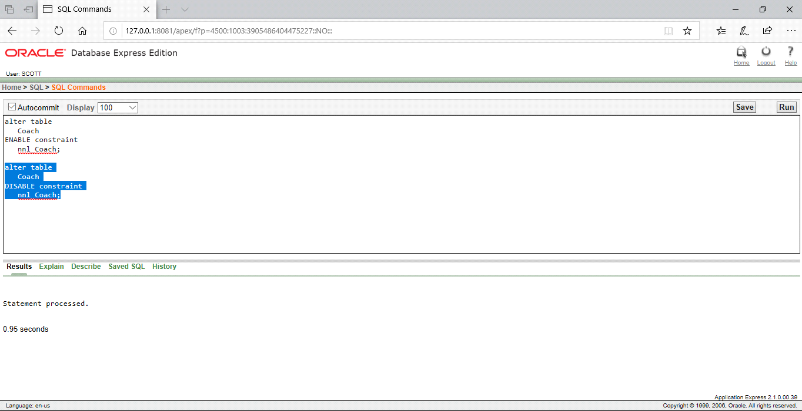

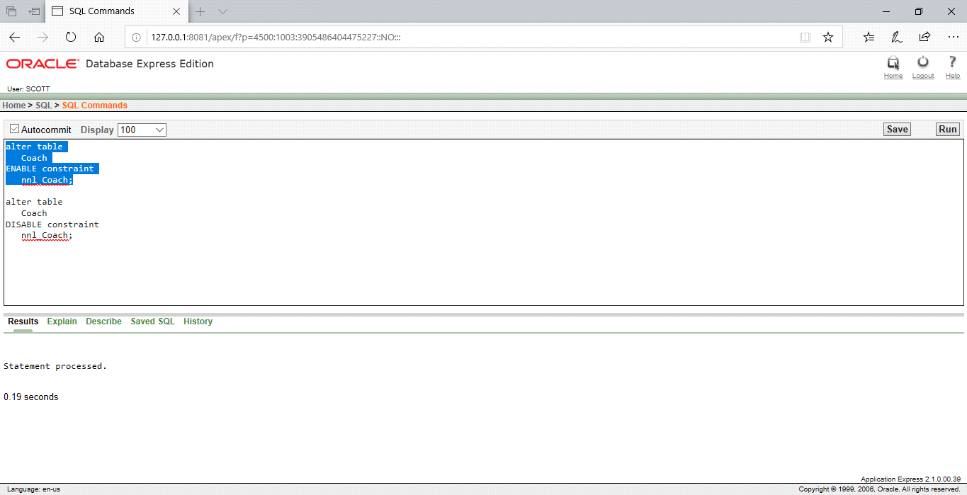

8.List the plname those are string with ‘X’ and with three characters:

∏Plname(σPlname like ‘X_ _ _’(Player))

9.Display the coach name,salary and city from Coach table:

σcname,csalary,ccity(Coach)