**Excel Technologies Ltd.**

**Competency Assessment**

Position: Software Engineer

Total Marks: 30

*Ensure you are indicating accurately what question you are answering. Make sure your script is clean and easily readable. Do not forget to fill up the box below with your information. Attach the question paper with you script. During competency assessment, you are not allowed to use internet through any means.*

|  |  |  |  |  |  |  |  |  |  |  |  |  |  |  |  |  |  |  |  |  |  |
| --- | --- | --- | --- | --- | --- | --- | --- | --- | --- | --- | --- | --- | --- | --- | --- | --- | --- | --- | --- | --- | --- |
| Name | S | A | L | M | A |  | T | A | B | A | S | S | U | M |  | J | A | H | A | N |  |
| Cellphone | 0 | 1 | 5 | 3 | 3 | 3 | 9 | 1 | 9 | 8 | 0 |  |  |  |  |  |  |  |  |  |  |
| Email | s | t | j | 1 | 1 | 1 | 2 | 2 | 0 | 1 | 4 | @ | g | m | a | i | l | . | c | o | m |

Answer to Ques No: 1 - a

1. Consider the following register. Holy Family Red Cross Hospital is using this register to manage doctors’ list, their contact number, and the departments where the doctors are belongs to. With this register, the hospital is also managing doctor’s service points within the hospital.

* 1. Apply normalization rule to normalize this register up to 3rd normal form.

|  |  |  |  |
| --- | --- | --- | --- |
| **Doctor Id (Pk)** | **Doctor** | **Contact Number** | **Department Id (Fk)** |
| 1 | Dr. Lissa Mwenda | +260766219936 | 1 |
| 2 | Dr. Yvonne Sishuwa | +260766219937 | 2 |
| 3 | Dr. Machalo Mbale | +260766219938 | 3 |

|  |  |
| --- | --- |
| **Department Id (Pk)** | **Department Name** |
| 1 | Gynecology |
| 2 | Pediatrics |
| 3 | Radiology and Imaging |

|  |  |
| --- | --- |
| **Service Point Id (Pk)** | **Service Point Name** |
| 1 | Antenatal Care |
| 2 | Family Planning |
| 3 | Postnatal Care |

|  |  |
| --- | --- |
| **Doctor Id (Pk)** | **Service Point Id (Pk)** |
| 1 | 1 |
| 1 | 2 |
| 1 | 3 |
| 2 | 2 |
| 2 | 3 |
| 3 | 1 |

# P a g e 1 | 6

Answer to Ques No: 1 - b

* 1. After normalization, draw Entity Relationship Diagram and show the degree of cardinality among entities using crow’s foot notation.

|  |  |  |  |
| --- | --- | --- | --- |
| **Doctor** | **Contact Number** | **Service Points** | **Department** |
| Dr. Lissa  Mwenda | +260766219936 | Antenatal Care,  Family Planning,  Postnatal Care | Gynecology |
| Dr. Yvonne Sishuwa | +260766219937 | Family Planning, Postnatal Care | Pediatrics |
| Dr. Machalo Mbale | +260766219938 | Antenatal Care | Radiology and Imaging |

# P a g e 2 | 6

Answer to Ques No: 2

1. Consider the following loop. Trace the value of “n” in every iteration of the loop.

int n = 30;

for (int i = 0; i <= 5; i++)

{ n += i;

}

print(n);

|  |  |  |
| --- | --- | --- |
| Iteration No | Value of i | Value of n |
| 1 | 0 | 30+0=30 |
| 2 | 1 | 30+1=31 |
| 3 | 2 | 31+2=33 |
| 4 | 3 | 33+3=36 |
| 5 | 4 | 36+4=40 |
| 6 | 5 | 40+5=45 |

# P a g e 3 | 6

Answer to Ques No: 4

1. Explain method overloading and method overriding with example. Write your code in C# programming language.

Method overloading and method overriding are two approaches to implementing polymorphism in C#.

**Method overloading**

Method overloading is a feature of Object Oriented Programming that allows us to define multiple methods with different parameters.

public int AddNumbers(int num1, int num2)

{

return num1 + num2;

}

public int AddNumbers(List<int> numbers)

{

int sum = 0;

for(int i=0; i<numbers.Count; i++)

{

sum= sum + numbers[i];

}

return sum;

}

public double AddNumbers(double num1, double num2)

{

return num1 + num2;

}

Here three methods are defined with the same name “AddNumbers” and different paremeters and return types. This is how Method overloading is implemented in C#.

**Method overriding**

Method overriding allows us to extend or modify the behavior of an inherited method. It also enables the derived class to provide its own implementation of a method that is defined in the base class.

public class Season

{

public virtual void Print()

{

Console.WriteLine("I am Season");

}

}

public class Summer : Season

{

public override void Print()

{

Console.WriteLine("I am Summer");

}

}

public class Winter : Season

{

public override void Print()

{

Console.WriteLine("I am Winter");

}

}

Here “Season” is the base class and “Summer” and “Winter” are derived classes. The “Print()” method is defined in the base class. But as it is inherited, the derived classes have provided their own implementation.

P a g e 4 | 6

Answer to Ques No: 5

1. Translate the following UML Class Diagram into program code. Write your code in C# programming language.

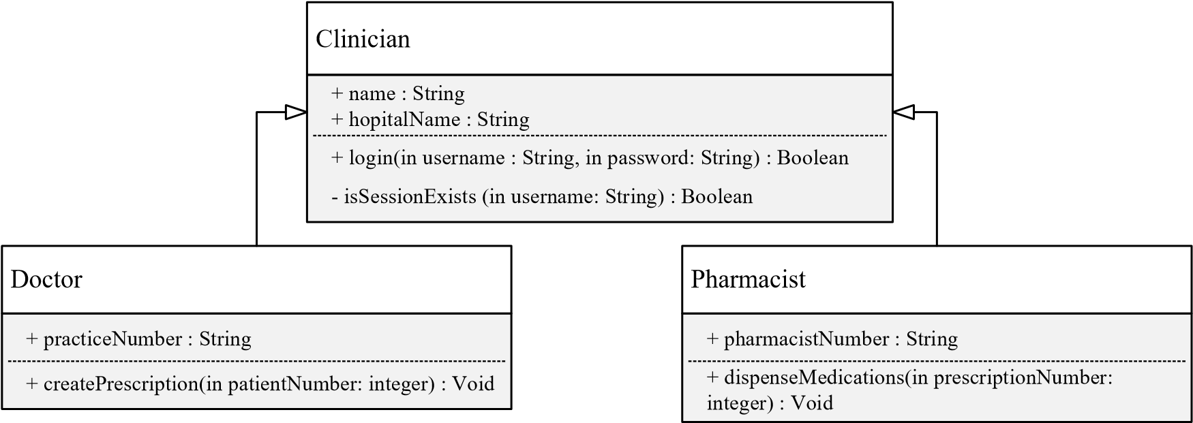Marks 5 X 2 = 10

internal class Clinician

{

public string Name { get; set; } = null!;

public string HospitalName { get; set; } = null!;

public bool login(string in_username, string in_password)

{

return true;

}

private bool isSessionExists(string in_username)

{

return false;

}

}

internal class Pharmacist:Clinician

{

public string PharmacistNumber { get; set; } = null!;

public void dispenseMedications(int in_prescriptionNumber)

{

}

}

internal class Doctor:Clinician

{

public string PracticeNumber { get; set; } = null!;

public void createPrescription(int in_patientNumber)

{

}

}

# P a g e 5 | 6

Answer to Ques No: 6

6 Translate the UML Activity diagram into program code. Write your code either in C# programming language. 5

Read integer values

for varables n1, n2

and n3

n1 < n2

min = n2

min = n1

No

Yes

n3 < min

min = n3

Yes

No

Print min

public void PrintMinNum(int n1, int n2, int n3)

{

int min = 0;

if(n1 < n2)

{

min = n1;

}

else

{

min = n2;

}

if(n3<min)

{

min = n3;

}

Console.WriteLine($"Minimum Number : {min}");

--------------------END------------------

# P a g e 6 | 6