Every student should know the working of all the algorithms discussed in the class, application steps, intermediate steps and final sorted result, the sequence of input that result in best case, average case and worse case complexity.

- Given an array A of n numbers, write an efficient algorithm to find the most frequently occurred element in that array (Mode of that array). Also analyze the time complexity of your algorithm.

- Consider the problem of finding three numbers in an array A of integers that is sorted, such that their sum should be equal to a number T. Array A having n integers and number T is also given as an input.
Design a solution for that problem that takes Θ (nlgn) time

- We have two input arrays A and B, each having n integers. Design a solution for finding such two numbers A[i] and B[j] that their sum is equal to Zero.
Your solution should take O (n²).
Your solution should take O (nlgn).

- Consider the problem of finding two elements in an array of n elements, such that their sum should be equal to the value of the key (provided as an input). Design an efficient solution for this problem having time complexity Θ (nlgn).

- We have an input array A of n integers, describe O (nlgn) worst-case time algorithm to find two elements x, y Є A such that |x – y| ≤ |a – b| for all a, b Є A. Also analyze the time complexity of your algorithm.

- Solve problem 2-1 from your book.

- Solve problem 4-5 from your book.

- Solve exercise 6.1-1, 6.1-2, 6.1-3, 6.1-4, 6.4-3 and 6.5-9 from your book

- Solve exercise 7.1-2, 7.1-4, 7.2-2, 7.2-3 and 7.2-4 , problem 7-1 and 7-2 from your book

- Solve problem 8-2, 8-3 and 8-4 from your book.

- Solve exercise 16.1-2, 16.1-3, 16.1-4 and 16.1-5 from your book.

- We have an input array A of n integers, describe algorithm to find two elements x, y Є A such that (|x|–|y|) ≤ (|a| – |b|) for all a, b Є A. Also analyze the time complexity of your algorithm.

- We have an input array A of n integers, describe algorithm to find two elements x, y Є A such that
(x – y) ≤ (a – b) for all a, b Є A. Also analyze the time complexity of your algorithm.

- We have an input array A of n integers, describe a O (nlgn) worst-case time algorithm to find two elements x, y Є A such that |x – y| ≥ |a – b| for all a, b Є A. Also analyze the time complexity of your algorithm.

- We have an input array A of n integers, describe algorithm to find two elements x, y Є A such that (|x|–|y|) ≥ (|a| – |b|) for all a, b Є A. Also analyze the time complexity of your algorithm.

- We have an input array A of n integers, describe algorithm to find two elements x, y Є A such that
(x – y) ≥ (a – b) for all a, b Є A. Also analyze the time complexity of your algorithm.

- We have an input array A of n integers, describe O (nlgn) worst-case time algorithm to find two elements x, y Є A such that |x + y| ≤ |a + b| for all a, b Є A. Also analyze the time complexity of your algorithm.

- We have an input array A of n integers, describe algorithm to find two elements x, y Є A such that (|x|+|y|) ≤ (|a| + |b|) for all a, b Є A. Also analyze the time complexity of your algorithm.

- We have an input array A of n integers, describe algorithm to find two elements x, y Є A such that
(x + y) ≤ (a + b) for all a, b Є A. Also analyze the time complexity of your algorithm.

- We have an input array A of n integers, describe a O (nlgn) worst-case time algorithm to find two elements x, y Є A such that |x + y| ≥ |a + b| for all a, b Є A. Also analyze the time complexity of your algorithm.

- We have an input array A of n integers, describe algorithm to find two elements x, y Є A such that (|x|+|y|) ≥ (|a| + |b|) for all a, b Є A. Also analyze the time complexity of your algorithm.

- We have an input array A of n integers, describe algorithm to find two elements x, y Є A such that
(x + y) ≥ (a + b) for all a, b Є A. Also analyze the time complexity of your algorithm.

- We have an array of integers, when we apply Quick sort, the sorted array does not remain stable. What sequence of integers is needed?

- We have an array of integers, when we apply Heap sort, the sorted array does not remain stable. What sequence of integers is needed?

- Given an array of n integers, consider the problem of finding the maximum sum in any contiguous sub array of the input, integers are positive, negative and zero. Design O (n)² time algorithm to find the solution for this problem. Design O (nlgn) time algorithm to find the solution for this problem. Design O (n) time algorithm to find the solution for this problem.

- We have two input arrays A and B. Array A with n elements and array B with m elements, where m ≤ n. There may be duplicate elements in both arrays. We want to decide that if every element of A is also an element of B. Describe an algorithm to solve that problem in О (nlgm) worst case time. Also analyze the time complexity of your algorithm.

- We have k sorted lists of integers, we want to merge these k sorted lists into one sorted list, where total number of integers in all k lists are n. Here every list is sorted with respect to its integer values. Design an efficient algorithm to solve this problem. (using Merge Sort or using Heap Sort)

- We have an input array A of n integers, these integers could be duplicates. Design a solution for finding first minimum and the second minimum in the array, but keeping in mind that we can only run a single loop for n integers. Array A has at least two distinct integers. Complexity of your solution should be Θ (n).

- We have an input array A of n integers, these integers could be duplicates. Design a solution for finding first maximum and the second maximum in the array, but keeping in mind that we can only run a single loop for n integers. Array A has at least two distinct integers. Complexity of your solution should be Θ (n).

- We have three input arrays A, B and C, each having n integers. Design a solution for finding such three numbers A[i], B[j] and C[k] that their sum is equal to Zero.
Your solution should take O (n³).
Your solution should take O (n²lgn).
Your solution should take O (n²).
Your solution should take O (n(lgn)²).
Also analyze the complexity of your algorithm.

- Let A [1…n] be an array of n distinct numbers. If i < j and A[i] > A[j], then the pair (i, j) is called an inversion of A. Give an algorithm that determines the number of inversions in any permutation on n elements in Θ(n lgn) worst case time. (Think about merge sort) Does that concept of inversion is related to insertion sort in any way?

- Let A [1…n] be an array of n distinct numbers. If i < j and A[i] < A[j], then the pair (i, j) is called an inversion of A. Give an algorithm that determines the number of inversions in any permutation on n elements in Θ(n lgn) worst case time. (Think about merge sort) Does that concept of inversion is related to insertion sort in any way?

- Let A [1…n] be an array of n distinct numbers. If i > j and A[i] > A[j], then the pair (i, j) is called an inversion of A. Give an algorithm that determines the number of inversions in any permutation on n elements in Θ(n lgn) worst case time. (Think about merge sort) Does that concept of inversion is related to insertion sort in any way?

- Let A [1…n] be an array of n distinct numbers. If i > j and A[i] > A[j], then the pair (i, j) is called an inversion of A. Give an algorithm that determines the number of inversions in any permutation on n elements in Θ(n lgn) worst case time. (Think about merge sort) Does that concept of inversion is related to insertion sort in any way?

- Consider the problem of adding two n-bit binary integers, stored in two n-element arrays A and B. The sum of the two integers should be stored in binary form in an (n + 1) element array C.
State the problem formally and write pseudo code for adding two integers.

- Aslam wants to throw a party and is deciding whom to call. He has n people to choose from, and he has made up a list of pairs who know each other. He wants to pick as many people as possible, subject to only one constraint: At the party, each person should have at least $\frac{n}{4}$ other people whom he knows and at most $\frac{n}{8}$ other people whom he does not know. Give an efficient algorithm that takes as an input the list of n people and the list of pair who know each other, output should be the list of those people who meet that condition. Also give the running time in term of n.

- The analysis of Quick-Sort shows that we use PARTITION procedure to divide the input array.
Our partition procedure returns an index q such that each element of A [p…q – 1] is less than or equal to A[q] and each element of A [q + 1…r] is greater than A[q].
Modify the PARTITION procedure to produce a procedure PARTITION’ (A, p, r), which permutes the elements of A [p . . . r] and return two indices q and t, where p ≤ q ≤ t ≤ r, such that
    - All elements of A [q . . . t] are equal
    - Each element of A [p . . . q – 1] is less than A[q] and
    - Each element of A [t + 1 . . . r] is greater than A[q]

Solve all the other variations of the above given problem also.

- Three couples are at one side of the river and want to go to the other side of the river. Three couples Xx, Yy and Zz, one boat can carry at most two people, wives may not be with a man on any side or in the boat unless their husband is present

- We have an array of n data elements, each element consists of two numbers, let’s say x and y. An element A is said to be dominated by an element B if x and y of B are greater than or equal to the x and y of A. We have to analyze and design a method to find that is there an element in the data which is not dominated by any other point (that point is called maximal)

- Assume you have an array A [1. . . n] of n elements. A majority element of A is any element occurring in more than n /2 positions (so if n = 6 or n = 7, any majority element will occur in at least 4 positions). Assume that elements cannot be ordered or sorted, but can be compared for equality. (You might think of the elements as chips, and there is a tester that can be used to determine whether or not two chips are identical.) Design an efficient divide and conquer algorithm to find a majority element in A (or determine that no majority element exists).

- Imagine two rooms with no visibility between them. In one room there n numbered light switches s1, s2, . . . , sn. In the other room there are n numbered light bulbs l1, l2, . . . , ln. It is known that each switch turns on and off to exactly one bulb but we do not know anything about the wiring between the switches and the bulbs. Initially we are in the room with the switches. Our job is to tell the exact wiring, i.e. which switch operates which bulb. We are allowed to press any switches and then go to the room with the bulbs and perform an observation. We are not allowed to touch the bulbs – our only source of information is the observation of the bulbs. The switches are such that their physical appearance does not change when toggled so we have no way of knowing beforehand whether pressing a certain switch leads to turning on or turning off of a bulb. Every switch has, of course, two states only, as any normal light switch. Describe an algorithm that discovers the wiring with minimum number of observations, i.e. with minimum visits to the room with the bulbs. The algorithm should work iteratively, at each iteration simulating toggling some switches and then simulating an observation by calling some function Observe. The toggling is simulated by writing into a 0-1 array P[1, . . . ,n]. Say, P[i] = 1 means si is toggled, and P[i] = 0 means si is not toggled. The result of the “observation” is written in some 0-1 array L[1, . . . ,n]. Say, L[i] = 1 means li is on, and L[i] = 0 means li is off. After every call to Observe, the algorithm temporarily halts, the execution is supposed to be transferred to an outside agent and the algorithm resumes after the outside agent finishes writing into L. Prove an asymptotic lower bound for the number of observations. Is your algorithm optimal in the asymptotic sense?

- Solve Exercise 22.1-3 from your book, give separate solution for Adjacency list and Matrix.

- In a graph how you can find a sink. Design an efficient algorithm. (Adjacency list and Matrix)

- In a graph how you can find in degree and out degree. Design an efficient algorithm. (Adjacency list and Matrix)

- In a graph how you can find a source. Design an efficient algorithm. (Adjacency list and Matrix)

- In a graph how you can find that it is a tree. Design an efficient algorithm.

- Draw a graph that the application of Prim’s and Dijkstra result in same selected tree

- Draw a graph that the application of Prim’s and Dijkstra result in different selected tree

- Draw a graph that if we have some negative weight edge there, then behavior of Dijkstra sometime remains correct and sometime does not produce correct result, give example for that.

- We have a graph G = (V, E), all edges have the same weight, we want to find Shortest path in that graph, which algorithm will be most efficient.

- Solve Exercise 22.1-7, 22.2-1, 22.2-2, 22.2-3, 22.2-4, 22.2-5 and 22.2-7 from your book.

- Solve exercise 22.5-1, 22.5-2 and 22.5-3, problem 22-1 from your book.

- Solve Exercise 22.2-8 from your book, on the following graph, starting from E.

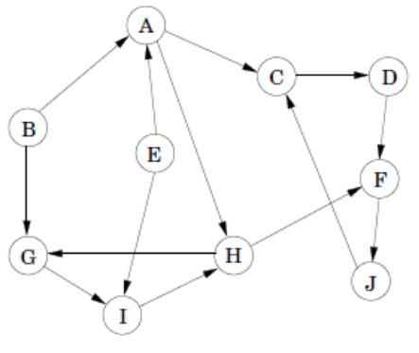

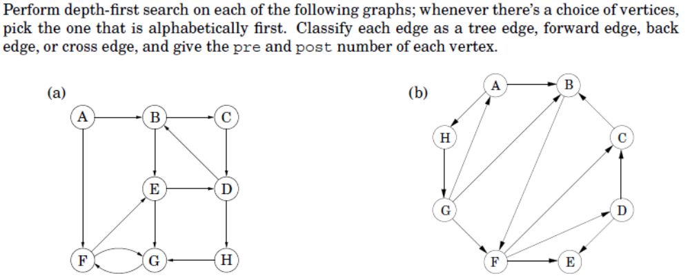

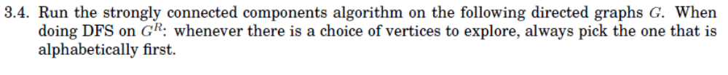
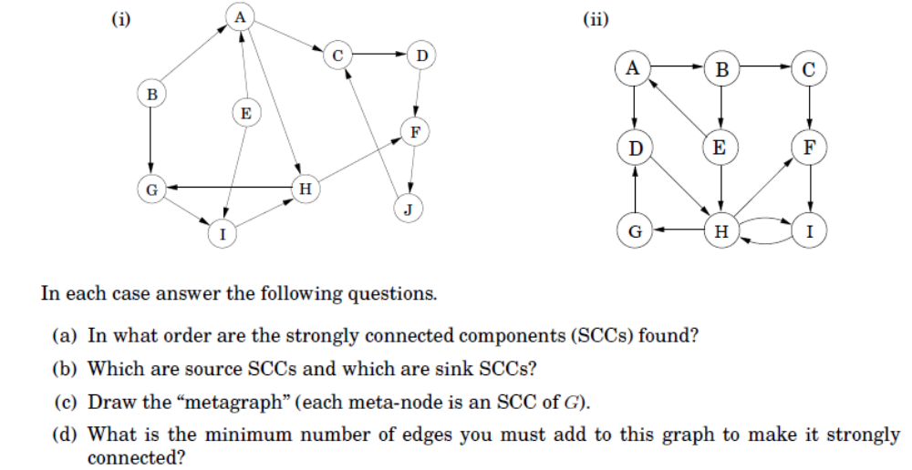

56.
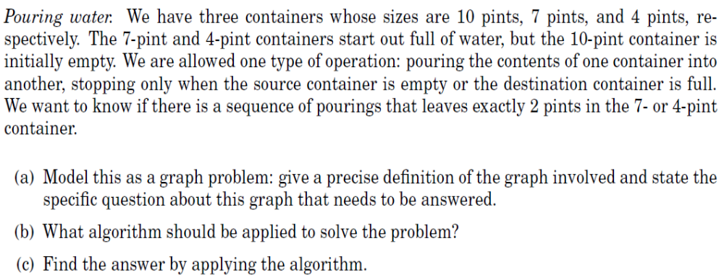

57.
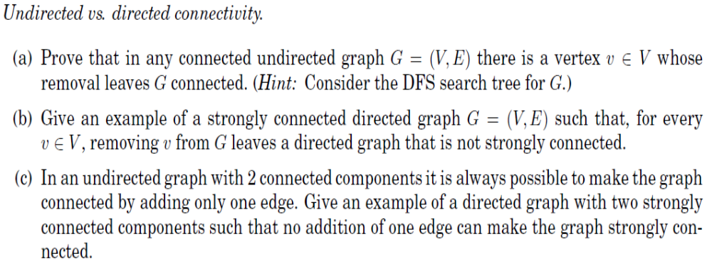
58.
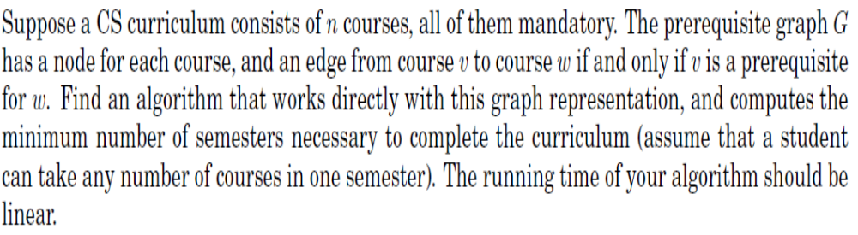

59.
