1. [select](http://localhost/phpmyadmin/url.php?url=https://dev.mysql.com/doc/refman/8.0/en/select.html" \t "mysql_doc) employee.Fname,employee.Lname,employee.Address from employee INNER JOIN department on department.Dnumber=employee.Dno where department.Dname="Research";

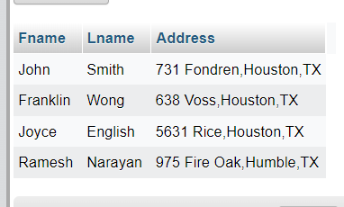

1. [select](http://localhost/phpmyadmin/url.php?url=https://dev.mysql.com/doc/refman/8.0/en/select.html) project.Pnumber,department.Dnumber,employee.Lname,employee.Address,employee.Bdate from employee,department,project where project.Plocation="Stafford" [and](http://localhost/phpmyadmin/url.php?url=https://dev.mysql.com/doc/refman/8.0/en/logical-operators.html%23operator_and) employee.Ssn=department.Mgr\_ssn [and](http://localhost/phpmyadmin/url.php?url=https://dev.mysql.com/doc/refman/8.0/en/logical-operators.html%23operator_and) project.Dnum=department.Dnumber;

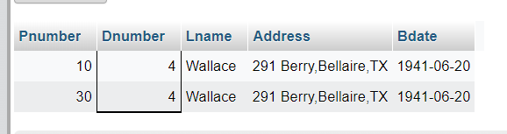

1. [SELECT](http://localhost/phpmyadmin/url.php?url=https://dev.mysql.com/doc/refman/8.0/en/select.html) t.Fname as employee,employee.Lname as supervisor FROM employee INNER join employee as t

ON t.Ssn=employee.Super\_ssn;

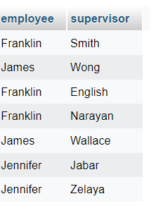

1. [select](http://localhost/phpmyadmin/url.php?url=https://dev.mysql.com/doc/refman/8.0/en/select.html) employee.Fname,employee.Lname,employee.Salary from employee;
2. [select](http://localhost/phpmyadmin/url.php?url=https://dev.mysql.com/doc/refman/8.0/en/select.html) DISTINCT Salary from employee;
3. [SELECT](http://localhost/phpmyadmin/url.php?url=https://dev.mysql.com/doc/refman/8.0/en/select.html" \t "mysql_doc) DISTINCT project.Pnumber FROM project,employee,works\_on WHERE employee.Lname="Smith" [AND](http://localhost/phpmyadmin/url.php?url=https://dev.mysql.com/doc/refman/8.0/en/logical-operators.html%23operator_and) project.Pnumber=works\_on.Pno [and](http://localhost/phpmyadmin/url.php?url=https://dev.mysql.com/doc/refman/8.0/en/logical-operators.html%23operator_and) employee.Ssn=works\_on.Essn;
4. [select](http://localhost/phpmyadmin/url.php?url=https://dev.mysql.com/doc/refman/8.0/en/select.html) Fname,Lname FROM employee where Address [LIKE](http://localhost/phpmyadmin/url.php?url=https://dev.mysql.com/doc/refman/8.0/en/string-comparison-functions.html%23operator_like) "%Houston,TX";
5. [select](http://localhost/phpmyadmin/url.php?url=https://dev.mysql.com/doc/refman/8.0/en/select.html) Fname,Lname FROM employee where Bdate [LIKE](http://localhost/phpmyadmin/url.php?url=https://dev.mysql.com/doc/refman/8.0/en/string-comparison-functions.html%23operator_like) "195%";

9) select Fname,Lname,SUM(10/100\*Salary)

from employee,project

where project.Pname="ProductX";

10) [SELECT](http://localhost/phpmyadmin/url.php?url=https://dev.mysql.com/doc/refman/8.0/en/select.html) Fname,Lname FROM employee WHERE Salary BETWEEN 30000 [AND](http://localhost/phpmyadmin/url.php?url=https://dev.mysql.com/doc/refman/8.0/en/logical-operators.html%23operator_and) 40000;

11) SELECT Lname,Fname,project.Pname FROM employee,works\_on,project,department

WHERE works\_on.Essn=employee.Ssn

AND works\_on.Pno=project.Pnumber

AND project.Dnum=department.Dnumber

ORDER BY department.Dname,employee.Fname,employee.Lname ASC;

12) [SELECT](http://localhost/phpmyadmin/url.php?url=https://dev.mysql.com/doc/refman/8.0/en/select.html) works\_on.Essn FROM works\_on,employee GROUP BY works\_on.Pno,works\_on.Hours HAVING works\_on.Essn=123456789;

13) [SELECT](http://localhost/phpmyadmin/url.php?url=https://dev.mysql.com/doc/refman/8.0/en/select.html) Fname,Lname,Salary from employee where Salary>([SELECT](http://localhost/phpmyadmin/url.php?url=https://dev.mysql.com/doc/refman/8.0/en/select.html)([MAX](http://localhost/phpmyadmin/url.php?url=https://dev.mysql.com/doc/refman/8.0/en/aggregate-functions.html%23function_max)(Salary)) from employee,department where department.Dnumber=5);