Errors and resolved queries

1)

CREATE TABLE EMPLOYEE(

Fname CHAR(200),

Minit CHAR(10),

Lname CHAR(200),

Ssn int PRIMARY KEY,

Bdate DATE,

Address VARCHAR(200),

Sex CHAR(10),

Salary int,

Super_ssn int,

FOREIGN KEY (Super_ssn)

REFERENCES EMPLOYEE(Ssn)

ON UPDATE CASCADE

ON DELETE CASCADE

) ENGINE=INNODB;

2)

[alter](http://localhost/phpmyadmin/url.php?url=https://dev.mysql.com/doc/refman/8.0/en/alter-table.html) [table](http://localhost/phpmyadmin/url.php?url=https://dev.mysql.com/doc/refman/8.0/en/alter-table.html) employee add FOREIGN KEY(Dno) REFERENCES department(Dnumber);

3)

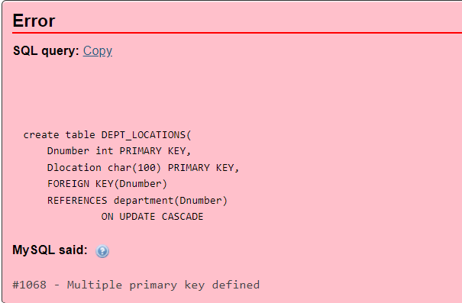

[create](http://localhost/phpmyadmin/url.php?url=https://dev.mysql.com/doc/refman/8.0/en/create-table.html) [table](http://localhost/phpmyadmin/url.php?url=https://dev.mysql.com/doc/refman/8.0/en/create-table.html) DEPT_LOCATIONS( Dnumber int, Dlocation char(100), PRIMARY KEY (Dnumber,Dlocation), FOREIGN KEY(Dnumber) REFERENCES department(Dnumber) ON [UPDATE](http://localhost/phpmyadmin/url.php?url=https://dev.mysql.com/doc/refman/8.0/en/update.html) CASCADE ON [DELETE](http://localhost/phpmyadmin/url.php?url=https://dev.mysql.com/doc/refman/8.0/en/delete.html) CASCADE ) ENGINE=INNODB;

4)

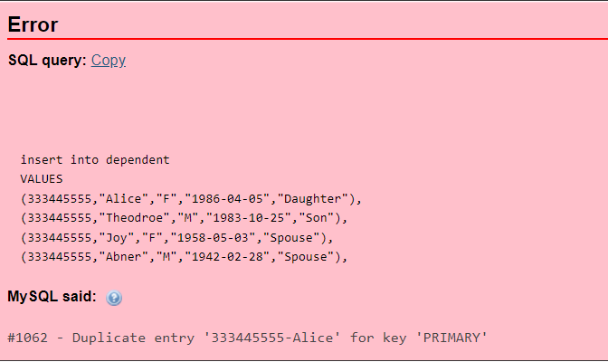

[insert](http://localhost/phpmyadmin/url.php?url=https://dev.mysql.com/doc/refman/8.0/en/insert.html) into dependent [VALUES](http://localhost/phpmyadmin/url.php?url=https://dev.mysql.com/doc/refman/8.0/en/miscellaneous-functions.html%23function_values) (333445555,"Alice","F","1986-04-05","Daughter"), (333445555,"Theodroe","M","1983-10-25","Son"), (333445555,"Joy","F","1958-05-03","Spouse"), (987654321,"Abner","M","1942-02-28","Spouse"), (123456789,"Michael","M","1988-01-04","Son"), (123456789,"Alice","F","1988-12-30","Daughter"), (123456789,"Elizabeth","F","1967-05-05","Spouse");

