CS587 — Individual Research Project
Data Analysis Report
Relational Reasoning in Vision-Language Models Across a Compute Spectrum:
A Preliminary Evaluation of Scale-Dependent Degradation
Tabeen Raoof [CONFIRM: student ID] [CONFIRM: date]
M.S. Computer Science (AI/ML) — San Francisco Bay University

1. Introduction and Research Question
Vision-language models (VLMs) are increasingly deployed as the perception layer of robotic and embodied systems, where a model must reason about the relationships between objects in a scene, not merely recognize the objects themselves. Deployment on such systems, however, pushes toward smaller and more heavily quantized models that fit on power- and memory-constrained edge hardware. This study measures how reliably relational reasoning survives reductions in model scale.
Research question. Across a spectrum of model compute, which classes of visual relational reasoning degrade, and do they degrade uniformly or differentially? This report presents a preliminary analysis across three model scales; on-device evaluation on quantized edge hardware (NVIDIA Jetson Orin Nano) is in progress and will be incorporated into the final paper.
Hypotheses. H1: degradation is non-uniform across relation types. H2 (deferred to on-device work): precision reduction affects smaller models disproportionately. This report primarily addresses H1 along the model-scale axis.

2. Data and Preparation

2.1 Data source and evaluation set
Evaluation items were drawn from the Visual Spatial Reasoning (VSR) dataset (Liu, Emerson & Collier, TACL 2023), a benchmark of true/false judgments about spatial relations in real images (licensed CC-BY-4.0). This is secondary data — curated, not collected firsthand. Items were filtered into two relation categories and sampled into a balanced evaluation set.
Design element | Specification
Categories | Projective spatial (e.g. left of, above, behind); topological containment (e.g. inside, contains, at the edge of)
Sample size | 300 items — 150 per category, balanced 75 True / 75 False within each
Sampling | Deterministic hash-ranked, label-stratified, fixed seed (reproducible; nesting-safe)
Item identity | Content-derived SHA-256 hash, enabling item-level pairing across model runs
Excluded | Proximity relations (near, next to) and ambiguous contact relations, as out of scope

2.2 Models evaluated
Three models spanning a compute spectrum, all evaluated on the identical 300-item set:
- Qwen2.5-VL-3B — small open model, run locally (Ollama), representing the edge-deployable tier.
- Qwen2.5-VL-7B — larger open model of the same architecture family, run locally. Same-family scaling isolates the effect of size.
- Gemini 2.5 Flash — frontier API model, serving as the least-constrained ceiling reference.

2.3 Procedure
Each item presented the image and its caption; the model judged the caption True or False via a fixed single-word prompt (identical across all three models, so the only variable is the model). Responses were parsed to yes/no and scored against ground truth. The pipeline recorded, per item: raw response, parsed label, correctness, and latency. Runs were crash-safe and resumable.

2.4 Data Preparation and Quality Control
Two data-integrity bugs were identified and fixed before analysis. First, item identifiers were originally positional, which would have silently mis-paired items across model runs; they were made content-derived (hash-based) so identical items align across runs. Second, a resume routine skipped previously-errored items on rerun, which would have shrunk the effective sample; it was corrected to retry them. A label-balance and taxonomy-coverage check confirmed all relations were accounted for.
Output quality was high across all three runs:
Model | Items | Errors | Unparseable | Unique IDs
Gemini 2.5 Flash | 300 | 0 | 0 | 300
Qwen2.5-VL-7B | 300 | 0 | 0 | 300
Qwen2.5-VL-3B | 300 | 0 | 0 | 300
All three runs completed with zero errors and zero unparseable responses; item identifiers were verified identical across models, enabling paired analysis.

3. Analysis Methods
Quantitative, with the following tests:
- Two-proportion z-tests as an unpaired cross-check on overall model accuracy differences.
- McNemar's paired test for model comparisons on identical items (higher power; controls for item difficulty).
- Fisher's exact test for the association between model errors and human-contested items (exact, appropriate at small cell counts).
- Spearman rank correlation of per-relation accuracy across models, to test whether the difficulty ranking is shared (rank-based; on relations with at least 5 evaluation items).
- Signal detection (hit rate vs. false-alarm rate) to separate genuine discrimination from response bias.

4. Results

4.1 Overall accuracy
Aggregate accuracy was 81.7% (Gemini), 82.3% (7B), and 76.7% (3B). Notably, the frontier model and the 7B open model were statistically indistinguishable (0.7pp, p = 0.8317): scaling from 7B to a frontier model bought no measurable aggregate accuracy on this task. The 3B model was lower, but the unpaired difference from 7B did not reach significance (p = 0.0848).
Model | Overall | Projective | Containment
Gemini 2.5 Flash | 81.7% | 77.3% | 86%
Qwen2.5-VL-7B | 82.3% | 82% | 82.7%
Qwen2.5-VL-3B | 76.7% | 70.7% | 82.7%
Table 3. Accuracy overall and by relation category. The containment column is flat across all three scales; the projective column is not.

4.2 The key finding: degradation is concentrated in one category
The aggregate hides the important result. A paired McNemar test confirms the 3B model is genuinely worse than the 7B model (5.7pp, 95% CI [1.4, 9.9], p = 0.01372). But that deficit is not spread evenly. Reducing scale from 7B to 3B produced a significant 11.3pp drop in projective-spatial accuracy (82% → 70.7%, paired McNemar p = 0.003) and essentially no change in topological containment (82.7% → 82.7%, McNemar p = 0.79).
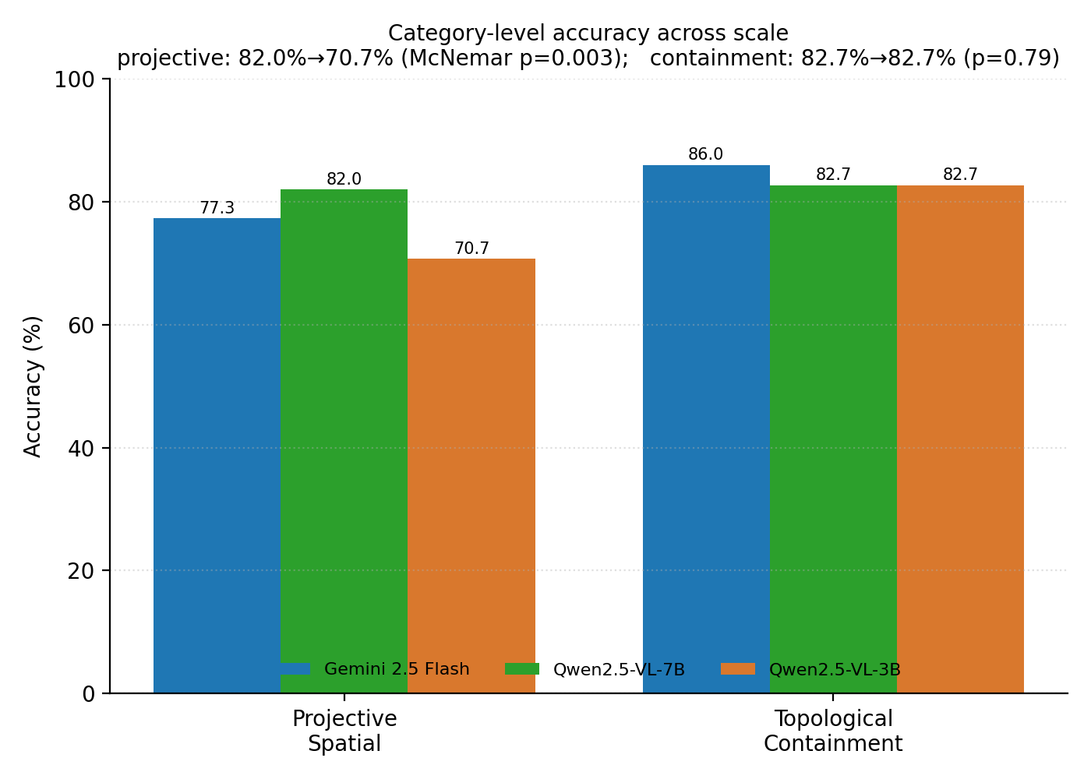
Figure 1. Category-level accuracy across three model scales. All degradation from 7B to 3B is concentrated in projective-spatial relations; containment is unaffected.

4.3 Relation difficulty is substantially shared across scale
Because per-relation accuracy is noisy when a relation has few items, the difficulty ranking is compared with Spearman rank correlation over the 20 relations that have at least 5 evaluation items. Which relations are hard is strongly and similarly shared across all three models (Gemini–7B ρ = 0.71; Gemini–3B ρ = 0.65; 7B–3B ρ = 0.65; all p < 0.01), and the association stays significant when the threshold is relaxed to ≥3 items (ρ = 0.45–0.56, all p < 0.03). Which specific relations are hard is therefore substantially a property of the task rather than of any one model. This is reported with a rank-based statistic deliberately: a Pearson correlation on the same data is sensitive to the item-count threshold (it is weak and non-significant if every low-count relation is pooled in), so the rank measure is the more robust summary.
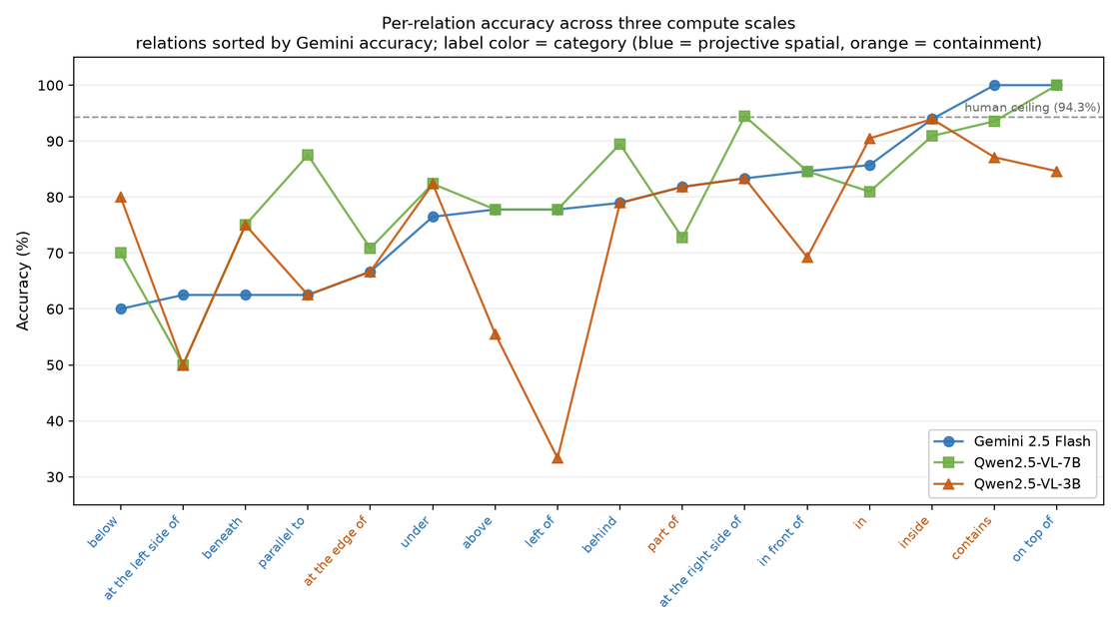
Figure 2. Per-relation accuracy across three scales, sorted by Gemini accuracy. Label color indicates category. Most relations track together; several projective relations (e.g. “left of”, “above”) break sharply downward only at 3B.

4.4 Errors concentrate on human-contested items
VSR ships validator votes; 52 of 300 items (17.3%) had at least one validator disagree with the gold label, implying a human ceiling of 94.3% rather than 100%. Model errors concentrate on exactly these contested items. For the 3B model the effect is strong (80.6% accuracy on unanimous items vs. 57.7% on contested; 2.19× error rate, Fisher p < 0.001); for Gemini it is present but weaker (1.79×, p = 0.0468); for the 7B model it is not significant (1.25×, p = 0.5481). Crucially, on the 248 items where all human validators agreed, all three models still leave roughly 16–19 points on the table — so the accuracy plateau reflects genuine capability failure, not annotation noise.

4.5 The response bias is a prompt-framing artifact, not a capability gap
All three models answered False more readily than True: true-recall was 64.7% (3B), 72.7% (7B) and 70.0% (Gemini), against false-specificity of 88.7%, 92.0% and 93.3% respectively (signal-detection criterion c between 0.39 and 0.48, all positive). Because the evaluation set is balanced 50/50, this conservative criterion lowers accuracy without reflecting a discrimination failure. Sensitivity (d′) confirms this: it is high for every model, and the 3B model’s projective deficit appears as a genuine drop in sensitivity on that category (d′ = 1.18 versus 1.99 for the 7B), not merely a shift in response criterion — so the category effect is perceptual, not a bias artifact.
A direct control confirms the bias is driven by question wording. Re-running Gemini on 100 items with the question polarity reversed (asking whether the caption is false) raised true-recall from 72% to 84% (McNemar p = 0.031) and equalised recall and specificity, with no change in overall accuracy (p = 1.0). The response bias is therefore a property of the yes/no framing rather than of any one model; it is reported here but not corrected in the accuracy figures. This control was run on Gemini only, so its generalisation to the Qwen tiers is assumed rather than demonstrated.

5. Interpretation

5.1 Revised H1: non-uniform, and inverted from the prediction
H1 predicted non-uniform degradation across categories, with containment expected to be the more fragile category. The data support the non-uniformity but reverse the direction: topological containment is compute-robust (no measurable degradation from 7B to 3B), while projective-spatial reasoning is compute-sensitive (an 11.3pp drop). A plausible account is that containment may be solvable from local, low-level visual cues (enclosure and boundary detection) that survive at reduced scale, whereas projective relations (left/right, above/below) depend on viewpoint-relative reasoning that is more capacity-sensitive. We treat this as a refinement of H1, not a refutation: the central claim — that relational reasoning degrades non-uniformly across category — holds; the predicted direction was wrong.

5.2 Scale saturates at the aggregate but not at the relation level
That the 7B and frontier models are indistinguishable in aggregate, yet a specific subset of relations still fails at every scale, indicates the remaining errors are structural rather than capacity-limited. More parameters do not fix which relations are hard; they only shift the overall level modestly. This is itself an argument for relation-stratified evaluation: an aggregate accuracy number would have hidden both the category-specific degradation and the shared difficulty structure.

5.3 Limitations
- Two scales, one architecture. The open-model tiers are one family (Qwen2.5-VL); cross-architecture generalization is untested here.
- Per-relation cell sizes. Individual relations have as few as 8–10 items; single-relation figures are indicative, not conclusive. Category-level results (n=150/category) carry the statistical weight.
- Response format. A binary true/false protocol was used; all three models showed a mild bias toward answering “No” (e.g. true-recall ~65–73% vs. false-specificity ~89–93%), which Section 4.5 shows is largely a prompt-framing artifact (diagnosed with a polarity-reversed control), reported but not corrected for in the headline accuracy.
- Edge hardware not yet included. The on-device, quantized tier (Jetson Orin Nano) central to the study’s deployment framing is in progress; H2 (precision sensitivity) is deferred to the final paper.

5.4 Next steps
The immediate next step is on-device evaluation of the 3B model quantized to INT4/INT8 on the Jetson Orin Nano, to test whether quantization independently widens the projective-spatial gap identified here or introduces new failure modes (H2). A second open-model family would test architectural generality of the containment-robust / projective-fragile pattern.

Appendix A. Statistical Detail

A.1 Paired model comparisons (McNemar)
Comparison | Discordant | Diff (pp) | 95% CI | p-value
Gemini vs 7B | 48 | -0.7 | [-5.2, 3.9] | 0.88543
7B vs 3B | 43 | 5.7 | [1.4, 9.9] | 0.01372

A.2 Response latency (seconds per item)
Model | Median | Mean | Trimmed mean | Outliers (>10s)
Gemini 2.5 Flash | 1.15 | 4.21 | 1.3 | 14
Qwen2.5-VL-7B | 3.35 | 5.07 | 3.34 | 1
Qwen2.5-VL-3B | 2.34 | 2.3 | 2.3 | 0
Medians reported as primary; means are inflated by timeout-retry outliers (e.g. Gemini had 14 items exceeding 10s). Latency is a full-system measure, not a clean compute metric, since two runs used different local/remote infrastructure.

A.3 Reproducibility
Evaluation set: VSR (CC-BY-4.0), 300 items, seed 42, deterministic hash-ranked sampling. Models: qwen2.5vl:3b, qwen2.5vl:7b (Ollama), gemini-2.5-flash (API). Identical prompt across models; temperature 0. All raw per-item outputs retained in result CSVs.

