PROJECT REPORT ON

***“Library Management System Using Tkinter”***

Submitted By:

Abhishek Kumar Thakur, UID- 24MCA20326

**Under The Guidance of:**

Mrs. Deepali Saini

**OCTOBER, 2024**



**University Institute of Computing**

**Chandigarh University, Mohali, Punjab**

**CERTIFICATE**

This is to certify that Abhishek Kumar Thakur (UID- 24MCA20326) have successfully completed the project title “***Library Management System Using Tkinter***” at University Institute of Computing under my supervision and guidance in the fulfilment of requirements of first semester, Master of Computer Application Of Chandigarh University, Mohali, Punjab.

Dr. Abdullah Mrs. Deepali Saini

Head of the Department Project Guide Supervisor University Institute of Computing University Institute of Computing

**ACKNOWLEDGEMENT**

We deem it a pleasure to acknowledge our sense of gratitude to our project guide Mrs. Deepali Saini under whom we have carried out the project work. Her incisive and objective guidance and timely advice encouraged us with constant flow of energy to continue the work.

We wish to reciprocate in full measure the kindness shown by Dr. Abdullah (H.O.D, University Institute of Computing) who inspired us with his valuable suggestions in successfully completing the project work.

We shall remain grateful to Dr. Manisha Malhotra, Additional Director, University Institute of Technology, for providing us a strong academic atmosphere by enforcing strict discipline to do the project work with utmost concentration and dedication.

Finally, we must say that no height is ever achieved without some sacrifices made at some end and it is here where we owe our special debt to our parents and our friends for showing their generous love and care throughout the entire period of time.

Date: 24.10.2024

Place: Chandigarh University, Mohali, Punjab

Abhishek Kumar Thakur, UID- 24MCA20326

**ABSTRACT**

The Library Management System (LMS) developed using Python's Tkinter module presents a user-friendly and efficient solution for managing a library’s essential functions, including book cataloging, member information management, and transaction tracking. The primary aim of this project is to automate traditional library operations, ensuring streamlined workflows, reducing human errors, and improving overall accessibility for librarians and users.

Tkinter, as Python’s standard GUI toolkit, provides an intuitive and visually accessible interface for the LMS, with various widgets that facilitate interaction with the system. The application supports core features such as book inventory management, member registration, and tracking of borrowing and returning activities. It includes search and filter functionalities, allowing users to locate resources quickly, and an authentication system to restrict access, ensuring data security.

The LMS integrates with a database (e.g., SQLite) to store and manage data persistently, making information retrieval efficient and organized. This system is ideal for small- to medium-sized libraries seeking to modernize their processes with a reliable and interactive platform. By enhancing operational efficiency and accuracy, the Library Management System using Tkinter meets the demands of modern libraries and serves as a cost-effective, accessible solution for library management.

TABLE OF CONTENTS

INTRODUCTION 6

TECHNOLOGIES USED 6

Python Tkinter 6

MySQL database………………………………………………………………………………..6

DATABASE REQUIREMENT 6

RESULTS/ SNAPSHOT 7

REFERENCES 9

# INTRODUCTION

A **Library Management System (LMS)** is a software application designed to manage the operational tasks of a library efficiently. Traditional library systems often involve manual record-keeping, which can be prone to errors, time-consuming, and challenging to manage, especially as the library grows.

The primary goal of an LMS is to automate and centralize library processes, making it easier for librarians and users to manage books and memberships efficiently. Using Tkinter for this system enables an intuitive, visually accessible interface, facilitating ease of use even for individuals with minimal technical expertise.

# TECHNOLOGIES USED

## Python Tkinter

Tkinter is the most commonly used library for developing GUI (Graphical User Interface) in Python. It is a standard Python interface to the Tk GUI toolkit shipped with Python. As Tk and Tkinter are available on most of the Unix platforms as well as on the Windows system, developing GUI applications with Tkinter becomes the fastest and easiest.

## MySQL database

XAMPP is a small and light Apache distribution containing the most common web development technologies in a single package. Its contents, small size, and portability make it the ideal tool for students developing and testing applications in Python and MySQL. XAMPP is available as a free download in two specific packages: full and lite. While the full package download provides a wide array of development tools, XAMPP Lite contains the necessary technologies that meet the Ontario Skills Competition standards. The light version is a small package containing Apache HTTP Server, PHP, MySQL, phpMyAdmin, Openssl, and SQLite.

# DATABASE REQUIREMENT

**Table Structure**

|  |  |
| --- | --- |
| **Fields** | **Datatypes** |
| Id | INTEGER |
| TITEL | TEXT |
| AUTHOR | TEXT |
| YEAR PUBLISHED | INTEGER |

# RESULTS/ SNAPSHOT

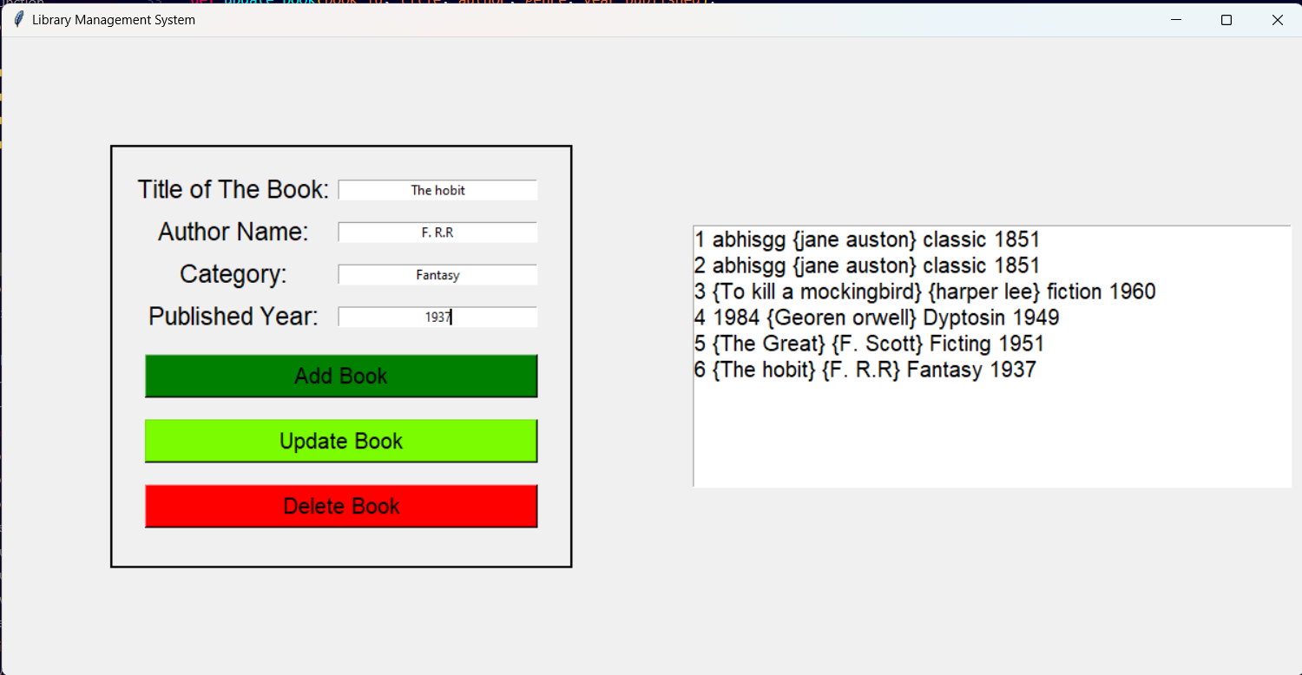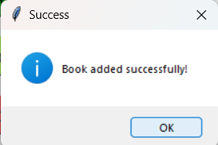

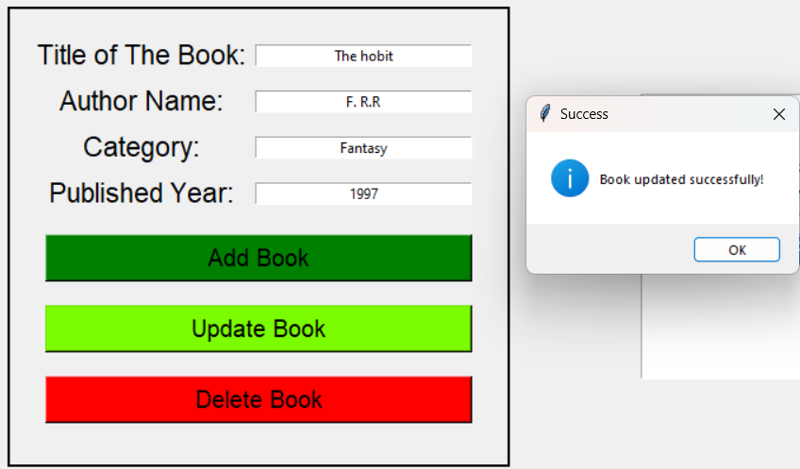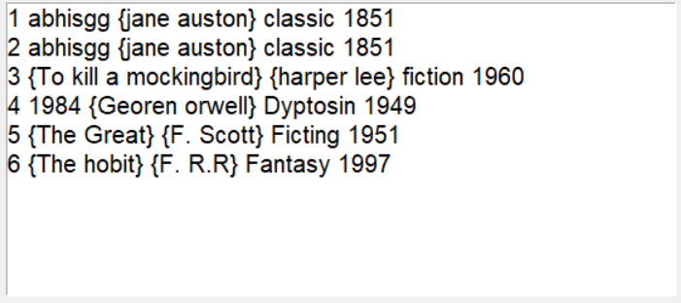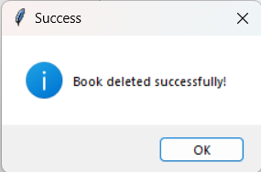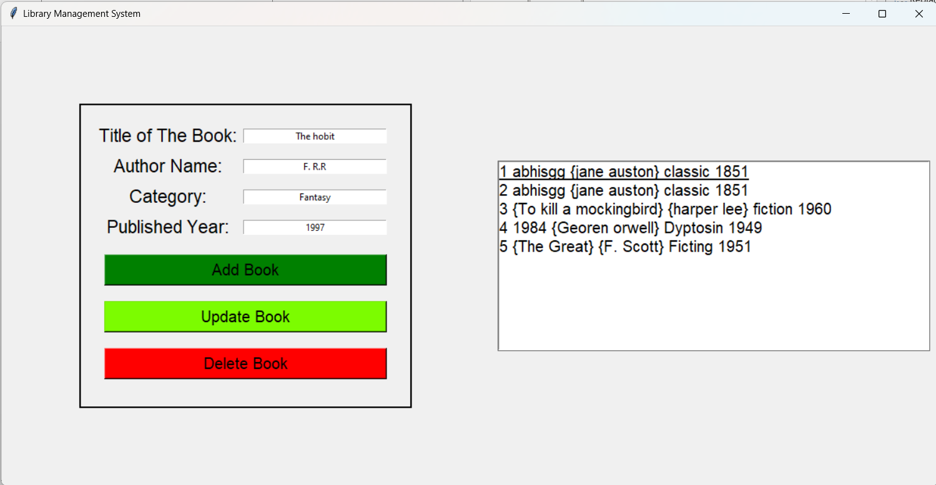

# REFERENCES

* <https://docs.python.org/3/library/tk.html>
* [https://www.geeksforgeeks.org/](https://www.geeksforgeeks.org/conditional-statements-shell-script/)