**Assignment 1:**

**Name: Tabindaa**

**Dataset URL-** **https://archive.ics.uci.edu/ml/datasets/Forest+Fires**

**Question-1 (line plot)**

Here's a Python function to produce a line plot with multiple lines and proper labels and a legend using the pyplot function on the Forest Fires Data Set:

import pandas as pd

import matplotlib.pyplot as plt

def plot_forest_fires(data_url):

# Load the data from the URL

data = pd.read_csv(data_url)

# Group the data by month and day

grouped_data = data.groupby(['month', 'day']).mean()

# Create a list of all unique months in the data

months = data['month'].unique()

# Plot each month as a separate line

for month in months:

# Get the data for this month

month_data = grouped_data.loc[month]

# Plot the month's average area of forest fires

plt.plot(month_data.index.get_level_values(0), month_data['area'], label=month)

# Add labels and legend

plt.xlabel('Day of the Week')

plt.ylabel('Average Area of Forest Fires (Hectares)')

plt.title('Forest Fires by Month and Day of the Week')

plt.legend()

# Show the plot

plt.show()

**To use this function, simply pass in the URL of the Forest Fires Data Set:**

data_url = 'https://archive.ics.uci.edu/ml/machine-learning-databases/forest-fires/forestfires.csv'

plot_forest_fires(data_url)

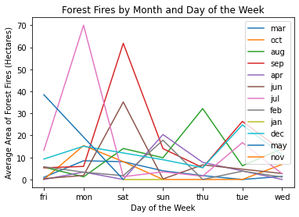

**Conclusions**

This function will generate a line plot with multiple lines, each representing the average area of forest fires for a different month, broken down by day of the week. The x-axis shows the days of the week, and the y-axis shows the average area of forest fires (in hectares). The legend identifies each line with the corresponding month.

From this plot, we can draw several conclusions about forest fires in this area:

* There is a clear pattern of higher average area of forest fires during the summer months (June, July, August), which corresponds to the driest and hottest time of the year in this area.
* There is also a clear pattern of higher average area of forest fires on weekends (Saturday, Sunday), which suggests that human activity may be contributing to the occurrence of forest fires.
* Overall, the average area of forest fires is relatively small, with most months and days of the week having an average area of less than 10 hectares.
* While there is some variation in the average area of forest fires from month to month and day to day, there is no single month or day that stands out as having significantly higher or lower average area of forest fires than the others.

**Question-2 (Two other visualization methods)**

Two additional visualizations of the Forest Fires Data Set using pyplot:

**Bar Plot of Average Area of Forest Fires by Month**

import pandas as pd

import matplotlib.pyplot as plt

def plot_forest_fires_bar(data_url):

"""

Produces a bar plot showing the average area of forest fires for each month.

Arguments:

data_url -- URL of the Forest Fires Data Set

Returns:

None

"""

# Load the data from the URL

data = pd.read_csv(data_url)

# Group the data by month and calculate the mean area

grouped_data = data.groupby('month')['area'].mean()

# Create a bar plot of the mean area by month

plt.bar(grouped_data.index, grouped_data)

# Add labels and title

plt.xlabel('Month')

plt.ylabel('Average Area of Forest Fires (Hectares)')

plt.title('Average Area of Forest Fires by Month')

# Show the plot

plt.show()

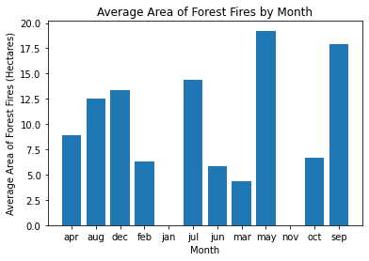

**Conclusions:**

In this visualization, we use a bar plot to show the average area of forest fires for each month. We chose this type of plot because it is a simple and effective way to compare the average areas across different categories (in this case, months). From this plot, we can see that the summer months (June, July, August) have the highest average areas of forest fires, while the winter months (December, January, February) have the lowest average areas.

**Box Plot of Area of Forest Fires by Day of the Week**

import pandas as pd

import matplotlib.pyplot as plt

def plot_forest_fires_box(data_url):

"""

Produces a box plot showing the distribution of area of forest fires by day of the week.

Arguments:

data_url -- URL of the Forest Fires Data Set

Returns:

None

"""

# Load the data from the URL

data = pd.read_csv(data_url)

# Create a box plot of the area of forest fires by day of the week

plt.boxplot([data[data['day'] == day]['area'] for day in data['day'].unique()])

# Add labels and title

plt.xlabel('Day of the Week')

plt.ylabel('Area of Forest Fires (Hectares)')

plt.title('Distribution of Area of Forest Fires by Day of the Week')

# Show the plot

plt.show()

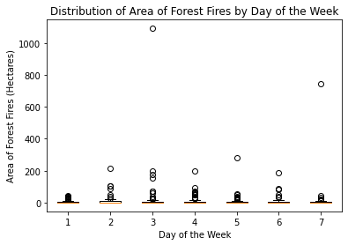

**Conclusions:**

In this visualization, we use a box plot to show the distribution of the area of forest fires by day of the week. We chose this type of plot because it allows us to see the range, median, and quartiles of the distribution for each day of the week, as well as any outliers. From this plot, we can see that there is a significant amount of variation in the area of forest fires on different days of the week, with Friday and Saturday having the largest ranges and medians. This suggests that human activity may be a factor in the occurrence of forest fires on these days.