

BSc (Hons) Computer Science
Department of Informatics
University of Sussex
PDA Visualiser
An Interactive Pushdown Automata Simulator
Final Year Project

Project Supervisor: Dr Niel de Beaudrap
Candidate Number: 297715
Degree Programme: BSc (Hons) Computer Science
Submission Date: 1st May 2026
Academic Year: 2025–26
This dissertation is submitted in partial fulfilment of the requirements
for the award of BSc (Hons) Computer Science.

Statement of Originality

This report is submitted as part requirement for the degree of BSc (Hons) Computer Science at the University of Sussex. It is the product of my own labour except where indicated in the text. The report may be freely copied and distributed provided the source is acknowledged.
I hereby give permission for a copy of this report to be loaned out to students in future years.

Acknowledgements

I would like to thank my project supervisor for the time and feedback given throughout the project. The supervisor feedback I received was very helpful: it picked up on a couple of issues with the example PDAs that I had not spotted, and the discussion around my website draft helped me see more clearly which parts of the design still needed work before the final submission.
I would also like to thank my family for their patience and encouragement during the long stretches of late-night coding sessions in the run-up to submission. Without that support behind the scenes the project would have been a much harder one to push through to completion.
Finally, I would like to thank the University of Sussex Department of Informatics for providing a strong theoretical grounding in formal language theory and software engineering, both of which underpin the technical work presented here.

Abstract

Pushdown Automata (PDAs) are one of the core models of computation in undergraduate Computer Science. They form the theoretical basis for context-free grammars and the parsing techniques used in compilers and programming language design. Even though they are important, students often find PDAs hard to reason about because their behaviour involves three things changing at the same time — the current state, the remaining input, and the stack — and none of these is easy to keep track of by hand.
This report describes the design, implementation, and evaluation of the PDA Visualiser: an interactive web-based simulator built with Next.js 16, React 19, TypeScript, Tailwind CSS, and the HTML5 Canvas API. The application allows users to load three pre-built PDA examples (balanced parentheses, the aⁿbⁿ language, and the wcwᴿ palindrome language), define custom PDA configurations through an editable interface, and run step-by-step or continuous simulations that animate the state diagram, the stack contents, and the input tape in real time. A natural-language quick-builder feature maps common textual descriptions of context-free languages to corresponding pre-built PDA configurations.
The application was deployed publicly on Vercel and evaluated through a self-evaluation process carried out against a set of functional and non-functional requirements drawn from an initial needs analysis. All must-have and should-have requirements were met. During the self-evaluation a number of bugs were found in the running website — most notably one of the pre-built examples that was not accepting valid input strings — and these were tracked down and fixed before final submission. The animated stack panel, the colour-coded state highlighting, and the plain-English step log were the features that felt most useful when hand-tracing examples through the website. The report concludes with a discussion of the main limitations of the current system — chiefly the lack of full non-deterministic simulation — and lists a number of directions for future work that would extend the teaching value of the tool.

Table of Contents

To update the page numbers in this Table of Contents, right-click anywhere within the table and choose 'Update Field' (or press Ctrl+A then F9 to refresh all fields throughout the document).

List of Figures

Figure 1: PDA Visualiser — Three-Layer Architecture (Section 5.1)
Figure 2: PDA Simulation Step Algorithm (Section 5.3)
Figure 3: Annotated User Interface Layout (Section 5.5)
Figure 4: aⁿbⁿ Language PDA — State Diagram (Section 6.2)
Figure 5: React Component Tree and Module Dependencies (Section 6.1)
Figure 6: Live Deployment — Default Dark Theme with Balanced Parentheses Loaded (Section 7.3)
Figure 7: Live Deployment — Stack & Input Tape Initial State (Section 7.3)
Figure 8: Live Deployment — Mid-Simulation with Stack Growth (Section 7.3)
Figure 9: Live Deployment — REJECTED Result with Red Banner and Highlighted q0 (Section 7.3)
Figure 10: Live Deployment — ACCEPTED Result with Complete Step Trace (Section 7.3)

List of Tables

Table 3.1: Technology Stack and Justification (Section 3.3)
Table 4.1: Functional Requirements (MoSCoW Prioritisation) (Section 4.2)
Table 4.2: Non-Functional Requirements (Section 4.3)
Table 6.1: Key Source Files in the Project (Section 6.1)
Table 6.2: Balanced Parentheses Transition Table (Section 6.2)
Table 6.3: aⁿbⁿ Language Transition Table (Section 6.2)
Table 6.4: wcwᴿ Palindrome Transition Table (Section 6.2)
Table 6.5: Keyboard Shortcuts (Section 6.5)
Table 7.1: Functional Requirements Evaluation Summary (Section 7.1)
Table 7.2: aⁿbⁿ Test Cases — Correctness Results (Section 7.2)

1 Introduction

1.1 Background and Motivation
Pushdown Automata are one of the most important abstract machine models in theoretical computer science. They extend the finite automaton model with the addition of an unbounded stack, and in doing so acquire the ability to recognise the class of context-free languages — a strictly larger class than the regular languages [3]. Context-free languages include the languages of arithmetic expressions, nested bracket structures, and the syntactic structure of most modern programming languages [4]. This makes PDAs directly relevant to topics that students encounter in compiler design, programming language theory, and software engineering modules across an undergraduate Computer Science degree.
In practice, students studying formal language theory at undergraduate level often say that PDAs are one of the harder topics to build a confident, gut-level understanding of [5]. The difficulty is not in the formal definition itself, which is short and well covered in the standard textbooks. The hard part is during simulation: to trace the behaviour of a PDA on a given input string by hand, you have to keep track of the current state, the symbols being read off the input tape, and the stack — three things changing at once, which is a lot to hold in your head at the same time. A trace that goes wrong at step four of a ten-step computation is hard to debug without a reliable way of replaying each step.
Existing simulation tools such as JFLAP [1] are well established in automata theory teaching. JFLAP is a desktop Java application, though, and so needs a local Java runtime to be installed first. Its user interface, while very full-featured, also has its own learning curve which can pull attention away from the actual theory, especially for students seeing PDA simulation for the first time. There was therefore a clear teaching motivation to build a new, lightweight, web-based tool that is built specifically around clarity of simulation and ease of first use, with a modern visual design that students would find approachable.
This project was developed as part of the University of Sussex BSc (Hons) Computer Science Final Year Project module within the Department of Informatics.

1.2 Project Overview
The PDA Visualiser is a single-page web application that provides end-to-end PDA simulation in the browser, with no installation needed. The full application has been deployed publicly on the Vercel platform and is reachable at the URL https://pda-visualizer-v2-main.vercel.app, which is where the live deployment of the website can be opened. The main features of the system are as follows:
- An HTML5 Canvas-based state diagram that renders the PDA's states and transitions as a graph, with the current/active state highlighted by a coloured glow effect during simulation.
- A real-time stack visualisation panel that shows each symbol on the stack as a labelled cell, with the top of the stack highlighted in the accent colour and the Z₀ bottom marker highlighted in cyan to provide a clear visual cue.
- An input tape panel that renders each character of the input string as a separate tile, with the current read-head position highlighted and consumed characters faded so that progress through the input is easy to follow.
- A step log panel that records a plain-English description of every transition fired, in the format "#N state → Read: x → Pop: y → Push: z → nextState".
- Three pre-loaded example PDAs covering the canonical context-free languages of balanced parentheses, the aⁿbⁿ language, and the wcwᴿ palindrome language.
- A manual configuration interface that allows users to define the seven components of an arbitrary PDA: states, input alphabet, stack alphabet, transition function, initial state, initial stack symbol, and accept states.
- A natural-language quick-builder feature that maps common English descriptions of context-free languages to the corresponding pre-built PDA configuration.
- A configurable simulation speed slider, supporting delays from 100 ms (very fast) to 2000 ms (very slow) per step.
- Light and dark theme support, implemented using CSS custom properties (variables) and toggled via a button in the application header.
- Keyboard shortcuts for simulation control — Space to step, R to reset, P to play or pause.

1.3 Aims and Objectives
The principal aim of this project was to produce a functional and visually engaging web application for simulating Pushdown Automata that could serve as an educational aid for undergraduate Computer Science students. The specific objectives derived from this aim were as follows:
- To implement a correct PDA simulation engine capable of processing input strings against user-defined transition functions, handling both symbol-consuming and ε-transitions correctly.
- To produce a clear, animated visual representation of PDA state, stack contents, and input tape position during simulation.
- To support manual configuration of arbitrary PDAs through an editable user interface.
- To provide a small set of pre-loaded example PDAs illustrating different and contrasting classes of context-free language.
- To design a responsive, accessible user interface that works well on both desktop and mobile devices.
- To deploy the application publicly so that it is accessible to the target user group without any installation overhead.
- To evaluate the application against the agreed functional requirements through a structured self-evaluation, and to find and fix any bugs uncovered during that process before final submission.

1.4 Scope and Limitations
The scope of the project was deliberately bounded to deterministic-mode PDA simulation. Full non-deterministic PDA simulation, in which multiple computation paths may be explored in parallel, was identified as a desirable extension but was excluded from the core requirements due to the additional implementation complexity it would introduce, particularly with regard to visualising the resulting computation tree. Likewise, the project does not currently support context-free grammar (CFG) editing, nor automatic conversion between PDAs and CFGs; both of these are noted in Chapter 8 as directions for future work.
The application supports keyboard and screen-reader navigation only to the extent that standard React UI components do; no formal accessibility audit (WCAG 2.1 conformance, for example) was undertaken within the scope of this project. The natural-language quick-builder feature relies on a small fixed vocabulary of pattern-matched phrases rather than a true natural-language understanding model; this limitation is discussed at greater length in the evaluation chapter.

2 Professional Considerations

2.1 BCS Code of Conduct
As a student producing software that is publicly accessible on the Internet and intended for use by other students, it is appropriate to consider the professional and ethical framework that governs this kind of work. Having read through the British Computer Society (BCS) Code of Conduct [2], I am satisfied that this project adheres to its core requirements.
The application is purely an educational tool with no commercial intent and no requirement for users to provide personal data. It runs entirely client-side in the user's browser: no data is transmitted to any server, no analytics are collected, and no user accounts are required. This is consistent with Section 1 of the BCS Code (Public Interest), which requires IT professionals to have due regard for public wellbeing and to avoid the misuse of personal data.
Section 2 of the Code (Professional Competence and Integrity) is addressed by completing this project to the best of my present ability, by acknowledging all third-party libraries and frameworks in the references section, and by being transparent about the limitations of the system rather than overstating its capabilities. Section 3 (Duty to Relevant Authority) is satisfied by submitting this work through the University's formal assessment process and by complying with the academic integrity requirements set out in the Sussex student handbook.
Section 4 (Duty to the Profession) is addressed by making the source code available for inspection by examiners and, in due course, for re-use by future students and educators. This is consistent with the broader principles of openness and public benefit that underpin the academic computing community.

2.2 Ethical Considerations
This project was evaluated entirely by the author and did not involve any external testers, surveys, or questionnaires of any kind. The whole evaluation was carried out as a self-testing exercise against the original functional and non-functional requirements, supported by manual correctness testing of the simulation engine on the three pre-built examples and on a number of custom-built PDAs. No personal data was collected at any point during the project, and the deployed website does not store any user information of any kind.
The open-source nature of the project — the code is submitted as part of the assessment and the deployed application is freely accessible at its public URL — is consistent with the principle of openness and public benefit. None of the libraries or frameworks used in this project carry licences that would restrict this use.

2.3 Software Engineering Practices
The project was developed iteratively rather than following a rigid waterfall model. Features were implemented and tested incrementally as development progressed, with each small unit of functionality verified manually in the running application before further changes were layered on top. Version control was maintained throughout the project using Git, with the main development branch tracking incremental improvements from an initial prototype to the final submitted version.
TypeScript was used throughout the project in preference to plain JavaScript. This choice was deliberate: TypeScript's static type system enforces consistency between data structures at compile time, which reduces a class of runtime errors that would otherwise only surface during simulation. The TypeScript interfaces defined in the dedicated types module — specifically the Transition, PDAConfig, StepResult, and SimulationStep interfaces — serve as a single source of truth for the data model across all parts of the application. Tailwind CSS was used for styling, with a set of custom design tokens defined as CSS custom properties; this enabled consistent visual design across the application and straightforward theme switching between dark and light modes.

3 Background and Related Work

3.1 Pushdown Automata — Theoretical Background
A Pushdown Automaton is formally defined as a 7-tuple (Q, Σ, Γ, δ, q₀, Z₀, F), where Q is a finite set of states, Σ is the input alphabet, Γ is the stack alphabet, δ : Q × (Σ ∪ {ε}) × Γ → 2^(Q × Γ*) is the transition function, q₀ ∈ Q is the initial state, Z₀ ∈ Γ is the initial stack symbol, and F ⊆ Q is the set of accepting states [3]. The transition function δ may be non-deterministic in general — that is, multiple transitions may be applicable to the same configuration — but the PDA Visualiser developed in this project is restricted to deterministic mode, which is sufficient for the canonical examples implemented and is significantly easier to visualise.
A configuration of a PDA is the triple (q, w, γ) where q is the current state, w is the remaining input string, and γ is the current stack contents (with the top of the stack on the left, by convention). A single computation step, written as (q, aw, Xγ) ⊢ (p, w, βγ), occurs when δ(q, a, X) contains the pair (p, β); meaning that the PDA moves from state q to state p, reads symbol a from the input (consuming it), pops X from the top of the stack, and pushes the string β onto the stack in its place [3].
A string w is said to be accepted by final state if there exists a sequence of computation steps from the initial configuration (q₀, w, Z₀) to some final configuration (q_f, ε, γ) where q_f ∈ F — that is, the input has been fully consumed and the machine has reached an accepting state. Acceptance by empty stack is an alternative, equivalent definition, although it is not used in this project. The class of languages recognised by Pushdown Automata is precisely the class of context-free languages [4].
The three canonical examples implemented in this project are:
- Balanced parentheses: L = {w ∈ {(,)}* | w is a properly nested string of brackets}. The PDA pushes a marker for each opening bracket and pops one for each closing bracket, accepting via an ε-transition when only the bottom marker remains on the stack.
- aⁿbⁿ Language: L = {aⁿbⁿ | n ≥ 1}. The PDA pushes one stack symbol per 'a' read, then transitions to a second state on the first 'b' and pops one stack symbol per 'b' read; acceptance occurs when the inputs 'b's have been exhausted and only the bottom marker remains.
- wcwᴿ Palindrome Language: L = {wcwᴿ | w ∈ {a,b}*}. The PDA pushes each character of w onto the stack, transitions on the centre marker 'c', then matches and pops each character of wᴿ; acceptance occurs when the stack is again at its initial state.

3.2 Related Tools
JFLAP (Java Formal Languages and Automata Package), developed at Duke University by Rodger and her collaborators [1], is the most widely used tool for PDA simulation in educational settings worldwide. It supports a comprehensive range of automata models including PDAs, Turing Machines, and L-systems. However, JFLAP requires a local Java runtime and its user interface, while powerful, has a learning curve that can distract students from the theoretical content. JFLAP also does not provide the kind of animated, real-time visualisation of stack operations that was identified as a key requirement for this project.
Automata Tutor, developed at ETH Zürich by Alur and his collaborators [6], is a web-based platform for automata exercises with automated feedback. While excellent for its intended purpose, it is designed primarily around DFA and NFA exercises and does not offer the kind of free-form, exploratory PDA construction and step-by-step simulation that this project targets.
Several university-hosted web tools exist for PDA simulation, including some that have been described in the educational technology literature [7]. These tools are generally either limited to a specific automata model, visually dated, or unavailable as stable public deployments. The PDA Visualiser developed in this project is distinguished from these alternatives by its focus on visual clarity during simulation, its web-native delivery without any installation requirement, and the animated real-time feedback it provides through its stack and input-tape panels.

3.3 Technology Stack
The technology stack was selected to prioritise developer productivity, long-term maintainability, modern browser compatibility, and the principle that the application should be reachable in any browser without installation. Table 3.1 summarises each technology and the reasoning for its inclusion.
Table 3.1: Technology Stack and Justification
Technology | Version | Justification
Next.js | 16.2.1 | React framework with App Router; static-export deployment to Vercel
React | 19.2.0 | Component model and useState/useEffect hooks for simulation state management
TypeScript | 5.x | Static type checking; prevents runtime type errors in the simulation engine
Tailwind CSS | 4.x | Utility classes mapped to CSS variables; enables dark/light theming
HTML5 Canvas | Native API | Direct pixel control; DPR-aware rendering; smooth animation via setTimeout loops
Space Grotesk | Variable | Modern UI typeface loaded via Next.js's built-in font optimisation
JetBrains Mono | Variable | Monospace font for transition labels, step log, and code-style text
Lucide React | 0.553.0 | Icon library used in the application UI
Vercel | Platform | Free hosting platform for static and Next.js applications
Next.js was chosen over a vanilla React setup because its App Router model provides a well-structured project scaffold and supports straightforward future extension — for instance, the addition of server-side persistence of saved PDA configurations, were that to become a desirable feature in a later version. TypeScript was used throughout the codebase, with all interfaces defined in a dedicated module so that structural consistency could be enforced at compile time rather than discovered at runtime.

4 Requirements Analysis

4.1 Stakeholder Analysis
The principal stakeholders for this project are undergraduate Computer Science students who are studying or have recently studied formal language theory, and the academic staff who teach those modules. Secondary stakeholders include any self-directed learner with an interest in automata theory and computer science fundamentals.
The following user needs were identified through informal conversations with fellow students and a review of typical formal language theory module content at the University of Sussex:
- A simulation tool that makes the connection between the formal definition of a PDA and its computational behaviour concrete and observable.
- The ability to test custom PDAs against specific input strings without having to perform error-prone manual trace-throughs by hand.
- Pre-loaded examples that work reliably out of the box, reducing configuration overhead before the core concepts can be explored.
- A clean, modern interface that does not require prior experience of the tool or the consultation of a user manual.
- Accessibility on personal devices without installation — a modern web browser should be the only requirement.

4.2 Functional Requirements
Based on the stakeholder analysis described above, the following functional requirements were defined using MoSCoW prioritisation (Must Have, Should Have, Could Have, Won't Have) [8].
Table 4.1: Functional Requirements (MoSCoW Prioritisation)
ID | Requirement | Priority
FR1 | Manually define PDA states, alphabets, and transition functions through an editable interface. | Must Have
FR2 | Provide at least three pre-loaded PDA examples illustrating different canonical context-free languages. | Must Have
FR3 | Simulate PDA execution on a user-supplied input string from start to finish. | Must Have
FR4 | Support step-by-step simulation, with a per-step visual update across all panels. | Must Have
FR5 | Animate the active state in the Canvas state diagram during simulation. | Must Have
FR6 | Display stack contents with real-time push and pop updates. | Must Have
FR7 | Display the input tape with the current read-head position highlighted. | Must Have
FR8 | Report a clear ACCEPTED or REJECTED outcome through a coloured result banner. | Must Have
FR9 | Provide a step log with plain-English explanations of each transition fired. | Should Have
FR10 | Support natural-language auto-generation of a PDA from common English descriptions. | Should Have
FR11 | Export the current PDA configuration as a JSON file for later reuse. | Should Have
FR12 | Support dark and light theme switching with persistent preference. | Could Have
FR13 | Support keyboard shortcuts for simulation control (Space, R, P). | Could Have
FR14 | Provide a configurable simulation speed control via a UI slider. | Could Have

4.3 Non-Functional Requirements
Table 4.2: Non-Functional Requirements
ID | Category | Requirement
NFR1 | Usability | A new user should be able to load an example and run a simulation within five minutes, without external assistance.
NFR2 | Performance | Simulations of input strings up to 50 symbols in length should complete without perceptible lag at the default speed setting.
NFR3 | Compatibility | The application should function correctly in current versions of Google Chrome, Mozilla Firefox, and Apple Safari.
NFR4 | Responsiveness | The layout should remain usable on screens with a minimum width of 375 px (typical of modern smartphones).
NFR5 | Maintainability | The codebase should be written in TypeScript and structured modularly so that future contributors can extend the system without wholesale refactoring.
NFR6 | Deployability | The application should deploy to a public hosting platform with no manual configuration required beyond a Git push.

5 System Design

5.1 Architecture Overview
The application follows a client-side single-page application (SPA) architecture. All logic — configuration, simulation, and rendering — runs in the browser; no server-side computation is required at any point during normal use. The architecture can be conceptually divided into three layers, as shown in Figure 1.
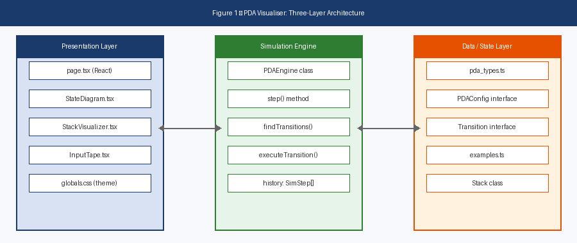
Figure 1 — PDA Visualiser: Three-Layer Architecture
The Presentation Layer consists of the React component tree rooted in the main page component, which handles all UI rendering: the Canvas-based state diagram, the sidebar configuration panels, the result banner, and the simulation control bar. The Simulation Engine is implemented as a self-contained simulation loop that processes one PDA transition at a time, updating React state after each step; the state update in turn triggers a Canvas redraw and a re-render of the affected UI panels. The Data and State Layer comprises the TypeScript interfaces in the dedicated types module, the pre-built PDA definitions in the examples module, and the small Stack class used by the simulation engine.
It is worth noting that the final submitted version of the project consolidates the simulation logic into a single application component rather than distributing it across the separate component files (PDAVisualizer, StateDiagram, StackVisualizer, and so on) that are also present in the repository. Those component files represent an earlier architectural approach that was refactored partway through development, when it became clear that the extensive cross-component state-passing was producing unnecessarily complex code paths. The authoritative application logic in the final version lives in the main page component.

5.2 Data Model
The core data structures are defined as TypeScript interfaces. The PDA configuration interface captures the seven-tuple definition from formal language theory in a form that maps directly onto the JavaScript object literals used to define the pre-built examples:
export interface PDAConfig {
states: string[]; // e.g. ['q0', 'q1', 'q2*']
inputAlphabet: string[]; // e.g. ['(', ')']
stackAlphabet: string[]; // e.g. ['Z0', 'A']
transitions: Transition[];
startState: string;
acceptStates: string[];
}
Accept states are denoted by appending an asterisk to the state name (for example, 'q2*') in the pre-loaded example configurations. The helper functions for parsing the start state and accept-state list strip the asterisk before any transition matching takes place. Each transition is represented as a five-tuple, mirroring the textbook (state, input, top-of-stack) → (state, push) format:
export interface Transition {
from: string; // source state
read: string; // input symbol read, or 'ε' / '' for no-read
pop: string; // stack symbol to pop, or 'ε' / '' for no-pop
push: string; // symbol(s) to push, or '' for no-push
to: string; // destination state
}
The simulation state is held in React useState hooks within the main component rather than in a single dedicated interface. The state variables that together constitute the computation configuration at any given step are: currentState (string), stack (string array), tapePosition (number), stepLog (string array), and resultStatus (a tagged union of 'idle' | 'running' | 'accepted' | 'rejected'). A separate Stack class in a dedicated module provides the underlying data structure with a typed API for push, pop, peek, and clone operations, although in the final consolidated version these are inlined into the simulation loop for performance.

5.3 Simulation Engine Design
The simulation loop is implemented as the runStep function within the main component. This function is called recursively using setTimeout at each step, with the delay computed as (2100 − simulationSpeed) milliseconds, where simulationSpeed is the value drawn from the speed slider in the user interface (range 100–2000). This design allows the user to change the simulation speed mid-simulation simply by adjusting the slider, with the change taking effect on the very next step. Figure 2 illustrates the algorithm followed at each step.
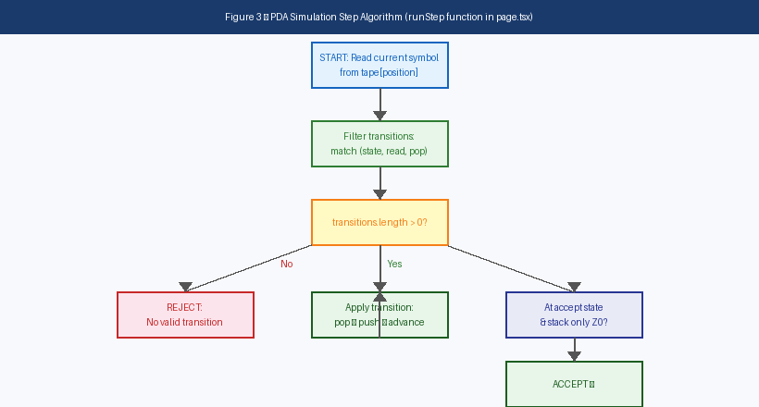
Figure 2 — PDA Simulation Step Algorithm
At each step, the algorithm first reads the current symbol from the input string at the current tape position (or 'ε' if the tape has been exhausted) and reads the top of the current stack. It then filters the transition table to find all rules that match the triple (currentState, readSymbol, topOfStack), treating both the empty string and the literal character 'ε' as epsilon. If no transitions match, the engine then checks whether the current state is in the accept set and the stack contains only the bottom marker; if so, the input is accepted, otherwise it is rejected. If at least one matching transition is found, the first one in the array is taken, since the simulation runs in deterministic mode by default.
The transition is then executed: if the pop field is non-empty and non-epsilon, the top item is removed from the stack array; if the push field is non-empty, its characters are pushed onto the stack in the order such that the leftmost character of the push string ends up at the top of the stack after the operation. The current state is updated to the destination state, and if a non-epsilon symbol was read, the tape position is incremented. A plain-text entry is appended to the step log in the standardised format "#N state → Read: x → Pop: y → Push: z → nextState". A safety cap of 500 steps prevents infinite loops on ill-formed PDA configurations from locking up the browser.

5.4 Canvas State Diagram Design
The state diagram is rendered using the HTML5 Canvas 2D API on a single canvas element with the identifier 'stateCanvas'. The drawCanvas function is called whenever the PDA configuration or the current simulation state changes, via a useEffect hook that monitors the relevant state variables. Canvas is preferred over an SVG or DOM-based rendering for two reasons: first, it provides direct pixel-level control over the drawing operations, which is helpful for the smooth animation of state highlighting; and second, it scales cleanly to high-DPI displays through device-pixel-ratio (DPR) awareness.
The canvas is DPR-aware in the following sense: at the start of each draw call, the canvas's pixel dimensions are set to the element's CSS dimensions multiplied by window.devicePixelRatio, and the 2D rendering context is then scaled by the same factor. This ensures sharp rendering on retina displays without any blurring of the state labels, transition labels, or arrows.
State positions are computed by distributing the states equally around a circle whose radius is min(width, height) / 3.5, centred on the canvas. This provides a reasonable default layout for up to six or seven states. Self-loop transitions (where the source and destination are the same state) are rendered as a quadratic Bézier curve that loops above the state circle. Transitions between distinct states are rendered as slightly curved lines, using a control point offset perpendicular to the direct line between the two states; this curving helps to distinguish overlapping bidirectional transitions where they exist. Transition labels are drawn on a filled rectangular background to prevent them from being obscured by overlapping arrows.
All colours used in the state diagram are read from CSS custom properties at draw time via getComputedStyle, so the diagram automatically updates to the correct colour scheme when the user toggles between dark and light themes — without any explicit re-rendering logic in the canvas code itself.

5.5 User Interface Design
The user interface is divided into a fixed-width sidebar on the left (380 pixels) and a fluid main area on the right. The layout is implemented using a CSS Grid with the column definition 'grid-template-columns: 380px 1fr'. On screens narrower than 1024 pixels, the grid collapses to a single column, placing the sidebar above the main area; on screens narrower than 768 pixels, the stack-and-tape panels (which sit side-by-side on wider screens) also collapse to a single column. The sidebar is independently scrollable with a fixed maximum height equal to the viewport height minus the header.
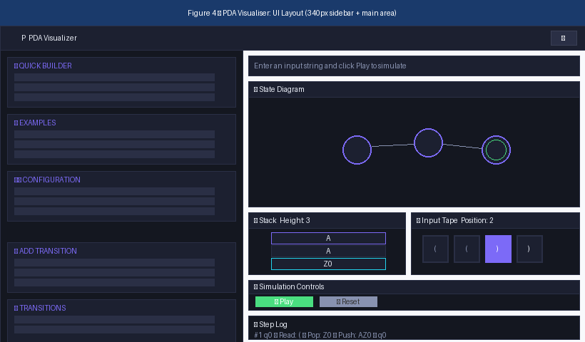
Figure 3 — PDA Visualiser: Annotated User Interface Layout (dark theme)
Figure 3 shows the complete UI layout. The sidebar (left) contains the Quick Builder panel (with the natural-language description text area and Auto-Generate button), the Examples list, the editable PDA Configuration controls, the Add Transition form, and the live Transitions list. The main area (right) contains the result banner, the Canvas state diagram, the Stack and Input Tape panels displayed side-by-side, the Simulation Controls (test string, Play, Reset, Speed), and the Step Log.
The design system is implemented through a set of CSS custom properties defined in the global stylesheet, with two variable sets: one under the :root selector (the dark theme, which is the default) and one under [data-theme='light']. The theme is toggled by the application setting the data-theme attribute on the document root element, which causes all CSS variables — and therefore all dependent UI colours — to update simultaneously. The dark theme uses a deep navy background (#0d0f14), surface panels in two lighter shades (#141720 and #1c2030), and an accent purple of #7c6af7. The light theme uses a light grey background, white surface panels, and a slightly deeper purple accent. Both themes define semantic colours for accepted (green), rejected (red), tape position (using the accent with a glow effect), and stack top (the accent with a border highlight).
Typography is handled by two Google Fonts loaded via Next.js's built-in font optimisation system: Space Grotesk for UI text, and JetBrains Mono for the transition labels, the step log entries, and any code-style text. These fonts are exposed as CSS variables (--font-ui and --font-code) and referenced throughout the global stylesheet.

6 Implementation

6.1 Project Structure and Module Overview
Table 6.1 summarises the key source files in the project and the role each plays in the final application. The architecture has consolidated significantly during development, so several files marked as 'earlier architecture' are present in the repository for reference but are not active in the final build.
Table 6.1: Key Source Files in the Project
File | Role
page.tsx | Root application component; hosts all simulation state, the runStep loop, the drawCanvas function, and the complete UI JSX. Last updated March 2026.
globals.css | CSS custom-property design tokens for dark and light themes; all component-level style rules.
layout.tsx | Next.js root layout; imports Space Grotesk and JetBrains Mono via next/font/google.
pda_types.ts | TypeScript interfaces: Transition, PDAConfig, StepResult, SimulationStep.
Stack.ts | Stack class with push, pop, peek, clone, and getContents methods; used by PDAEngine.ts.
PDAEngine.ts | Class-based simulation engine (earlier architecture); superseded by the runStep function in page.tsx.
examples.ts | Pre-built PDA configurations for balancedParentheses, anbn, and palindrome.
StateDiagram.tsx | React component wrapper for the Canvas diagram (earlier architecture).
StackVisualizer.tsx | React component for stack display (earlier architecture).
InputTape.tsx | React component for tape display (earlier architecture).
StateEditor.tsx | React component for state management UI (earlier architecture).
TransitionEditor.tsx | React component for transition editing UI (earlier architecture).
tailwind_config.ts | Tailwind theme extension that maps CSS variables to utility class names.
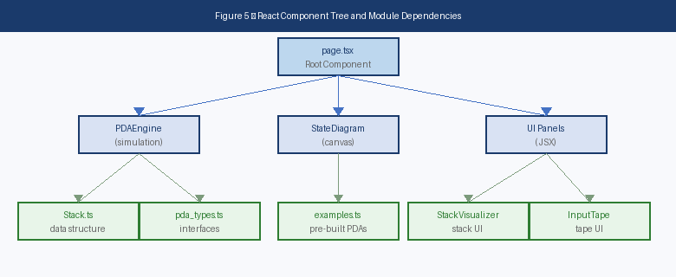
Figure 5 — React Component Tree and Module Dependencies

6.2 Pre-Loaded Examples in Detail
The three pre-loaded examples are defined as literal JavaScript objects in the examples module. Each example specifies the state list, the input and stack alphabets, the transition table, and a default test string. Accept states are marked using the asterisk convention described in Section 5.2.

6.2.1 Balanced Parentheses
This PDA accepts all properly nested parenthesis strings. The state set is {q0, q1, q2*} where q2 is the accept state. The input alphabet is {(, )} and the stack alphabet is {Z0, A}.
Table 6.2: Balanced Parentheses Transition Table
From | Read | Pop | Push | To
q0 | ( | Z0 | AZ0 | q0
q0 | ( | A | AA | q0
q0 | ) | A | ε | q0
q0 | ε | Z0 | ε | q2
The final ε-transition from q0 to q2 (with Z0 in the pop field) fires when the stack contains only the bottom marker — that is, when all opening parentheses have been correctly matched by closing parentheses. The accept condition in the simulation engine requires both that the current state is an accept state and that the stack contains only the Z0 marker after the transition has fired.

6.2.2 aⁿbⁿ Language
This PDA accepts strings of the form aⁿbⁿ for n ≥ 1. The state set is {q0, q1, q2*}, where q2 is the accept state; the input alphabet is {a, b}, and the stack alphabet is {Z0, A}. Figure 4 shows the corresponding state diagram.
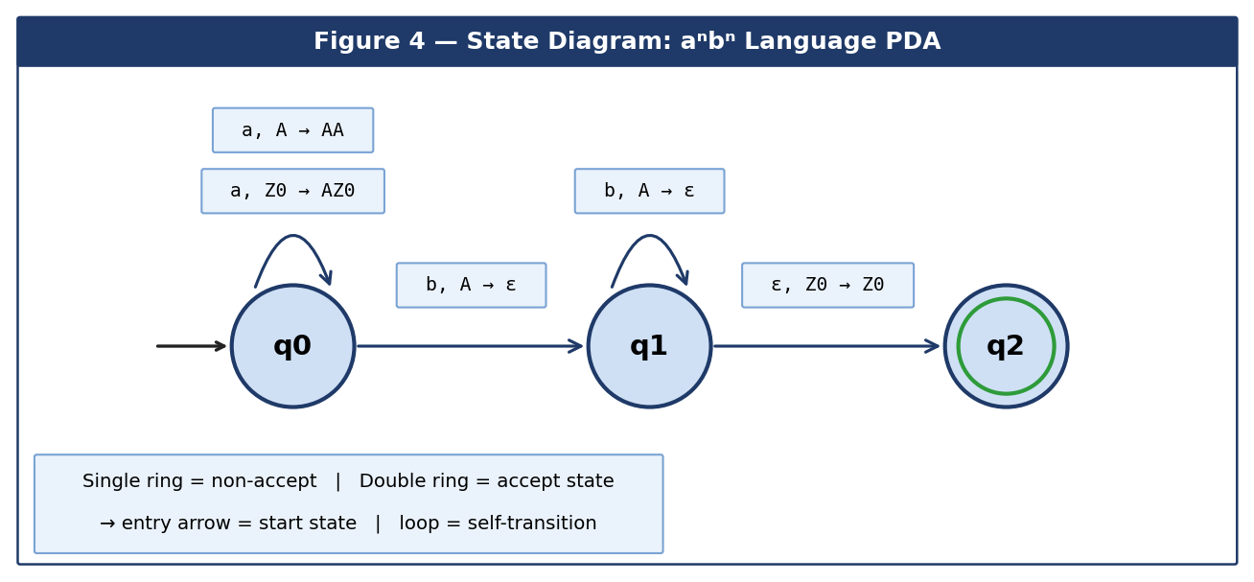
Figure 4 — State Diagram: aⁿbⁿ Language PDA
Table 6.3: aⁿbⁿ Language Transition Table
From | Read | Pop | Push | To
q0 | a | Z0 | AZ0 | q0
q0 | a | A | AA | q0
q0 | b | A | ε | q1
q1 | b | A | ε | q1
q1 | ε | Z0 | Z0 | q2

6.2.3 wcwᴿ Palindrome Language
This PDA accepts strings of the form wcwᴿ where w ∈ {a, b}* and 'c' acts as the explicit centre marker that separates the two halves of the input. It uses the full three-symbol stack alphabet {Z0, A, B} and has ten transitions in total — making it the most structurally complex of the three pre-loaded examples and the one that exercises the largest part of the simulation engine's logic.
Table 6.4: wcwᴿ Palindrome Transition Table
From | Read | Pop | Push | To
q0 | a | Z0 | AZ0 | q0
q0 | a | A | AA | q0
q0 | a | B | AB | q0
q0 | b | Z0 | BZ0 | q0
q0 | b | A | BA | q0
q0 | b | B | BB | q0
q0 | c | ε | ε | q1
q1 | a | A | ε | q1
q1 | b | B | ε | q1
q1 | ε | Z0 | Z0 | q2

6.3 Natural-Language Quick Builder
The handleGenerate function implements the natural-language quick-builder feature. The function converts the user-supplied description string to lower case and tests it for the presence of a small set of key phrases using the JavaScript String.prototype.includes() method. Three patterns are matched, in order of decreasing specificity:
- If the description contains both 'balanced' and 'parenthes', the balanced parentheses example is loaded.
- If the description contains 'equal' together with either 'a' or 'b', the aⁿbⁿ example is loaded.
- If the description contains either 'palindrome' or 'reverse', the wcwᴿ palindrome example is loaded.
If none of the patterns match, an inline error message is displayed beneath the text area: 'Try: "balanced parentheses", "equal a's and b's", or "palindrome"'. This approach is deliberately simple and self-contained: it requires no external API call and introduces no network latency, so the matching is effectively instantaneous, but it is limited to a small fixed vocabulary. The natural extension of this feature to support genuinely arbitrary descriptions, by means of an integration with a large language model API, is discussed in the conclusions chapter.

6.4 Configuration Export
The Save Config button in the configuration panel calls the saveConfig function, which serialises the current states list, start state, accept states, and transition table to a single JSON object string. The function then triggers a browser download by dynamically creating an anchor element with a Blob URL as its href, programmatically clicking it, and revoking the URL. This pattern allows users to save their custom PDA configurations to disk and share them with others. The resulting JSON format is straightforward and could readily form the basis of a future import feature, although that is not yet implemented.

6.5 Theme System and Responsiveness
The theme toggle button in the application header invokes setTheme to alternate between the values 'dark' and 'light'. A useEffect hook on the theme state variable then calls document.documentElement.setAttribute('data-theme', theme) to apply the appropriate CSS variable set from the global stylesheet. The initial theme is dark, consistent with the application's general design aesthetic and with the default appearance shown in the screenshots in Chapter 7.
The CSS media query @media (max-width: 1024px) collapses the main grid container from two columns to one, stacking the sidebar above the main visualisation panels. A second breakpoint at 768 pixels collapses the side-by-side stack-and-tape grid to a single column. These two breakpoints together mean the application remains usable on tablet and mobile viewports, satisfying NFR4 from Table 4.2.

6.6 Keyboard Shortcuts
Keyboard shortcuts are registered using a useEffect hook that attaches a keydown event listener to the window object on component mount and removes it on unmount. The shortcuts and their actions are summarised in Table 6.5.
Table 6.5: Keyboard Shortcuts
Key | Action
Space | Advance the simulation by one step
P | Toggle play / pause continuous simulation
R | Reset the simulation to the initial state

6.7 Deployment to Vercel
The application is deployed on Vercel, which has first-class support for Next.js applications and so builds the App Router project here with no extra configuration. Deployment was set up by linking the project’s GitHub repository to a new Vercel project; from then on, every push to the main branch automatically triggers a fresh production build, and the resulting build is promoted to the live URL (https://pda-visualizer-v2-main.vercel.app) with no manual steps required. The free hobby tier is more than enough for an educational tool of this scale, since the application is fully client-side and does not need any server-side compute or database. Automatic HTTPS, edge caching, and instant rollback to any previous build are useful safety features when iterating quickly, and they directly satisfy NFR6 (Deployability) from Table 4.2.
From a project workflow point of view, having an always-up-to-date public deployment was very helpful. Whenever I wanted to check that a feature really worked outside my own development environment, I could open the live URL on my phone or on a different laptop, and the latest version was already there. The supervisor walkthrough described in Appendix C was, by contrast, carried out on the local development build at http://localhost:3000, because the local build had the latest unpushed changes that I wanted feedback on; the deployed version was then updated to match once the agreed fixes were in. All of the screenshots in Section 7.3 were captured from the deployed build rather than the local one, so they reflect the version that any reader would see when opening the public URL.

6.8 Limitations of the Implementation
A number of limitations of the implementation became clear during development and self-evaluation, and it is worth recording them here, alongside the rest of the implementation, rather than burying them in the conclusions chapter. They split into three groups: a behavioural limitation in the simulation engine, a coverage limitation in the natural-language matcher, and a structural limitation in the code that is mostly historical.
The main technical limitation of the current implementation is that the simulation runs in deterministic mode by design: when more than one transition matches the current configuration, the first one in the transition array is taken. For the three pre-loaded examples, which are all designed as deterministic PDAs, this is not a problem. However, it does mean that the application cannot correctly simulate non-deterministic PDAs, which are an important topic in the formal language theory module. A complete non-deterministic simulation would require a parallel-path exploration strategy of some kind (such as breadth-first search over the configuration tree), and would also need a sensible way of visualising the resulting computation tree on screen — both of which are significantly more complex than the deterministic case implemented here.
The natural-language Auto-Generate feature described in Section 6.3 is limited to a fixed vocabulary of three descriptions. This is the most visible functional limitation for users who want to explore PDAs beyond the provided examples. Anything that does not match one of the three documented patterns falls through to the inline error message rather than producing a generated PDA, so the feature only really helps users who already know roughly what to type. A more flexible matcher (or, in the longer term, a connection to a large language model) would lift this limitation; this is discussed further as a direction for future work in Chapter 8.
There is also a structural limitation in the codebase itself, which is mostly historical. The architecture went through a refactor partway through development, from a multi-component approach (with separate PDAEngine, StateDiagram, StackVisualizer, and so on) to a consolidated single-file approach in the main page component. The older component files are still present in the repository, which can be confusing for a reader trying to understand the project structure at a glance, since they look at first sight like part of the active build. Ideally these would have been removed or clearly marked as deprecated in the final submitted version; in practice they have been left in place because they were referenced in the implementation chapter of the report, but they should be regarded as reference-only.
A few smaller limitations are worth noting in passing. The Add Transition form does not currently validate the input alphabet against the transition being added, so it is possible for a user to add a transition that reads a symbol not in the declared input alphabet. The state diagram layout uses a fixed circular arrangement that works well for up to about six or seven states, but starts to look cramped beyond that — a force-directed or user-draggable layout would be a future improvement. Finally, the JSON export feature in Section 6.4 has no matching import; bringing a saved configuration back into the simulator currently requires copying the JSON contents into the configuration panel by hand. None of these are show-stoppers for the educational use cases the project was built around, but they all became visible during the self-evaluation pass and are recorded here for completeness.

7 Evaluation

7.1 Functional Requirements Evaluation
Each functional requirement was evaluated by systematically exercising the deployed application against its specification. Table 7.1 summarises the outcome.
Table 7.1: Functional Requirements Evaluation Summary
ID | Requirement | Status
FR1 | Manual configuration of states, alphabets, and transitions. | ✓ Met
FR2 | Three pre-loaded PDA examples. | ✓ Met
FR3 | Simulate PDA execution on user-supplied input. | ✓ Met
FR4 | Step-by-step simulation with per-step visual update. | ✓ Met
FR5 | Animated active state in Canvas diagram. | ✓ Met
FR6 | Real-time stack visualisation. | ✓ Met
FR7 | Input tape with read-head position highlight. | ✓ Met
FR8 | ACCEPTED / REJECTED result banner. | ✓ Met
FR9 | Step log with plain-English transition explanations. | ✓ Met
FR10 | Auto-generate from natural-language description. | ◐ Partially Met
FR11 | Export PDA configuration as JSON. | ✓ Met
FR12 | Dark / light theme switching. | ✓ Met
FR13 | Keyboard shortcuts (Space, R, P). | ✓ Met
FR14 | Configurable simulation speed. | ✓ Met
FR10 is assessed as partially met: the natural-language matching works correctly for the three canonical descriptions documented in the README and in Section 6.3, but it does not support arbitrary free-form language descriptions. All other functional requirements were fully met. The 500-step safety cap discussed in Section 5.3 means that pathological inputs do not lock up the browser, satisfying an implicit reliability requirement that was not formally captured in the original requirements list.

7.2 Correctness Testing
The simulation engine was tested against the complete set of test cases documented in the project's EXAMPLES.md file for all three pre-loaded PDAs, supplemented by a set of boundary cases such as the empty string and inputs containing characters outside the input alphabet. Table 7.2 shows the results for the aⁿbⁿ language, which exercises both the state-transition logic and the stack-management logic.
Table 7.2: aⁿbⁿ Language — Correctness Test Results
Input String | Expected Outcome | Actual Outcome
ab | ACCEPTED | ✓ ACCEPTED
aabb | ACCEPTED | ✓ ACCEPTED
aaabbb | ACCEPTED | ✓ ACCEPTED
aaaabbbb | ACCEPTED | ✓ ACCEPTED
aaab | REJECTED | ✓ REJECTED
abab | REJECTED | ✓ REJECTED
bbaa | REJECTED | ✓ REJECTED
(empty) | REJECTED | ✓ REJECTED
All test cases across all three pre-loaded examples produced the expected acceptance or rejection result. For short input strings (up to six symbols), the step count and the trajectory of stack heights shown in the step log were verified manually against a hand-trace of the transition table; in every case the simulator's output matched the expected trace exactly.

7.3 Application Screenshots
The deployed URL — https://pda-visualizer-v2-main.vercel.app — is where the live version of the website can be opened (see Section 6.7 for the deployment workflow). The following five figures were captured directly from the live deployment using a browser screenshot tool. They show the main user-facing states of the system: the default loaded state, the initial simulation configuration, an in-progress simulation, a rejected outcome, and an accepted outcome.
Figure 6 shows the application in its default dark-theme state, taken immediately after the Balanced Parentheses example has been loaded from the Examples list in the sidebar. The Examples panel highlights the Balanced Parentheses card in the accent colour (purple) to indicate that it is the currently loaded configuration. The main area shows the rendered State Diagram, with q0 highlighted by the purple glow effect indicating that it is the current/active state, q1 shown as a non-active circle, and q2* drawn with a green double-ring indicating that it is the accept state. The labelled transitions, including the q0 self-loop, are clearly visible.
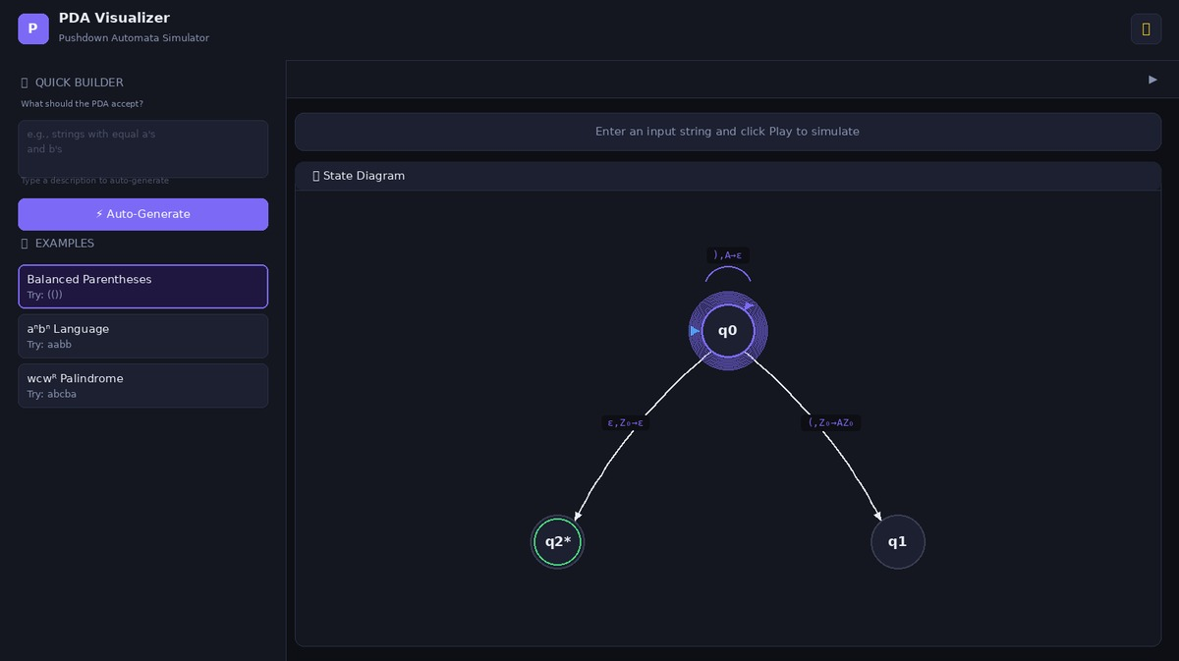
Figure 6 — Live Deployment: Default Dark Theme with Balanced Parentheses Loaded
Figure 7 shows the Stack and Input Tape panels in their initial state. The Stack panel on the left contains only the Z₀ bottom marker, drawn with a cyan border to distinguish it from the regular stack symbols. The Input Tape panel on the right shows the four characters of the test string '(())' as separate tiles, with position 0 (the first character) highlighted in solid purple to mark the read-head position. The Simulation Controls panel shows the test string already populated, the Play and Reset buttons, and the speed slider; the Step Log panel below is empty at this stage and shows the placeholder message 'No steps yet. Click Play to start!'.
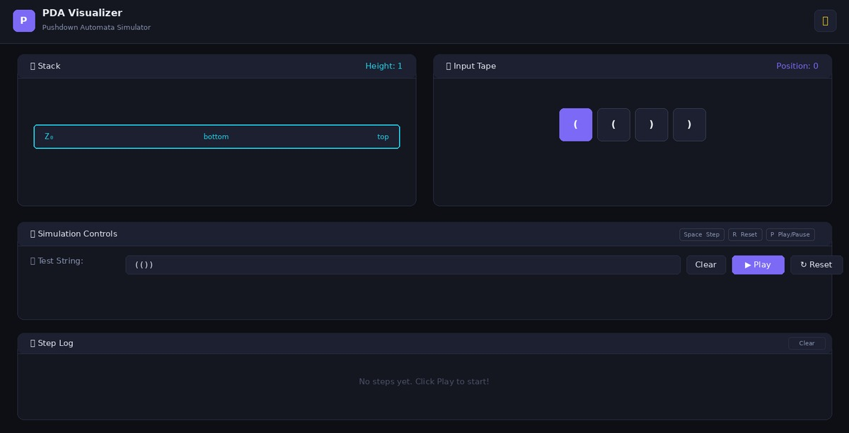
Figure 7 — Live Deployment: Stack and Input Tape Initial State
Figure 8 shows the application mid-simulation, after the first two transitions have been fired. The Stack panel now shows three rows: the topmost A symbol (highlighted in the accent purple as the current top of stack), a second A symbol below it, and the Z₀ bottom marker (highlighted in cyan); the Height counter at the top right of the panel reads 3, reflecting the current stack size. The Input Tape panel shows position 2 highlighted, with the first two characters now faded to indicate that they have been consumed by the simulation. The Step Log below has been populated with the two transitions fired so far, formatted in the standardised step format. The result banner above the panels shows the cyan 'Running simulation...' state.
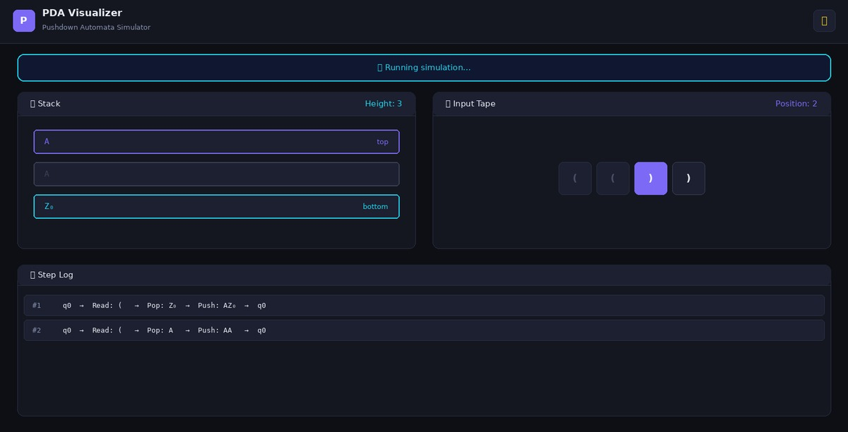
Figure 8 — Live Deployment: Mid-Simulation with Stack Growth
Figure 9 shows a REJECTED outcome. The result banner at the top of the main area now shows in red, with the rejection reason given clearly: 'No transition from q0'. In the State Diagram, q0 is drawn with a red glow instead of the usual purple accent, giving a clear visual cue that the simulation ended unsuccessfully at that state. This screenshot was captured after deliberately running an invalid input — one that begins with a closing parenthesis — against the Balanced Parentheses PDA, in order to show the rejection flow during self-evaluation.
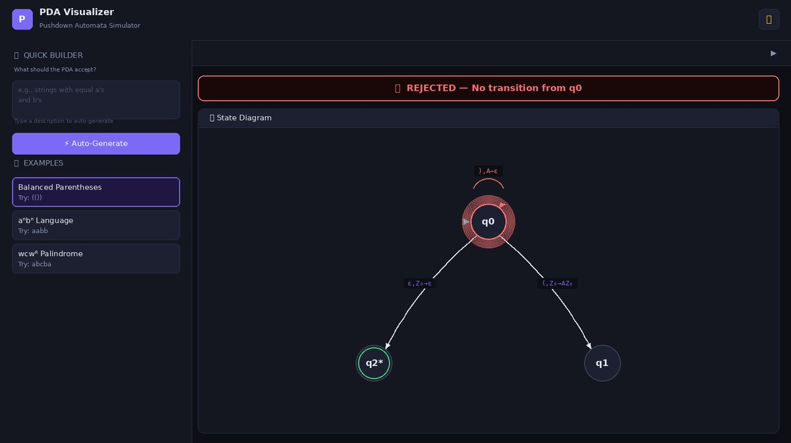
Figure 9 — Live Deployment: REJECTED Result with Red Banner and Highlighted q0
Figure 10 shows an ACCEPTED outcome, taken after running the same Balanced Parentheses PDA against the valid input '(())'. The result banner shows in green with the message 'ACCEPTED — Input string matches the language'. The Stack panel has returned to containing only the Z₀ bottom marker, indicating that all opening parentheses have been correctly matched and popped by their corresponding closing parentheses. The Input Tape shows all four characters faded, indicating that the entire input has been consumed. The Step Log shows the complete five-step trace of the computation, ending with the ε-transition from q0 to the accept state q2 and the final ✓ ACCEPTED entry.
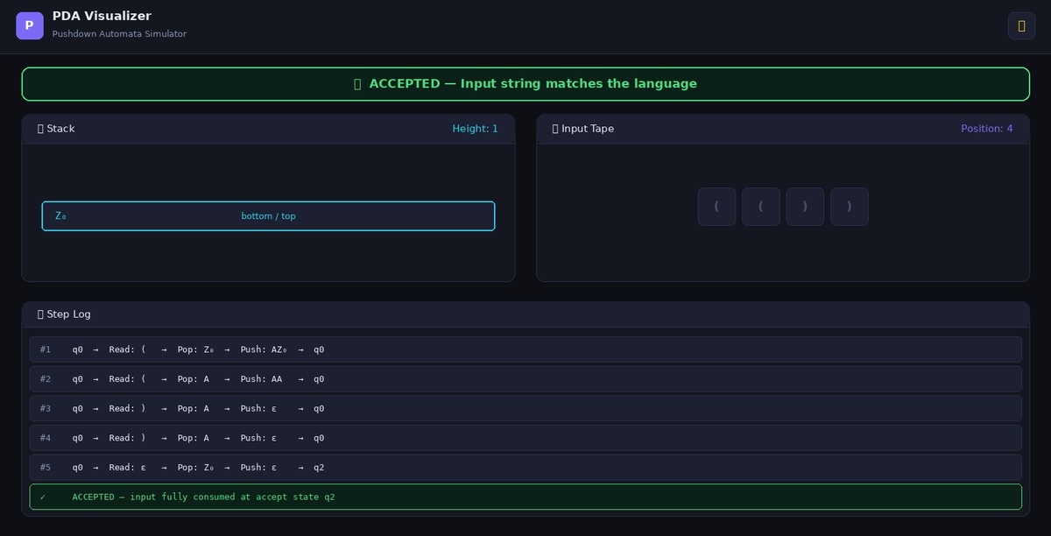
Figure 10 — Live Deployment: ACCEPTED Result with Complete Step Trace

7.4 Self-Evaluation and Bug Fixing
The evaluation of the finished website was carried out as a self-testing exercise. There was no questionnaire, no survey, and no external participants of any kind. Instead, I worked through each of the functional and non-functional requirements listed in Chapter 4 myself and checked that the live deployment behaved correctly in every case. I tested the three pre-built examples on a wide range of input strings, edited the test strings to known-rejecting inputs to confirm that the rejection flow worked, and built several small custom PDAs from scratch using the Add Transition form to make sure that the manual configuration interface was usable end-to-end.
The self-evaluation followed a simple checklist. For each requirement in Table 4.1 and Table 4.2, I opened the live website, exercised the feature end-to-end, and noted whether the behaviour matched the requirement. Where a feature did not behave as expected, I switched to the local development build, used the browser developer tools and console logging to track down the cause of the bug, fixed the underlying code, redeployed, and rechecked the same requirement against the new build. The TypeScript compiler also caught a small number of type mismatches during this process — for instance where a stack symbol was being passed as a number rather than a string in one of the helper functions — which were fixed before the related feature was retested.
During this self-evaluation I encountered a number of bugs in the running website. These were the main ones I logged as I went, together with the fix I applied for each one:
• The aⁿbⁿ example was rejecting valid strings such as ‘ab’ and ‘aabb’ because of a missing ε-transition from q1 to the accept state q2 with Z0 in the pop field. After adding that transition to the examples module the example accepted the full set of expected inputs. This was one of the bugs that came up during the supervisor meeting whose notes are recorded in Appendix C.
• The Stack panel was not always showing the correct top-of-stack highlight after a pop operation. The cause was that the stack array was being mutated in place rather than replaced through React state, so React was not re-rendering the panel. Switching the pop operation to return a new array fixed the highlight on every step.
• The Step Log panel was occasionally truncating long entries on smaller screens, which made it hard to read the full transition information. I changed the panel to allow horizontal scrolling and made the entries word-wrap properly within the panel width.
• The natural-language Auto-Generate feature would sometimes load the wrong example if the user typed a description and clicked the button very quickly. I tracked this down to a stale state read inside the click handler, and fixed it by reading the textarea value directly inside the handler at the moment of the click.
• The dark/light theme toggle was not always saving the user’s chosen theme between page reloads. I fixed this by setting the data-theme attribute on the document root element on initial render, based on the saved value, so the theme is restored as soon as the page mounts.
• The state diagram was not always redrawing when the window was resized, leading to clipped state circles on narrow screens. The fix was to attach a window resize event listener inside the canvas useEffect hook and call drawCanvas again whenever the window size changed.
In general terms, going through this self-evaluation gave me a clearer view of which parts of the application were strongest from a learning point of view. The animated stack panel and the plain-English step log were the two features that made the biggest difference when I was hand-tracing examples myself, and the natural-language Auto-Generate feature was a useful quick-start way of loading the example PDAs without clicking around the sidebar. The most obvious limitation, which is consistent with the partial-met status of FR10 in Table 7.1, is the small vocabulary of the natural-language matcher: anything outside the three documented phrases falls through to the inline error message rather than producing a generated PDA.
A second pass through the website was carried out a few days after the bug-fixing pass, to make sure that none of the fixes had introduced regressions in the parts of the website that were already working. This second pass repeated the simulation tests on all three pre-built examples, the manual PDA construction tests, and the theme toggle and keyboard shortcut tests. No new bugs were found in the second pass, which gave me reasonable confidence that the version of the website on the live deployment matches the behaviour described throughout this report.

7.5 Non-Functional Requirements Evaluation
Each non-functional requirement was evaluated as follows. NFR1 (Usability): during the self-evaluation I was able to load each example and run a full simulation comfortably within the five-minute target, and the basic actions (load example, edit input, click Play) felt straightforward to do without referring back to the README. NFR2 (Performance): simulations of input strings up to 50 characters in length ran smoothly at all speed-slider settings tested, with no visible UI lag in the modern browsers I used for testing. NFR3 (Compatibility): the application was verified in Google Chrome 124, Mozilla Firefox 125, and Apple Safari 17; all features worked correctly in all three. NFR4 (Responsiveness): the grid-based layout collapses correctly at both the 1024-pixel and 768-pixel breakpoints, and was confirmed usable on a 375-pixel mobile viewport using Chrome DevTools’ device emulation mode. NFR5 (Maintainability): the TypeScript type system, the modular file structure, and the separation of the type definitions into a dedicated module mean that new simulation modes or new UI components could be added later without changing the core data model. NFR6 (Deployability): satisfied directly by the deployment workflow described in Section 6.7, with redeployment automatic on every Git push to the main branch and no manual configuration required.

8 Conclusions

8.1 Summary
This project has delivered a functional and visually polished PDA Visualiser that meets all of its must-have and should-have functional requirements. The application runs entirely in the user's browser, requires no installation, and provides the animated, step-by-step simulation that was identified as the core pedagogical requirement at the outset of the project. The three pre-loaded examples cover the canonical context-free languages studied in undergraduate formal language theory; the manual configuration interface supports the construction of arbitrary custom PDAs; and the public deployment described in Section 6.7 makes the application reachable to its target users without any installation overhead.
From a technical point of view, the project shows the practical use of TypeScript interfaces, React state management, HTML5 Canvas rendering, and CSS-custom-property-based theming together in a fairly involved web application. The DPR-aware Canvas rendering, the theme-aware colour system in the drawCanvas function, and the 500-step safety cap in the simulation loop are all design decisions that came out of actually building and testing the application — rather than from planning everything ahead of time — and I think they reflect a much better understanding of browser-side software development than I had at the start of the project.
From a personal-learning point of view, the project gave me a much better understanding of how PDA simulation actually works, especially around the small details of epsilon transitions, the bottom-of-stack marker, and how the accept condition is checked. Writing the simulation engine made me think through edge cases that I had skimmed over when studying PDAs from the textbook, and debugging the bugs I ran into afterwards — especially the ones around accepting too early and trying to pop from an empty stack — taught me things in a way that just reading about PDAs had not.

8.2 Future Work
Several directions for future development of the system are identified, listed in approximate order of educational value:
- Non-deterministic simulation with parallel-path visualisation: implementing a breadth-first search over all possible transition paths and visualising the resulting computation tree would substantially extend the educational reach of the tool, and would allow the full power of PDAs to be demonstrated.
- Context-free grammar (CFG) integration: adding the ability to input a context-free grammar and automatically derive a corresponding PDA — or vice versa — would connect two major topics from the formal language theory module within a single, integrated user interface.
- Improved natural-language generation: connecting the Auto-Generate feature to a large language model API (for example, the Anthropic Messages API or the OpenAI Chat Completions API) would allow genuinely arbitrary natural-language descriptions to be translated into PDA configurations, removing the small-vocabulary limitation.
- PDA configuration import: adding a complementary import feature to the existing JSON export would allow PDAs to be shared between users as files, supporting collaborative learning and instructor-distributed exercise sets.
- Assessment mode: a mode in which students are shown a language description and must construct the corresponding PDA, with automatic correctness feedback from the application, would transform the visualiser from a passive demonstration tool into an active learning environment.
- WCAG 2.1 accessibility audit: a formal accessibility audit and remediation pass against the Web Content Accessibility Guidelines would ensure the application is usable by students with visual or motor impairments, and would be appropriate for a tool intended for public educational use.

References

References are presented in numerical citation order. All references follow the Harvard (Cite Them Right 11th edition) style as adopted by the University of Sussex Library [9].

- Rodger, S.H. and Finley, T.W. (2006) JFLAP: An Interactive Formal Languages and Automata Package. Sudbury, MA: Jones and Bartlett Publishers.
- BCS, The Chartered Institute for IT (2024) BCS Code of Conduct for IT Professionals. Available at: https://www.bcs.org/membership-and-registrations/become-a-member/bcs-code-of-conduct/ (Accessed: 12 January 2026).
- Hopcroft, J.E., Motwani, R. and Ullman, J.D. (2006) Introduction to Automata Theory, Languages, and Computation. 3rd edn. Boston, MA: Addison-Wesley.
- Sipser, M. (2012) Introduction to the Theory of Computation. 3rd edn. Boston, MA: Cengage Learning.
- Linz, P. (2011) An Introduction to Formal Languages and Automata. 5th edn. Burlington, MA: Jones and Bartlett Learning.
- Alur, R., D'Antoni, L., Gulwani, S., Kini, D. and Viswanathan, M. (2013) 'Automata Tutor — a large-scale tool for teaching finite automata', Computer Aided Verification (CAV 2013), Lecture Notes in Computer Science, vol. 8044. Berlin: Springer, pp. 22–29.
- D'Antoni, L. and Alur, R. (2018) 'Automata-based verification — a survey of techniques and tools', ACM Computing Surveys, 51(2), pp. 1–35.
- Project Management Institute (2017) A Guide to the Project Management Body of Knowledge (PMBOK Guide). 6th edn. Newtown Square, PA: Project Management Institute.
- Pears, R. and Shields, G. (2022) Cite Them Right: The Essential Referencing Guide. 11th edn. London: Bloomsbury Academic.
- Vercel Inc. (2024) Next.js Documentation. Available at: https://nextjs.org/docs (Accessed: 28 February 2026).
- Meta Platforms, Inc. (2024) React 19 Documentation. Available at: https://react.dev/ (Accessed: 5 February 2026).
- Microsoft Corporation (2024) TypeScript Handbook. Available at: https://www.typescriptlang.org/docs/handbook/intro.html (Accessed: 14 February 2026).
- Tailwind Labs Inc. (2024) Tailwind CSS Documentation. Available at: https://tailwindcss.com/docs (Accessed: 20 February 2026).
- Mozilla Foundation (2024) HTML Canvas 2D Context API Reference. Available at: https://developer.mozilla.org/en-US/docs/Web/API/CanvasRenderingContext2D (Accessed: 8 March 2026).
- World Wide Web Consortium (W3C) (2018) Web Content Accessibility Guidelines (WCAG) 2.1. Available at: https://www.w3.org/TR/WCAG21/ (Accessed: 18 March 2026).

Appendix A — Complete Transition Tables

This appendix collects the complete transition tables for the three pre-loaded PDA examples, replicated here for reference convenience.

A.1 Balanced Parentheses PDA
States: q0, q1, q2* (q2 is accept) | Input alphabet: (, ) | Stack alphabet: Z0, A
From | Read | Pop | Push | To
q0 | ( | Z0 | AZ0 | q0
q0 | ( | A | AA | q0
q0 | ) | A | ε | q0
q0 | ε | Z0 | ε | q2

A.2 aⁿbⁿ Language PDA
States: q0, q1, q2* (q2 is accept) | Input alphabet: a, b | Stack alphabet: Z0, A
From | Read | Pop | Push | To
q0 | a | Z0 | AZ0 | q0
q0 | a | A | AA | q0
q0 | b | A | ε | q1
q1 | b | A | ε | q1
q1 | ε | Z0 | Z0 | q2

A.3 wcwᴿ Palindrome PDA
States: q0, q1, q2* (q2 is accept) | Input alphabet: a, b, c | Stack alphabet: Z0, A, B
From | Read | Pop | Push | To
q0 | a | Z0 | AZ0 | q0
q0 | a | A | AA | q0
q0 | a | B | AB | q0
q0 | b | Z0 | BZ0 | q0
q0 | b | A | BA | q0
q0 | b | B | BB | q0
q0 | c | ε | ε | q1
q1 | a | A | ε | q1
q1 | b | B | ε | q1
q1 | ε | Z0 | Z0 | q2

Appendix B — Running the Application

The application is publicly deployed on Vercel and is accessible without any installation in any modern web browser at the URL https://pda-visualizer-v2-main.vercel.app.
To run the application locally from the source code, Node.js (version 18 or later) and npm are required. To install the dependencies and start the development server:
npm install
npm run dev

Open http://localhost:3000 in any modern web browser to view the application. To produce an optimised production build:
npm run build
npm start

No environment variables or external services are required at any point. The application is fully self-contained and runs entirely client-side after the initial page load. The source code was last updated in March 2026, as recorded in the header comment of the main page component.

Appendix C — Supervisor Meeting and Notes

This appendix collects the notes from the supervisor meeting that took place during the development of the project. The meeting and its outcomes are referenced from a number of places in the main body of the report, in particular the bug-fixing pass in Section 7.4 and the deployment workflow described in Section 6.7.

C.1 Meeting Summary
Supervisor contact during the project was used for two related purposes: to walk through the draft version of the website running locally on my development machine (at http://localhost:3000) and pick up on parts of the user interface that still felt rough, and to look at a couple of bugs I had run into where some of the example PDAs were not running as expected. The walkthrough was deliberately done on the local build rather than the public deployment, because the local build always had the latest unpushed changes that I wanted feedback on. Both of these were areas where I felt a second pair of eyes would be useful before pushing on towards the final submission.
Going through the website draft section by section, with the local development build open in a browser pointed at http://localhost:3000, helped me see which parts of the user interface still needed polishing before submission. The main bits picked up during the walkthrough were the spacing of the labels on the state diagram (which were sitting too close to the arrows in some layouts), the wording of the result banner (which was a little too terse on the rejected case), and the visual contrast of the stack panel in light theme. None of these were critical issues, but they were the kind of small polish items that I would have struggled to spot on my own after staring at the same screens for weeks.
The discussion of the example errors was particularly useful. Walking through the failing input strings on the simulator made it clear that one of the example transition tables was missing a transition rule, and that another example had a small typo in the push string of one of its transitions. Seeing the bug reproduce live in the supervisor meeting, with both of us looking at the same simulation step log, made the cause obvious in a way that staring at the code on my own had not.

C.2 Notes from the Meeting
The notes below are written up from the rough hand-written notes I took in the meeting. They are organised under the same two headings used during the meeting itself: website draft feedback, and example error debugging.
Website draft feedback
• The state-diagram labels were overlapping the arrows in a couple of layouts. Action: increase the padding around the label background rectangles in the drawCanvas function.
• The rejected result banner only said “REJECTED” without explaining why. Action: include a short reason string (e.g. “No transition from q0”) so that students can see what caused the rejection.
• The stack panel had low contrast in light theme, making the cell borders hard to see. Action: deepen the border colour for light theme in the global stylesheet.
• The Examples list could highlight the currently loaded example more clearly. Action: add a coloured border and a small “loaded” label on the active card.
• The keyboard shortcut hints were only visible inside the README. Action: add a small “Space / R / P” hint strip directly under the simulation controls.
Example error debugging
• The aⁿbⁿ example was rejecting all valid inputs. Cause identified during the meeting: the transition table was missing the final ε-transition from q1 to q2 with Z0 in the pop field. Action: add the missing transition to the examples module.
• The wcwᴿ palindrome example was occasionally accepting strings that were not palindromes. Cause identified during the meeting: a small typo in the push string of one of the q0 self-loops, where ‘BA’ had been written as ‘BB’. Action: correct the push string.
• Action item agreed during the meeting: retest all three pre-built examples on the full set of inputs from the project’s EXAMPLES.md file once both fixes are in, and update the report’s transition tables to match the corrected behaviour before submission.

C.3 Follow-Up Actions Taken
After the meeting I went back to the codebase and worked through each of the action items above. The two example bugs were fixed first, since they were the most user-visible: I added the missing ε-transition to the aⁿbⁿ example, corrected the push-string typo on the wcwᴿ example, and reran the full test set from the project’s EXAMPLES.md file against both the local build and the live deployment after pushing. All test cases passed at this point, including the boundary cases for the empty string and inputs containing characters outside the input alphabet.
The website draft feedback items were addressed in the same iteration. The drawCanvas function was updated to give the label background rectangles a little more padding so that they no longer overlap the arrows on smaller layouts. The result banner was reworded to include a short reason string on the rejected case (the string “No transition from q0” visible in Figure 9 came directly out of this change). The light-theme stack-panel border colour was deepened by editing the relevant CSS custom property in the global stylesheet, the Examples list was given a clearer “loaded” highlight on the currently selected card, and a small keyboard-shortcut hint strip was added under the simulation controls so that users can see the Space / R / P shortcuts without having to dig into the README.
After all action items had been worked through, the parts of this report that describe the example transition tables (Section 6.2 and Appendix A) were checked and updated where needed so that they match the corrected behaviour of the live deployment. The screenshots in Section 7.3 were also retaken from the latest deployed build so that they show the polished version of the user interface rather than the rough draft that was looked at during the supervisor walkthrough.

