**Project**

**Payroll System**

**Group Members:**

**Project Instructor**

AQSA UMAR

Saima Spy

Tabish Alam

(student id : BAI-23S-065)

Zunaira

(student id: BAI-23S-030)

Muhammad Subhan Shakir

(student id: BAI 23S 051)

**Table of content**

1. Acknowledgement.
2. Introduction.
3. Hardware/Software Requirements.
4. Snapshots

**Acknowledgement**

We are thankful to almighty, ALLAH that by his grace we have completed our project using C# & Workbench.

We are also thankful to our teachers and parents and our batch mates and friends who have guided us in order to complete our project. We have sorts of important points into consideration and made as friendly user as possible.This is our first project of OOP & Database.

Our project has been designed and developed using c#, Workbench, ASP .NET and following necessary concepts of Object Oriented Programming and Database Management System.

Our project is about Payroll System. We have made an Ecommerce or Education website where we have a store of different type of Medical appliances and in this website you can do lot of thing like you can do appointment. In this website the student can learn and see there lectures time and day

We have made a complete website and we have given our best to complete it. And it was our main objective to make a responsive and dormice website. We have made a very easy website any user can understand it easily.

**Introduction**

We have designed a unique website on clinic management system. We have made this website with HTML5, CSS, JavaScript, ASP .net MVC and bootstrap.

We have designed a very beautiful, responsive and user friendly Payroll Management System .We have made different categories.

Of products so any one can find product easily. We have given our best to complete it with in time we have used beautiful images for categories. And designed beautiful forms with bootstrap and html. Our website is fully responsive and is compatible with all types of screens. Our website is very quick in response and in this website you can learn about medical. You can do appoinment.

**Requirement Specification**

**Hardware**

* A minimum computer system that will help you access all the tools in the courses is a Core i3 or better
* 4 gigabytes of RAM or better

**Software**

* Visual Studio .Net / ASP
* .Net Framework
* Workbench OR Any DBMS
* Notepad
* Libraries(Depends on project type)

**Snapshots**

**Home:**

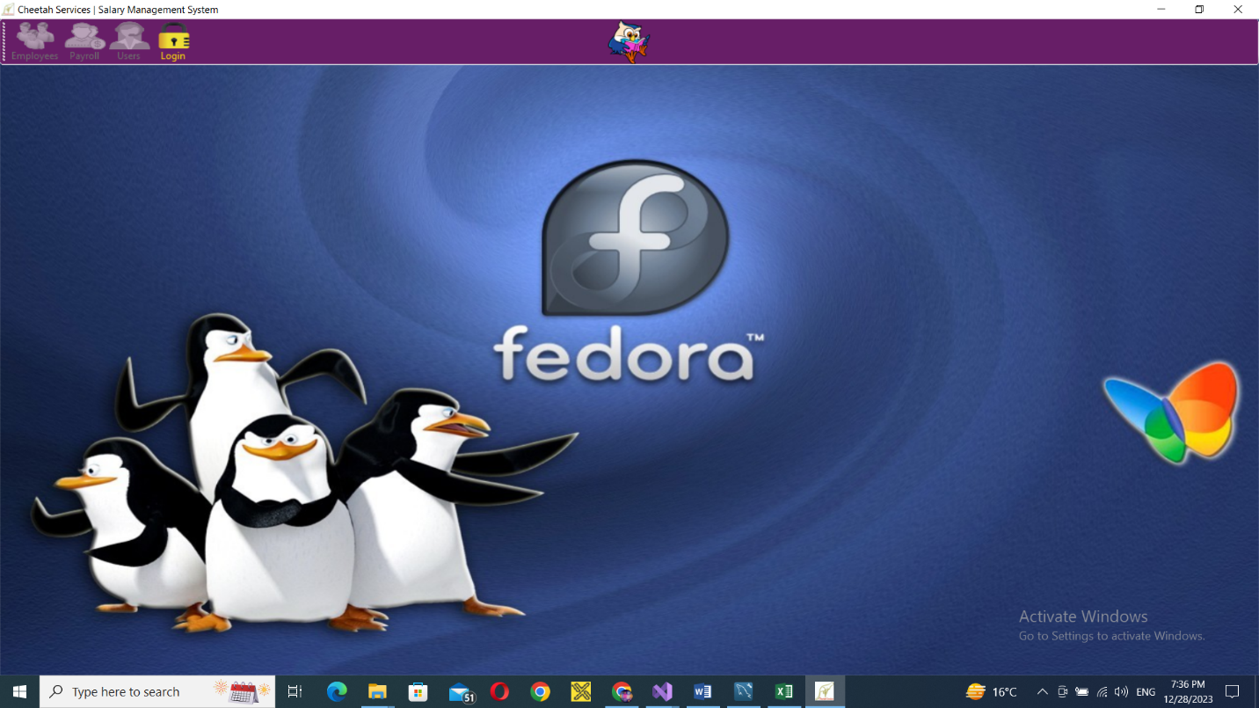

**Login:**

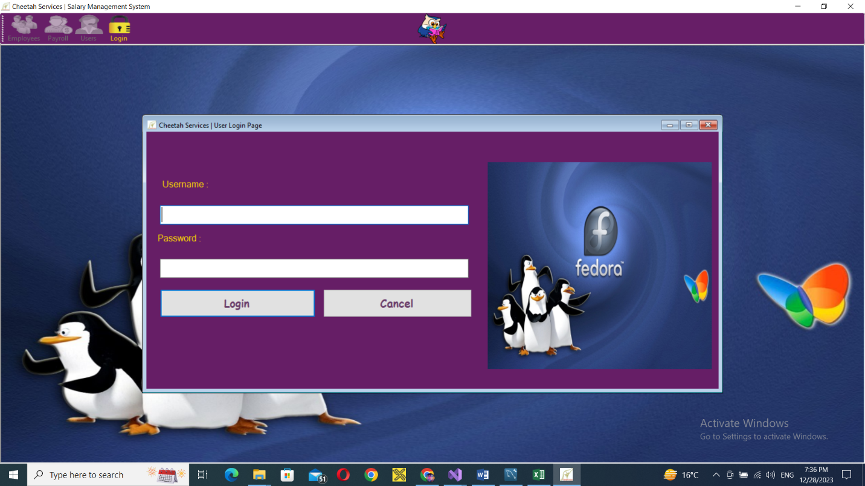

**Payroll:**