1.1.1.

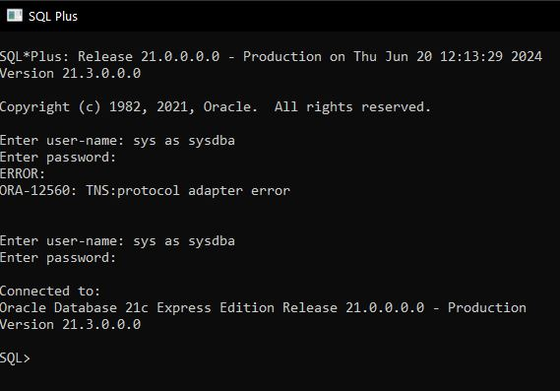

1.1.2.

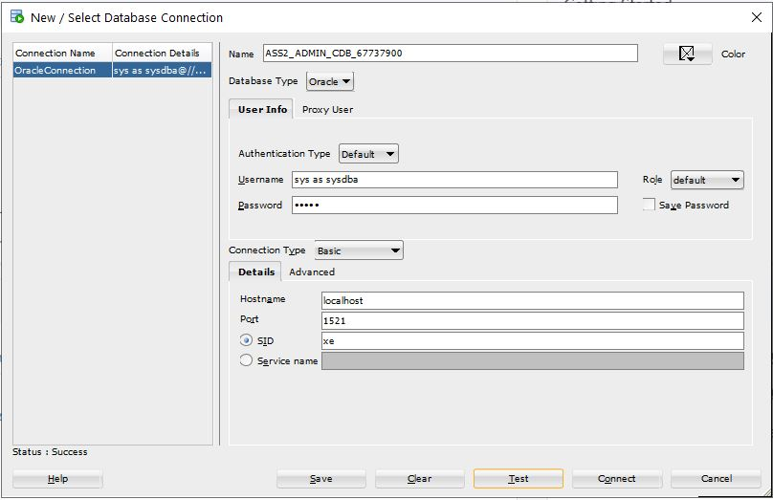

1.2.

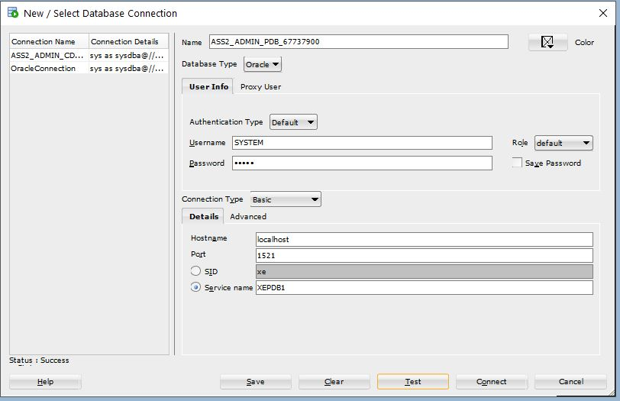

1.3.1.

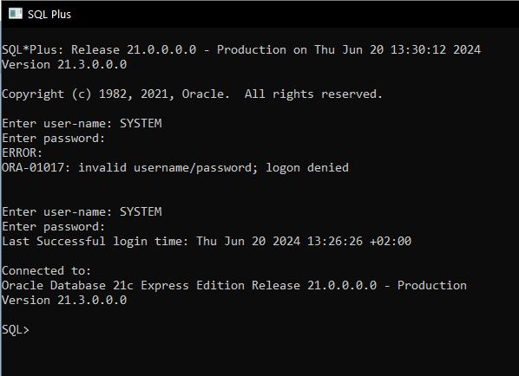

1.4.3.

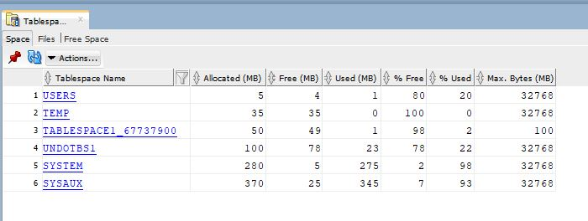

1.5.2

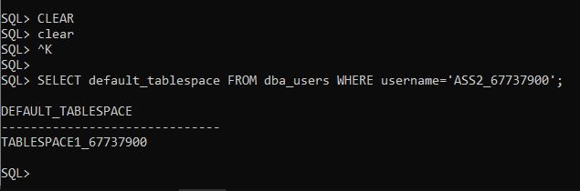

1.6.

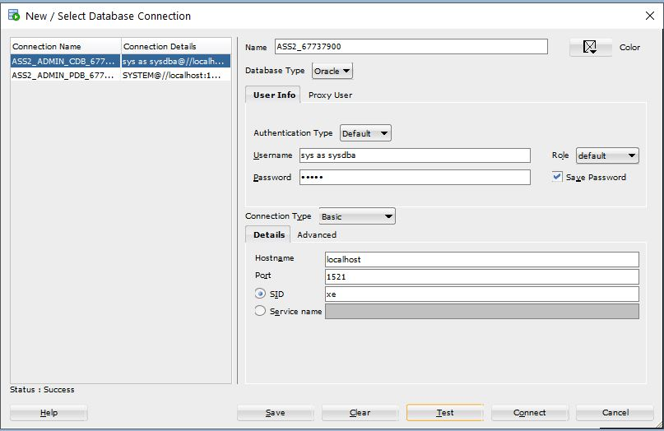

2.1.1.

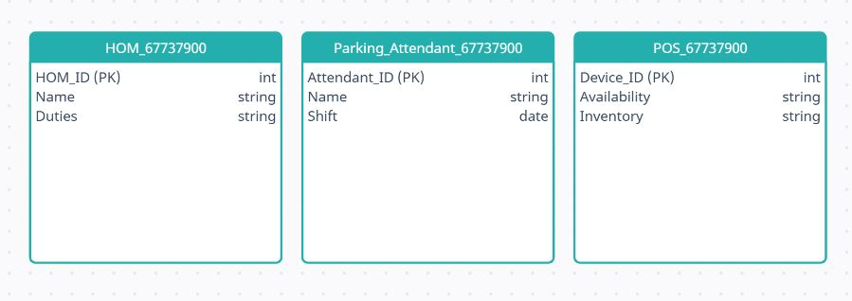

2.1.2.

HOM_67737900: Represents individuals like Siya Khumalo and Deacon Willemse who manage the shopping centre’s maintenance.

Parking_Attendant_67737900: Represents the parking area staff who work in shifts and may or may not check out POS devices.

POS_67737900: Represents the POS devices that can be checked out by Heads of Maintenance and used by parking attendants.

2.1.3.

HOM_67737900: HOM_ID(PK)

Parking_Attendant_67737900: Attendant_ID(PK)

POS_67737900: Device_ID(PK), HOM_ID(FK1), Attendant_ID(FK2)

2.2.1.

INV_GENERATOR_67737900 Table:

* Business Rule 1: Each invoice line is uniquely identified by the combination of Inv_number and Line_number.
* Business Rule 2: Each line item on an invoice references a service, identified by Service_code, which must exist in the CLEANING_SERVICE_67737900 table.
* Business Rule 3: Each line item on an invoice is part of an invoice identified by Inv_number, which must exist in the INVOICE_67737900 table.

CLEANING_SERVICE_67737900 Table:

* Business Rule 4: Each cleaning service is uniquely identified by Service_code.
* Business Rule 5: Each cleaning service has a description (Service_descript) and a price (Service_Price).

INVOICE_67737900 Table:

* Business Rule 6: Each invoice is uniquely identified by Inv_number.
* Business Rule 7: Each invoice references a vehicle, identified by Vehicle_reg, which must exist in the VEHICLE_REG_67737900 table.
* Business Rule 8: Each invoice records the date (Inv_date) on which the invoice was created.

VEHICLE_REG_67737900 Table:

* Business Rule 9: Each vehicle is uniquely identified by Vehicle_reg.
* Business Rule 10: Each vehicle has an associated customer phone number (Customer_phone).

2.2.2.

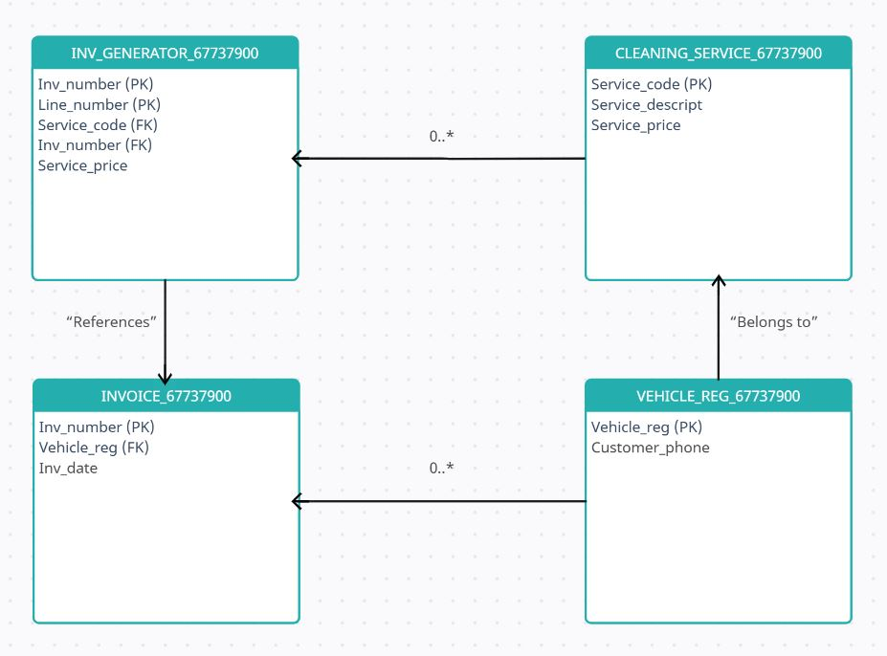

3.1.1.

CREATE TABLE POS_DEVICE_ 67737900 (

Device_ID VARCHAR(50) PRIMARY KEY,

Manufacturer VARCHAR(100)

);

3.2.1.

CREATE TABLE POS_CHECKOUT_67737900 (

Shift_ID VARCHAR(50) PRIMARY KEY,

Device_ID VARCHAR(50) FOREIGN KEY

);

3.2.2.

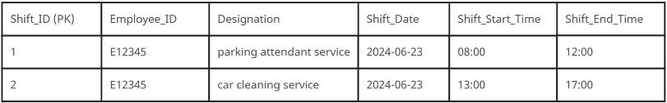

3.3.1.

Employee_contact is the multivalued attribute as it can hold multiple contact numbers for an employee.

3.3.2.

Entity name: EMPLOYEE_CONTACTS_ 67737900

Attributes:

* Contact_ID (PK)
* Employee_ID (FK referencing PARKING_LOT_EMPLOYEES_ 67737900)
* Contact_Number

3.3.3.

CREATE TABLE EMPLOYEE_CONTACTS_67737900 (

Contact_ID INT PRIMARY KEY,

Employee_ID INT,

Contact_Number VARCHAR(50),

FOREIGN KEY (Employee_ID) REFERENCES PARKING_LOT_EMPLOYEES_67737900(Employee_ID)

);

3.4.1.

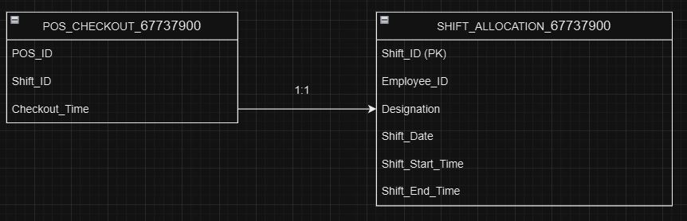

3.4.2.

CREATE TABLE SHIFT_ALLOCATION_67737900 (

Shift_ID INT PRIMARY KEY,

Employee_ID INT,

Designation VARCHAR(50),

Shift_Date DATE,

Shift_Start_Time TIME,

Shift_End_Time TIME

);

CREATE TABLE POS_CHECKOUT_67737900 (

POS_ID INT PRIMARY KEY,

Shift_ID INT,

Checkout_Time TIME,

FOREIGN KEY (Shift_ID) REFERENCES SHIFT_ALLOCATION_67737900(Shift_ID)

);

3.5.1.

HOM and POS_Checkout:

* Each Head of Maintenance (HOM) can manage multiple POS checkouts, but each checkout must be supervised by exactly one HOM.
* A POS checkout cannot occur without being supervised by a HOM.

POS_Checkout and POS_Device:

* Each POS device can be checked out multiple times, but each checkout must involve exactly one POS device.
* A POS device must be linked to a checkout record when in use.

POS_Checkout and Shift_Allocation:

* Each shift allocation can have one POS checkout, but the checkout is optional for the shift.
* A checkout record must correspond to exactly one shift allocation.

4.1.1.

CREATE TABLE HOM_67737900 (

HOM_ID VARCHAR(2) PRIMARY KEY,

HOM_Name VARCHAR(50),

HOM_Surname VARCHAR(50),

HOM_Contact VARCHAR(15)

);

4.1.2.

CREATE TABLE HOM_67737900 (

HOM_ID VARCHAR(20) PRIMARY KEY,

HOM_Name VARCHAR(20),

HOM_Surname VARCHAR(20),

HOM_Contact VARCHAR(20),

MALL_ID VARCHAR(20)

);

4.1.3.

CREATE TABLE HOM_67737900 (

HOM_ID VARCHAR(20),

HOM_Name VARCHAR(20),

HOM_Surname VARCHAR(20),

HOM_Contact VARCHAR(20),

MALL_ID VARCHAR(20),

CONSTRAINT PK_HOM_ID PRIMARY KEY (HOM_ID)

);

4.1.4.

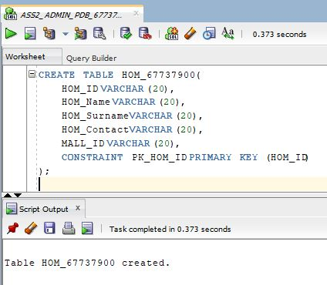

4.2.2.

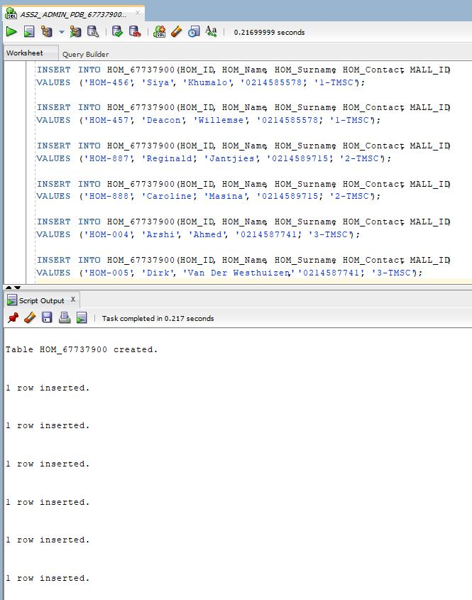

4.3.4.

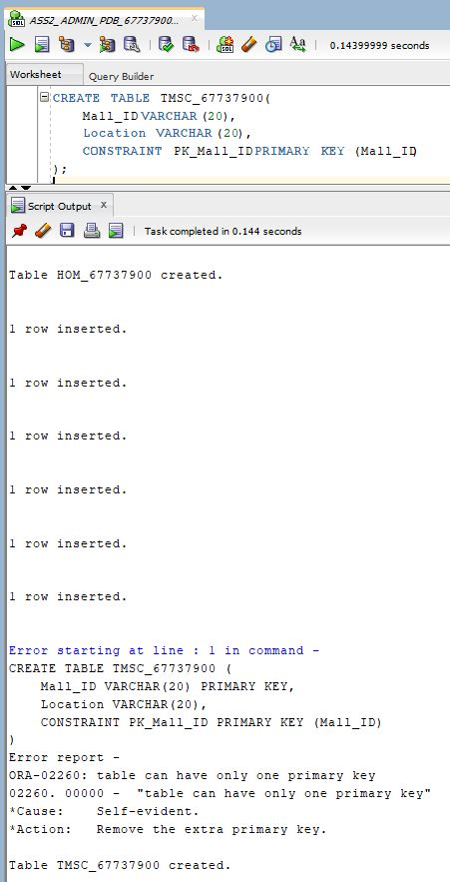

4.4.1.

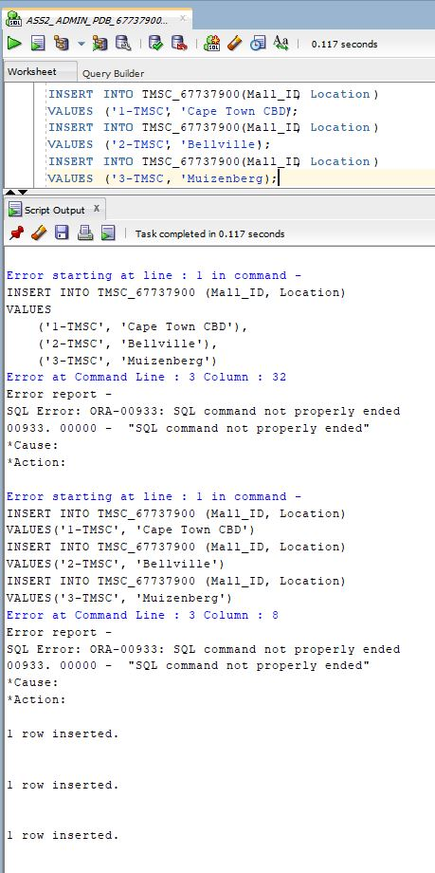

4.5.1