Q.1 Oracle 21c XE.

Q.2 -Disk space: 8.5 gigabytes minimum for Oracle software, plus 2 gigabytes or more for temporary storage.

-RAM: 2 gigabytes RAM minimum.

Q.3

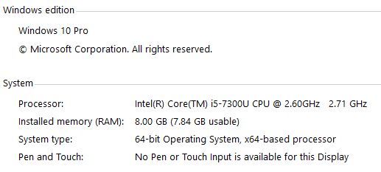

Q.4 You can install 1 copy of Oracle XE per logical environment.

Q.5 Oracle Database XE has a limit on user data storage of 12 GB. If this limit is exceeded, the database will no longer accept new data and will restrict access to existing data until the amount of stored user data is reduced below the limit.

Q.6 You login by providing your credentials in the SQL\*PLUS interface. Also, making sure the oracle database is running in your window’s services.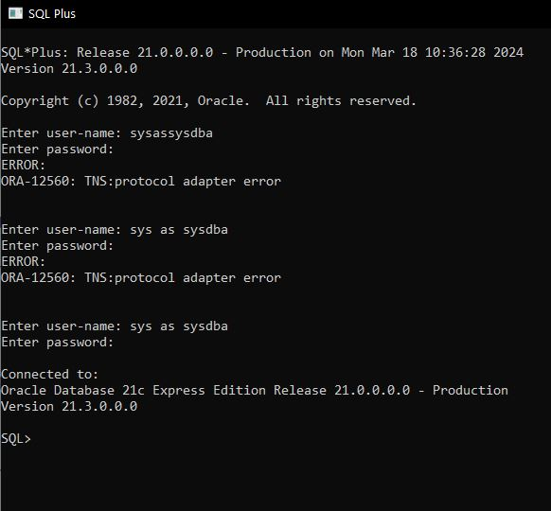

Q.7 ALTER PLUGGABLE DATABASE ALL OPEN;

Q.8 It's a feature introduced in Oracle Database 12c that allows you to create multiple databases within a single Oracle instance. Each pluggable database operates as a self-contained entity with its own set of data files, system and user tablespaces, and administrative users.

Q.9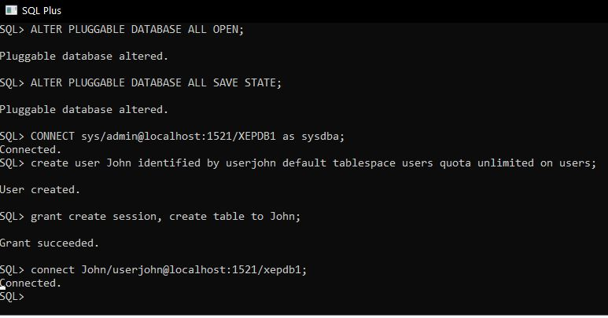

Q.10