Q.1.

1.1.

-Security and safety concerns: Low socio-economic areas can sometimes be associated with higher crime rates or safety concerns. There is a risk that delivery personnel or the meals themselves could be targeted for theft or vandalism.

-**Accessibility and Infrastructure Challenges:** These areas may have poor infrastructure, including inadequate roads, unreliable addresses, or lack of proper signage.

1.2.

-**Real-Time Tracking and Monitoring:** Implement a GPS tracking feature that allows real-time monitoring of delivery vehicles and personnel.

-**SOS Alerts and Panic Buttons:** Include an SOS alert or panic button within the app for delivery personnel to use in case they encounter any danger or threats.

-**Offline Maps and Directions:** Equip the app with offline map capabilities to ensure that delivery personnel can access directions even in areas with poor internet connectivity.

1.3.

-**Theft or Loss of Goods:** If meals are stolen or vandalized, there would be a direct cost to replace the lost or damaged food.

-**Injury to Delivery Personnel:** If delivery personnel are harmed or threatened, there could be medical expenses, compensation claims, and potential legal costs.

-**Delayed Deliveries:** Poor infrastructure leading to delays can increase operational costs due to longer delivery times, higher fuel consumption, and potentially the need for additional delivery staff to cover the same area.

1.4.

-Subsidized Transportation Vouchers: This can reduce the financial burden of travel for beneficiaries.

-Crowdfunding and Donations for Transportation: Allows community members and donors to directly support transportation costs.

-Partnerships with Transportation Services: Direct partnerships can secure better rates and ensure reliable transportation options.

1.5.

-**Enhanced Engagement:** Allowing clients to opt-in for donations actively engages them in the charitable process, creating a personal connection to the cause.

-**Flexibility in Contributions:** Clients can choose the amount they wish to donate, which can potentially lead to higher donations than a fixed percentage of profits.

-**Clear Financial Separation:** By keeping donations separate from meal prices, Culinary Bargain can maintain clear financial records.

-**Profit Stability:** Relying solely on a percentage of net profits for donations can be risky, especially during periods of low profitability.

-**Transparent Pricing:** Separating donations from meal prices keeps the pricing structure transparent for customers.

1.6.1.

If I had to evaluate the potential of both coercive power and reward power, in this case I would have to say coercive power’s potential will be low and reward power’s potential will be high.

-Coercive reason: Using penalties or negative consequences for not collecting meals can discourage beneficiaries from participating in the program.

-Reward reason: Offering incentives for timely meal collection, such as loyalty points, future discounts, or additional meal vouchers, can positively motivate beneficiaries to collect their meals.

1.7.1

-Efficiency and Speed: Freelance developers with specialized knowledge can design and implement the GPS system more quickly than an in-house team starting from scratch.

-Cost-Effectiveness: Outsourcing can be more cost-effective by avoiding long-term employment costs associated with hiring and training in-house staff.

-Access to Cutting-Edge Technology: Collaborating with them provides access to state-of-the-art technology and innovative solutions that might not be available in-house.

Q.2.

2.1.1.

Year 0: -R55,000.00

Year 1: -R32,000.00

Year 2: R2,000.00

Year 3: R54,000.00

Year 4: R119,000.00

Year 5: R196,000.00

2.1.2.

In this case the payback period is the second year. Cash flow at end of year 1 = -R32000 and at the end of year 2 = R2000.

Payback period = 2 years + (2000/34000)

= 2 years and 0.706 months

Therefore, payback period is 2 years and 21 days.

2.2.1.

-R98,000.00 + R23,000.00 + R34,000.00 + R52,000.00 + R65,000.00 + R77,000.00 = R153,000.00

Therefore, the annual cumulative (Years 0 - 5) cash flow for Project T is R153,000.00.

2.2.2.

The third year is the payback period:

Payback period = 3 years + [(11000/52000)*12] months

= 3 years + 0.2115*12

Therefore, payback period is 3 years 2 months and 16 days.

2.3.1.

Net profit = R196000

2.3.2.

ROI = 256%

2.4.1.

Net profit = R55000

2.4.2.

ROI = 79%

2.5.1.

The annual discounted cash flows for Project O, based on the provided discount factors, are:

- Year 0: -R55,000.00

- Year 1: R21,390.00

- Year 2: R29,240.00

- Year 3: R41,080.00

- Year 4: R47,450.00

- Year 5: R52,360.00

2.5.2.

Total discounted cash inflow for Project O is R136,520.00.

2.5.3.

Initial Investment (Year 0 Cumulative Cash Flow): -R55,000.00

Total discounted cash inflow: R136,520.00

NPV = Total discounted cash inflow - Initial Investment

NPV = R136,520.00 - (-R55,000.00)

NPV = R136,520.00 + R55,000.00

NPV = R191,520.00

Therefore, the Net Present Value (NPV) for Project O is R191,520.00.

2.6.1.

NPV = -R98,000.00 + R21,390.00 + R29,240.00 + R41,080.00 + R47,450.00 + R52,360.00 NPV = R93,520.00

2.7.1.

-**Control over Delivery Services:** By partnering directly with Uber for delivery services, Culinary Bargain can ensure a high level of service quality.

-**Brand Independence:** While leveraging Uber Eats' existing infrastructure is advantageous for Project O, Project T maintains brand independence and control over its delivery operations.

-**Cost Management:** Over time, as Culinary Bargain scales its operations and optimizes its delivery processes, it may achieve cost efficiencies comparable to or even better than those offered by Uber Eats.

-**Customization and Innovation:** Project T allows Culinary Bargain to innovate and customize its delivery experience according to its unique business model and customer base.

3.1.

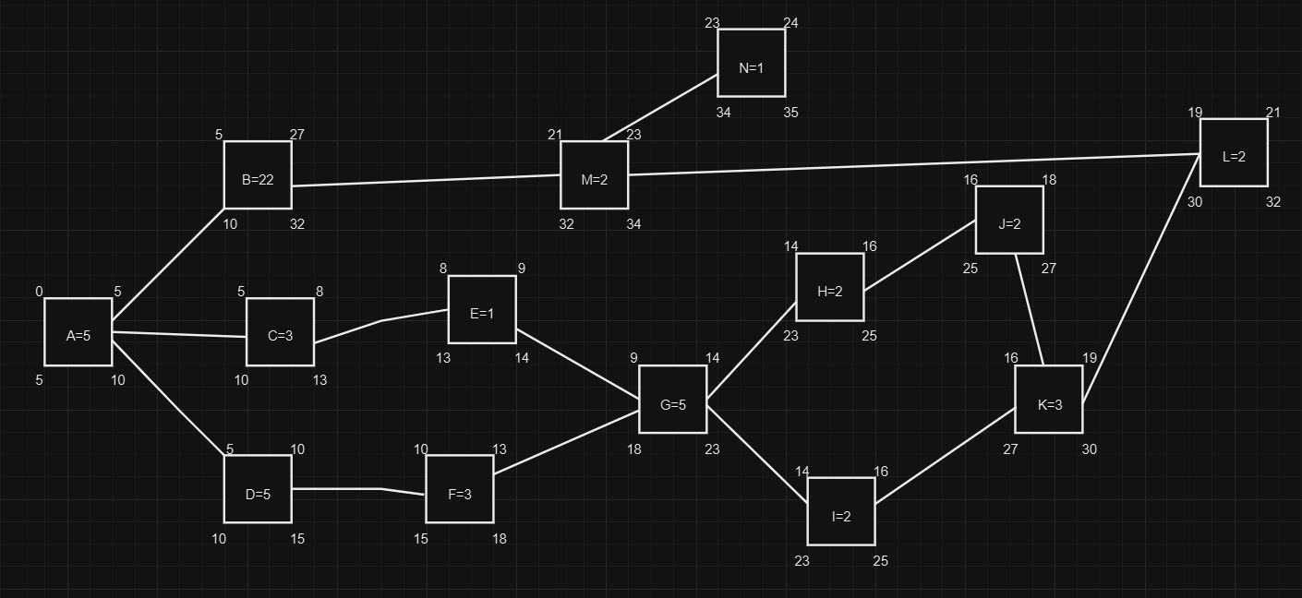

3.2.

Critical path = A-B-M-N

3.3.

There are no activities with a positive slack.

3.4.

1.

-Design the UI for order placement, order status and delivery tracking.

-Implement UI components for placing orders and receiving ETA.

2.

-Document APIs, algorithms and overall system.

-Develop algorithms to determine the best route for delivery.

These dependencies represent the natural order of tasks and cannot be changed or avoided. They are essential for the logical sequence of activities within a project.

Q.4.

4.1.

EV = BAC * Percentage of work completed

EV = 50000*0.28

EV = R14000

4.2.

CV = EV – AC

CV = 14000 – 12500

CV = R1500

4.2.1.

The CV indicates that currently this project is under budget.

4.3.

SV = EV – PV

SV = 14000 – 16667

SV = -R2667

4.3.1.

The negative value of the SV of this project indicates that the project is currently behind schedule.

4.4.

CPI = EV/AC

CPI = 14000/12500

CPI = 1.12

4.4.1.

The CPI of this project indicates that this project is performing well in terms of cost efficiency.

4.5.

SPI = EV/PV

SPI = 14000/16667

SPI = 0.84

4.5.1.

The calculated SPI of 0.84 indicates that this project is currently behind schedule.

4.6.

EAC = BAC/CPI

EAC = 50000/1.12

EAC = R44642.86

4.7.

EAC (time) = Planned duration/SPI

EAC = 30/0.84

EAC = 35.71 days