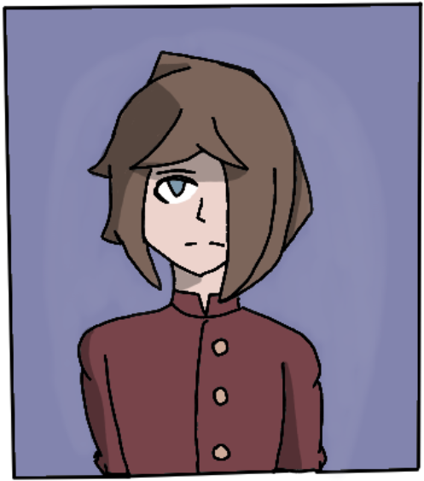

Name: Colton

Age: 6

Birthday: 2078

Gender: Male

Height: 103cm

Weight: 38kg

Nationality: Australian

Occupation: Student

Manga Debut: Chapter 2 - Mayhem Devil

Colton is a disabled live young student who attended Kelvin's school 18 years ago. He became Kelvin's first friend at school after they stood up for him against a group of bullies.

**Appearance**

Colton is a thin boy of small stature and has pale skin. He has blue eyes and brown hair styled in a fringe that covers one of his eyes. He wears a maroon button up school uniform and can be seen wearing leg braces and walking using crutches.

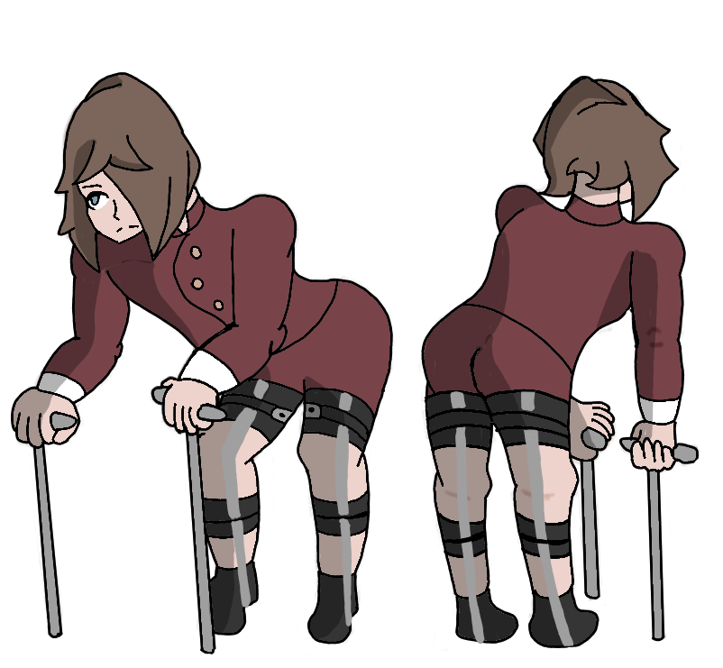

**Personality**

Colton is a timid and nervous but well mannered boy. He appears to be sensitive which is shown when Colton begs for one of his school bullies to give him his crutches back only for them to laugh at and make fun of him. After Kelvin sticks up for him Colton expresses gratitude towards Kelvin and quickly becomes friends with them. When Kelvin explains his family situation to Colton, the boy expresses empathy for Kelvin.

**Relationships**

Kelvin - Colton became friends with Kelvin after they stood up for him. Their friendship is brand new and has only just began developing. It is unknown what Kelvin and Colton’s relationship is like in the current day.