Step 1: Setup the virtual environment

1. Open the **forummind** folder
2. Ensure you have **python3** and **virtualenv** installed**.**
3. Open up a terminal
   1. For Windows: Open Windows Powershell(Non ISE Version)
   2. For macOS open up a bash terminal
4. Change directory into the working directory of the **forummind** folder
5. Create a virtual environment using the following command and wait for installation.

virtualenv myenv

1. Activate the virtual environment typing the following command into the terminal.

For Windows: myenv/scripts/activate

For macOS: source myenv/bin/activate

Step 2: Install Requirements and run web app

1.Type **pip install -r requirements.txt** in the terminal

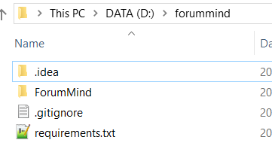(In this example, directory **forummind** is here)

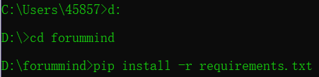

2.Run server by saying **python manage.py runserver** in the directory **forummind/ Forummind**.

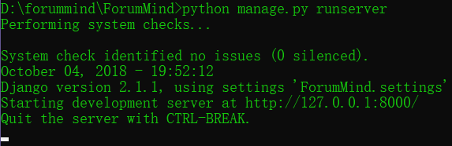

3.Open **localhost:8000/visualiser** in browser.



4. The web application should be activated.