**Question#1**

**R code:**

q1a<-c(229,109,118,46)

> label<-c("Government","Military","Commercial","Civil")

> pct<-round(q1a/sum(q1a)*100)

> label<-paste(label,pct)

> label<-paste(label,"%",sep="")

> pie(q1a,labels=label,col=rainbow(length(q1a)),main="Ownership Secors")

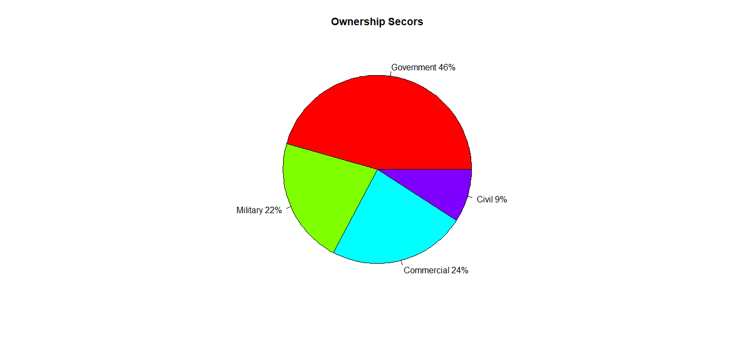

q1b<-c(59,91,281,1)

> label<-c("Government","Military","Commercial","Civil")

> label<-paste(label,pct)

> label<-paste(label,"%",sep="")

> pie(q1b,labels=label,col=rainbow(length(q1b)),main="Ownership Sectors")

