Tabitha Roemish

Assignment 3: RationalNumbers

Testing File Name: CRationalTests.cpp

See next page for additional, non-unit testing

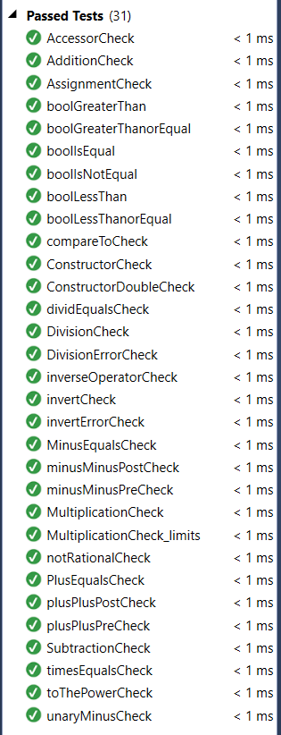

|  |  |  |  |  |
| --- | --- | --- | --- | --- |
| Values entered | Expected output | Actual Output | Reason for Discrepancy | Reason for Test |
| a: 5/24  b: 3.207 | a: 5 /24  b: 3207/1000 | … | When the double constructor is built, the safeRead breaks so I’ve added a prompt to press enter again because I ran out of time to resolve this. | To make sure that the operator>> function reads in all data types. |
| a: 32 | B: 32 | 0 | Does not work for int |  |
|  |  |  |  |  |