Tabitha Roemish

CSS 342 B

HW5 – Tree Traversal

**Program Definition:**

This program demonstrates the preOrder, inOrder, postOrder and breadth search of three binary search trees with 10 or more integers. The three binary trees model a left-imbalance, right-imbalance and balanced tree. The breadth “search” does not traverse the tree but flattens the tree into a queue. And if necessary, searching would be possible within the queue. Since traversal for breadth wasn’t specified I believe this is a valid search option.

I wrote unit tests for this project and included the file in the zip folder (CATCH_UNIT_TESTS.cpp). It’s been commented out because it cannot run with main so if you are compiling you can just exclude it. Here is test output:

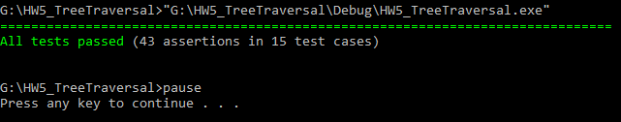

**Program Instructions:**

There is no input required for this program. The program demonstrates the 4 traversal/searches on three trees.

**Program output:**

