Pokémon Card Coliseum

ECE4007 Senior Design Project

Section L03, TableTop Team
Project Advisor, Dr. Linda Milor

Nanley Chery
Cameron Lewis
Pratima Narlajarla
Catherine Runyan
Wes Swinson

Submitted

February 13, 2012
Table of Contents

Executive Summary ii

- Introduction 1

  - Objective 1
  - Motivation 2
  - Background 2

- Project Description and Goals 3

- Technical Specification 6

- Design Approach and Details

  - Design Approach 8
  - Codes and Standards 13
  - Constraints, Alternatives, and Tradeoffs 13

- Schedule, Tasks, and Milestones 15

- Project Demonstration 16

- Marketing and Cost Analysis 17

  - Marketing Analysis 17
  - Cost Analysis 18

- Summary 20

- References 21

Appendix A 22

Appendix B 23

Appendix C 24
Executive Summary
Team TableTop is requesting $309,250 in funding to develop Pokémon Card Coliseum, an interface between the traditional Pokémon Trading Card Game (TCG) mat and a tablet PC via an RFID reader. The Pokémon Card Coliseum provides players with a unique way to play the traditional Pokémon TCG, displaying real time animation based on game play using 2D graphics. The project engineers will design a Pokémon TCG mat with integrated RFID reader to interface with an Android tablet, specifically a Samsung Galaxy 10.1 tablet for the prototype. During game play, players will swipe Pokémon cards with RFID tags over the RFID reader and "into" the game, an Android application developed by project engineers. This will allow the tablet to track and animate game play. The design prototype will include a limited set of Pokémon cards to demonstrate game play. Five Pokémon, basic energy cards (Fighting, Fire, Grass, Lightning, Psychic, and Water), and three trainer cards will be used. The major components include an Android Tablet with 30-pin input, a USB-to-30-pin-input adapter, a USB-out RFID reader, and a standard Pokémon TCG mat containing spaces for: a bench, active Pokémon, prize cards, the player’s deck, and a discard pile. The design team will demonstrate various aspects of play, showing the software cleanly handles varying aspects of the card game and displaying relevant information to the user easily. The design of our GUI has been streamlined to include as few buttons as possible, providing an immersive experience for users.
There will be an estimated $2,975,000 in profit over Pokémon Card Coliseums four year lifetime, with units to be sold at between $100 and $125.
Pokémon Card Coliseum
1. Introduction
Team TableTop is requesting $309,250 in funding to develop Pokémon Card Coliseum, an interface between the traditional Pokémon Trading Card Game (TCG) mat and a tablet PC via an RFID reader. Pokémon Card Coliseum will enable players to keep score via the tablet, while enjoying animated game play.
  - Objective
The Pokémon Card Coliseum provides players with a unique way to play the traditional Pokémon TCG, displaying real time animation based on game play using 2D graphics. Recently, video games have overtaken card games in popularity because video games provide dramatic play via game visualization. Pokémon Card Coliseum will similarly dramatize the Pokémon TCG, converting cards into animated Pokémon on-screen. This combines the best elements of both playing cards and video games – players will still have concrete cards to collect, but will also be able to animate their play via a tablet display. This virtual platform will provide current Pokémon card players with a new way to play their favorite game and also draw the interest of users who would otherwise choose video games over the more traditional TCGs. Moreover, with the popularity of tablets among every age rising rapidly, Pokémon Card Coliseum is ensured a continuously growing customer base over its lifetime.

  - Motivation
The Pokémon TCG has remained unchanged for years, causing a decline in its popularity. However, TableTop’s Pokémon Card Coliseum will bring a fresh perspective to one of the world’s most popular TCGs [1]. Pokémon TCG players range in age from as young as six to players in their early twenties, providing a large target audience.
  - Background
While there have been plenty of video games that simulate TCGs, there have been few commercially available products designed to link physical cards with video games. A similar product, the Academy Duel Disk, improves the Yu-Gi-Oh TCG. However, this Yu-Gi-Oh extension only functions as a display of game statistics (e.g. player’s health points). The Pokémon Card Coliseum aims to not only track the status of game, but also provide real-time animation.

2. Project Description and Goals
The project engineers will design a Pokémon TCG mat with integrated RFID reader to interface with an Android tablet, specifically a Samsung Galaxy 10.1 tablet for the prototype. Figure 1 contains a mock up for this prototype.
Playing Mat
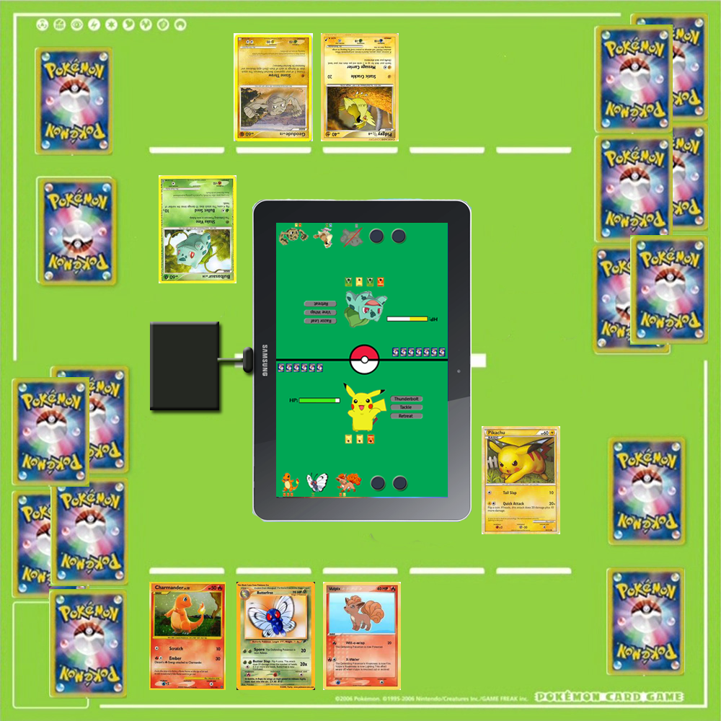
RFID Reader
Tablet
Pokémon Card
Reader to Tablet Connection
Figure 1. Mock-up for Pokémon Card Coliseum mat with connected tablet.
During game play, players will swipe Pokémon cards with RFID tags over the RFID reader and "into" the game, an Android application developed by project engineers. This will allow the tablet to track and animate game play.
The mat will have the following properties:
- Integrated low frequency RFID reader able to output to USB
- Connection to Samsung Galaxy Tablet 10.1 from RFID reader via a USB to 30-pin input converter
- Power received from tablet to RFID reader via same USB connection
- Cost no more than $150 to cover the cost of materials and application development
Also, the Android application must provide the following functionality:
- Display animations corresponding to players' game moves
- Keep score by tracking of each Pokémon’s hit points (HP)
- Simulate die rolls and coin flips as necessary throughout game
- Display each player's active and benched Pokémon, and associated energy and HP
- Allow players to add energy and trainer cards to Pokémon
Traditionally, the Pokémon TCG requires energy tokens to track damage to individual Pokémon from attacks executed by the opposing player. With Pokémon Card Coliseum’s tablet interface, damage can now be tracked by the program, eliminating the need for extraneous energy tokens. Similarly, certain plays in the game require players to flip coins and roll die to determine a moves outcome. The Android application eliminates the need for these items as well, as it will simulate both coin flips and die rolls as appropriate during game play. The only requirement placed on players is that as they put new cards into play, the card must be scanned over the RFID reader. From that point, all moves available in the game can be selected through the tablet interface.
The design prototype will include a limited set of Pokémon cards to demonstrate game play. Five Pokémon, basic energy cards (Fighting, Fire, Grass, Lightning, Psychic, and Water), and three trainer cards will be used. The code required for these cards can easily be extended to include the additional 250 Pokémon cards available to Pokémon TCG players today, but will require the allocation of supplementary funding to produce.
These project goals will provide an easy, interactive way for players to play the Pokémon TCG, eliminating the need for peripheral items beyond Pokémon cards as well as providing a visual representation of the game’s progression.
- Technical Specifications
The design’s two major components are the RFID system and the host computer, a Samsung Galaxy 10.1 Tab tablet. The RFID reader is powered from the host computer’s USB port via a USB adapter. As cited in Table 1, the size of the reader is 62.2mm by 85.5mm, making the RFID reader easy to integrate into the mat.
Table 1. Parallax RFID Reader Module (#28340) Specifications
Parameter | Specification
Supply Voltage (V_{cc}) | 4.5V-5.5V
Supply Current, Idle (I_{Idle}) | 10mA
Supply Current, Active (I_{cc}) | 100mA-200mA
Input LOW voltage (V_{IL}) | 0.8V
Input HIGH voltage (V_{IH}) | 2.0V
Output LOW voltage (V_{OL}) | 0.6V
Output HIGH voltage (V_{OH}) | Vcc-0.7V
Dimensions | 62.2mm x 85.5mm
Operating Temperature | - 40ºC – 85ºC

The RFID system is activated at 125 kHz and has a reading range of 2-5 inches as shown in Table 2. Low frequency RFID readers such as the Parallax are characterized by small reading radii, which will ensure that cards on the mat will only be scanned when a player intentionally swipes the card over the reader.
Table 2. RFID Tag Specifications

Parameter | Specification
Activating Frequency | 125 kHz
Range | 2 to 5 inches
Dimension | 54mm X 85 mm

As shown in Table 1, the RFID reader consumes 10mA when idle and 100-200mA of current when active. Since the tablet, as shown in Table 3, has a 7000mAh battery life, the tablet should be able to support the RFID reader for approximately 450 hours. Essentially, the power consumption by the reader will not have a negative impact on the tablet’s battery life.
Table 3. Samsung Galaxy Tab 10.1 Tablet Specifications

Parameter | Specification
Size | 256.7 x 175.3 x 8.6mm
Pixels per inch | 149 ppi
Battery | 7000mAh (built-in)
Operating System | Honeycomb

- Design Approach and Details
  - Design Approach
    - Components
The Card Coliseum is designed with consideration for user experience as well as technical feasibility. The major components include an Android Tablet with 30-pin input, a USB-to-30-pin-input adapter, a USB RFID reader, and a standard Pokémon TCG mat containing spaces for: a bench, active Pokémon, prize cards, the player’s deck, and a discard pile. Figure 2 shows this setup.
Pokémon Bench

Prize
Cards

Discard Pile

Player Deck

Active Pokémon

Figure 2. Mock-up for playing mat with tablet interface.

    - Android Tablet
The Samsung Galaxy Tab 10.1 tablet will be used to provide visual feedback on the current game status as well as an input method to perform game functions. The designers decided on this tablet because of its open and extendable Android platform. As this tablet runs Android 3.2, the programmed Android application will be targeting the 3.2 API. The game will be rendered using an Android game development framework called libgdx. This gaming framework will abstract much of the basic Android drawing API and allow developers to start developing the user-facing components soon after programming begins.
    - RFID Reader
The Parallax RFID Card Reader Module with USB (#28340), shown in Figure 3, will read RFID tags and transfer the information to the Samsung Galaxy tablet. Every tag has a unique 10 digit ID. These tags will activate at an operating frequency of 125 kHz, classified as a low frequency RFID system. The range within which a tag is detected and read by the reader is two to five inches.
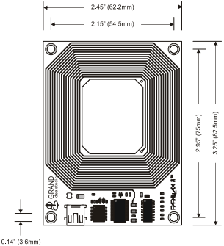

Figure 3. Parallax RFID Reader Module

A USB adapter, connected to the tablet through the 30-pin input, will be used to make the connection between the reader and the tablet. The reader will be powered from the adapter’s USB port and will utilize an industry-standard TDI FT232R device to provide this connectivity. Figure 4 shows the connection between the RFID reader and the tablet.
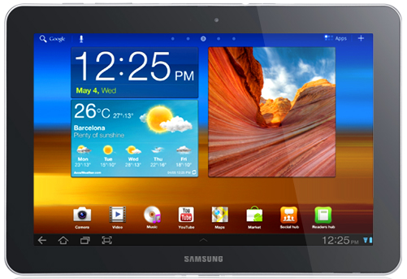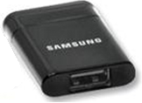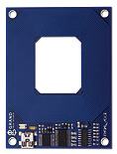
Samsung Galaxy Tab 10.1 Samsung Galaxy Tab Parallax RFID Reader
USB Adapter Module

Figure 4. Connection between RFID reader and tablet.

The information sent from the RFID reader can be accessed via a Virtual COM port when connected to the tablet. A COM port number will be automatically assigned to the reader output, which can then be accessed by any software application for the tablet that provides COM port connectivity. This will allow the data stream transmitted by the module to be read by the application [2].
When the RFID Card Reader is active and a valid RFID tag is placed within range of the activated reader, the tag’s unique 10 digit ID will be transmitted as a 12-byte ASCII string serially to the tablet in the following format:
Start Byte | Digit 1 | Digit 2 | Digit 3 | Digit 4 | Digit 5 | Digit 6 | Digit 7 | Digit 8 | Digit 9 | Digit 10 | Stop Byte
The start and the stop bytes that correspond to the line feed and carriage return characters are used to identify the correct string. The remaining 10 bytes are the RFID tag’s unique ID. TableTop’s Android application will decode this string of bits to determine which card has been swiped. For example, a Pikachu Pokémon card might be represented by the ID “Start 1235438760 Stop.”
    - GUI
Figure 5 shows the game user interface (GUI) main screen.
Defeated Pokémon
Benched Pokémon
Open Bench Spots

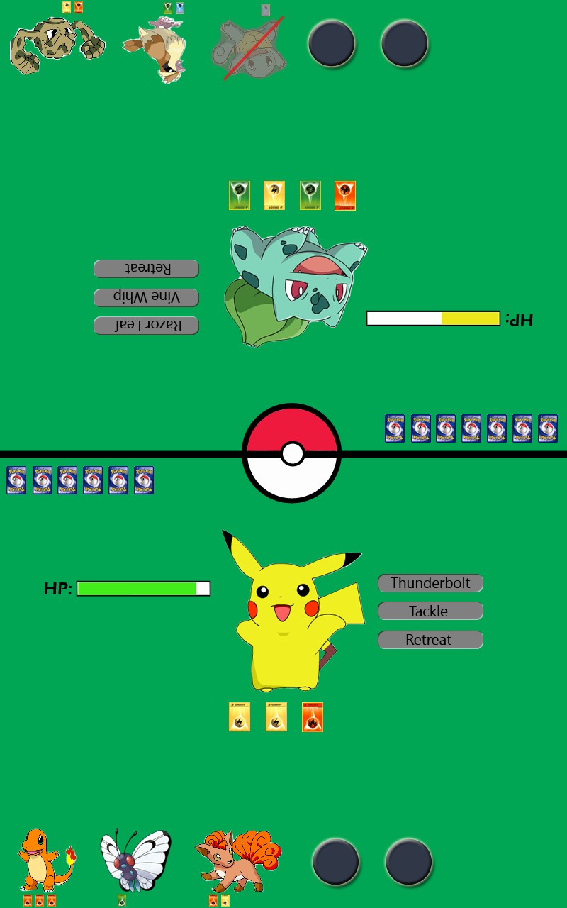
Remaining Prize Cards
Active Pokémon
Remaining HP
Possible Moves
Energy Cards

Figure 5. GUI main screen mock-up.

The screen will display the active Pokémon in the center with energies attached below and a bar to represent the Pokémon’s remaining HP points to the left. Energy cards are required to execute attacks during the game. Therefore, the application will check to make sure a player has the prerequisite energy required to before allowing an attack. Buttons to the right of the Pokémon represent a player’s possible moves. The bottom of the display shows the benched Pokémon and their associated energy. On the top left side of the field is a count of the Player’s remaining Prize Cards. Each time a player defeats an opponent’s Pokémon, they are allowed to select one Prize Card set aside at the beginning of game play. When a player has no remaining Prize cards, they have won the game.
    - Organization and Testing
The Android application will be cooperatively developed by all team members. Groups will be formed to separately develop input, audio, graphics, and logic.
The groups in charge of audio an graphics will use a combination of freely available media as well as manually generated media for our game. Both groups define the specifications of each file as well as the specifications needed to interface with media.
The group in charge of the game logic will initially define an API for each of their classes. This will allow each member within the group to work on separate parts of the whole game.
The modules created by each group will be uploaded to a server containing an online Version Control System (VCS). Such systems allow developers to see the history of changes that occur during development and provide the ability to revert to earlier versions of code to erase unwanted changes. A Distributed VCS named Git has been chosen by the design team due to its speed and ability to work offline. One team member will act as an integration manager, reviewing the changes uploaded by each member and making sure there are no inter-module conflicts.
The software developed for the game, as well as the code used to interface with the RFID reader, will be written and tested prior to uploading the code into the central server. The integration manager will routinely test the code in the central branch and make sure each module is performing as specified. This methodology will quickly catch newly introduced problems.
  - Codes and Standards
The Parallax RFID Card Reader (#28340) will use industry-standard TDI FT232R device to provide connectivity to the tablet’s USB port. It features:
- Single chip USB to asynchronous serial data transfer interface
- Data transfer rates from 3000 baud to 3 Mbaud at TTL Levels [3].
  - Constraints, Alternatives, and Tradeoffs
    - Constraints
The RFID reader is connected to the tablet through the 30-pin input, which is also used to power the tablet. Therefore, the user cannot play the game and power the tablet simultaneously. However, the tablet’s long battery life minimizes the impact of this conflict. The team chose this design to eliminate the need for an additional power source for the mat.
Also, developing Pokémon Card Coliseum on an Android platform restricts the number of tablets on the market the game can be played with. Specifically, the game will not be compatible with iPads or Microsoft OS tablets. However, since Android is an open source platform, there is a wealth of code already available to jump start the programmer’s game development. In addition, further development of Pokémon Card Coliseum could easily include versions for both iPads and Microsoft OS tablets.

    - Alternatives
Camera-based image processing was considered as an alternative to using RFID tags and readers. This technology would allow trading card manufacturers to continue producing cards without the addition of RFID components. It would also allow players to use their current collection of cards, eliminating the need for players to buy a RFID tag add-on or new cards with embedded tags. While this technology would save money for current card owners and manufacturers, it would also limit the flexibility and increase the price of the product. Optical processing would require the user to have proper lighting conditions and would require technically complex software for image analysis - increasing the chance of bugs and card-detection failure.

Additionally, the team considered implementing the design with a wireless component to transfer data between the RFID reader and the tablet. While this would allow the tablet to be powered during game play, it would also require an external power source for the mat, making game play impractical in location without power outlets. Furthermore, the wireless protocol necessary to connect the reader to tablet would lengthen the design process and complicate the design schematic. Therefore, the simpler, more user friendly design was selected.

The design team also studied a number of platforms, APIs, and GUI developers to program the game before choosing the Android platform for its open source nature. Specific APIs and GUI developers were chosen based on the programming team’s past experience to facilitate strong programming foundation. Team members new to programming will be able to refer to members with some experience in these environments.
5. Schedule, Tasks, and Milestones
The TableTop team will be designing and implementing a Pokémon Card Coliseum prototype over the next three months. Appendix A contains the list of project tasks and major milestones in the form of a Gantt chart. Pratima will be the head of the hardware design team and will check periodically to ensure hardware design is on schedule. The team has projected a March 4th deadline for a preliminary mat prototype to be constructed. Similarly, Nanley will head the software team. Application design should be completed by April 28th. The final presentation on May 4th marks project completion. Katie will be responsible for compiling the presentation slides and the team will be conducting rehearsals the week prior.
- Project Demonstration
Our demonstration will include a run though of gameplay with our product. TableTop will construct a prototype consisting of a USB-out RFID reader, an input converter (from USB to Samsung Galaxy Tab’s 30-pin input), and a Samsung Galaxy Tablet PC. The demonstration game will be played with the product prototype. The design team will demonstrate various aspects of play, showing the software
- cleanly handles varying aspects of the card game
- displays relevant information to the user easily
- ensures adherence to the rules of the game
- reduces clutter during play by removing certain cards and counters from the field of play
The product will be able to read in a variety of Pokémon cards. If a user attempts to play a card invalidly, the game will explain why that card cannot be played, and dismiss the action.
- Marketing and Cost Analysis
  - Marketing Analysis
The target audience of the Pokémon is children under the age of 18. The Pokémon franchise has succeeded in large part due to its marketing strategy, encouraging competition amongst its audience and selling the idea that each new product is necessary in order to become an expert, or “Pokémon Master.”

Beginning with the original Pokémon video game for the Game Boy, players needed to obtain every individual Pokémon in order to beat the game. Since different version of the game were packaged with different sets of Pokémon, players had to either purchase both versions of the game or trade Pokémon with friends to “catch ‘em all.” This strategy worked well, encouraged interaction amongst players in an unprecedented way and selling what were essentially duplicates of the same game. The trading cards, released shortly after the video games, added an additional component for players to collect.

These products are the backbone of the Pokémon franchise, and the success of Pokémon Card Coliseum hinges on its ability to create a new experience for the Pokémon enthusiast. Each new product brings something different to the table. A new card set features new Pokémon for the player to collect. The new versions of the video game feature new Pokémon in each installment. For Pokémon Snap the object of the game was to take pictures of Pokémon. This put Pokémon in a different frame for players, making them appear as wild animals that had to be lured out into the open for their pictures to be taken. Another aspect of Pokémon to be pushed by the Pokémon franchise, players could actually print out the pictures they had taken in game, providing a new, previously unavailable experience. Pokémon Card Coliseum will do much of the same.

In order for Pokémon Card Coliseum to become another staple in the franchise, TapleTop must market the device as a new way to experience an aspect of Pokémon that already has a wide user base. The team will do this by demonstrating the product not only provides an engaging display for players, but improves gameplay by removing some of the physical clutter of the card game and acting as a monitor. The Pokémon Card Coliseum offers a new experience for TCG players
  - Cost Analysis
The total development cost for prototype development is approximately $309,250, as shown in Table 4.
Table 4. Total Development Cost
Total Non-Recurring Cost | $103,083
Overhead (200%) | $206,167
Total Development Cost | $309,250
Total Units Sold | 100,000
Development Cost Per Unit | $3.09

Appendix B details the total non-recurring costs for product development. Over the prototype’s development will three engineers, two programmers, and one non-engineer over the course of four months. The largest cost during production will be employee compensation for research and development, estimated to be $73,501. Appendix C details estimated production costs.
Table 5 includes Revenue and Costs based on a projection of 105,000 units sold over the course of four years. Pokémon Card Coliseum will be priced between $100 and $125.
Table 5. Revenue and Costs
 | Year 1 | Year 2 | Year 3 | Year 4
Sales Volume (units) | 20,000 | 50,000 | 30,000 | 5,000
Unit Price | $100 | $120 | $125 | $110
Sales Revenue | $2,000,000 | $6,000,000 | $3,750,000 | $550,000
 | Year 1 | Year 2 | Year 3 | Year 4
Non-Re Cost per unit | $3.09 | $3.09 | $3.09 | $3.09
Non-Re Cost | $61,850 | $154,625 | $92,775 | $15,463
Research and Development | Year 1 | Year 2 | Year 3 | Year 4
Redesign | $2,500 | $2,500 | - | -
Change Order | $10,000 | $10,000 | - | -
Based on these projections, Table 6 provides a summary of total costs and profit for the product’s four year life cycle. There will be an estimated $2,975,000 in profit over Pokémon Card Coliseums lifetime.
Table 6. Summary
 | Year 1 | Year 2 | Year 3 | Year 4
Total Cost Per Year | $700,000 | $1,850,000 | $1,020,000 | $160,000
Overhead (150%) | $1,050,000 | $2,775,000 | $1,530,000 | $240,000
Adjusted Cost | $1,750,000 | $4,625,000 | $2,550,000 | $400,000
Adjusted Cost Per Unit | $87.50 | $92.50 | $85.00 | $80.00
Total Profit Per Year | $250,000 | $1,375,000 | $1,200,000 | $150,000
Profit Per Unit | $12.50 | $27.50 | $40.00 | $30.00
 |  |  | Total Profit | $2,975,000

- Summary
The design team has studied the game of Pokémon and planned the architecture for the visual display for our game. The GUI design has been streamlined to include as few buttons as possible, providing an immersive experience for users. Development has begun on the software for this product, and the design team hopes to develop the GUI as quickly as possible, so that development of the game itself can begin. Work has been allocated among group members as necessary for development of both hardware and software. Currently, parts are being ordered to build an initial hardware prototype. Hopefully product development will be completed early on in the design cycle, so most resources can be dedicated to software development.
- References
[1] B. David-Marshall, et al. “Trading Card Game Industry White Paper,” August 2009. [Online]. Available: http://www.top8magic.com/audio/2008q4/Trading%20Card%20Game%20Indust ry%20White%20Paper.pdf [Accesses Feb. 3, 2012].
[2] Parallax Inc., “RFID Card Reader Serial & USB” #28140/28340 datasheet, March 2010.
[3] Future Technology Devices International Limited, “FT232R USB UART IC” datasheet, Version 2.09, April 2011.

Appendix A: Gantt Chart
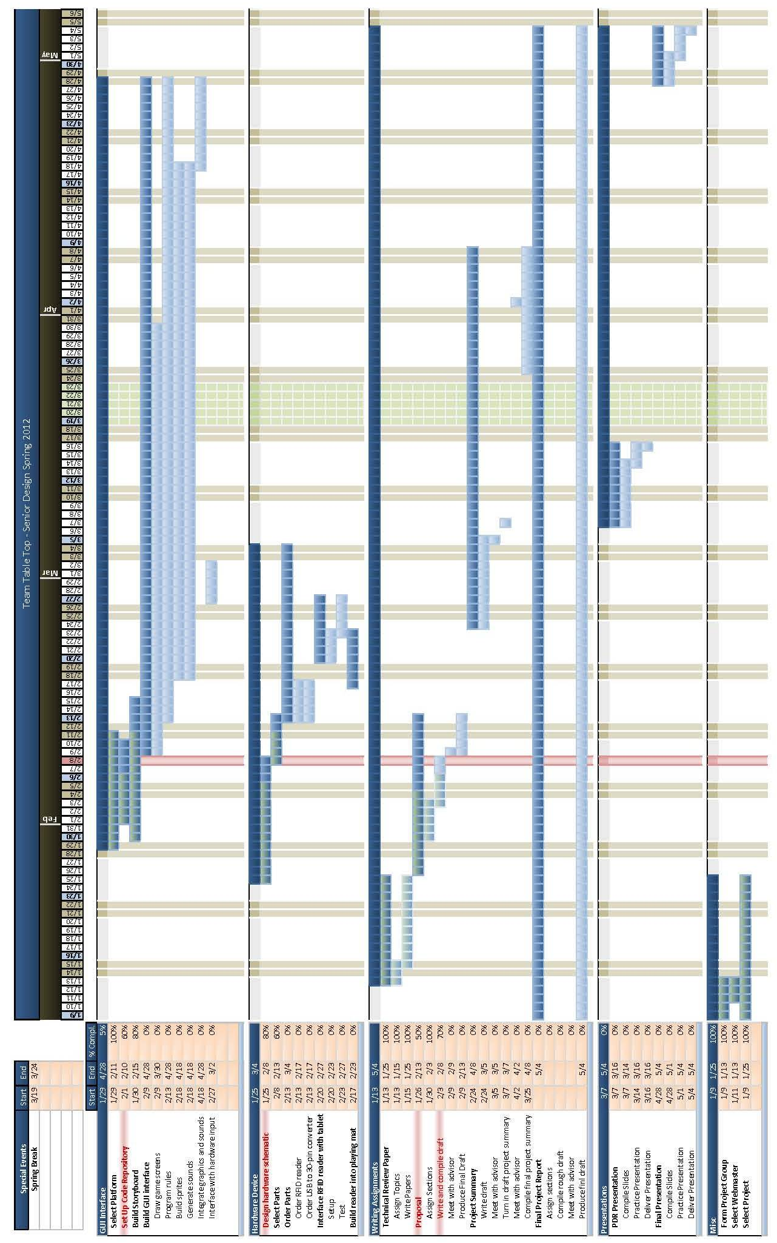
Appendix B: Non-Recurring Development Costs
Table 7. Non-Recurring Costs
Research and Development |  |  | Number | Salary/Yr |  | Months |  |  | Cost
Employees
 | Engineer |  | 2 | $50,000 |  | 2 |  |  | $16,667
 | Programmer |  | 2 | $50,000 |  | 4 |  |  | $33,333
 | Non-Engineer |  | 1 | $30,000 |  | 2 |  |  | $5,000
 | Materials & Supplies |  | - | - |  | - |  |  | $1,000
 | Computer Systems |  | - | - |  | - |  |  | $5,000
Documentation
 | Engineer |  | 1 | $50,000 |  | 1 |  |  | $4,167
Design for Testibility
 | Engineer |  | 1 | $50,000 |  | 1 |  |  | $4,167
 | Programmer |  | 1 | $50,000 |  | 1 |  |  | $4,167
Production |  |  | Number | Salary/Yr |  | Months |  |  | Cost
Setup Charges
 | Engineer |  | 1 | $50,000 |  | 0.5 |  |  | $2,083
 | Non-Engineer |  | 1 | $30,000 |  | 1 |  |  | $2,500
Testing Design
 | Engineer |  | 1 | $50,000 |  | 0.5 |  |  | $2,083
 | Non-Engineer |  | 1 | $30,000 |  | 1 |  |  | $2,500
Packaging |  |  | Number | Salary/Yr |  | Months |  |  | Cost
Package Design
 | Non-Engineer |  | 1 | $30,000 |  | 0.5 |  |  | $1,250
Miscellaneous |  |  | Number | Salary/Yr |  | Months |  |  | Cost
Marketing
 | Non-Engineer |  | 1 | $30,000 |  | 3 |  |  | $7,500
Sales
 | Non-Engineer |  | 1 | $30,000 |  | 2 |  |  | $5,000
Distribution
 | Non-Engineer |  | 1 | $30,000 |  | 1 |  |  | $2,500
Support
 | Engineer |  | 1 | $50,000 |  | 1 |  |  | $4,167
 |  |  |  |  |  | Total Non-Recurring Cost |  |  | $103,083
Appendix C: Non-Recurring Development Costs

Table 8. Production Costs
Production Costs per unit |  | Year 1 |  |  | Year 2 |  | Year 3 | Year 4
Parts |  | $30 |  |  | $32 |  | $29 | $27
Assembly |  | $2 |  |  | $2 |  | $2 | $2
Packaging |  | $1 |  |  | $1 |  | $1 | $1
Testing |  | $2 |  |  | $2 |  | $2 | $2
Marketing |  | $1.50 |  |  | $0.60 |  | $1 | -
Sales |  | $1.50 |  |  | $0.60 |  | $1 | $3
Distribution |  | $3 |  |  | $3 |  | $3 | $3
Support |  | $1.50 |  |  | $0.60 |  | $1 | $3
Total |  | $35 |  |  | $37 |  | $34 | $32
Total Production Costs |  | Year 1 |  |  | Year 2 |  | Year 3 | Year 4
Parts |  | $600,000 |  |  | $1,600,000 |  | $870,000 | $135,000
Assembly |  | $40,000 |  |  | $100,000 |  | $60,000 | $10,000
Packaging |  | $20,000 |  |  | $50,000 |  | $30,000 | $5,000
Testing |  | $40,000 |  |  | $100,000 |  | $60,000 | $10,000
Marketing (1 Non-Engineer) |  | $30,000 |  |  | $30,000 |  | $30,000 | -
Sales (1 Non-Engineer) |  | $30,000 |  |  | $30,000 |  | $30,000 | $15,000
Distribution |  | $60,000 |  |  | $150,000 |  | $90,000 | $15,000
Support (1 Non-Engineer) |  | $30,000 |  |  | $30,000 |  | $30,000 | $15,000
Total |  | $700,000 |  |  | $1,850,000 |  | $1,020,000 | $160,000

