How to create a Plan
Once the pool has been created, it’s time to create the plan. The plan defines the conditions that will apply to the grants issued under it, including key terms such as vesting, strike price or leaver definitions. These conditions will automatically apply to all grants linked to the plan, although they can be customized for specific grants if exceptions are needed.
To create the plan go to Equity Plans > Plans and complete the following fields:
- Plan name: name of the Plan. Employees receiving grants from a Plan will be able to see the name.
- From pool: pick the Pool to be used to issue shares for this Plan.
- Date: the day when the ESOP was approved, usually the same as the Pool creation date.
- Grant type: type of ESOP, pick between Stock options or Phantom shares. It's very important to choose the right one as it has implications for the cap table. If in doubt, review your legal documents or ask your lawyer.
- Price: set up strike and purchase price.
- Vesting: pick among the options to set up the vesting schedule, cliff, etc.
- Definitions: the details of good leaver, bad leaver and liquidation event. Stock holders will be able to see it.

How does an Employee Stock Option Plan work?
There are 3 typical financial instruments used for ESOPs: stock options, stock and phantom shares.

Stock options
Mainly, companies use stock options for their compensation plans. When these are granted, employees receive equity upon exercising under several conditions. The process can be explained using the graph. Observing it below, we can see that the grant date and the exercise date are different. The gap represents a cliff period under the vesting schedule that needs to pass before an employee can exercise.
For example, an employee can choose to exercise a desired number of vested (available) shares whenever she wants, during the exercise window. At the point of the exercise, the employee buys shares and pays only the strike price of $10,which represents a plan’s condition where an employee receives an 80% discount and pays only 20% of the fair market value of $50 ($50*0.2=$10). Moreover, to gain from the value increase, she holds these shares until deciding to sell.
It is essential to understand that the graph represents an ideal scenario where a company survives and its shares rise in value. However, since the world isn’t all rainbows and unicorns, there is a chance that companies’ shares don’t grow. In that case, an employee will have to think twice before deciding to exercise the grants and buying shares that have not (yet) grown in value.
Graph: An ideal scenario when granted employee stock options
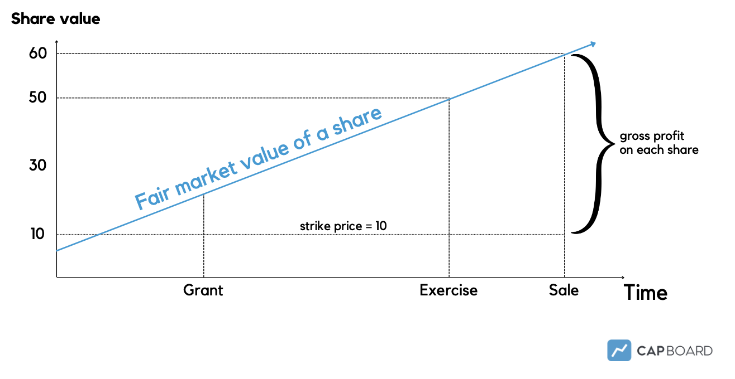

Stock
Companies can use other types of financial instruments as a part of their compensation plan. In the case when stocks are granted, employees receive shares at the moment of the grant. So these can be exercised right away without the need to wait for the vesting process to happen. Thus, employees can exercise the grants whenever they desire and become shareholders of the company at that moment.

Phantom shares
Phantom shares , also known as virtual stock options, work similarly to stock options. However, upon exercising or when the liqudity event (stakeholders can cash out their ownership: acquisition, merger, IPO) happens, employees receive cash directly rather than equity. It means that employees are granted the right to a payment at a prespecified time or during particular circumstances such as a liquidity event.
So, after having described what an ESOP is and how it works, let us now see how it can help your business and why it continues to gain popularity among companies all over the world.

SARs
Stock Appreciation Rights (SARs) is not a common type of equity compensation. SARs allow employees to benefit from the appreciation of a company's stock price. SARs owners are compensated with cash distributions that equal to the increase in stock price over a particular period. However, it is possible to settle with the issuance of stock for the amount equal to the compensation. Either way, employees don't need to pay in upfront costs to benefit from this type of equity compensation.

Warrants
Warrants are agreements between a company and another party that gives them the right to purchase the company's shares at a specified price. Warrants are primarily issued to investors.They can be exercised at any time, and the company has to issue shares when it happens. Warrants have an expiration date. After this date, the investors can no longer exercise their right to buy shares. Similar to stock options, warrants can have a vesting schedule. It can be time-based or performance-based, depending on the needs and wants of this relationship.

