**JANAM定制内容**

1：更改以下信息：

**Build.MANUFACTURER** and **Build.BRAND** must return **“Janam”**.

**Build.MODEL**, **Build.DEVICE**, and **Build.PRODUCT** must return **“XT101”**.

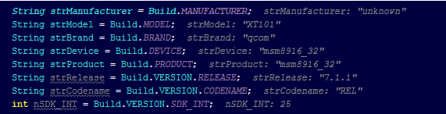

参考：

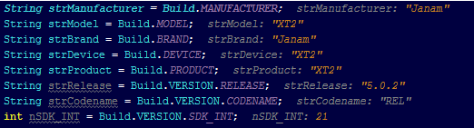

2：U2-R70的APP有中文显示 （Chinese popup for searching）

3: USB 连接改为“Charging”模式，（USB configuration set to "Charging" by default instead of "MTP".）

4：有线扫描里面的honeyware 要改为 Honeywell, 在Honeywell 设置里面需移除其他扫描头类型（Wired scan - "honeyware" - should be "Honeywell". Both 1D and 2D scanners work. On Honeywell setting. Other types should be removed）

5：扫描demo名字需更改为"scandemo"， 现在显示的是："com.example.urovoscan"

(Bugreport—>Scan Demo is named "com.example.urovoscan", should be "scandemo")

6：在线升级的地址不能现在urovo—> 改为Janam

给Janam 单独建立一个OTA升级的服务器

（Appears to be able to update remote. Will need to change location to Janam site.）