

**CMPS 490**

**PROJECT REPORT GUIDELINE**

**Department of Computer Sciences**

**College of Arts and Applied Sciences**

**February 2019**

**PREFACE**

The Final Year Project addresses area(s) of interest to the student. It requires the implementation of a project that reflects and demonstrates knowledge gained on the computer science undergraduate program. The final project will be a group project (a group of 2 or 3 students depending on the nature of the project. It consists of an integrated piece of work, with analyses of requirements and approaches, a software implementation of the proposed system, and a discussion of the system developed.

This guide is meant to assist and facilitate Bachelor of Science students of Department of Computer Science, Dhofar University in the preparation of their final year project report. The format of this guide covers the technical specifications, type of paper, and format of bibliographic citation.

It is hoped that this guide will provide a certain measure of uniformity for the reports.

All the best.

Department of Computer Science

Dhofar University

February 2019

**TABLE OF CONTENTS**

**Page**

**PREFACE** i

**TABLE OF CONTENTS** ii

**CHAPTER 1 GENERAL REQUIREMENTS OF REPORT**

* 1. Introduction 1
  2. Registration of Final Year Project 1
  3. Proposal 1
  4. Language 2
  5. Progress Meeting 2
  6. Presentation of Project 2
  7. Procedure for project discussion 2
  8. Technical Specifications 4

1.8.1 Pages 4

1.8.2 Paper 4

1.8.3 Margins 4

1.8.4 Typeface and Font Size 4

1.8.5 Spacing 5

1.8.6 Pagination 5

1.8.7 Figures, Tables, Maps and Diskettes 6

1.8.8 Paragraphs 6

1.8.9 Landscape 6

* 1. Binding 7

**CHAPTER 2 REPORT FORMAT**

* 1. Introduction 8
  2. Preliminary Pages 8

2.2.1 Title Page 8

2.2.2 Declaration Form 9

2.2.3 Table of Contents 9

2.2.6 List of Tables 9

2.2.7 List of Figures 9

* 1. Main Body 9
     1. Chapter Layout 9
     2. Numbering the Chapters and Sub-sections 10
     3. Tables 10
     4. Figures 10
     5. Equations 11
     6. Footnotes 12
     7. Quotations/Citations 12
  2. The Ending Pages 12
     1. References/Bibliography 12
     2. Appendices 12
     3. Any other relevant materials (optional) 13
  3. Use of Editorial Service 13
  4. Policy of Plagiarism 13

**APPENDICES**

A Title Page 15

B Declaration Form 16

C Table of Contents 17

D List of Tables 19

E List of Figures 20

F Samples of Figures 21

G Sample of American Psychological Association (APA)

Reference Format 23

**CHAPTER 1**

**GENERAL REQUIREMENTS OF REPORT**

**1.1 Introduction**

In completing the final year project, the students have to prove their ability to work in a team on a problem and to solve it with the tools acquired. Discussions with the supervisor about the state of the project every week is strongly recommended to recognize potential problems early and to find additional guidance and help.

The submission of a linguistically correct report is the responsibility of the students. Ask friends or colleagues to proofread the report. In addition, the form of appearance, i.e. the structure of the report, layout and drawings, clear phrasing, references etc. is second to the contents of the report. It’s not just the supervisor but also the jury members who should be impressed by the report. It is clear that these elements contribute to the grading.

This document outlines the guidelines that need to be followed in a final year project report. Please read these guidelines carefully.

**1.2 Registration of Final Year Project**

Once registered, the students will form their own group of 2 (or 3) and are responsible to talk about their topic of interest with any of the available lecturers and to choose any of them as their project supervisor. The supervisor can be a professor, an associate professor, an assistant professor or a lecturer rank from the faculty members only.

**1.3 Proposal**

Each group will submit a project proposal to the Supervisor.

**1.4 Language**

The report must be in English. The submission of a linguistically correct report is the responsibility of the student. Ask friends or colleagues to proofread your report.

**1.5 Progress Meeting**

Every member of a group shall meet the supervisor weekly and a progress report should be signed by both the students and the supervisor.

**1.6 Presentation of Project**

* The supervisor shall propose a date of presentation and invite 2 faculty members from the department as jury members when the students complete the project at the end of the semester.
* The project (report and codes) will be check with (TURNITIN) for similarity purposes. The maximum percentage of similarity is 20% for forming a presentation committee.
* Each group must submit 3 copies of project report to the supervisor not less than two days before the presentation date.
* The number of the jury members in forming the project presentation committee shall be as follows:

The committee shall comprise of **three** members as follows:

* One - the supervisor
* two – faculty members from the department

**1.7 Procedure for project presentation**

* One of the jury members will chair the session, introduce the other jury member and students, and moderate the discussions.
* A student from the group will introduce/make presentation in brief of the project for 10 minutes. Following the presentation, a demonstration of the project that was developed will be conducted for another 10 minutes.
* The chair will give the floor to the jury members to examine the student.
* The committee will withdraw to take its decision privately.
* The committee will assign the grades as outlined below:

\

|  |  |  |  |
| --- | --- | --- | --- |
|  | **Supervisor**  **(40%)** | **Jury member 1 (30%)** | **Jury member 2 (30%)** |
| **REPORT – FORM (15%)** |  |  |  |
| **REPORT –**  **TECHNICAL CONTENT (70%)** |  |  |  |
| **ORAL PRESENTATION (15%)** |  |  |  |
| **STUDENT DISCIPLINE (15%)** |  |  |  |
| **TOTAL** |  |  |  |
| **Weighted Total** | **40%=** | **30%=** | **30%=** |

* In addition to the grades, the following assessment will be given:

1. Project is acceptable with one the following results:

Excellent

Very good

Good

Medium

1. Project is acceptable with modifications stated in the committee evaluation form and the students will be given until the following semester to re-present his/her work. A grade of Incomplete will be given to every student in the group. Each student is required to complete the Incomplete Form and submit to the supervisor.
2. Project is not acceptable. A grade of 40 (Fail) will be given. In this case, the students will register the course again the following semester. He can maintain the same topic or propose a new topic with the same or a different supervisor.

* The committee chair will announce its decision publicly and in the presence of the students. The Final Project Evaluation form will be submitted by the supervisor to the Chair of the department.
* In the case of an Incomplete grade and after the students completes the modifications and presents the project the following semester, the committee will assign the grade as highlighted above. A Change of Grade form will be completed by the supervisor and submitted to the Chair of the department.
* If the students fail to complete the project in accordance with the committee’s feedback and within the time limit set thereby, they will be considered to have failed.

**1.8 Technical Specifications**

**1.8.1 Pages**

The number of pages is around 25-50.

**1.8.2 Paper**

The report should be printed on a good quality paper of A4 size. Three copies are to be provided to the Department for distribution to jury members.

**1.8.3 Margins**

The top, bottom and right margins should be 1”, while the left (binding side) margin should be of 1.5 inches to allow binding. Headers and/or footers must be placed within the 1” margin.

**1.8.4 Typeface and Font Size**

* The entire text of the report, including headings and page numbers must be produced using 12-point font size in Times New Roman.
* Fonts used in tables, illustrations and drawings shall not be less than 10-points. Use consistent fonts on all figures and tables.
* Footnotes should be 10-point.
* Bold print shall be used for headings.
* Underlining of text, titles or headings shall be avoided.
* Print must be letter quality or near letter quality with dark black characters that are consistently clear, crisp and easy to read. Accent marks and hand annotations must be done neatly in black ink (if they can only be done by hand).

**1.8.5 Spacing**

* The line spacing in the main body of text should be 1.5. However, single line space should be used in footnotes, indented quotations, tables etc.
* The spacing between the chapter number and the title, and between the title and the first line of a text shall be 3 (3 = 2 x 1.5) line spacing.
* The spacing between paragraphs shall be 3 (3 = 2 x 1.5) line spacing.

**1.8.6 Pagination**

* For the preliminary pages, use small Roman numerals (i, ii, iii, iv, etc.). The title page does not have a number but counts as page i; the following page is ii.
* For the body of the report including text, chapter title pages, section dividing pages, illustrations, appendices, and bibliography, use Arabic numerals (1, 2, 3, etc.). The numbering begins with the page 1, and runs consecutively to the final page. Do not use suffixes to the Arabic numerals, such as 12a.
* All page numbers are placed in the center at the bottom of the page. Page numbers must be at least two single spaces below the nearest line of text. All page numbers must be in the same font and size as the text.

**1.8.7 Figures, Tables, Maps and Diskettes**

* Figures must have scales and symbols defined on them or in the figure legend and not in the text.
* Figure captions must appear on the same page below the figure, while table captions must appear above the table.
* Both figure and table captions must be single spaced.
* Maps, figures, diagrams, etc, should be inserted in the appropriate place in the text.
* Illustrative material which cannot be bounded, diskettes or CD ROMS, should be held in a protective pocket inside the back cover.
* Photographs and-or maps are to be scanned or photocopied in color and included in the text. They are not to be attached using adhesive materials.
* Other supplementary materials, such as audio or video tapes, should be submitted in an appropriate binder.

**1.8.8 Paragraphs**

* All paragraphs in the main text shall be **justified** between margins.
* The number and the title of subsection shall be aligned with the left margin.
* A paragraph spanning between two pages shall leave at least two lines of text on both the pages.
* A heading or sub-heading cannot appear alone at the bottom of a page. It must be followed by at least two lines of text of the following paragraph.

**1.8.9 Landscape**

For text, illustrations, charts, graphs etc., printed in landscape form, the orientation should be facing away from the bound edge of the paper.

**1.9 Binding**

Before making the required number of copies and binding the report, ensure that all the department requirement of a report have been met. Check that all pages are in correct order and the report conform to the format.

Only soft binding is required for the project presentation.

**CHAPTER 2**

**REPORT FORMAT**

**2.1 Introduction**

The following describes the format for a report. Every final year project report is composed of three physical content divisions:

1. Preliminary pages
2. Text pages or main body, divided into chapters and sections
3. The ending pages

Each content division has several sections, which shall be arranged in the following sequence:

* 1. **Preliminary Pages**

**2.2.1 Title Page**

Please refer to Appendix A for the format. This page shall include the following information:

1. Full title of project (in uppercase);
2. Full name of author (in uppercase);
3. Degree for which the project is submitted
4. College of the program
5. Dhofar University; and
6. Month and year of final submission
7. Center on the back of the title page:

© Copyright by Syed Saleem 2019

All Rights Reserved

* + 1. **Declaration Form**

This page contains the signed declaration from the student on the authenticity of the project. The wordings of the declaration shall conform to the required standard format. Please refer to Appendix B.

* + 1. **Table of Contents**

This page serves as a guide to the content of the project report. Every heading and subheading within the text of the report shall be listed as in the Table of Contents which is limited to 4 subsections only (e.g. 4.3.2.1). Please refer to Appendix C.

* + 1. **List of Tables**

This list shows the exact titles or captions of all tables in the text and appendices, together with the beginning page number of each table. Please refer to Appendix D.

* + 1. **List of Figures**

The exact title of figures and its corresponding page number shall be listed. Figures shall be numbered consecutively throughout the report. Please refer to Appendix E.

* 1. **Main Body**

The main text of project report shall consist of introduction, analysis, design, and conclusions.

* + 1. **Chapter Layout**

The student can add any other chapter(s) as advised by the supervisor. A chapter may be divided into major sections and subsections. Major section and subsection of a chapter shall be identified by numbers. Major section is numbered first level (e.g. 1, 2, 3) and subsection is level numbered (e.g. 1.1, 1.1.1, 1.2.3, 1.2.3.4). This shall be consistent throughout the report and is limited to 4 levels.

* + 1. **Numbering the Chapters and Sub-sections**

All chapters and subsections must be numbered and followed by a label. The chapters are numbered using Arabic numeric, i.e. Chapter 1, Chapter 2, Chapter 3, and so on. The subsections shall not be indented but arranged in a structured manner up to 4 levels. Subsections beyond level four shall be labelled using characters.

* + 1. **Tables**

Tables are numbered consecutively with Arabic numerals throughout the report (including text and appendices). The numbering shall be by chapter (e.g. Table 1.1, 1.2, 1,3, in Chapter 1, and 2.1, 2.2 in Chapter 2 and so on). All tables are to be listed under List of Tables in the preliminary pages (including tables appearing in the appendices). Tables shall be placed after their first mention in the text. Table number, title and caption are placed above the table. Table sources and notes shall be placed directly below the caption. Please refer to Appendix G.

* + 1. **Figures**

Each of the figures is numbered consecutively according to the chapter throughout the report. The numbering shall be by chapter (e.g. Figure 1.1, 1.2, 1.3 in Chapter 1, and 2.1, 2.2 in Chapter 2 and so on). All figures are to be listed under the List of Figures in the preliminary pages (including figures appearing in the appendices). Figures shall be inserted after their first mention in the text. Figure number, title and caption are placed below the figure. Figure sources and notes shall be placed directly below the caption. Figures shall conform to standard margin requirements. Figures shall be referred in text as Figure 4.5 (first letter capitalized and not preceded by ‘the’). Please refer to Appendix H.

The following format and quality of figures shall be observed:

* + Figures shall be in electronic format. Hand-drawn figures are not acceptable
  + If photographs are used, they must be of high resolution. Both color (min. 400 dpi, 8 bit per pixel, uncompressed) and grayscale images (min 220 dpi, 8 bit pixel) may be used.
  + Graphs shall not use any colored or shaded background. Only major gridlines can be used when they are absolutely necessary.
  + Technical drawings shall follow the appropriate standards.
  + Large size drawings shall be placed in the appendix.
    1. **Equations**

All mathematical equations shall not be considered as text. They shall be typed on separate lines using an equation editor found in word processing programs. Equations shall be numbered consecutively following chapter number, and placed within bracket at the end of the line, for example:

(Equation 4.24)



Detailed derivation, if suitable, shall be placed in the appendix. Within body of text, an equation is referred to as for example, Equation 4.1. If there is more than one equation referred, list all of the equations in a single reference, for example Equation 4.1, 4.3 – 4.5.

* + 1. **Footnotes**

Footnotes are not encouraged because they tend to distract the reader from the main argument of the text. If footnotes are necessary, the indicators (the reference numbers in the text) are usually superscript (e.g. 1). Footnotes are numbered consecutively for each page separately. All footnotes shall be single-spaced, typed in 8-point font and left aligned.

* + 1. **Quotations/Citations**

A quotation which is inserted in a sentence must not be more than 40-words long and must always be written within inverted commas.

For example,

According to [4], “Ethical axioms are found and tested not very differently from the axioms of science. Truth is what stands the test of experience.”

Quotations which are more than 40-words in length must be typed separately in a new paragraph and italicized.

NOTE: Direct quotations must be minimized.

* 1. **The ending pages**
     1. **References/Bibliography**

Any report that makes sue of other works, either in direct quotation or by reference, must contain a reference listing of these sources. List only the sources which have been cited in the text. The citation format shall follow the American Psychological Association (APA) as in Appendix I.

* + 1. **Appendices**

Appendices contain those materials which are very important to help understand materials of the report, but are too detailed to be accommodated in the body of the main text. Appendices include programming codes, original data, summary, preliminary tests, tables that contain data of lesser importance, very lengthy quotations, supporting decisions, forms and documents, computer printouts, detailed drawings and other pertinent documents. Appendix materials shall be grouped by type, e.g. Appendix A: Questionnaire, Appendix B: Original Data, Appendix C: Results Tables.

* + 1. **Any other relevant materials (optional)**

Tables and figures in the appendices shall be numbered consecutively following the appendix number; captioned and listed in the List of Tables and List of Figures. For example, the figures or tables in the appendices shall be numbered as A.1, C.1, B.5, etc.

* 1. **Use of Editorial Service**

Some students employ professional editors to “polish” their report presentation. This shall be done before the report is sent for examination. The Department of Computer Science does not insist that all reports be sent to professional editor (who charge a fee for their services). However, students shall know that the department accepts only reports that are reasonably free of errors. The supervisor cannot be held responsible for errors in the report and the candidate cannot expect supervisor to be the editor. The supervisor may recommend the student(s) to engage a professional editorial service to “polish” the report presentation.

* 1. **Policy of Plagiarism**
* Plagiarism is defined as the unauthorized use of the work of another person, as one’s own, whether or not such work has been published.
* A student at Dhofar University shall not engage in plagiarism nor employ nor seek to employ any other unfair means for an examination or in other form of work submitted for assessment as part of any university course.
* The supervisor, at the beginning of the semester, shall explain to students the meaning of the term “plagiarism” and the consequences of committing such an act.

**Appendix A: Title Page**

**TITLE OF PROJECT**

(Uppercase, centered, bold, 12-point)

By

**NAME OF STUDENT**

(Uppercase, centered, bold, 12-point)

**Final Year Project Submitted to the College of Arts and Applied Sciences, Dhofar University, in Fulfilment of the Requirement for the Degree of**

**Bachelor of Science in Computer Science**

**Month and Year of PresentationAppendix B: Declaration Form**

**DECLARATION**

I hereby declare that the project is my original work except for quotations and citations which have been duly acknowledged. I also declare that it has not been previously, and is not concurrently submitted for any other degree at Dhofar University or at any other institutions. This report may be made available within the university library and may be photocopied and loaned to other libraries for the purpose of consultation.

(Signature)

____________________

**NAME OF STUDENT**

Date:

**Appendix C: Table of Contents**

**Table of Contents**

**Page**

**ABSTRACT** i

**ACKNOWLEDGEMENT** ii

**DECLARATION** iii

**LIST OF TABLES** iv

**LIST OF FIGURES** v

**LIST OF ABBREVIATIONS** vi

**CHAPTER 1 INTRODUCTION** 1

**CHAPTER 2 ANALYSIS** 5

2.1 Sub-heading 1 7

2.1.1 Sub-subheading 1 8

2.1.2 Sub-subheading 2 12

**CHAPTER 3 DESIGN** 25

3.1 Sub-heading 1 34

3.1.1 Sub-subheading 1 37

3.1.2 Sub-subheading 2 49

**CHAPTER 4 IMPLEMENTATION**  52

4.1 Sub-heading 1 54

4.1.1 Sub-subheading 1 57

4.1.2 Sub-subheading 2 69

**CHAPTER 5 CONCLUSION** 100

**REFERENCES**  112

**APPENDICES** 125

**Appendix E: List of Tables**

**LIST OF TABLES**

Table 1.1 The effect of Postgraduate Studies 31

Table 2.1 Students-Supervisors Relationship 42

**Appendix F: List of Figures**

**LIST OF FIGURES**

Figure 3.1 A schematic representation of the Decision Support system 38

Figure 5.2 Flowchart of Experimental Method 67

**Appendix G: Samples of Tables**

Table 1. Number of Postgraduate Students according to region in 2014.

|  |  |
| --- | --- |
| **Country** | **Numbers** |
| Middle East | 100 |
| Europe* | 34 |
| South East Asia | 250 |
| Australasia | 5 |
| North and South America | 3 |

**\***Excluding Russia and Ukraine

Table 3.8. Interactions around interfaces by each group

|  |  |  |  |  |  |  |  |  |
| --- | --- | --- | --- | --- | --- | --- | --- | --- |
| **Interactions** | **Group 1** | | **Group 2** | | **Group 3** | | **Group 4** | |
| **Table** | **PC** | **Table** | **PC** | **Table** | **PC** | **Table** | **PC** |
| Eye contact | 35 | 20 | 34 | 15 | 30 | 19 | 33 | 17 |
| Nodding | 71 | 57 | 60 | 49 | 52 | 40 | 57 | 41 |
| Small noises | 23 | 2 | 7 | 2 | 13 | 15 | 19 | 2 |
| Ask question | 9 | 10 | 4 | 3 | 9 | 7 | 2 | 1 |
| Give reply | 10 | 1 | 8 | 2 | 3 | 4 | 2 | 2 |

**Appendix H: Samples of Figures**



Figure 5.10: Average proportion of time spent during discussions

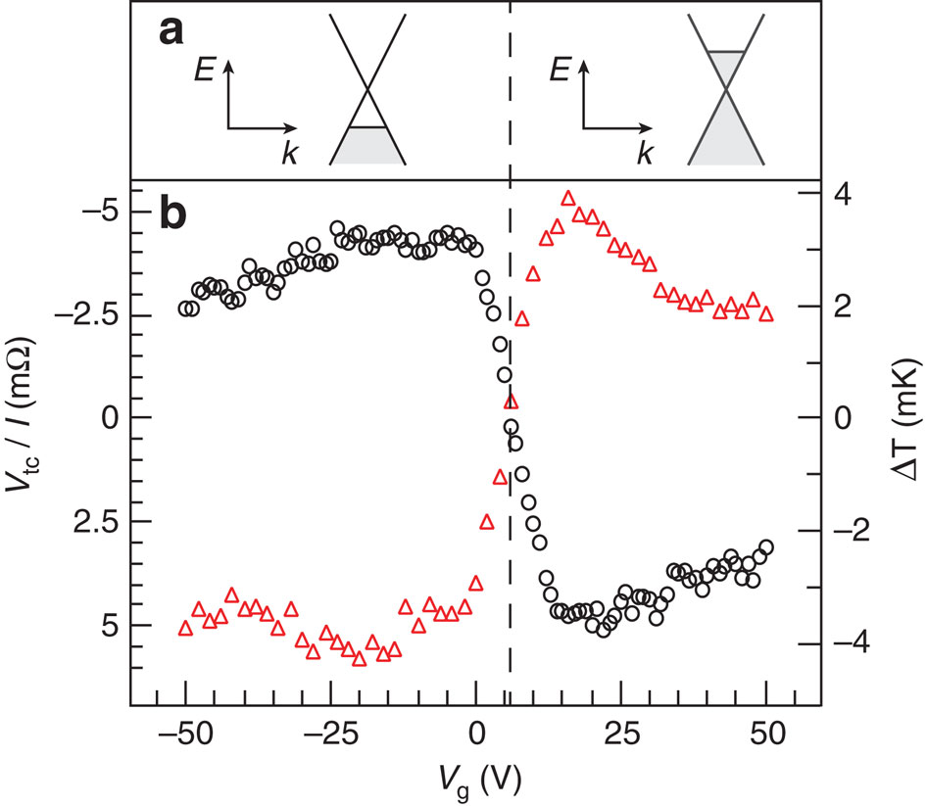

Figure 4.3: Direct electronic measurement**Appendix I: Samples of American Psychological Association (APA) Reference Format**

(from the 3rd edition of the Publication Manual of the American Psychological Association, 1983)

Brown, M. W. (1982). This is the title of a book (2nd ed.). City: Publisher.

Chin, Y. (1998). This is the title of a part of a book. In A.R. Finley, S.R. Taft, & M.N. Piper (Eds.), This the book title. (pp.25-37). City: Publisher.

Clark, B. W. (1988). *This is the title of a paper appearing in a published proceedings.*  In A.B. Cook (Ed.), Proceedings of the 100th Annual Meeting of the Society of Experimental Results (pp. 49-77). City: Publisher.

Fourney, T.T. & Heller, R. N. (January, 1991). *This is the title of an unpublished Paper presented at a meeting*. Paper presented at the 103rd annual meeting of the Society of Experimental Results, City of Meeting, ST.

Goff, A. M. (1987). *This is the title of a journal articles.* Journal of Experimental Results, 1 (3), 1-22.

Green, M. (1988, January). *This is the title of a magazine articles.* Magazine of Today, pp. 6-12.

Johnson, R.S. (1989, October 1). *This is the title of a newspaper article.* The Daily News, pp. 1, 6-8.

Jones, M. J., & Smith, A.R. (1990). *This is the title of a report.* (Report No. 90-1428). City:Publisher.

Miller, G.M. (1988). *This is the title of a master’s report.* Unpublished master’s Report, Any State University, City, ST.

Simmons, M.T. (1987). *This is the title of a doctoral dissertation (Doctoral dissertation,* Any State University, 1986). Dissertation Abstracts International, 47, 12