
TACEDGE
GEOTECH · V2.0
Prototype Walkthrough
First-use software for managing geotechnical operations.

PROTOTYPE WALKTHROUGH
Contents
A guided tour of the prototype, in the order it is presented.
Right-click and choose “Update Field” to generate the contents.

Projects
SCREEN 01 / 24
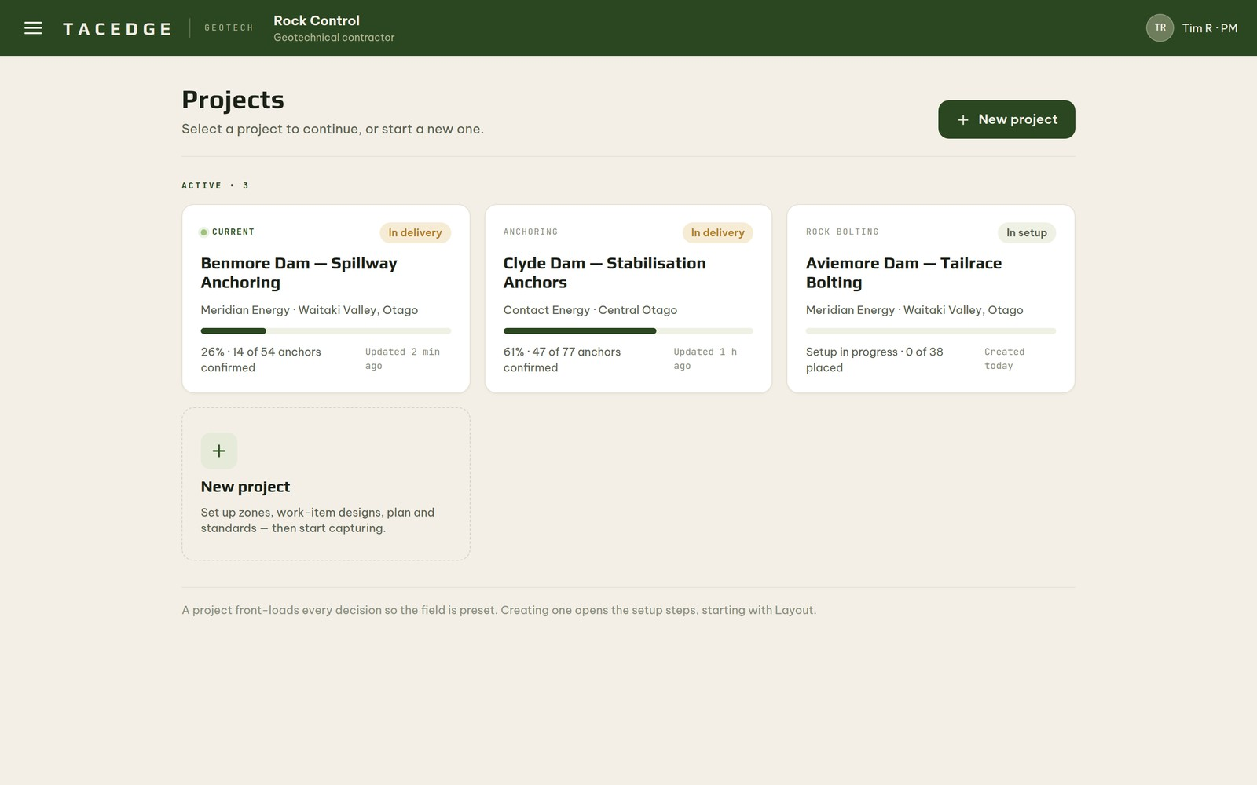
PURPOSE
The front door to the workspace. A project manager opens a live project or starts a new one, with every active job and its progress visible at a glance.
PRIMARY USER
Project Manager
KEY CAPABILITIES
- See all active projects with live progress and status
- Open a project straight into its full workspace
- Start a new project and step into setup
- Carry organisation and client context into everything that follows
WORKFLOW CONTEXT
Selecting a project opens its workspace; creating one begins the configure stage of the project.

Layout
SCREEN 02 / 24
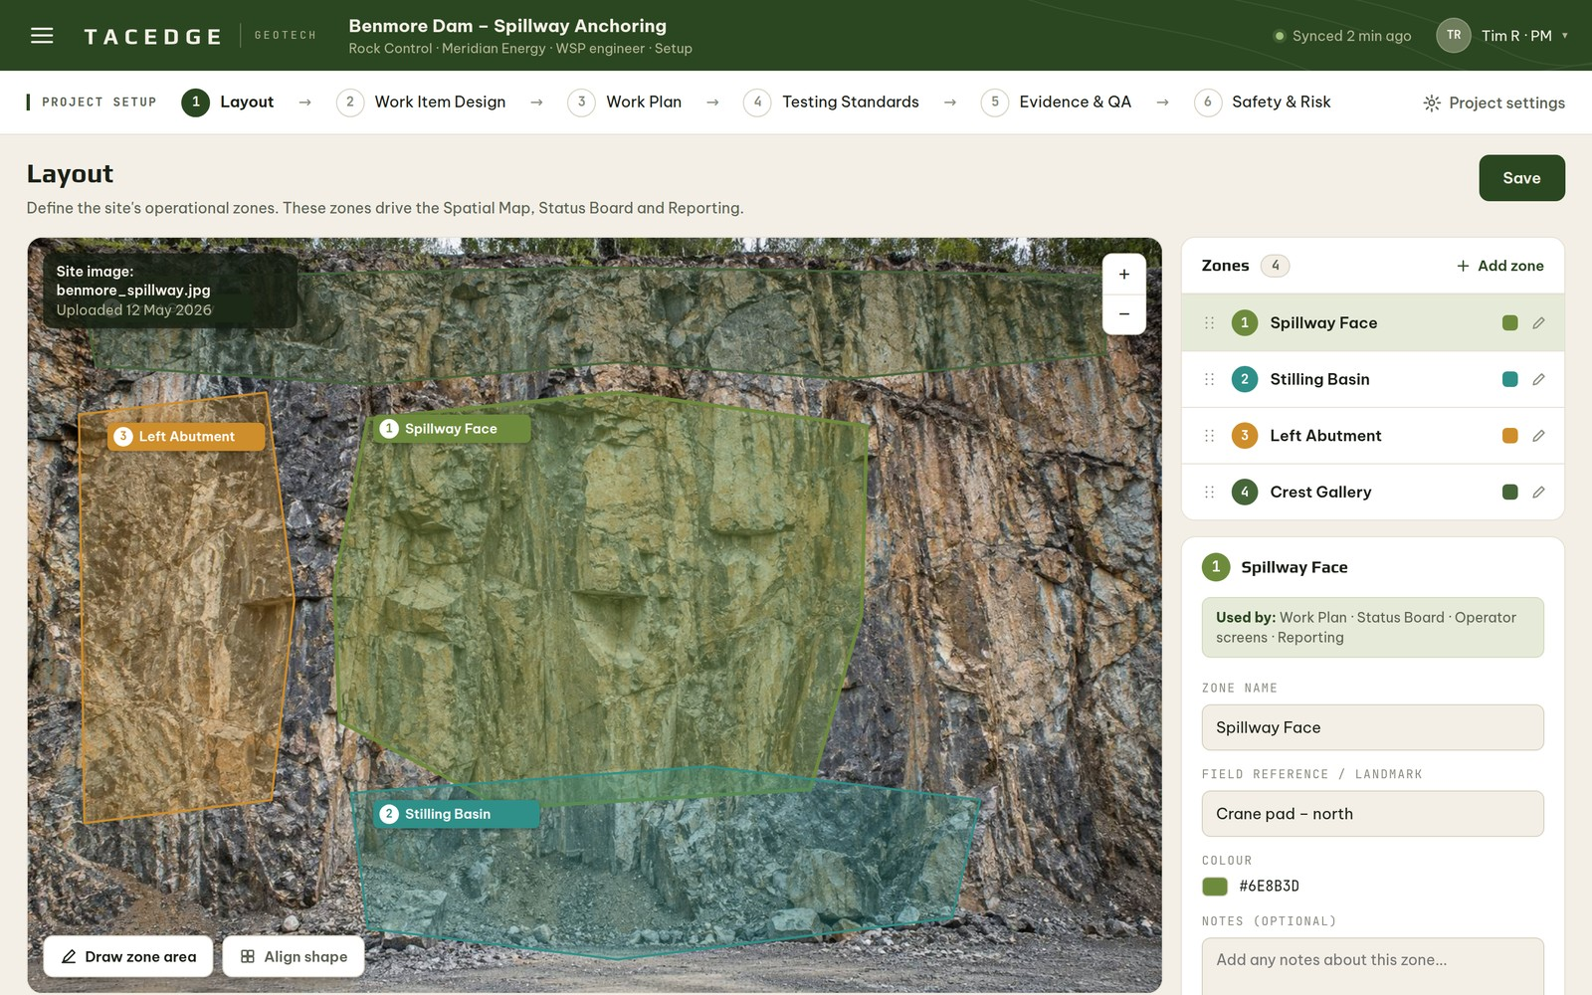
PURPOSE
Defines the site's operational zones over a real site image, giving every later screen a shared spatial frame of reference.
PRIMARY USER
Project Manager
KEY CAPABILITIES
- Divide the site into named operational zones
- Work directly over an uploaded site photo or drawing
- Establish the zones used across planning, status and reporting
- Keep the picture operational rather than survey-precise
WORKFLOW CONTEXT
One of the first setup steps. The zones defined here organise the plan, the status board and every field capture.

Work Item Design
SCREEN 03 / 24
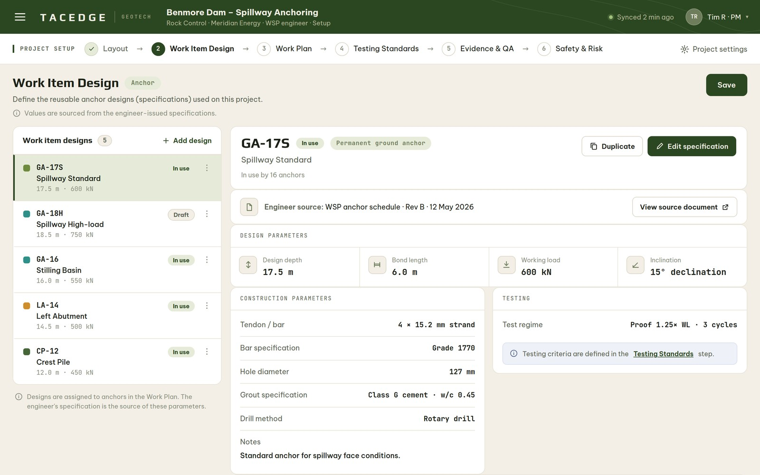
PURPOSE
A reusable library of anchor designs and specifications, drawn from the engineer's requirements and ready to place into the plan.
PRIMARY USER
Project Manager
KEY CAPABILITIES
- Build reusable designs from the engineer's specification
- Capture bar, bond, depth and grout parameters once
- Reuse a design across many anchors and zones
- Keep specifications consistent and engineer-sourced
WORKFLOW CONTEXT
Designs created here are placed as planned anchors in the Work Plan and inherited by the field automatically.

Work Plan
SCREEN 04 / 24
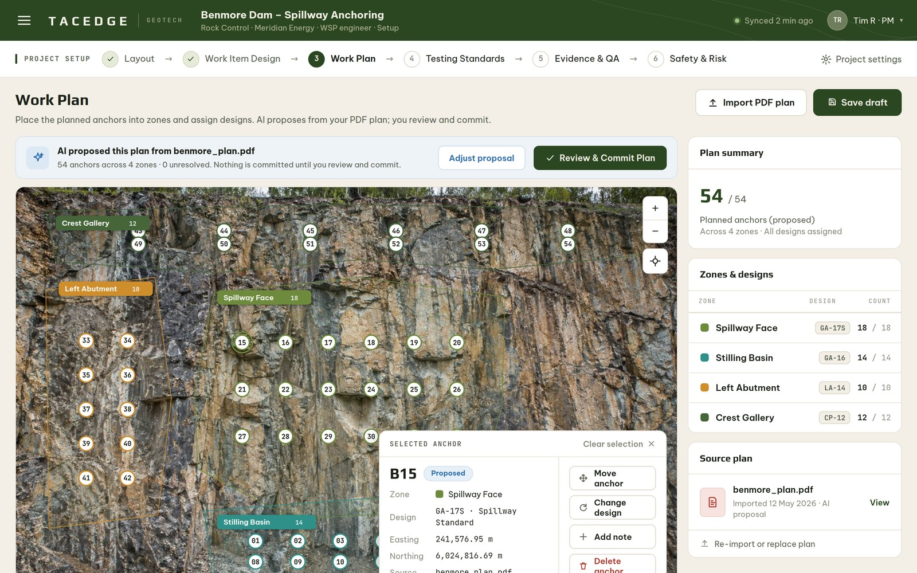
PURPOSE
Turns designs into a placed, sequenced plan of where each anchor goes — with an AI-proposed plan the manager reviews and commits.
PRIMARY USER
Project Manager
KEY CAPABILITIES
- Place designs as planned anchors by zone and row
- Accept an AI-proposed plan from a drawing
- Review and adjust before anything is trusted
- Commit the plan into executable field work
WORKFLOW CONTEXT
AI proposes, the manager approves. Committing the plan presets the field so operators select nothing on site.

Testing Standards
SCREEN 05 / 24
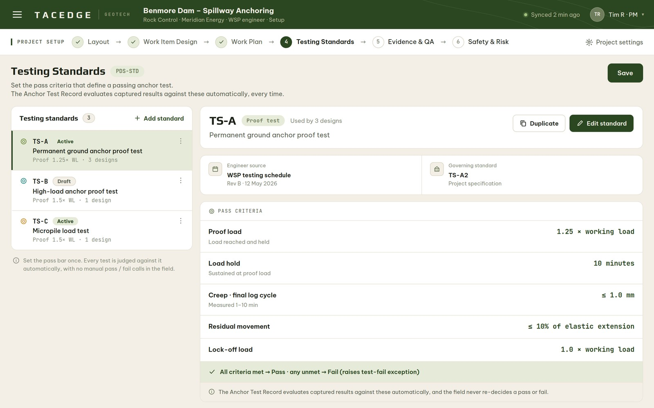
PURPOSE
Sets, once, what a passing test looks like — the acceptance criteria every anchor test is measured against.
PRIMARY USER
Project Manager
KEY CAPABILITIES
- Define acceptance and test criteria for the project
- Set the thresholds a result must meet to pass
- Apply one consistent standard across all testing
- Keep the criteria visible and auditable
WORKFLOW CONTEXT
Defined during setup. The QA process and the engineer's released record are both assessed against these standards.

Evidence & QA Requirements
SCREEN 06 / 24
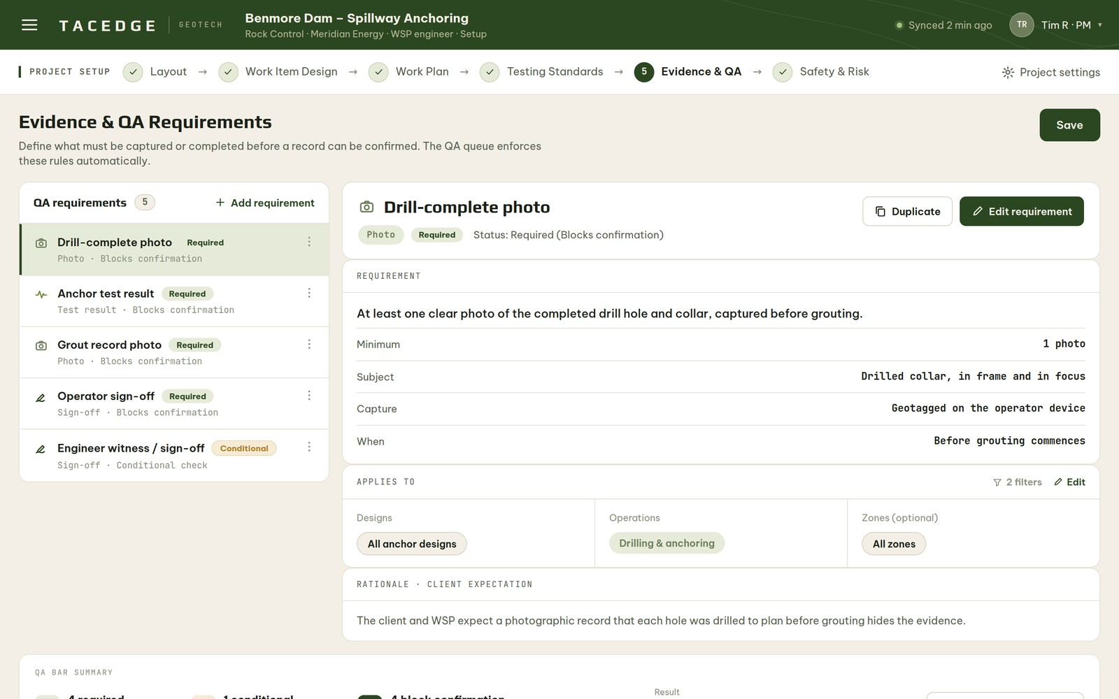
PURPOSE
Sets the evidence bar — what must be captured or completed before a record can be confirmed.
PRIMARY USER
Project Manager
KEY CAPABILITIES
- Define what evidence makes a record confirmable
- Set the requirements once for the whole project
- Ensure consistent, defensible records
- Drive the checks the QA queue enforces automatically
WORKFLOW CONTEXT
Configured during setup. These requirements gate confirmation, so only complete records can ever be released.

Safety & Risk Controls
SCREEN 07 / 24
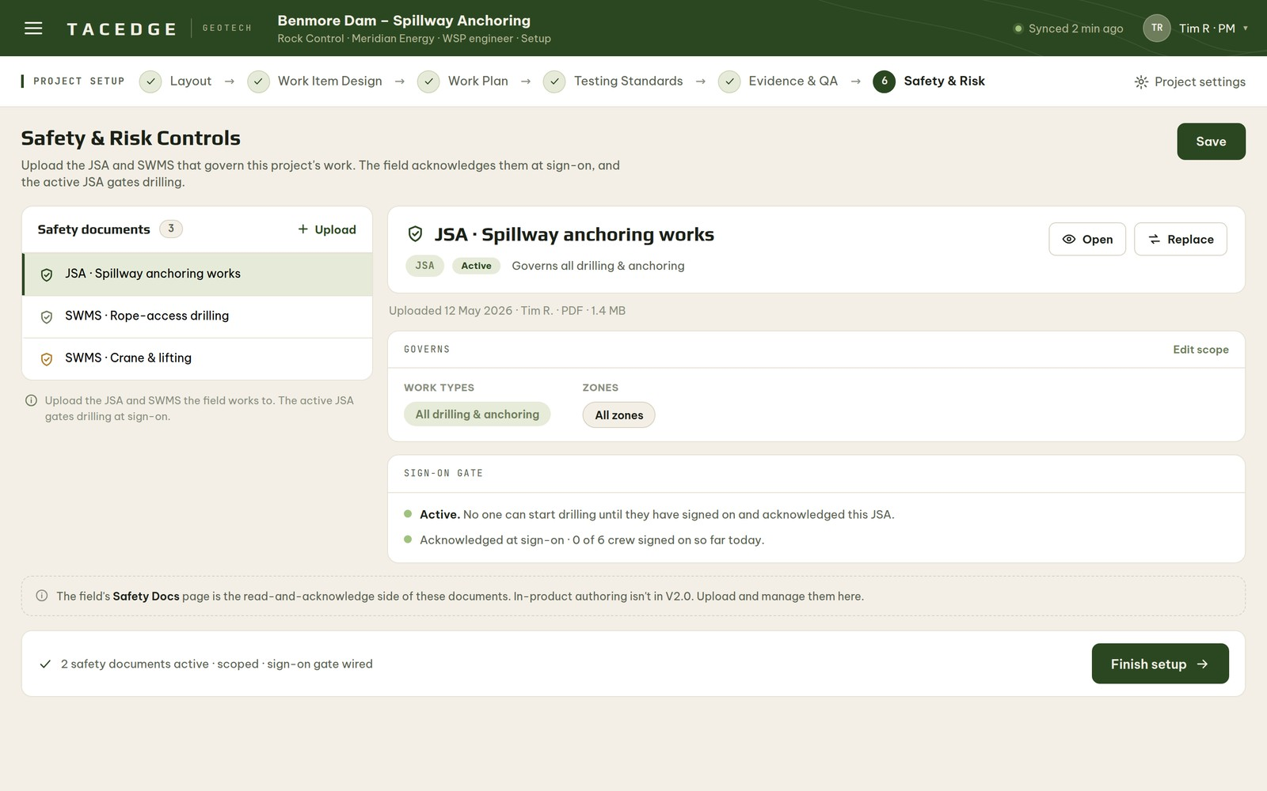
PURPOSE
Manages the JSA and SWMS safety documents that govern the work and feed the field sign-on gate.
PRIMARY USER
Project Manager
KEY CAPABILITIES
- Hold the project's JSA / SWMS and risk controls
- Publish the documents the field must acknowledge
- Connect controls to the daily sign-on gate
- Keep the current versions in one place
WORKFLOW CONTEXT
Set during setup. These documents become the safety gate every operator acknowledges before drilling can begin.

Overview
SCREEN 08 / 24
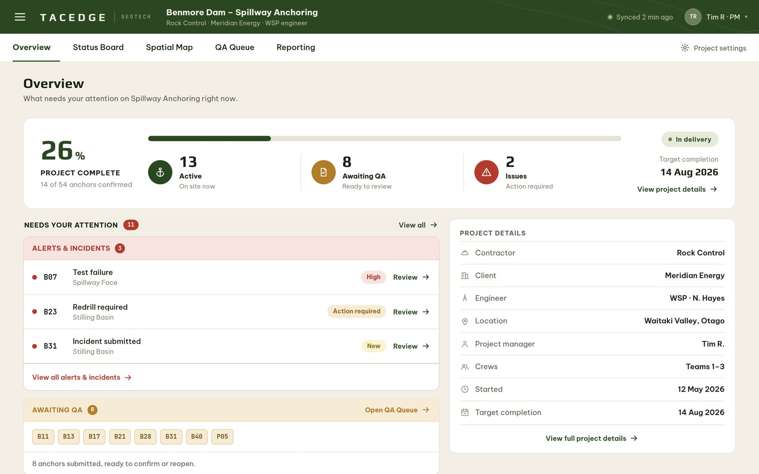
PURPOSE
The manager's command centre — what needs attention right now, at a glance, without resolving anything here.
PRIMARY USER
Project Manager
KEY CAPABILITIES
- See progress, alerts and compliance in seconds
- Surface the anchors needing attention or QA
- Jump to the right screen to act
- Read project state without manual upkeep
WORKFLOW CONTEXT
The inform layer of the manager's day: awareness happens here, action happens in QA, release happens in Reporting.

Status Board
SCREEN 09 / 24
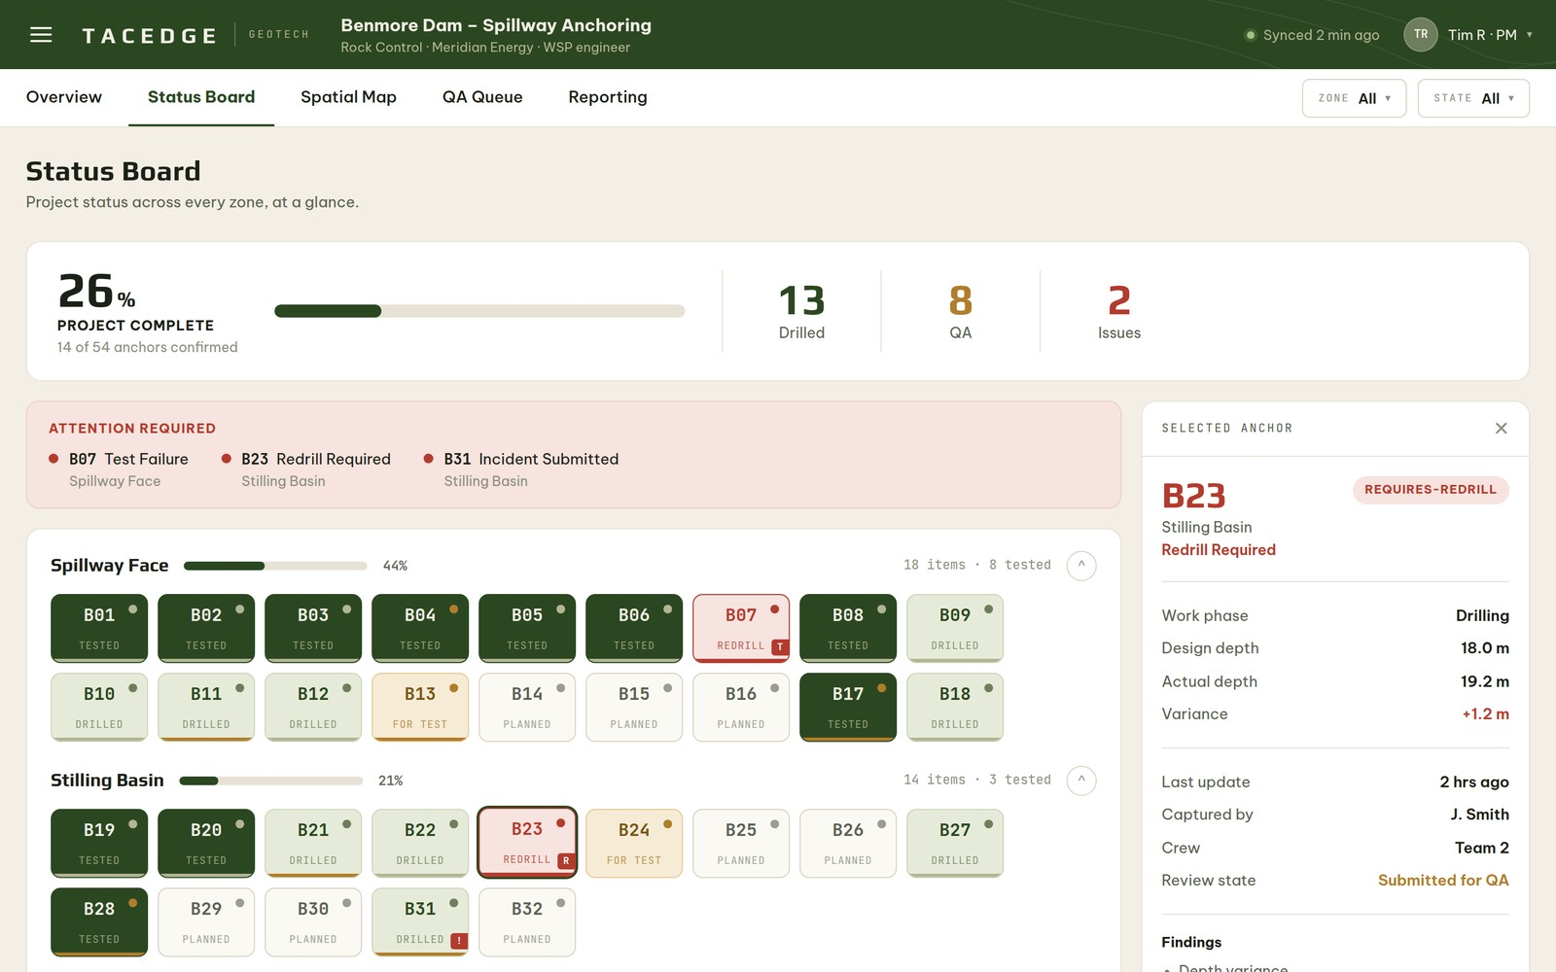
PURPOSE
Reads the whole project's status at a glance — every anchor, every zone, in one calm board.
PRIMARY USER
Project Manager · shared with the Engineer
KEY CAPABILITIES
- See every anchor's phase by zone at a glance
- Track progress against the plan, live
- Spot attention items and exceptions early
- Read the project's true state without compiling it
WORKFLOW CONTEXT
Reflects field reality automatically as operators work. It is the same truth the engineer sees, framed for the manager's job.

Spatial Map
SCREEN 10 / 24
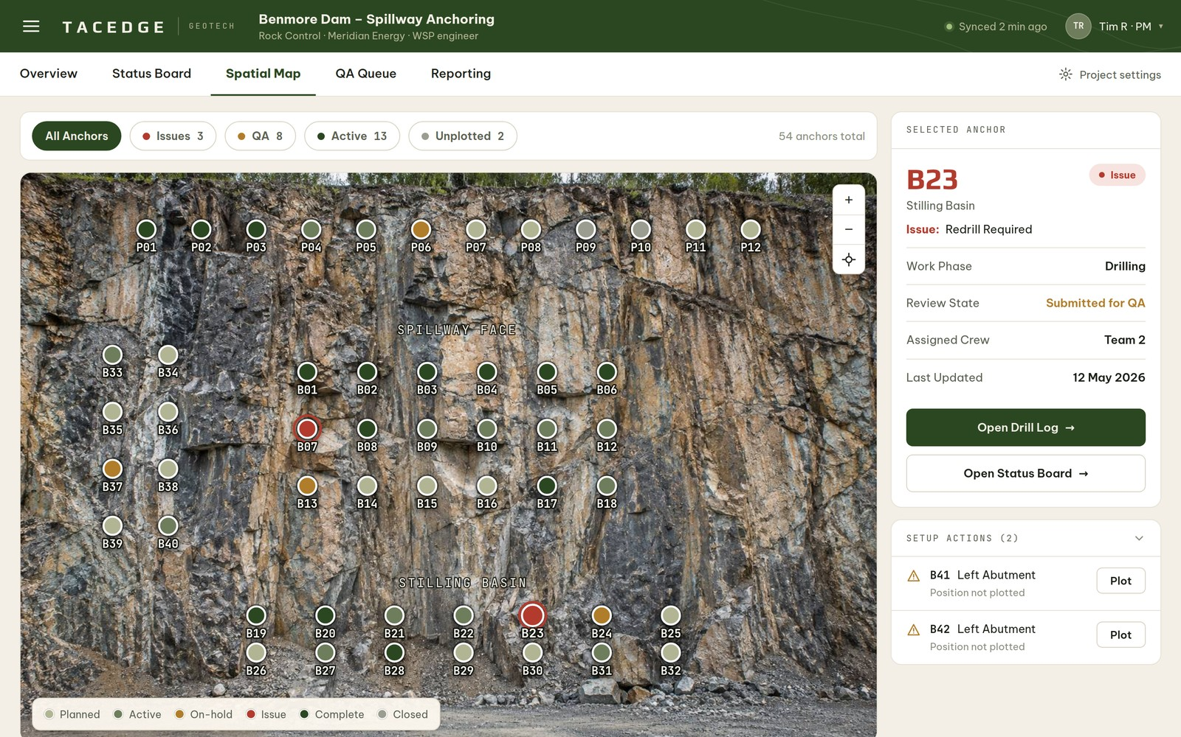
PURPOSE
Locates every anchor on a real site image so its position is unambiguous on the ground.
PRIMARY USER
Project Manager and Operator
KEY CAPABILITIES
- See every anchor plotted on the site image
- Read status spatially, by colour
- Identify exactly which anchor is which
- Share one located truth across office and field
WORKFLOW CONTEXT
The spatial twin of the Status Board — the same records, located on the real site for identification.

Crew Sign-On
SCREEN 11 / 24
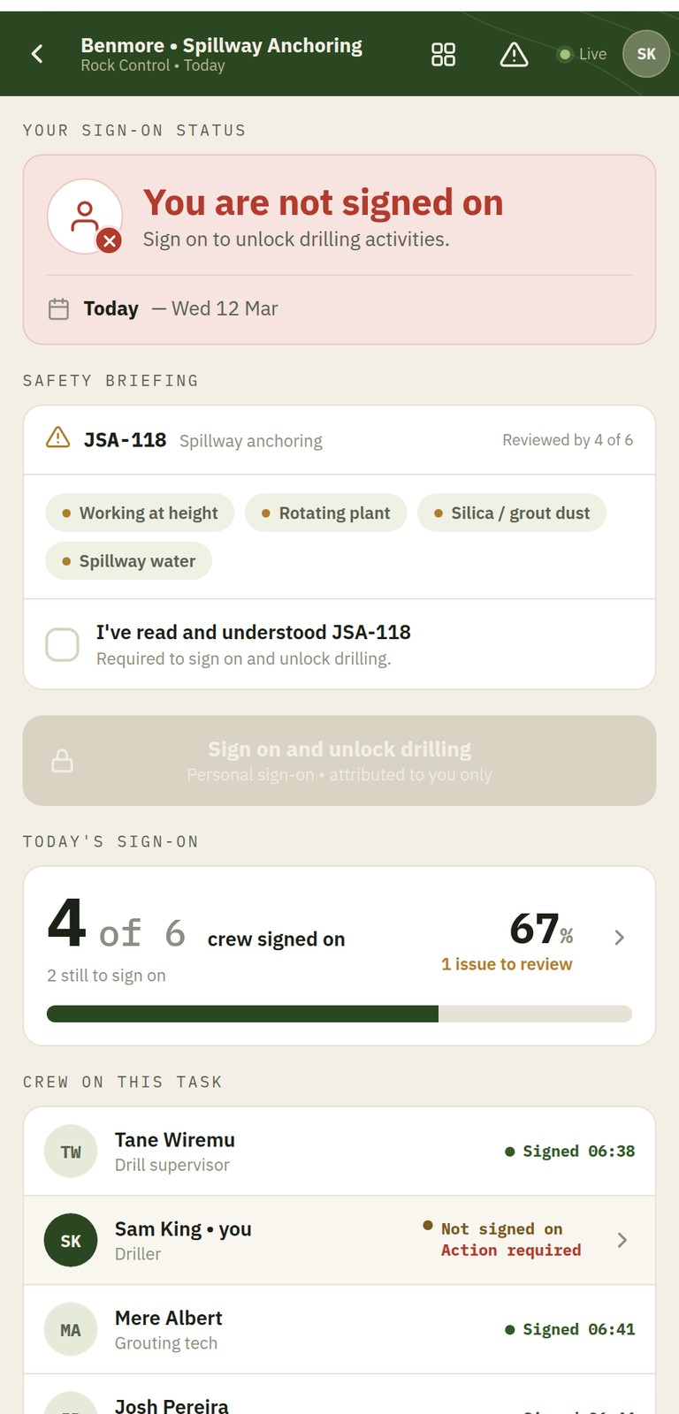
PURPOSE
A fast, individual sign-on that clears an operator to work for the day.
PRIMARY USER
Operator
KEY CAPABILITIES
- Sign on individually and attributably
- Acknowledge the current safety documents
- Clear the gate to begin drilling
- Keep compliance a one-person, one-tap act
WORKFLOW CONTEXT
The one enforced field gate: drilling cannot begin until the day's sign-on exists.

Drill Log
SCREEN 12 / 24
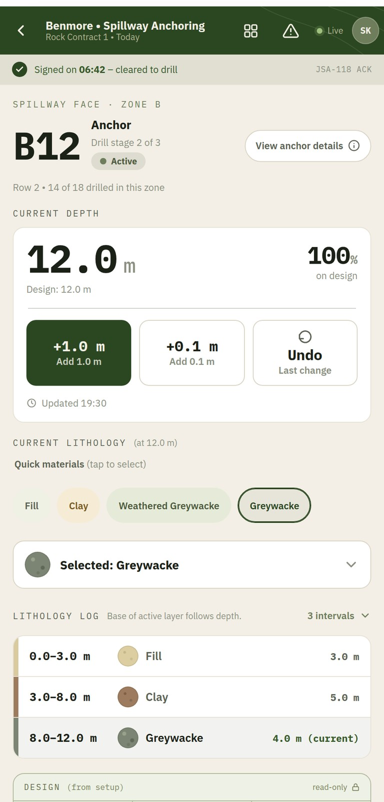
PURPOSE
Captures the actual drilling record — depth and the ground encountered — with minimal decision load in the field.
PRIMARY USER
Operator
KEY CAPABILITIES
- Record drilled depth as work progresses
- Log lithology layers as the ground changes
- Compare against design without calculating
- Submit the completed record to QA
WORKFLOW CONTEXT
The first field capture against a preset anchor; it advances the anchor's phase as each stage closes.

Grout Log
SCREEN 13 / 24
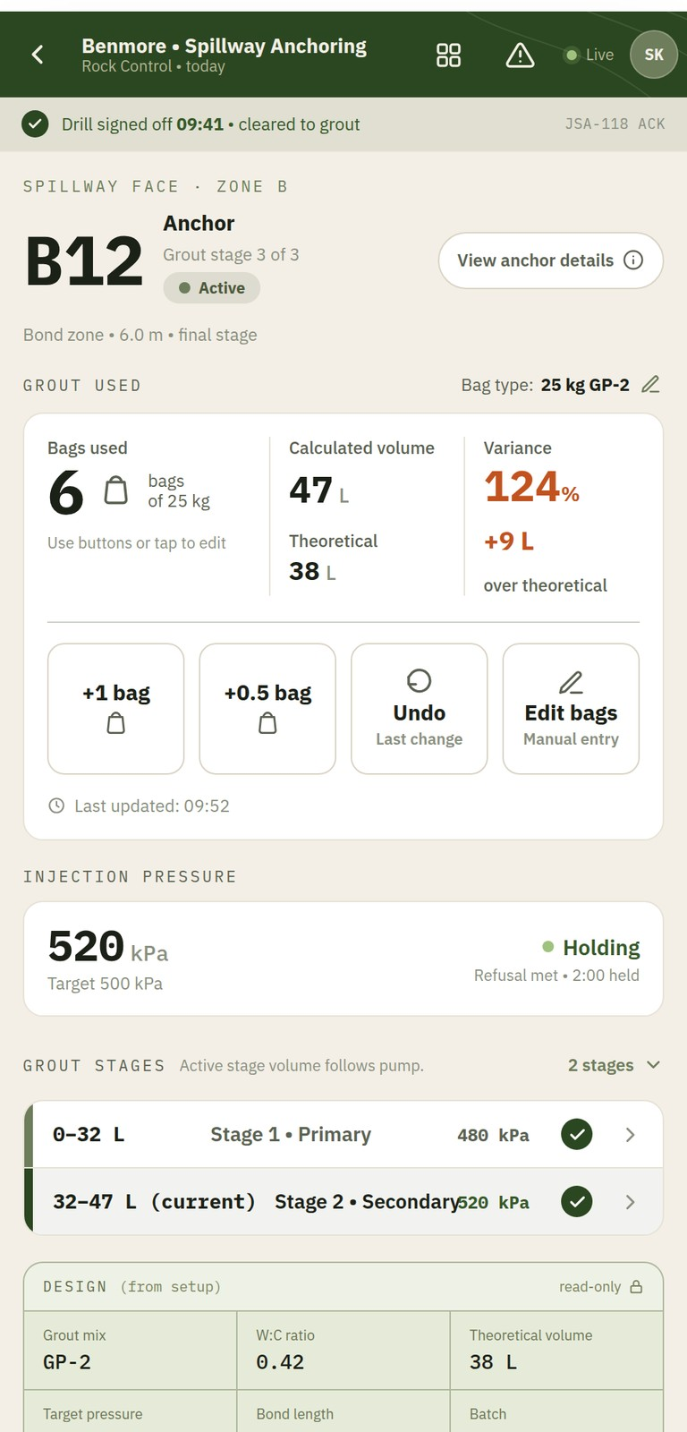
PURPOSE
Captures grout placed and lets the system compute the variance against design.
PRIMARY USER
Operator
KEY CAPABILITIES
- Record bags or volume of grout placed
- Let the system compute overbreak and variance
- Flag elevated take against the ground conditions
- Submit the record to QA
WORKFLOW CONTEXT
Follows drilling: the operator counts, the system calculates, keeping field decisions out of the hole.

Anchor Test Record
SCREEN 14 / 24
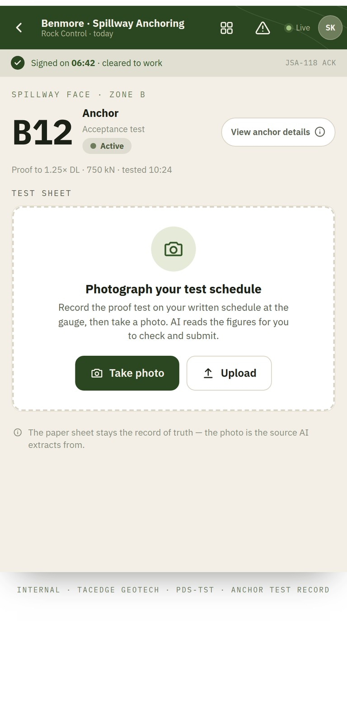
PURPOSE
Turns the written test schedule into a verified result — photograph it, AI reads the figures, the operator approves and submits.
PRIMARY USER
Operator
KEY CAPABILITIES
- Photograph the written test schedule
- Let AI extract the test figures
- Verify each figure against the sheet
- Confirm the result and submit to QA
WORKFLOW CONTEXT
AI proposes, the human approves, then it commits. The paper sheet stays the record of truth.

Incident / Near-Miss
SCREEN 15 / 24
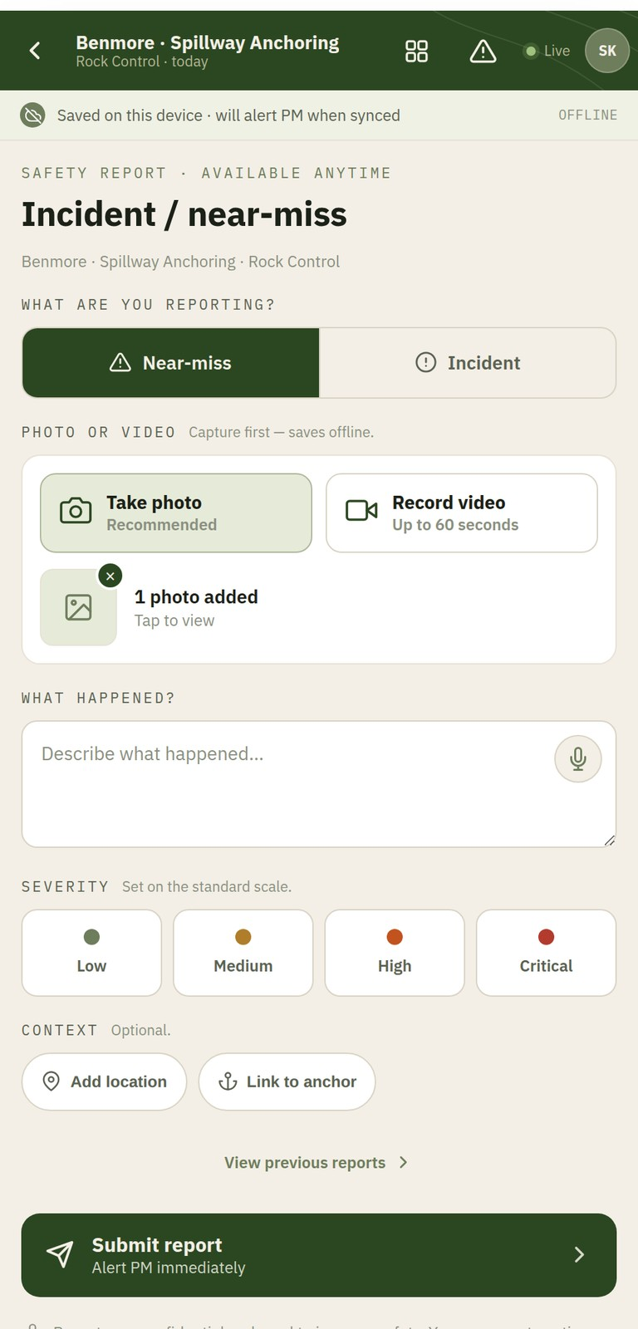
PURPOSE
A fast, photo-first way to report a safety event from anywhere, in under a minute.
PRIMARY USER
Operator
KEY CAPABILITIES
- Report an incident or near-miss at any time
- Lead with a photo and the critical facts
- Raise an immediate alert to the manager
- Reach it from every field screen
WORKFLOW CONTEXT
Always one tap away. An incident is an explicit, declared event that alerts the manager instantly.

Daily Activity Sheet
SCREEN 16 / 24
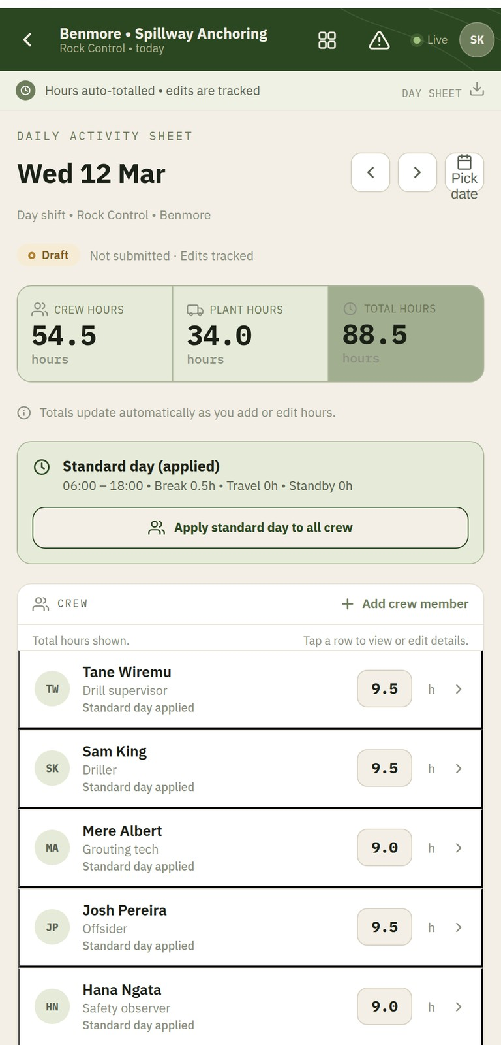
PURPOSE
Captures crew and plant hours by defaulting a normal day and editing only the exceptions.
PRIMARY USER
Supervisor
KEY CAPABILITIES
- Start from a standard day and edit exceptions
- Record crew and plant hours quickly
- Keep an auto-totalled, attributable sheet
- Stay clear of a payroll-software feel
WORKFLOW CONTEXT
A supervisor's daily record of resourcing, feeding cost and invoicing without slowing the field down.

Spatial Map · Field
SCREEN 17 / 24
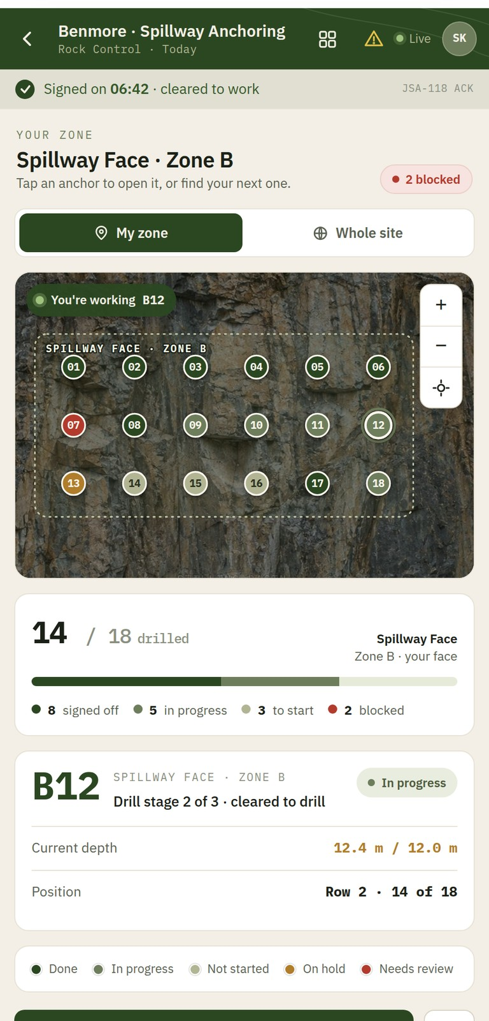
PURPOSE
The operator's on-the-ground map — find the right anchor and continue work on it.
PRIMARY USER
Operator
KEY CAPABILITIES
- Identify the exact anchor in front of you
- See status and your zone at a glance
- Tap an anchor to open its capture
- Continue work without leaving the field view
WORKFLOW CONTEXT
The same located truth as the office map, framed for the operator's job on site.

Safety Docs
SCREEN 18 / 24
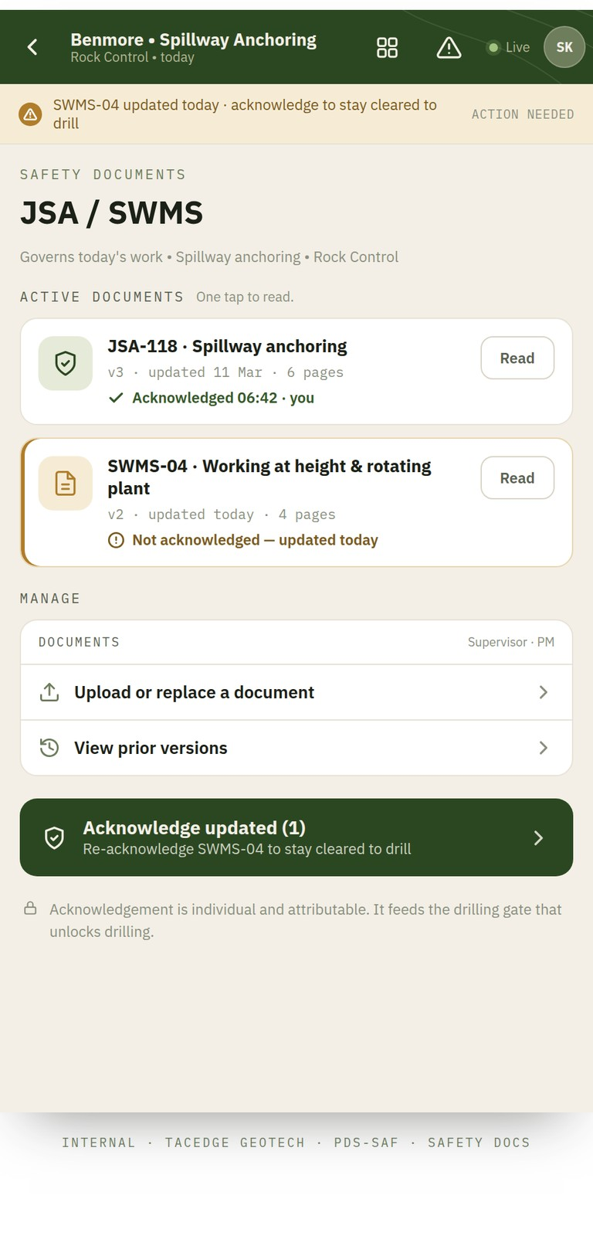
PURPOSE
The operator's view of the active JSA / SWMS — read and acknowledge to stay cleared to work.
PRIMARY USER
Operator
KEY CAPABILITIES
- Read the documents governing today's work
- Acknowledge updated versions individually
- Stay cleared to drill
- Keep the documents available offline
WORKFLOW CONTEXT
Feeds the sign-on gate. Acknowledgement is individual, attributable and never applied in bulk.

QA Queue
SCREEN 19 / 24
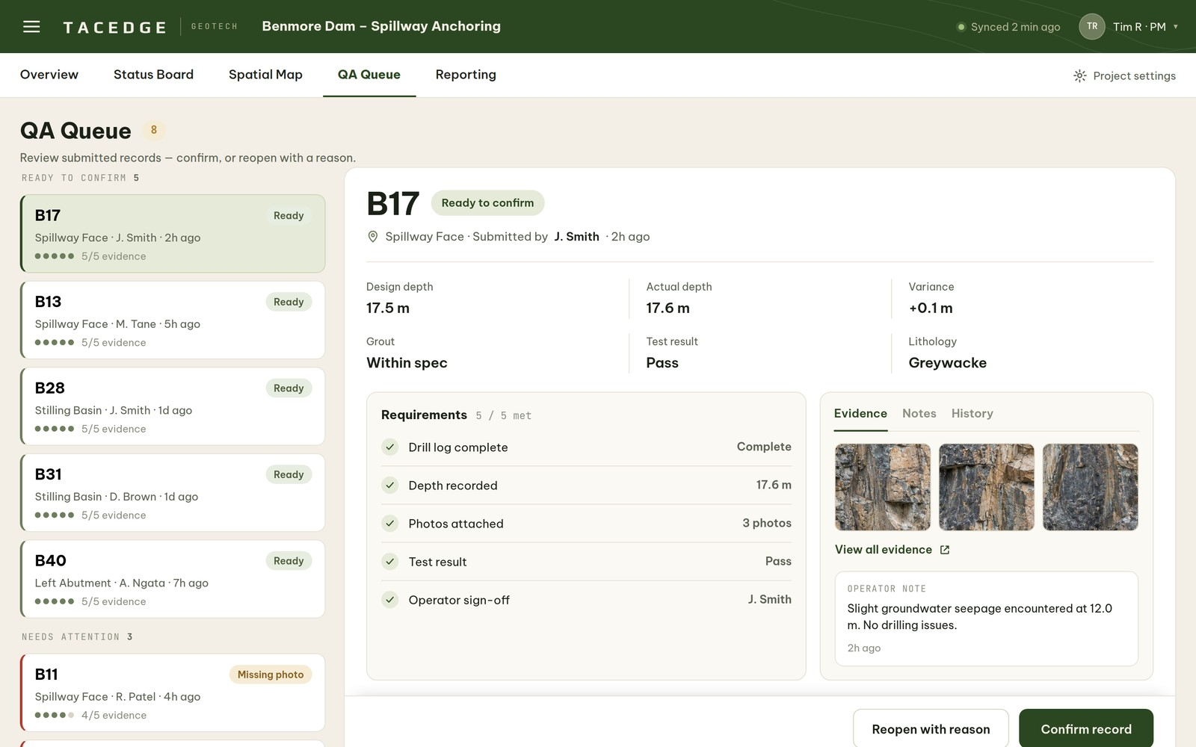
PURPOSE
The manager's review inbox — one queue, one selected record, one decision: confirm or reopen.
PRIMARY USER
Project Manager
KEY CAPABILITIES
- Review submitted records in a single queue
- Check evidence against the requirements
- Confirm a record, or reopen it with a reason
- Move work toward release with confidence
WORKFLOW CONTEXT
The act layer. Confirmation is the gate to the outside — only confirmed work becomes engineer-visible.

Reporting
SCREEN 20 / 24
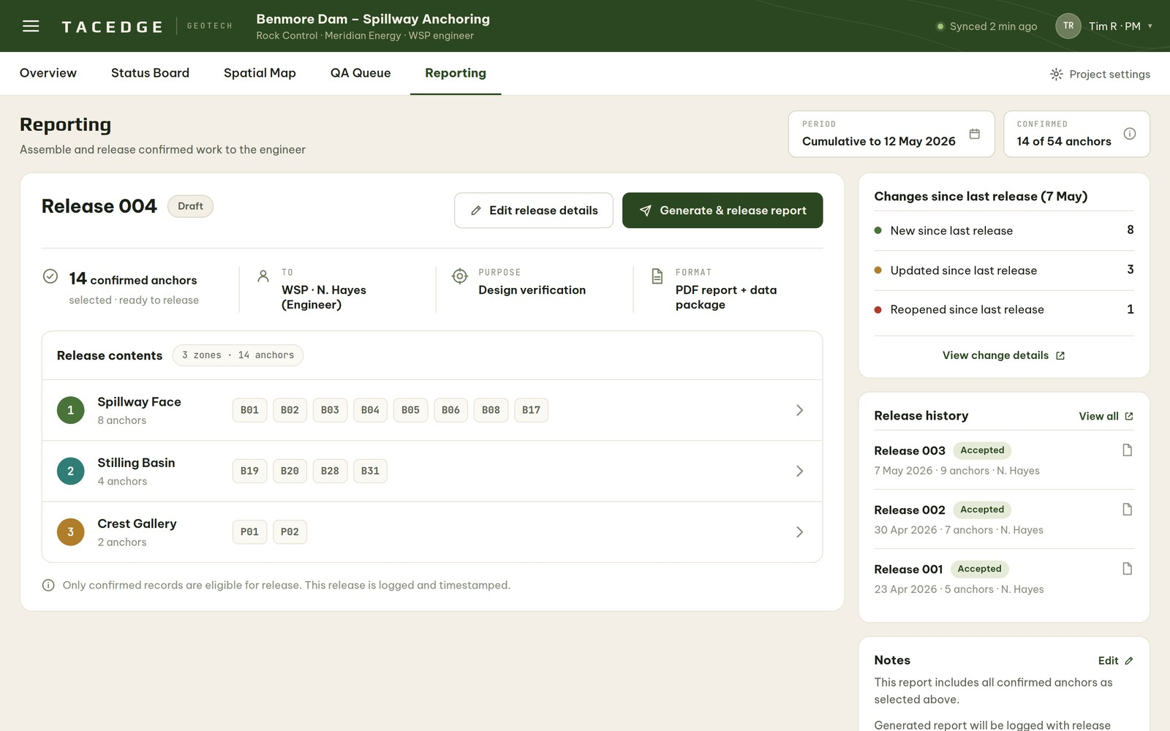
PURPOSE
Assembles and releases a trusted package of confirmed work to the engineer and client.
PRIMARY USER
Project Manager
KEY CAPABILITIES
- Build a release from confirmed work
- Set recipient, purpose, period and format
- Group the released contents by zone
- Generate and release the report
WORKFLOW CONTEXT
The release layer. Confirmed work is curated and released outward in a controlled, logged step.

Reference Documents
SCREEN 21 / 24
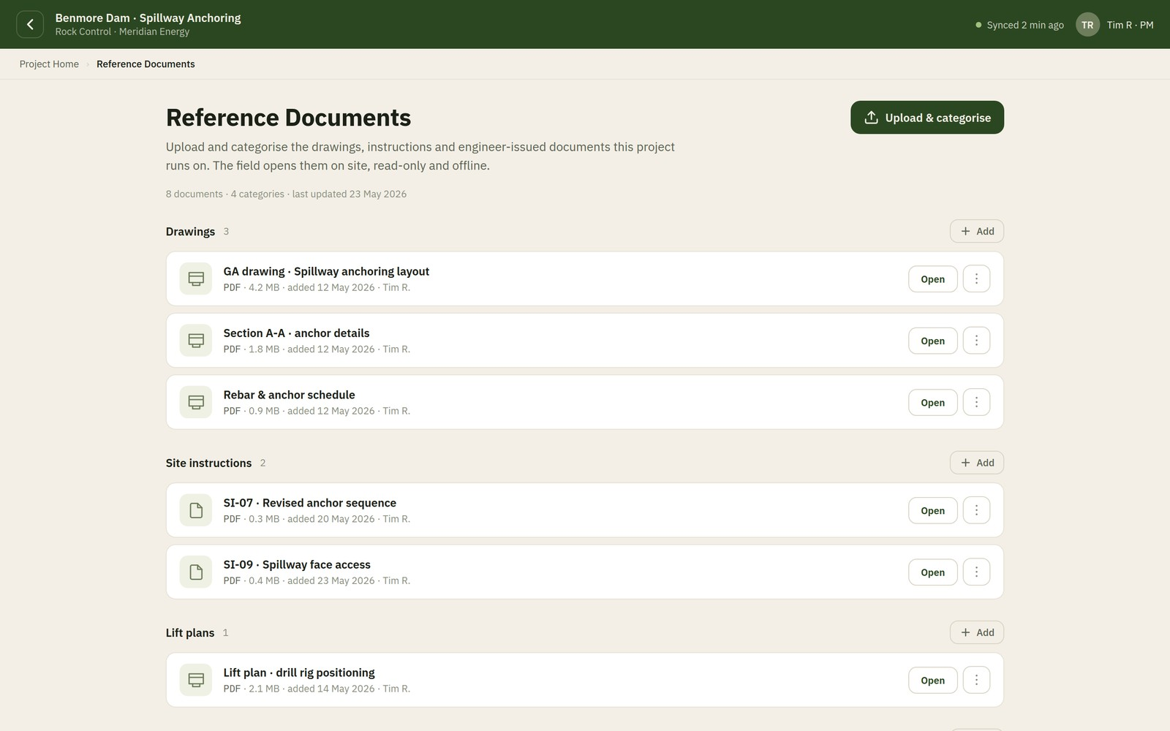
PURPOSE
A bounded project library of drawings, instructions and engineer-issued documents — available to the field offline.
PRIMARY USER
Project Manager · read by the field
KEY CAPABILITIES
- Hold inbound reference material in one place
- Keep it a tidy project folder, not a document system
- Make documents available offline to the field
- Keep reference material distinct from the safety sign-on
WORKFLOW CONTEXT
The project's read-only reference set: the manager curates, the field reads.

Engineer View
SCREEN 22 / 24
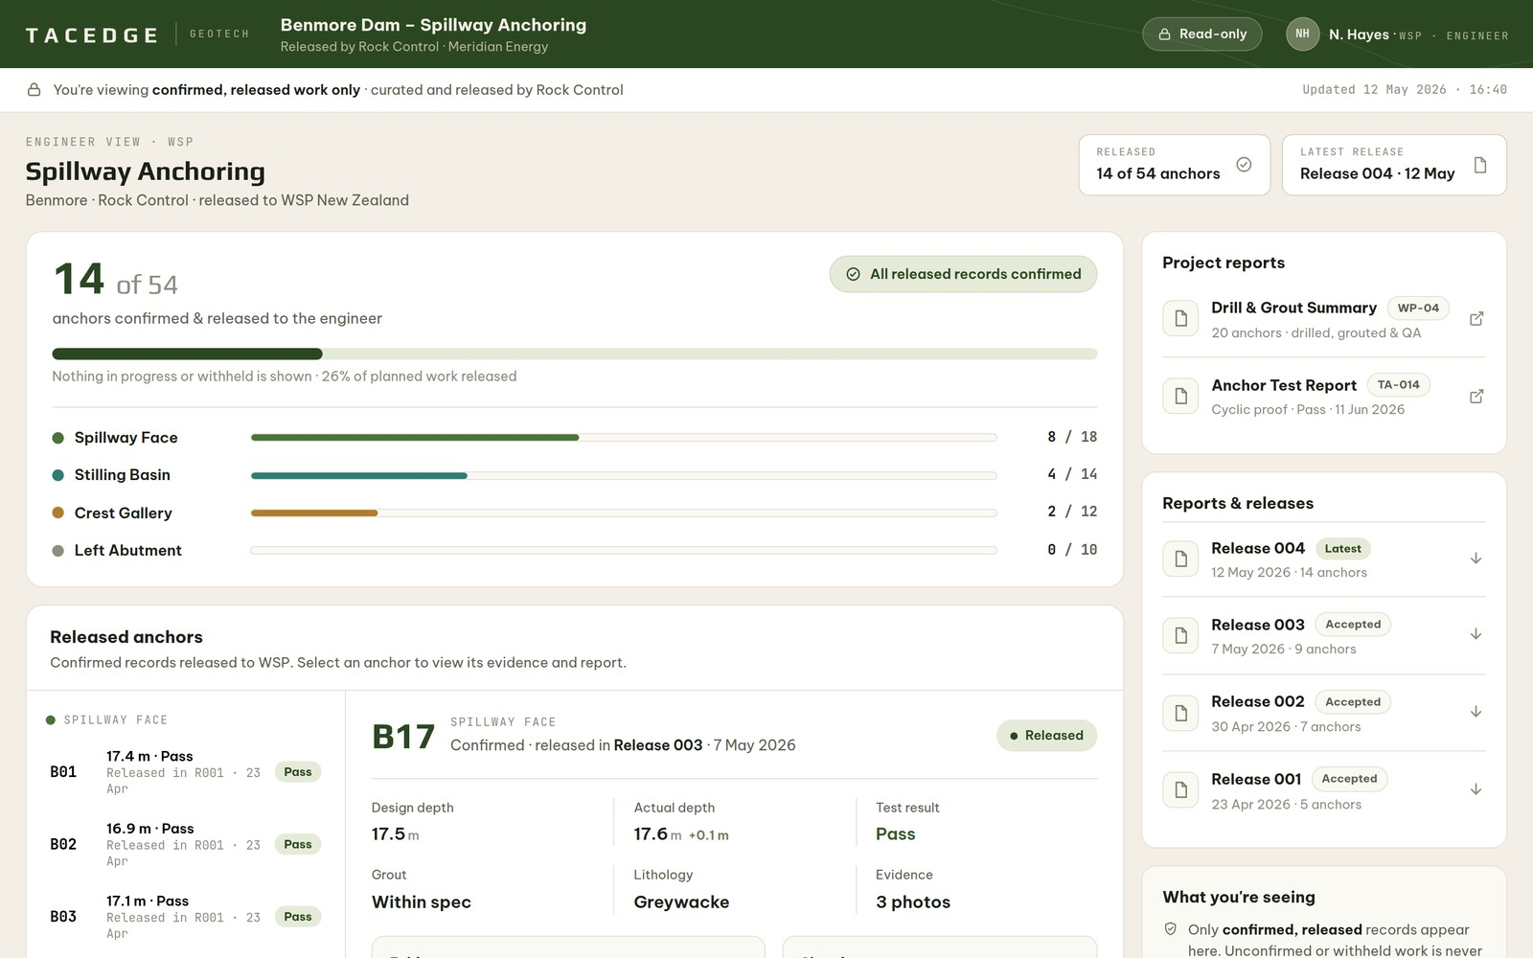
PURPOSE
The trusted client view — confirmed, released work only, read-only, ready to trust on sight.
PRIMARY USER
Engineer / Client
KEY CAPABILITIES
- See confirmed, released anchors only
- Read the status board and the full record
- Open the released project reports
- Acknowledge receipt of a release
WORKFLOW CONTEXT
The outward face of the workspace. Nothing reaches it until a manager has confirmed and released it.

Project Closeout
SCREEN 23 / 24
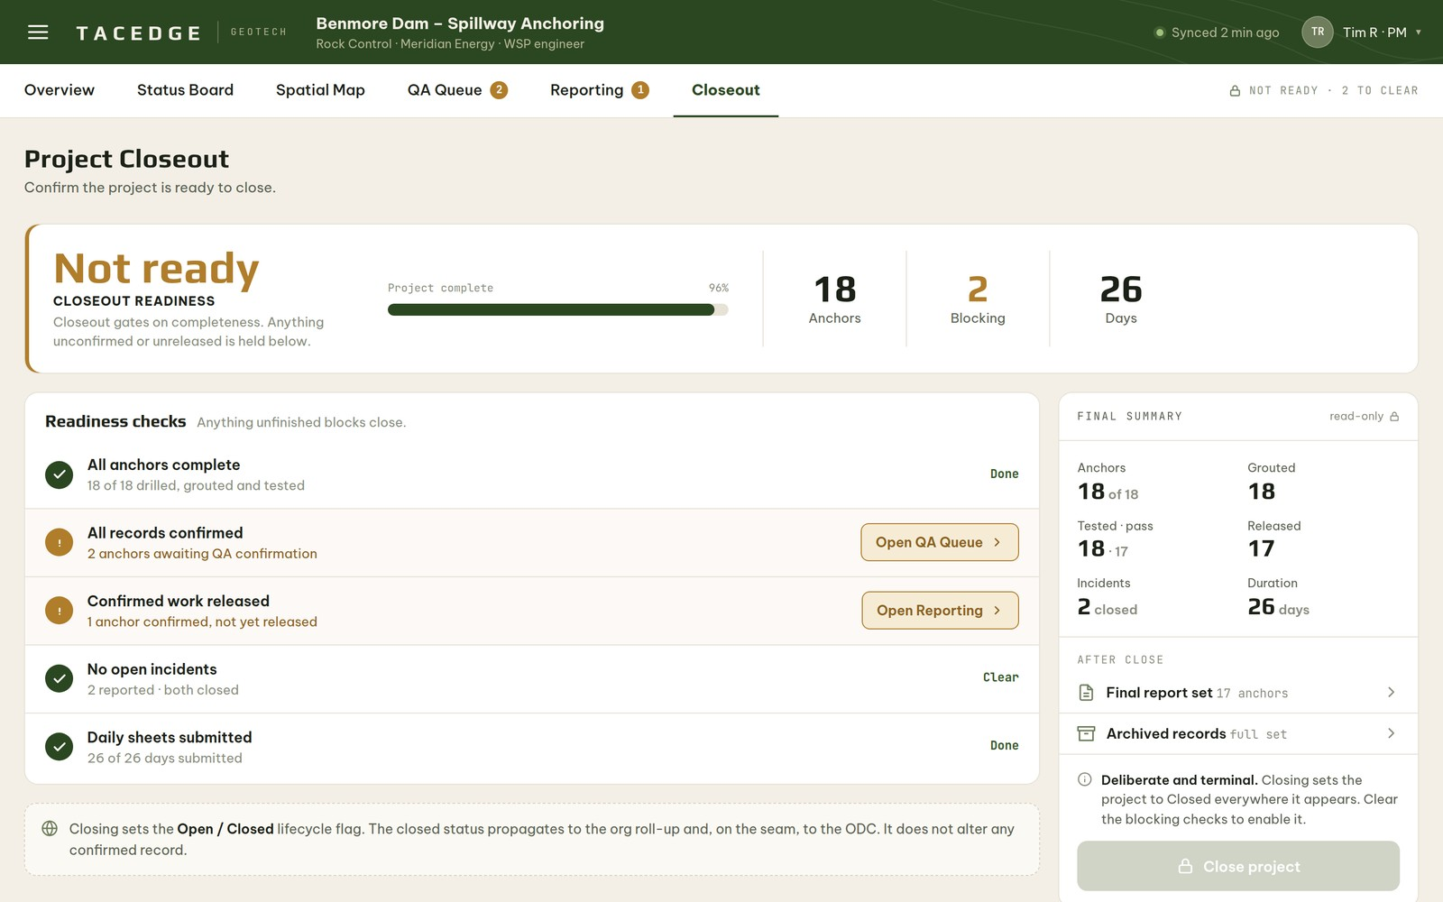
PURPOSE
A gated readiness check that confirms a project is complete and ready to close.
PRIMARY USER
Project Manager
KEY CAPABILITIES
- Check readiness against the closeout criteria
- Surface anything still blocking closure
- Confirm the project is complete
- Close the project cleanly
WORKFLOW CONTEXT
The final step once delivery and release are complete, declaring the project closed.

Reference Documents · Field
SCREEN 24 / 24
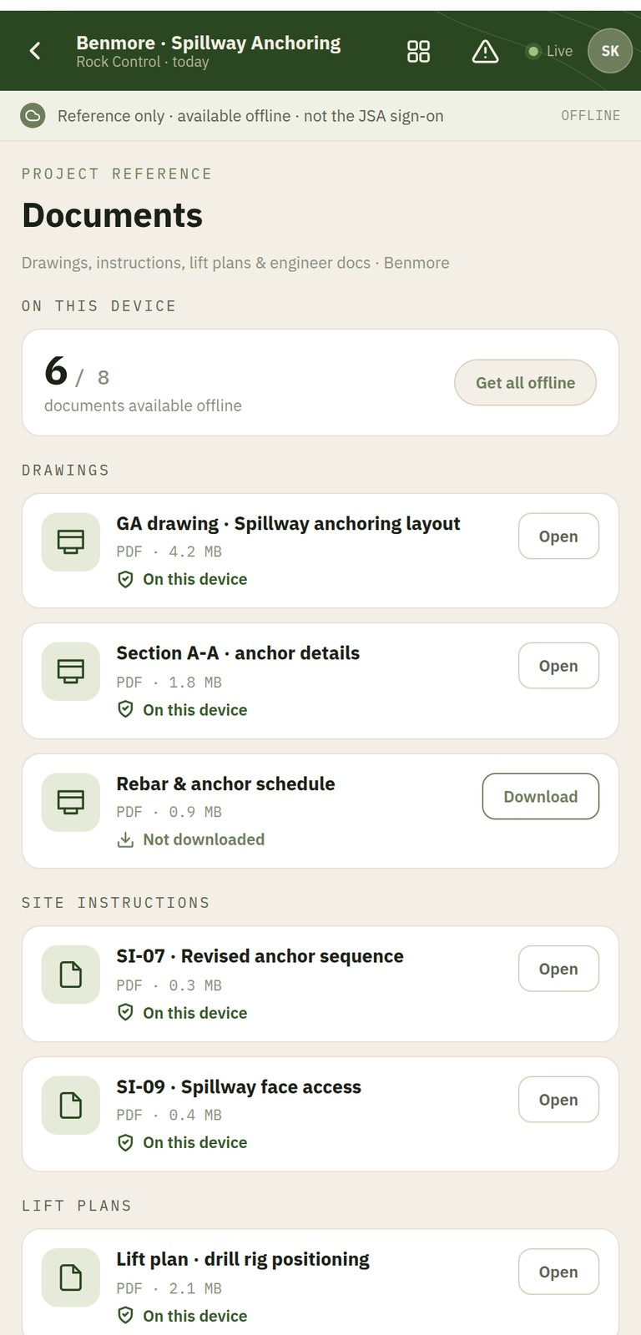
PURPOSE
The crew's offline copy of the project library, read on site.
PRIMARY USER
Operator
KEY CAPABILITIES
- Open project drawings and instructions on site
- Keep the documents available offline
- See what is downloaded to the device
- Keep reference material separate from the safety sign-on
WORKFLOW CONTEXT
The field-facing side of Reference Documents — the same library, read-only, in the operator's hand.


Thank you
TacEdge Geotech
Shared Operational Clarity.
first-use. fast.

