
NZ Army Combat Mindset
Framework Proposal
Remain effective. Act decisively.
Harder to kill.
Reference ACS 2026
Date August 2026
Originator Army Command School
Version V1.0

Contents
The Model on a Page 3
Purpose 4
1. The problem 4
2. Terminology and definitions 4
3. What already exists 6
4. Programme of work 7
5. Recommendations 8

The Model on a Page
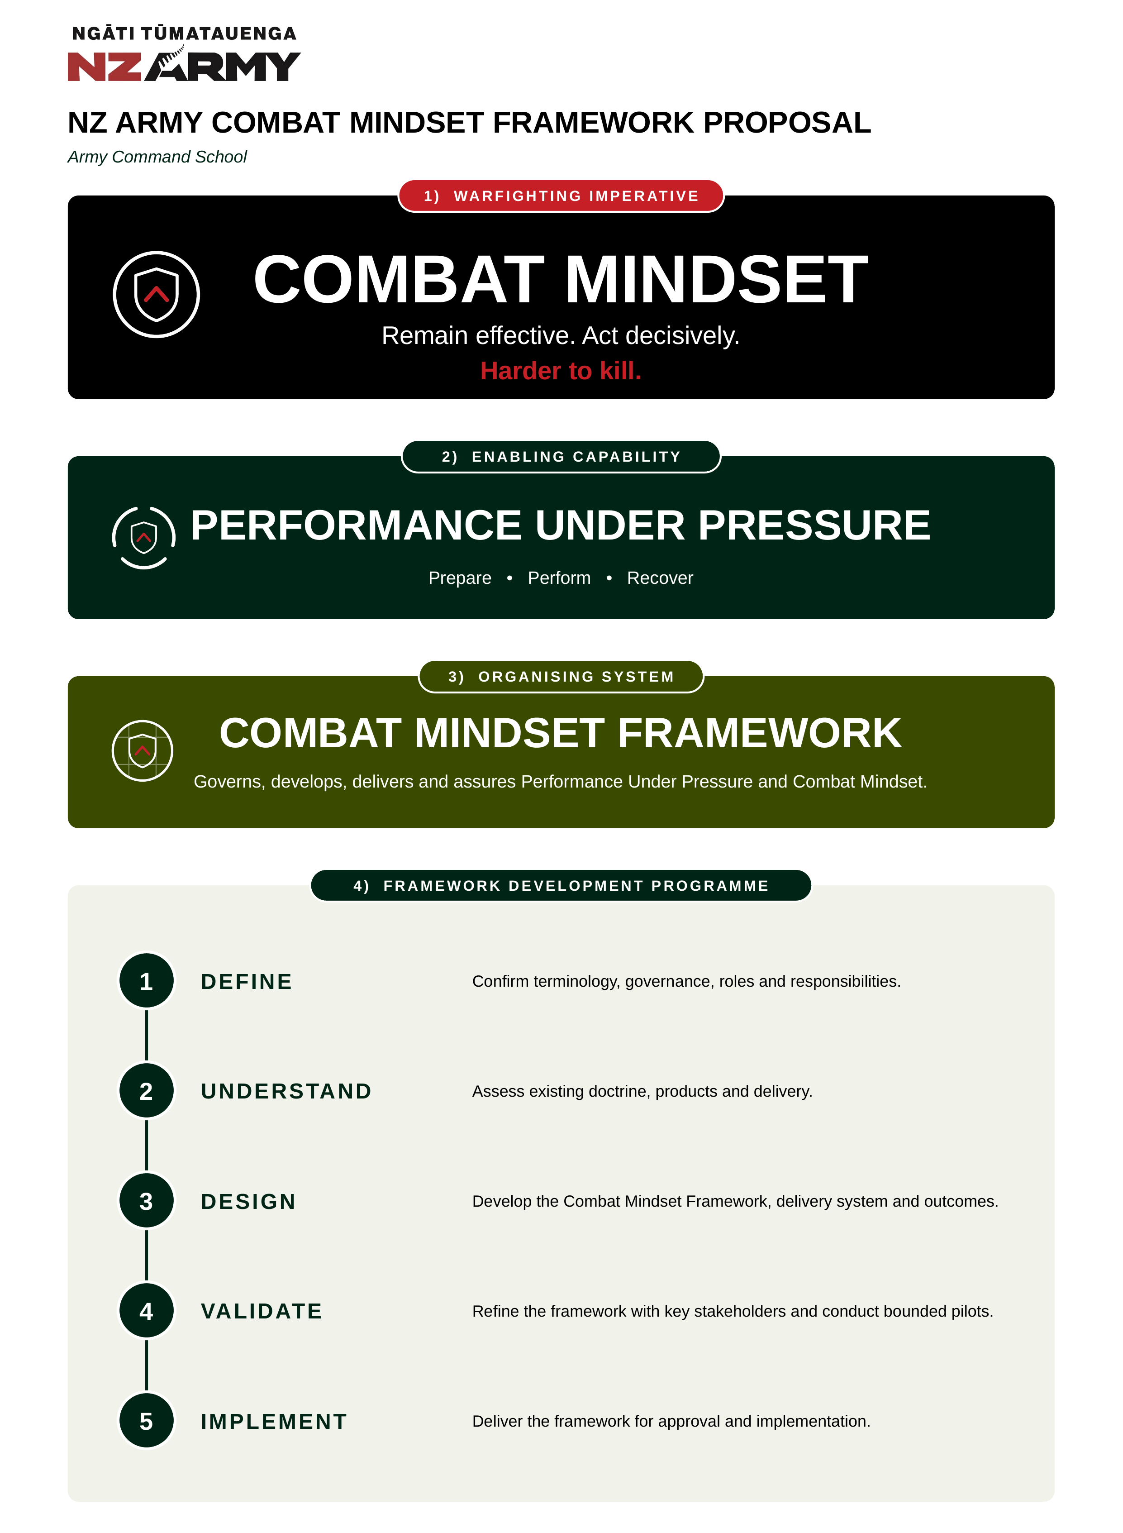

Purpose
This paper responds to COMDT ACS direction of 16 July 2026 for NZ Army Leadership Centre (NZALC), in conjunction with the Human Performance Cell (HPC), to develop a strategy to close the Combat Mindset policy and doctrine gap. It proposes the conceptual relationship between Combat Mindset and Performance Under Pressure, establishes the Combat Mindset Framework as the organising system, and seeks approval to commence a phased programme of work.
The programme of work is phased: Phase 1 defines terminology, governance, roles and responsibilities; Phase 2 assesses existing doctrine, products and delivery; Phase 3 designs the framework, its delivery system and outcomes; Phase 4 validates the framework with key stakeholders; and Phase 5 delivers the framework for approval and implementation.
The decisions sought establish the drafting baseline and the authority to commence the programme. Final doctrine, governance and implementation arrangements remain subject to the appropriate Army approval processes.

1. The problem
Considerable relevant capability, expertise and activity already exist across Army. What Army does not yet have is a coherent doctrine, governance and assurance model for Combat Mindset. The COMDT ACS guidance reaches the same diagnosis:
Substantial relevant capability already exists across ACS, NZALC, the Human Performance Cell, Army Psychology Services (APS), ILD, training establishments and units. The challenge is not primarily a lack of content. It is a lack of visibility, integration, common terminology, strategic ownership and assurance across that existing capability.
The underlying operational problem remains:
Under operational pressure, trained individuals and teams do not always retain access to their full capability.
Army must define the required human-performance capability, consolidate the substantial body of work already in existence, and describe its combat-specific expression. Existing evidence and capability are sufficient to commence that work.

2. Terminology and definitions
One structural decision must be made before the framework can be drafted: the relationship between Combat Mindset and Performance Under Pressure. Two options are offered.

Option 1: Combat Mindset as the combat-specific expression of Performance Under Pressure (recommended)
Combat Mindset is the combat-specific expression of Performance Under Pressure, the enabling human-performance capability that remains applicable wherever significant pressure exists. The Combat Mindset Framework is the organising system through which Army governs, develops, delivers and assures both.
The following formal definitions are proposed as the drafting baseline.
Combat Mindset. The individual and collective readiness and disposition to remain effective and act decisively and ethically under the threat, adversity and uncertainty of combat in order to achieve the mission. It is the combat-specific expression of Performance Under Pressure.
Performance Under Pressure. The trainable individual and collective human-performance capability to prepare for, maintain effective performance through, adapt within and recover from conditions that create significant physiological, cognitive, emotional or social interference.
Combat Mindset Framework. The framework through which Army governs, develops, delivers and assures Performance Under Pressure and its combat-specific expression, Combat Mindset.
A product, method or activity is combat-specific where it develops or applies Performance Under Pressure in a context that represents or deliberately simulates the defining demands of combat: opposition or threat, significant mission or human consequence, and ethical load. Products that do not represent these demands contribute to the enabling capability rather than its combat-specific expression.
In summary, Performance Under Pressure is the trainable capability; Combat Mindset is its combat-specific expression.
Advantages
• Gives each term one clear purpose: Combat Mindset is the combat-specific expression; Performance Under Pressure is the enabling capability; the Combat Mindset Framework is the organising system.
• Keeps Performance Under Pressure applicable wherever significant pressure exists without an enemy; command, crisis response, training, garrison leadership and high-risk technical activity.
• Guards against Combat Mindset being misread as aggression, motivation or resilience alone.
Limitations
• Requires Army to hold two related terms rather than one, so the distinction must be explained and sustained in doctrine, instruction and everyday use.

Option 2: Combat Mindset as the complete umbrella capability
Combat Mindset is treated as the complete capability itself, integrating leadership, human performance, resilience, mental skills and performance cognition, with performance under pressure expressed within it.
Advantages
• Maximises simplicity: one term serves as outcome, capability and framework alike.
• Matches common soldier usage, in which Combat Mindset already serves as the umbrella term, and avoids a two-term hierarchy that requires sustained explanation.
Limitations
• Conflates the combat-specific outcome with the broader human-performance capability, reducing applicability outside combat.
• Makes it difficult to distinguish doctrine, capability, framework and product.
• Increases the risk that Combat Mindset is interpreted as motivation or aggression alone.
Both options deliver the end state described in the COMDT ACS guidance. NZALC and HPC jointly recommend Option 1, and will implement whichever option COMDT ACS selects.

3. What already exists

Within ACS
NZALC Leadership Development System
NZALC delivers a leadership-development approach incorporating Performance = Potential – Interference, Red Head–Blue Head, Prepare–Perform–Recover, mental-skills techniques, psychometrics, experiential activity, feedback and Leadership Development Plans. This material is embedded across Lead Self, Lead Teams, Lead Leaders and Lead Systems.
HPC Cognitive Conditioning (COGCON)
COGCON is a developmental cognitive-conditioning product targeting selected aspects of performance cognition under physical and cognitive load, including arousal regulation, attention, cognitive control and working memory. Feasibility trials in military training have demonstrated acceptability and promising training trends. Its causal effectiveness, operational transfer, readiness validity, scalability and enduring delivery model have not yet been established. Its status and appropriate future role will be confirmed through the Phase 2 assessment.

Outside ACS
Army Psychology Services (APS), ILD and other stakeholders
These organisations hold additional professional expertise, learning products, delivery capability and assurance functions that will be confirmed during the Phase 2 assessment.
Initial review indicates considerable conceptual alignment across existing products. The Combat Mindset Framework will establish a common doctrinal language beneath which individual products and methods can be nested.
A full assessment of existing capability and products will be completed during Phase 2. The products described above contribute to Performance Under Pressure and, where applied in a warfighting context, to Combat Mindset; none constitutes the framework in isolation.

4. Programme of work
August 2026 is set aside for this paper to be socialised through the chain of command, and the programme is therefore proposed to commence in September 2026. The timeframes below are aspirational and depend to varying extents on external stakeholder availability and input. As such, activity extending into early 2027 is anticipated rather than unforeseen.
Phases may overlap, but each phase depends on the endorsed outputs of the one before it.

Phase 1: Define (September 2026)
Confirm terminology, governance, roles and responsibilities. Establish interim sponsorship, programme leadership, phase leads, stakeholder representation and decision authorities, while identifying the enduring capability ownership, technical-authority and assurance arrangements to be resolved through the programme.
Key output. Endorsed drafting baseline and confirmed interim governance.

Phase 2: Understand (September 2026)
Assess existing doctrine, products and delivery across ACS, NZALC, HPC, APS, ILD, training establishments and selected units against:
• doctrinal and policy holdings;
• capability outcomes, training products and methods;
• delivery organisations;
• evidence maturity, scalability and resource requirements; and
• gaps, duplication and integration opportunities.
Apply the combat-specificity test in section 2 to distinguish products that contribute to the broader Performance Under Pressure capability from those that support its combat-specific expression. Assess COGCON as one developmental product, establishing what it delivers, who owns it and whether it can be scaled.
Key output. A capability and product baseline identifying what already exists, gaps, duplication and integration opportunities.

Phase 3: Design (October 2026)
Develop the Combat Mindset Framework, delivery system and outcomes. The framework will establish how Army governs, develops, delivers and assures Performance Under Pressure and its combat-specific expression. The design will set developmental outcomes from Lead Self through Lead Systems, the architecture through which existing and future products contribute, common assurance principles, and the criteria by which products are recognised as part of the framework.
Existing products, including the NZALC Leadership Development System and COGCON, will be mapped against the endorsed outcomes and framework requirements rather than treated as the framework itself. The design will also identify how progression, transfer to performance, product quality and organisational adoption will be assessed.
Key output. Draft Framework v1.0, comprising developmental outcomes, product architecture, governance arrangements and assurance criteria.

Phase 4: Validate (November 2026)
Refine the framework with key stakeholders: convene ACS, NZALC, HPC, APS, ILD, selected training providers and units to test whether the framework is clear, coherent and workable. Where time and unit availability permit, bounded validation activities or pilots will be conducted within this phase or earlier alongside Phase 2 or Phase 3.
Key output. A validated framework and product architecture, with stakeholder positions recorded.

Phase 5: Implement (late November 2026)
Deliver the Combat Mindset Framework for approval and implementation: the validated product architecture; the proposed governance and assurance model; and an implementation plan.
Further evidence development, product alignment and assurance maturity will continue through implementation.
Key output. Framework v1.0 submitted for approval, with an implementation plan and back brief to COMDT ACS.

5. Recommendations
It is recommended that COMDT ACS:
1. Endorse the problem statement.
2. Approve the recommended relationship between Combat Mindset and Performance Under Pressure.
3. Endorse the initial working definitions of Combat Mindset, Performance Under Pressure and the Combat Mindset Framework as the drafting baseline for the programme.
4. Approve commencement of the proposed programme of work.
5. Note that the programme timeframes are aspirational and that activity may extend into early 2027.

