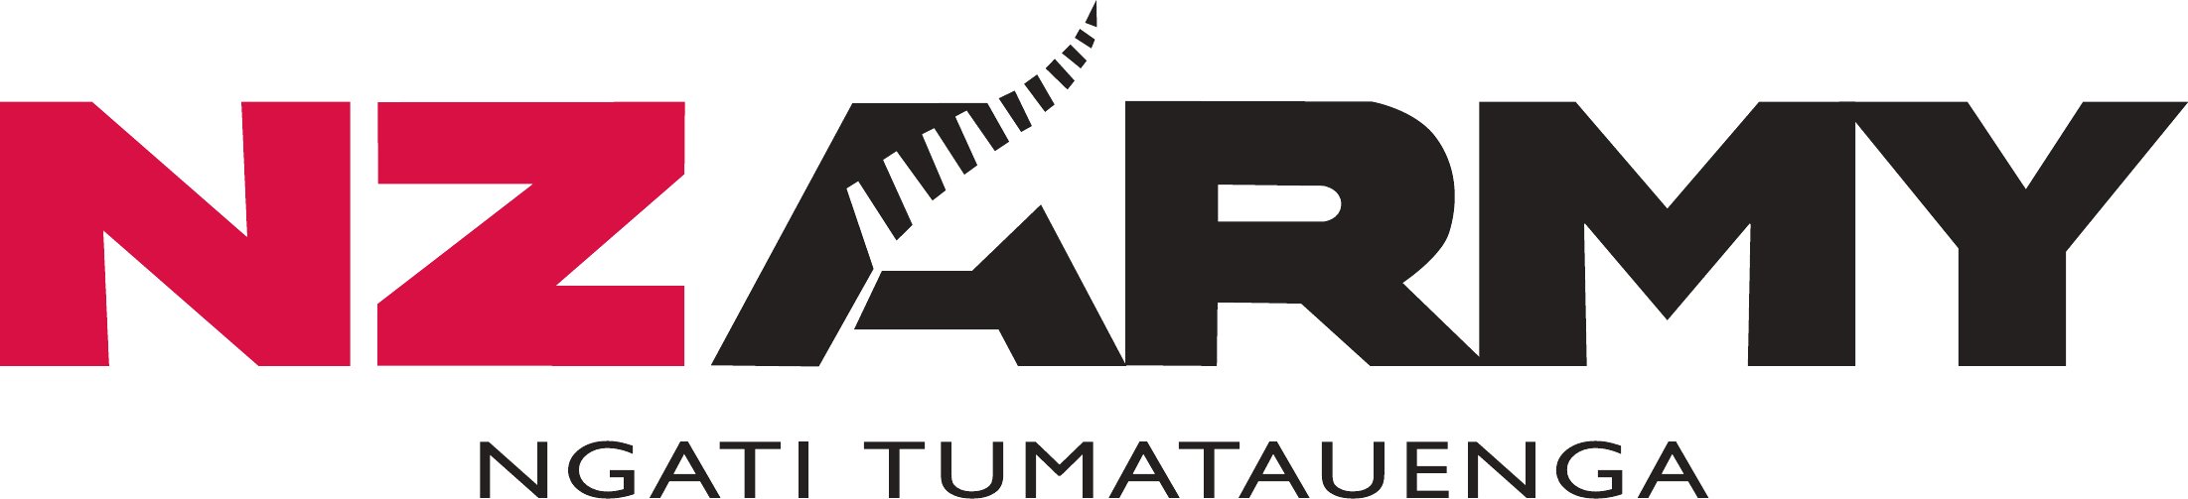
Testing the Approach
A falsification pack for the individual training and AI models
From [originator]
To [distribution]
Date September 2026
Return by [date]
Purpose To find where these models fail

Purpose
1. Two models have been produced from a short activity: an approach to individual training, and a framework for deciding where AI helps. Both are coherent, and both are untested. This pack exists to try to break them.
2. What is wanted back is where they fail. A return that agrees is of little use. A return that says "this does not describe how we train" or "following this would have led us to a bad decision" is worth more than any further drafting.
3. Both models will be amended on what comes back, or their claimed scope narrowed to what survives. Nothing here is settled.

Part 1: The Individual Training Model
Under test. The Army Approach to Individual Training, Version 1.0.
Foundation → Guided Practice → Independent Practice → Applied / Experiential Learning → Performance Under Pressure
Progression is shaped by risk, complexity, learner competence and the required operational outcome
4. The model claims that individuals develop progressively toward a common standard, that instructor direction reduces as competence grows, that the pathway may be adapted without diluting the standard, and that this applies to all Army individual training.
Your question: where does this not describe how you need to train?
5. Specific tests:
a. Does the progression describe your training, or does it cycle backwards, repeat stages, or skip them?
b. Where does an experienced learner still require high instructor control, and why?
c. Where would adapting the pathway put the standard, or safety, at risk?
d. Does the claim hold for recruit training, weapons qualification, trade training, command and staff education, refresher training and mandated high-risk training? Name where it does not.
e. What does the model not describe at all?
f. Does your training produce people who can still perform when information, technology, time or support degrade? Should the model say so?
Send to. Recruit training, a technical school, leadership instructors, and an operational unit that receives their output.

Part 2: The AI Framework
Under test. AI and Army Operational Effectiveness, Draft v0.2.
Output → Task → Constraint → AI → Human Role → Assurance → Competence → Effect
The more it matters if AI gets it wrong, the more human control and checking is required
6. The framework claims that AI should be reasoned about from the required output backwards, that the level of control should follow the consequence of error, and that effect should be measured on the Army output rather than on use of the tool.
Your question: where would following this framework lead us to a bad decision?
7. Specific tests:
a. Where would the framework approve something that should not be approved?
b. Where would it block or discourage something valuable?
c. Are the three assurance questions sufficient for the decisions you make, or what else must be asked?
d. The framework would suit almost any new technology. What is distinctive about AI that it fails to capture?
e. Are the priority areas the right ones for your function, and what is missing?
Send to. G3 and G5 planners, intelligence, logistics, CIS, training, and commanders at unit and formation.

What to Return
8. One page. Three headings: where it fails, what it misses, what you would change. Evidence from your own training or decisions is worth more than opinion.
9. Return by [date] to [appointment].

What Happens Next
10. Returns are consolidated and the models amended. Where a model does not survive a context, its scope is narrowed to what it does describe. Where it survives, the claim gets stronger because it has been tested rather than asserted.

