1. Complete the timing diagram below.
2. **Complete the timing diagram of A, B and z, assume each FF start at 0.**

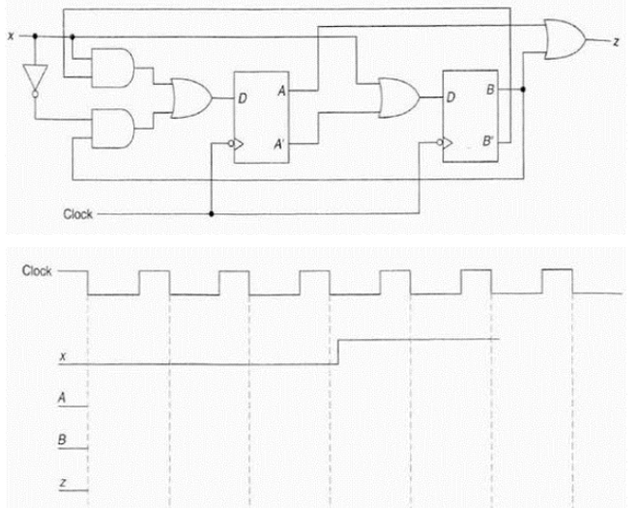

1. **Complete the timing diagram of q1 and q2, assume each FF start at 0.**

