Homework 2 - Digital System - Question 10, 11, 12, 17, 18

Nguyễn Vũ Thành Nguyễn - 1652437

10. Transforming X = A’B + B’A into NAND only:  
 => X = ((A’B)’.(B’A)’)’  
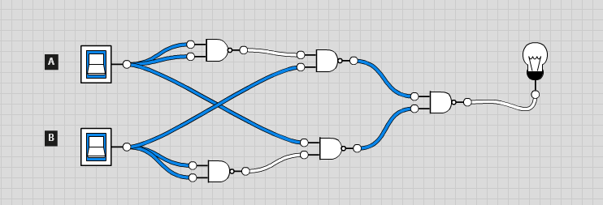

Transforming X = (A’+B’)’.BC into NAND only:   
 => X = ((ABC)’)’

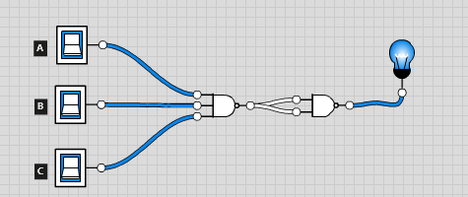

11. Transforming X = AB.(B’+C)’ into NOR only:  
 => X = (A’+B’+C)’

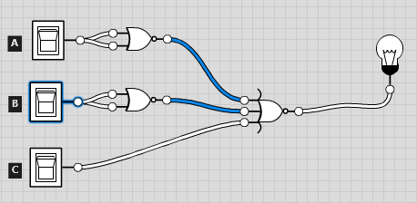

Transforming X = (A+B’).BC into NOR only:  
 => X = ((A+B’)’+B’+C’)’

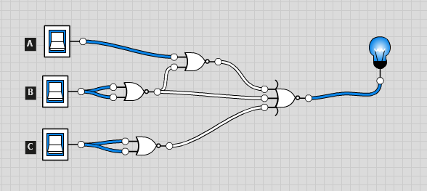

12. Transform 2 input NAND gate into 2 input NOR gates:

(AB)’ = ((A’+B’)’)’

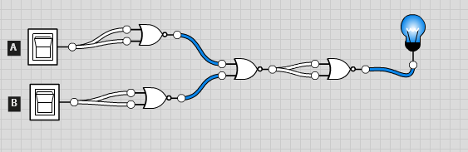

17. Implement X = ABC’ using only 1 2-input NOR gate and 1 2-input NAND gate.

=> X = ((AB)’ + C)’

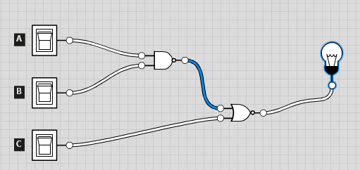

18. Implement Y = ABCD uses only 2-input NAND gates.

=> Y = ((((AB)’)’.((CD)’)’)’)’

