Student ID: 103038198

Name: Coryn Tyrrell

# Setup Screenshot

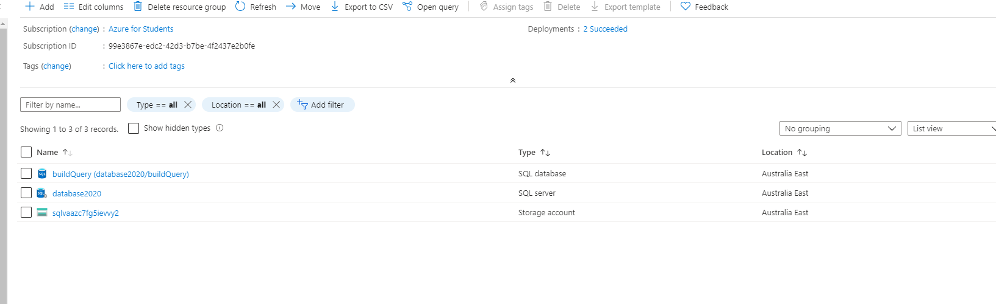

# Task 2 Screenshot

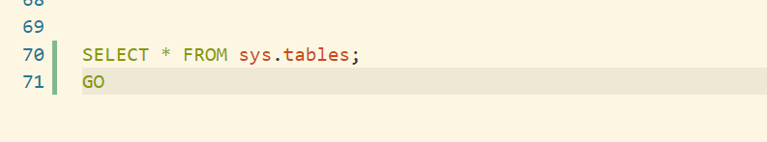

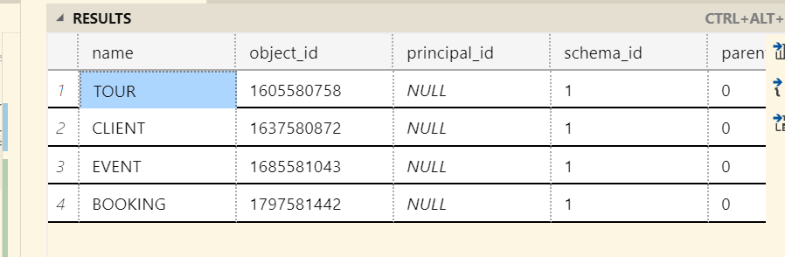

# Task 3 Screenshot

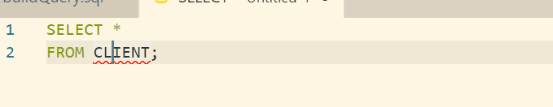

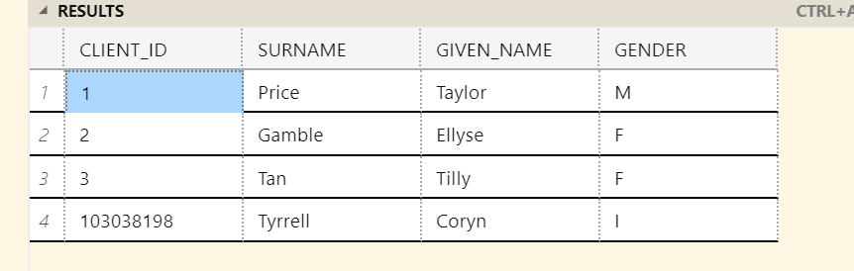

# Task 4 Screenshot

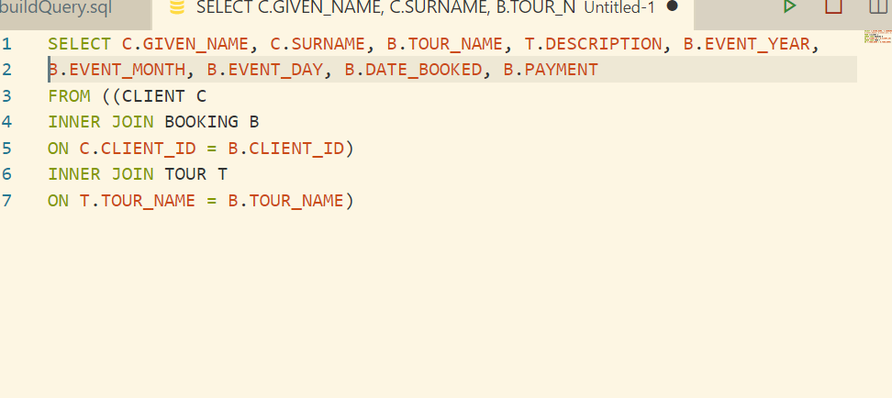

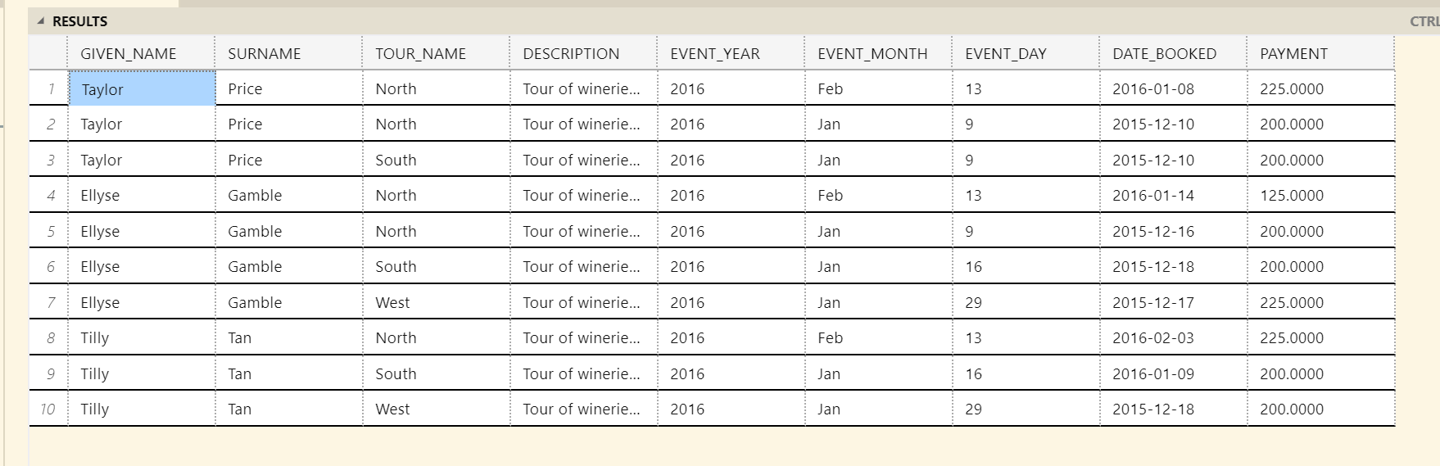

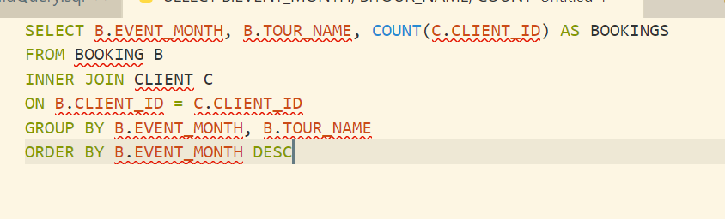

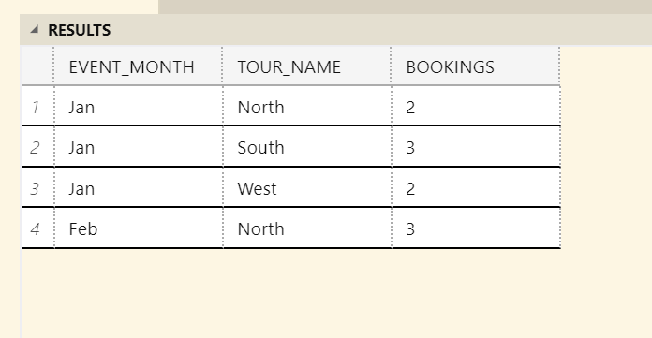

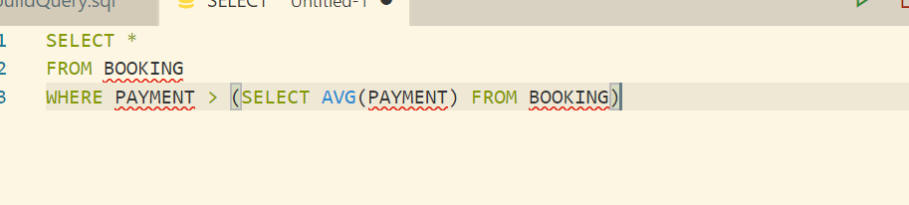

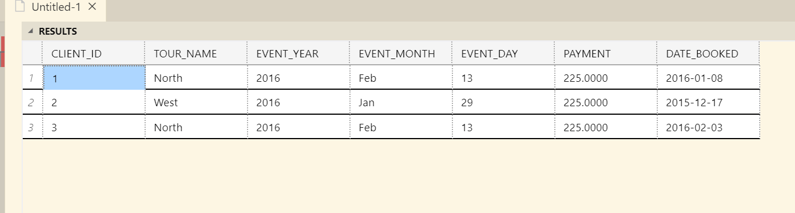

# Task 5 Screenshot

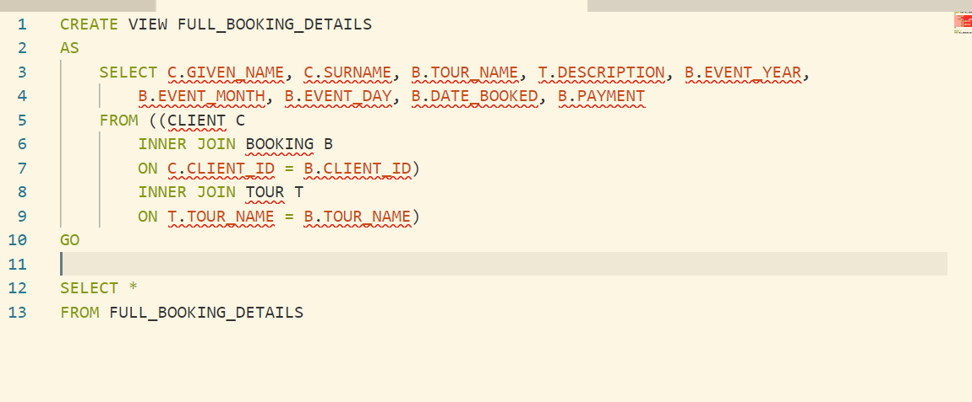

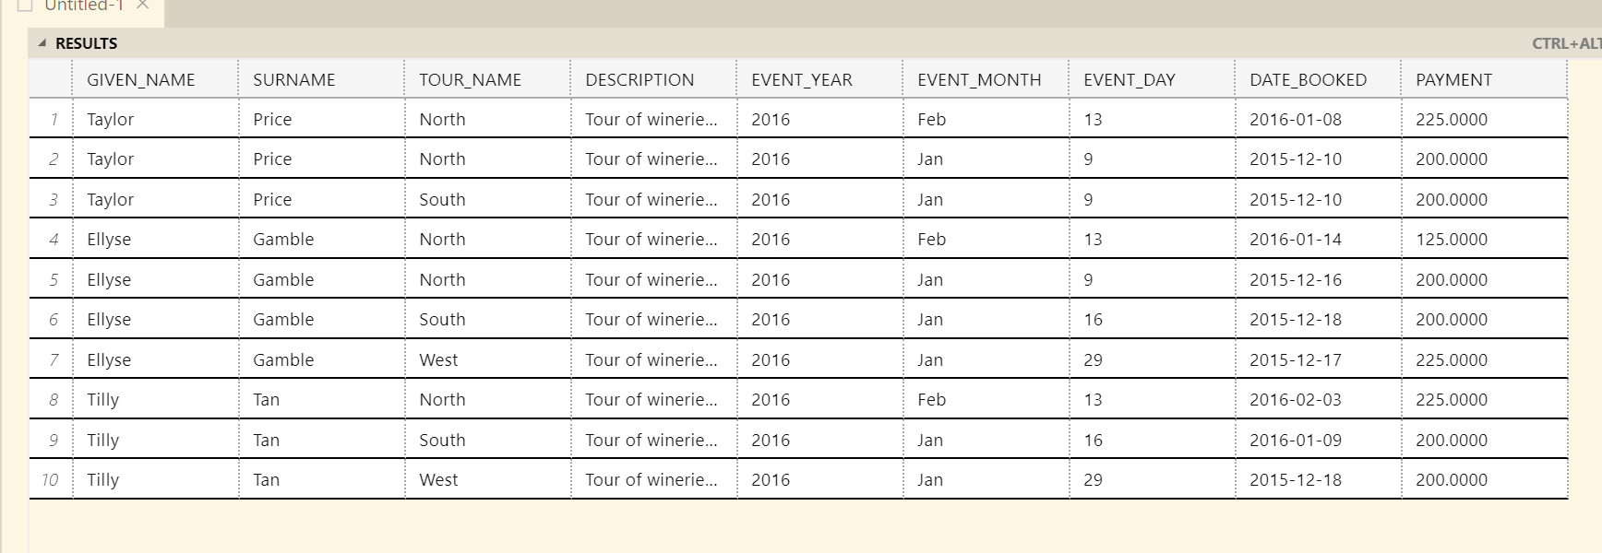

# Task 6 Screenshot