**SIGMA DELTA ADC MODULE**

**BY SZYMON FILIPKOWSKI**

Datasheet covers Sigma Delta ADC module by Szymon Filipkowski Rev 1.01  
Available on GITHUB <https://github.com/Tacot2009/Sigma-Delta-ADC-module-by-Szymon-Filipkowski> - currently empty branch. Adding files soon. **Power usage, sampling rate and bitrate are all approximation at this version.**

1. **Features**

* On-Board MCU
* 0V to 2.56V analog input range
* Single 3.3V voltage supply
* Easy mode change
* Plug-and-play feature
* Key specification
  + Resolution: 8 Bits
  + Accuracy at least 0.01V
  + Sampling rate at least 2Hz
  + Bitrate at least 16bps
  + Power usage less than 2mW

1. **Applications**

* Operates with any device supporting SWD communication protocol
* Interface to Temp Sensors, Voltage Sources, Transducers, Photoresistor,etc.

1. **Description**

“Sigma Delta ADC module by Szymon Filipkowski” is a 8bit successive approximation converters (ADC) that uses Sigma and Delta modulation to approximate digital value of input. This module uses stm32c0 mcu to decode digital signal into SWD message and sends it to output device. Hardware and software is open sourced at GITHUB, so everyone can tailor this module to their specifics requirements. I as Szymon Filipkowski am creator and software developer for this project. I take full credit for this project.

**Typical Application Schematic**

//TODO in the next revision of datasheet

1. **Revision history**

* Entry – first PCB project, software still in development

1. **Pin Configuration and Functions**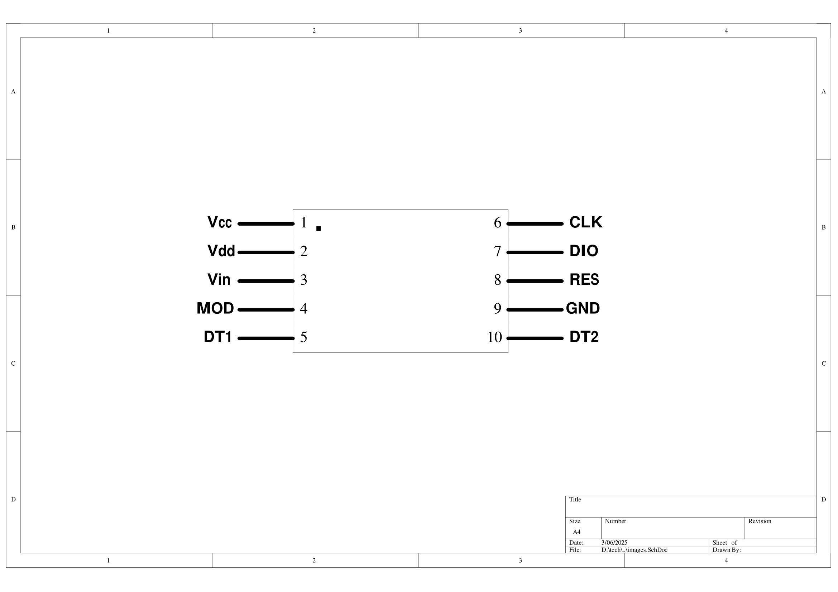

|  |  |  |  |
| --- | --- | --- | --- |
| **PIN** | | **I/O** | **DESCRIPTION** |
| **NO.** | **NAME** |
| 1 | Vcc | I | +3.3V supply voltage |
| 2 | Vdd | I | Ground pin |
| 3 | Vin | I | Analog input |
| 4 | MOD | I | Mode select pin |
| 5 | DT1 | O | +3.3V output |
| 6 | CLK | I | SWD clock |
| 7 | DIO | O | SWD data output |
| 8 | RES | I | NRST of mcu – for programming |
| 9 | GND | O | 0V reference for SWD communication |
| 10 | DT2 | O | 3.3V output if need and for easier repairs of module |

1. **Specifications**
   1. **Recommended Operating Conditions**

|  |  |  |  |
| --- | --- | --- | --- |
|  | **MIN** | **MAX** | **UNIT** |
| Vcc | 3.3 | 3.3 | V |
| Vdd | 0 | 0 | V |
| Analog Input Voltage | 0 | 2.56 | V |

* 1. **AC Electrical Characteristic – single conversion mode**

|  |  |  |
| --- | --- | --- |
|  | **TEST CONDITIONS** | **TYPICAL** |
| Single conversion time | Vin = 3.3V | 1 SEC |
| Power usage | Vin = 3.3V | 2 mW |

* 1. **AC Electrical Characteristic – continuous conversion mode**

|  |  |  |
| --- | --- | --- |
|  | **TEST CONDITIONS** | **TYPICAL** |
| Sampling rate | Vin = 3.3V | 2Hz |
| Power usage | Vin = 3.3V | 2mW |

1. **Detailed Description**
   1. **Functional Block Diagram\***

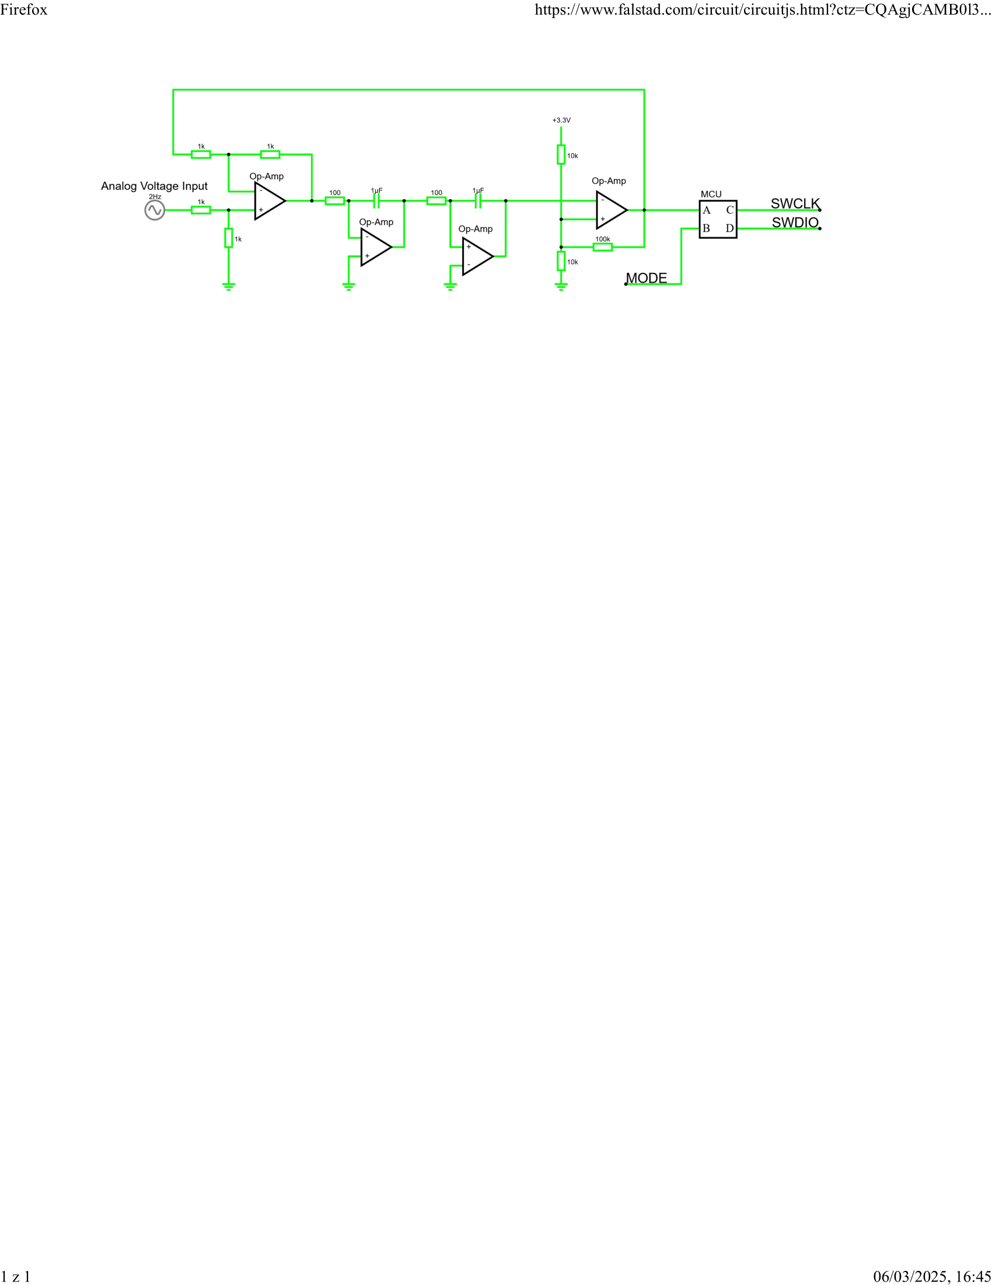

*Passive components specification may by different than in this Block Diagram, depending on version of module

* 1. **Analog Digital Approximation Mode Controll**

This ADC device support two operating mode. Call mode (or single mode) and continuous mode (or auto mode). The auto mode is default for this module. Shorting MOD pin to DT1 or MOD pin to 3.3V enables single mode. In this mode ADC makes one voltage approximation, sends it via SWD protocol. After this MCU goes into stop mode waiting for disconnecting MOD pin from DT1 or 3.3V. If MOD pin is left disconnected then module is in auto mode. In this mode module sends data via SWD protocol as soon as calculation of input voltage completes.

1. **Package Outline**

//TODO in the next revision of datasheet

1. **Pricing**

//TODO in the next revision of datasheet