What is Wireframing?
- Wireframes act as basic blueprints for websites and apps, helping teams focus on structure, user flows, navigation, and core functionality before visual design details are introduced.
- There are three main levels of fidelity: low-fidelity for layout and information architecture, mid-fidelity for refining interactions and content, and high-fidelity for near-final mockups with branding elements.
- Teams do not always need to start with low-fidelity wireframes; if a strong design system already exists, jumping straight to higher fidelity can still be efficient and productive.
- Effective wireframing follows key best practices, including defining clear design goals, choosing the correct screen size, keeping designs simple, maintaining consistency, prioritising intuitive navigation, and remaining open to iteration.
- A successful wireframe aligns stakeholders early, supports usability testing, clarifies user flows and essential screens, and ensures feedback focuses on core user needs rather than superficial visual details.

Wireframe Types & Fidelity
Fidelity | Characteristics | When you use it
Low | Simple layouts in greyscale, boxes for images, placeholder text, minimal detail, that are focused on structure and flow rather than visuals | Early in the process when coming up with ideas, deciding on goals, and gathering feedback
Mid | More well-made layouts, clearer content structure, annotations, defined elements, some interaction detail | When refining flows, testing functionality, and shaping framework before adding branding and visual additions
High | Detailed layouts resembling final product mock-ups, real content, branding elements such as fonts and colours, interactive components | Later stages of design for approval, realistic testing, and preparing for sending to developers

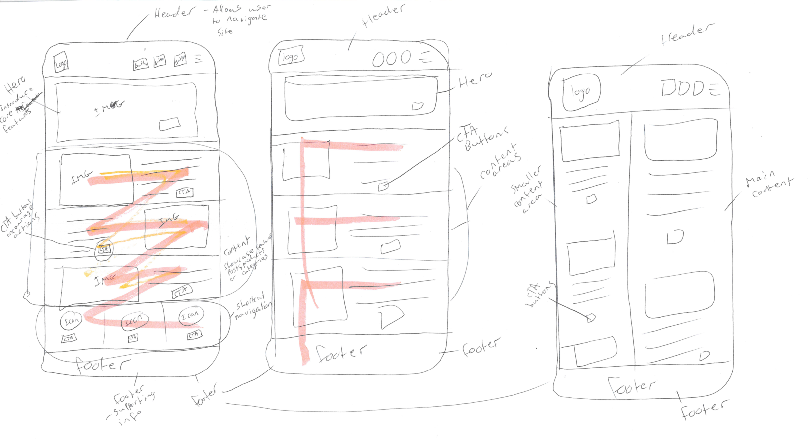

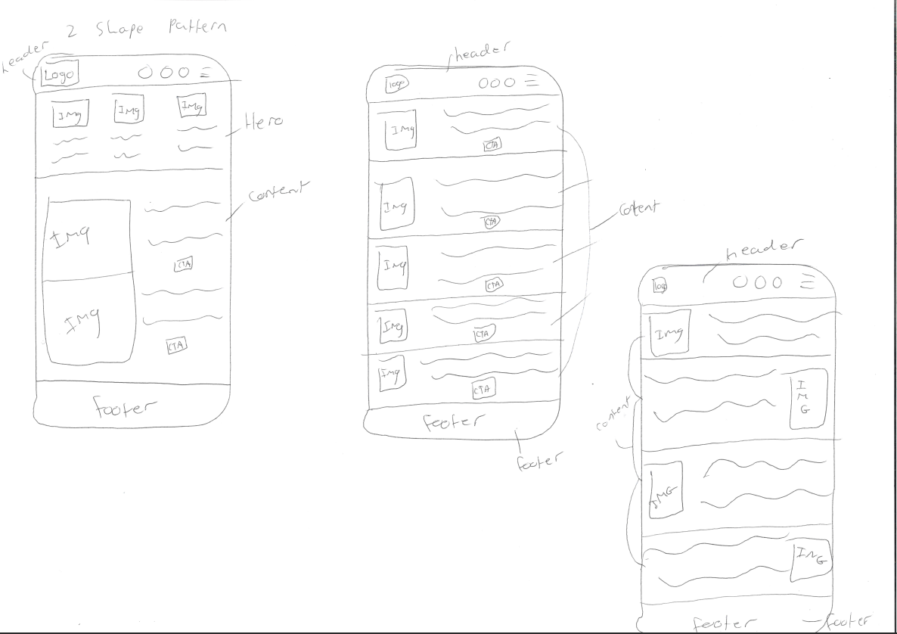

Reflection
The F-shaped wireframe is the best choice for DreamTrips Honeymoon because it follows the way users read and skim through digital content. Their attention begins at the top-left, immediately reinforcing brand identity through the logo and header area. From there, the layout guides the eye horizontally across the navigation bar, then vertically down the left side where the most important sections such as featured trips are positioned. This creates a clear, intuitive flow that helps users quickly locate the experiences they’re most interested in.
While a split-screen layout offers stronger visual storytelling and a more dramatic introduction to the company, the F-shape is far more effective at conversion-focused design. Because users can instantly access key trip information without distraction, it increases the likelihood of them exploring multiple packages and ultimately making a booking which aligns with the website’s primary goal.
The simplicity of the F-shaped structure also matches modern user expectations. The target audience, often younger and looking for a fast, efficient booking journey, will appreciate the clean, familiar layout. This makes the F-wireframe not only user-friendly but also perfectly suited to a service-oriented site like Dream Trips Honeymoon.

