PickleVerse Software Requirements Specification
  - Report 3 · Proposal scope and current implementation evidence
Working draft for team and reviewer discussion. Source snapshot c32f2a4c0a54 on 23 October 2026. No game/backend execution or code edits were performed. PKV is a working abbreviation; official code, names and approvals remain unconfirmed.

1 Purpose scope and evidence
This SRS defines the player learning, competition and administration requirements derived from the supplied registration proposal and Core Features document. It separates the required outcome from current source evidence so that a visible UI or a backend method is not treated as a passed acceptance test.
Source | Role in this draft
Doc/Proposal/PickleVerse_Capstone_Proposal.docx | Scope baseline; approved version and official code not verified.
Doc/Proposal/PickleVerse_Core_Features.docx | Supporting scope interpretation; optional wording cannot silently remove proposal commitments.
Review 2 guide and BM01–04 | Process, English submissions, diagrams, test commitments and ownership requirements.
c32f2a4c0a546d0ed4f0df1b2c97e185ed831fb6 | Current code/schema snapshot; read-only inspection. Earlier d44e8c0 audit is superseded for implementation status.

Conflicts requiring a recorded decision include dedicated simulation versus Photon Shared, proposed backend/UI stacks versus .NET/uGUI, and offline/friends/daily features described differently by the two scope documents. None has been silently approved or removed.

2 Users boundaries and assumptions
Actor | Goals
Player | Learn, practice, play, inspect progress and manage cosmetics.
Online player or room host | Queue, accept, organize teams, play and inspect durable results.
Administrator | Control access, publish content, inspect matches/moderation and operational metrics.
External support services | Photon sessions, SMTP email and S3 object storage; they do not replace a human actor or independently prove trusted simulation.

The AI opponent, API, database and rules engine are internal components. They are not additional external actors used to satisfy workflow counts. Named ownership is deferred by the user; M1–M4 are proposed role slots for four blank student rows in the supplied proposal, not statements of authorship.
The source curriculum contains 12 drill definitions: serve, drive, dink, volley, modifiers, drop, reset, smash, footwork, approach, doubles-cover and doubles-transition. Tier defaults are 150/225/300/450 Tokenpad and 5/7/10/15 XP; the active server catalog may configure them. The proposal says around 15 drills, so the team should confirm final breadth instead of claiming an exact 15 already deployed. Tutorial and learning execution still require current acceptance evidence.

3 Mandatory features and acceptance criteria

F01 Account and onboarding
Actor Player
Create and verify an account; sign in and load the same server profile; reject invalid credentials; record self-assessment for initial placement.
Current evidence Partial; account integration exists, self-assessment/placement not evidenced. My project/Assets/Scripts/Services/AccountService.cs:44
Trace: WF01; TC-F01-01 through -03; proposed owner M1.

F02 Tutorial and basic controls
Actor Player
Complete or replay rule and movement steps; skipped/completed status persists for that account.
Current evidence Source integrated; acceptance not run. My project/Assets/Scripts/LocalMatch/TutorialDirector.cs:11
Trace: WF01; TC-F02-01 through -03; proposed owner M1.

F03 Structured skill training
Actor Player
Select an unlocked drill, receive feedback and a 1–3 star result; only the first eligible completion earns the configured reward.
Current evidence Source integrated; client telemetry limitation. src/Backend/Services/Game/OnlineGameService.Training.cs:1
Trace: WF01; TC-F03-01 through -03; proposed owner M1.

F04 XP levels and cosmetic unlocks
Actor Player
Award XP once per eligible command; recompute level/unlocks and preserve balances after a refresh.
Current evidence Source integrated; acceptance not run. src/Backend/Services/Game/OnlineGameService.cs:90
Trace: WF05; TC-F04-01 through -03; proposed owner M1.

F05 Adaptive AI and skill coaching
Actor Player
Adjust bot challenge and recommend drills from measured skill; validate initial placement and technique classifiers against labelled data.
Current evidence Partial; Elo-tier bot and heuristic recommendations exist; ML evaluation not evidenced. My project/Assets/Scripts/LocalMatch/BhTreeBot.cs:15
Trace: WF02; TC-F05-01 through -03; proposed owner M2.

F06 Pickleball movement shots and rules
Actor Player
Serve and execute supported shots while moving; enforce court, kitchen, net, two-bounce and scoring rules in singles and doubles.
Current evidence Source implemented; current runtime not measured. My project/Assets/Scripts/LocalMatch/Rules/SinglesRules.cs:29
Trace: WF02; TC-F06-01 through -03; proposed owner M2.

F07 Skill queue and ready confirmation
Actor Online player
Match eligible players; show both clients a usable ready dialog; cancel a decliner and requeue consenting players under server policy.
Current evidence Source integrated; multi-client acceptance not run. src/Backend/Services/Game/OnlineGameService.OnlineMatches.cs:182
Trace: WF03; TC-F07-01 through -03; proposed owner M3.

F08 Private rooms and teams
Actor Host and invited player
Create/join a coded 1v1 or 2v2 room; validate membership, teams and readiness before start.
Current evidence Source implemented; room-code flow; optional account invitation not verified. My project/Assets/Scripts/Multiplayer/PhotonSession.cs:116
Trace: WF04; TC-F08-01 through -03; proposed owner M3.

F09 Online match synchronization
Actor Online players
Synchronize legal movement, shots and score for 1v1/2v2; apply disconnect policy and reject non-member commands.
Current evidence Partial; Fusion Shared differs from dedicated proposal. My project/Assets/Scripts/Multiplayer/PhotonSession.cs:116
Trace: WF03; TC-F09-01 through -03; proposed owner M3.

F10 Durable match result and rating
Actor Player
Finalize an agreed/validated result once; atomically update Elo, wallet, history and rewards; reject conflicting duplicate reports.
Current evidence Source integrated; client consensus trust limit. src/Backend/Services/Game/OnlineGameService.OnlineMatches.cs:182
Trace: WF03; TC-F10-01 through -03; proposed owner M3.

F11 Personal statistics history and replay
Actor Player
Read own progress and recent matches; open authorized replay data and inspect errors and frequently repeated drills.
Current evidence Source integrated; runtime acceptance not run. src/Backend/Services/Game/OnlineReplayService.cs:14
Trace: WF05; TC-F11-01 through -03; proposed owner M1.

F12 Friends and global leaderboard
Actor Player
Search and accept/remove friends; read ordered Elo standings and own position; reject unauthorized relationship changes.
Current evidence Source integrated; runtime acceptance not run. src/Backend/Services/Game/OnlineSocialService.cs:27
Trace: WF04; TC-F12-01 through -03; proposed owner M3.

F13 Daily missions streak and achievements
Actor Player
Advance eligible objectives and streaks; claim each period/reward once and refresh the server-owned state.
Current evidence Source integrated; runtime acceptance not run. src/Backend/Services/Game/OnlineGameService.cs:90
Trace: WF05; TC-F13-01 through -03; proposed owner M1.

F14 Offline practice and synchronization
Actor Player
Complete a drill without connectivity and reconcile its permitted progress once after reconnection.
Current evidence Gap; active runtime now requires online state. My project/Assets/Scripts/Progression/ProgressionRuntime.cs:8
Trace: WF05; TC-F14-01 through -03; proposed owner M1.

F15 Administrator access and user control
Actor Administrator
Authorize Admin only; list/filter users and apply valid ban/restore/role changes with an auditable outcome.
Current evidence Partial; web login contract and status defect. src/Backend/API/Controllers/AdminController.cs:10
Trace: WF06; TC-F15-01 through -03; proposed owner M4.

F16 Training content management
Actor Administrator
Create/edit and publish a valid lesson/drill configuration which becomes available in the game catalog.
Current evidence Partial; CRUD exists, playable publication gap. src/Backend/Services/Implementations/AdminService.cs:159
Trace: WF06; TC-F16-01 through -03; proposed owner M4.

F17 Match oversight and moderation
Actor Administrator and reporting player
Inspect live/completed matches and disconnects; review reports and appeal decisions with authorized state changes.
Current evidence Partial; appeal and full oversight not evidenced. src/Backend/API/Controllers/AdminController.cs:10
Trace: WF06; TC-F17-01 through -03; proposed owner M4.

F18 Operational and learning analytics
Actor Administrator
Show correctly defined active-user, retention, error and queue metrics for an explicit period.
Current evidence Partial; active-user metric is a total count. src/Backend/Services/Implementations/AdminService.cs:353
Trace: WF06; TC-F18-01 through -03; proposed owner M4.

4 User goals and detailed use cases
All use cases share a supported client and available dependencies unless registration or the explicit offline target states otherwise. Requests operate on the authenticated account, never a caller-supplied foreign owner. Detailed negative and duplicate paths are in the test register. These are required contracts; status and known gaps govern whether the source already supports them.
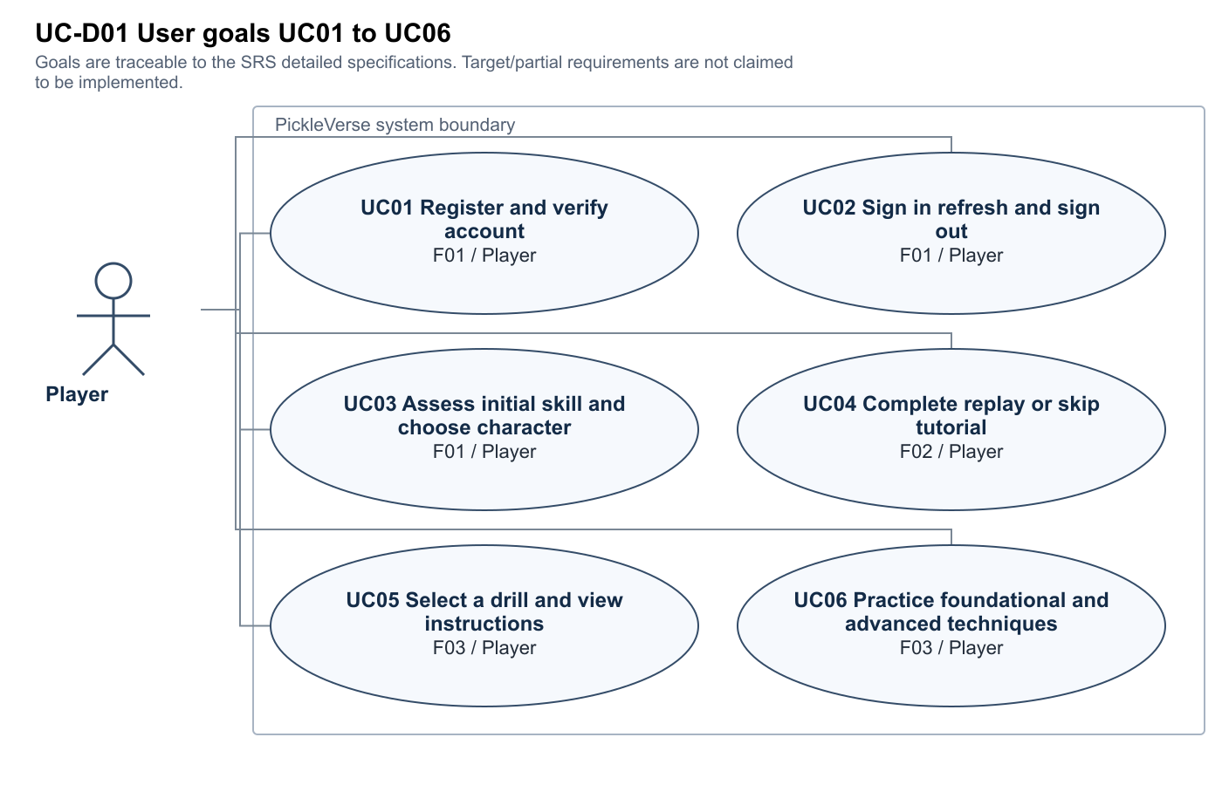
Figure UC-D01 · Editable source and full size SVG/PNG are in Diagrams/Current_c32f2a4.
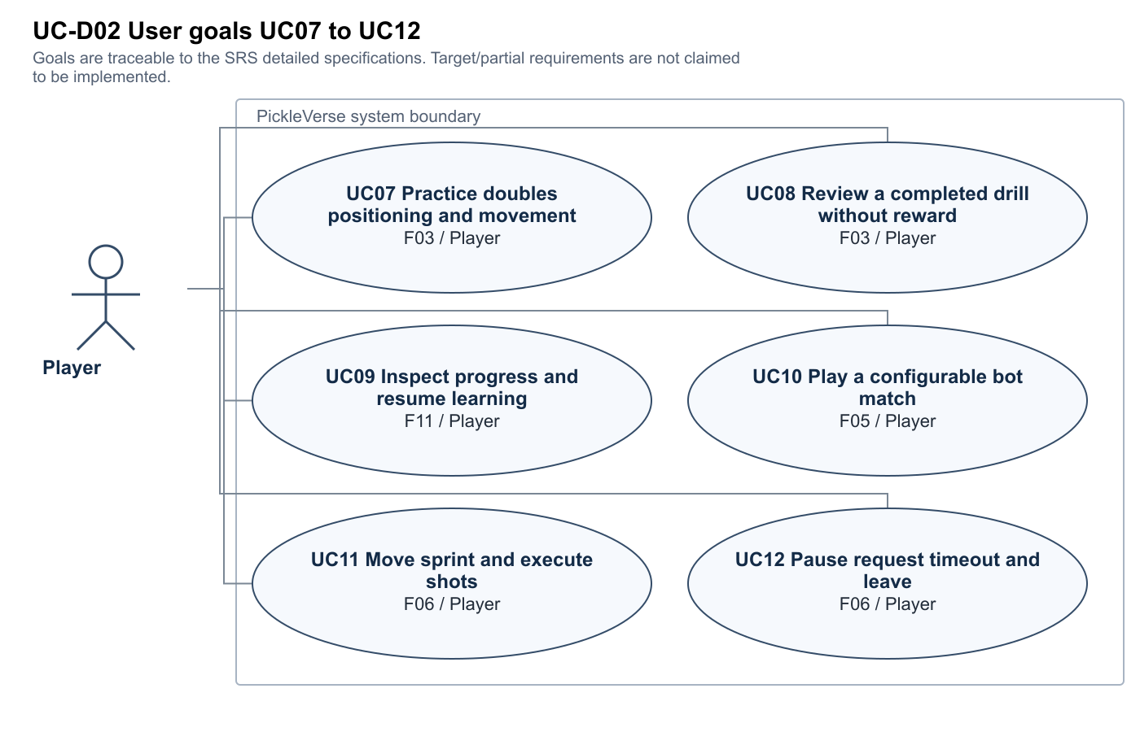
Figure UC-D02 · Editable source and full size SVG/PNG are in Diagrams/Current_c32f2a4.
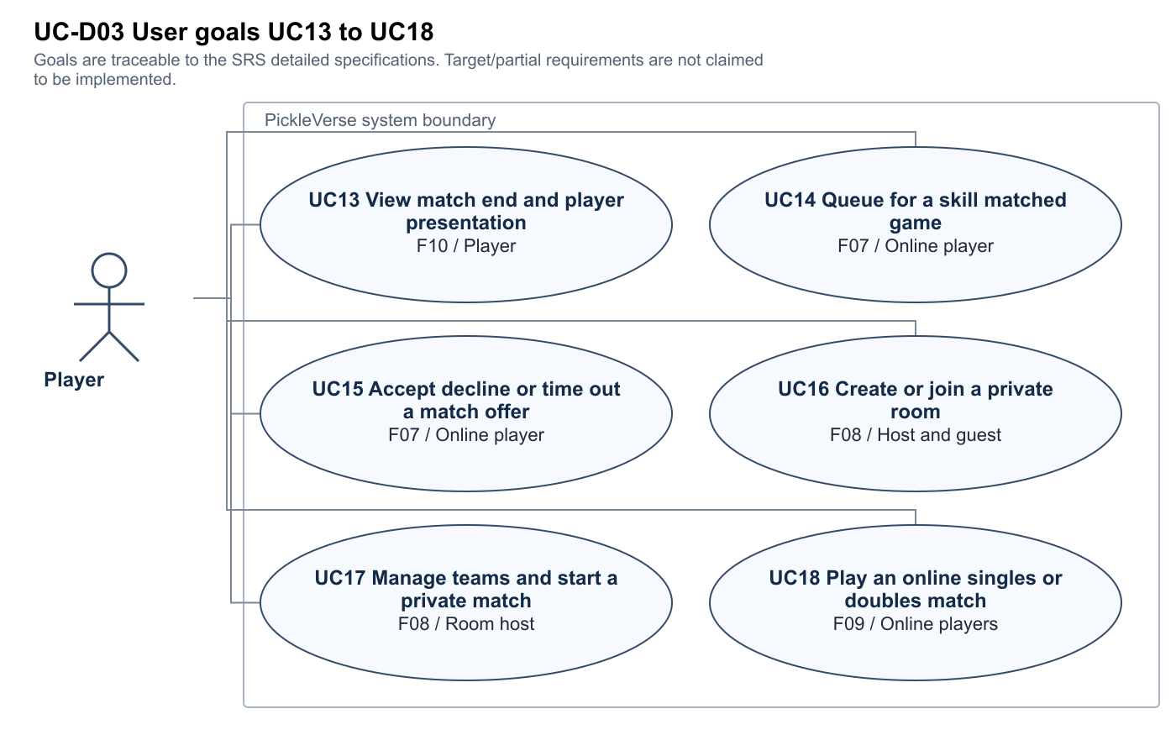
Figure UC-D03 · Editable source and full size SVG/PNG are in Diagrams/Current_c32f2a4.
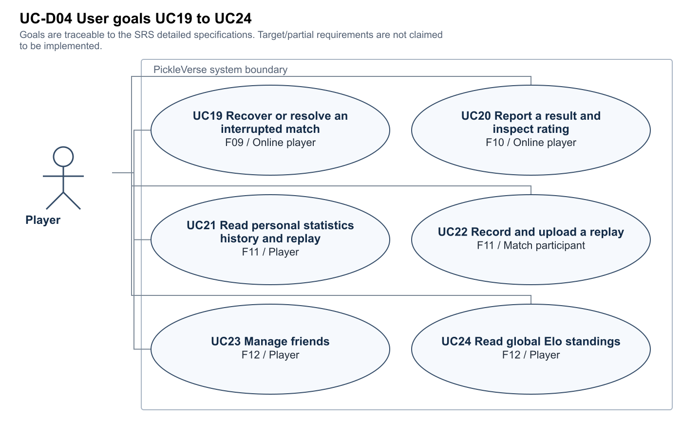
Figure UC-D04 · Editable source and full size SVG/PNG are in Diagrams/Current_c32f2a4.
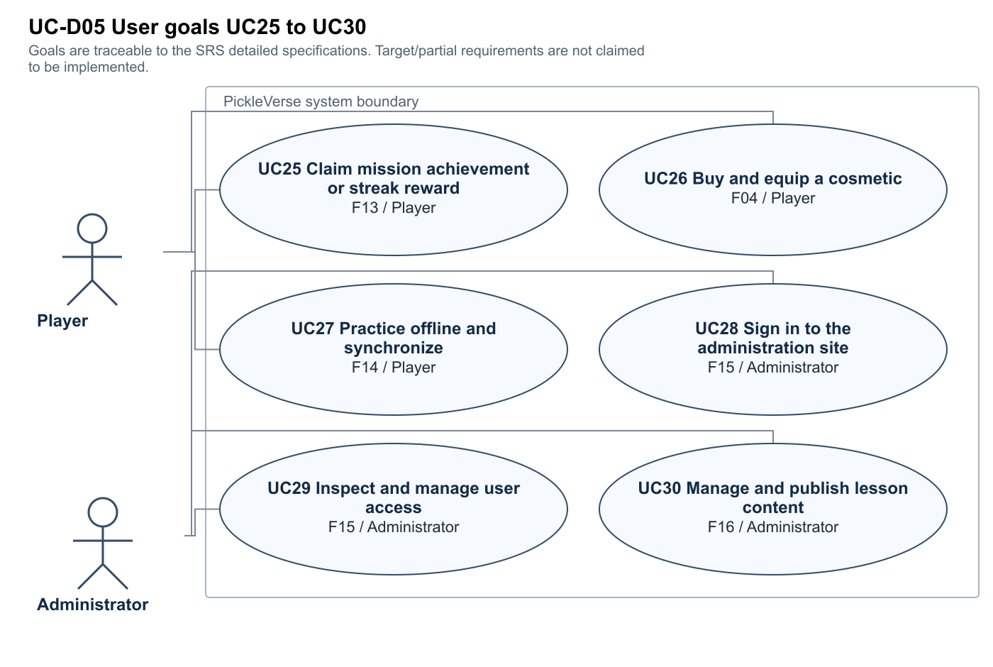
Figure UC-D05 · Editable source and full size SVG/PNG are in Diagrams/Current_c32f2a4.
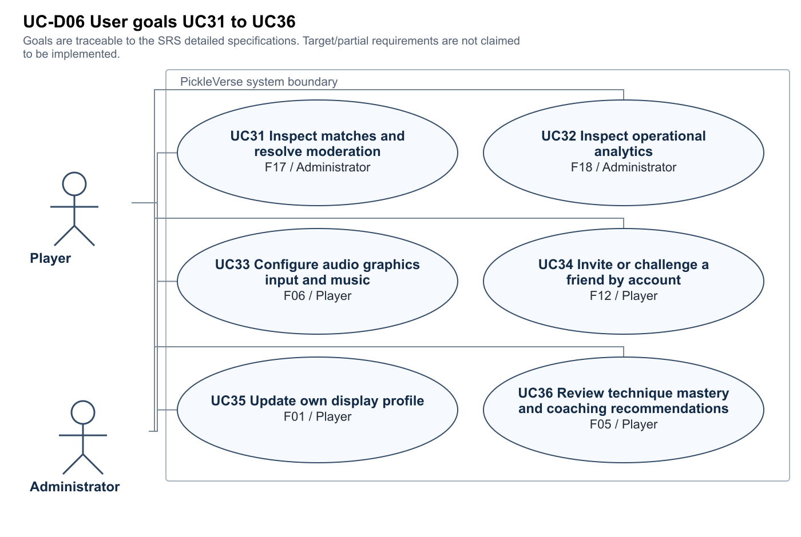
Figure UC-D06 · Editable source and full size SVG/PNG are in Diagrams/Current_c32f2a4.

UC01 Register and verify account
Actor and trigger Player; Submit valid registration.
Preconditions A valid supported client, catalog and authenticated account are available unless this is registration or the explicit offline target.
Main flow 1. Submit valid registration. 2. Receive and enter OTP. 3. Activate account.
Exceptions Duplicate email; Expired/incorrect OTP. Reject invalid mutation, preserve prior committed state and provide retry/policy feedback.
Postcondition Unverified account becomes verified.
Trace: F01 / WF01; Partial; account integration exists, self-assessment/placement not evidenced. Evidence: My project/Assets/Scripts/Services/AccountService.cs:44

UC02 Sign in refresh and sign out
Actor and trigger Player; Submit credentials.
Preconditions A valid supported client, catalog and authenticated account are available unless this is registration or the explicit offline target.
Main flow 1. Submit credentials. 2. Load authenticated profile. 3. Refresh expiring access token. 4. Revoke refresh token on logout.
Exceptions Invalid password; Expired/revoked refresh token. Reject invalid mutation, preserve prior committed state and provide retry/policy feedback.
Postcondition Only the authenticated profile is loaded; old sessions cannot overwrite a new one.
Trace: F01 / WF01; Partial; account integration exists, self-assessment/placement not evidenced. Evidence: My project/Assets/Scripts/Services/AccountService.cs:44

UC03 Assess initial skill and choose character
Actor and trigger Player; Answer self-assessment.
Preconditions A valid supported client, catalog and authenticated account are available unless this is registration or the explicit offline target.
Main flow 1. Answer self-assessment. 2. Choose male or female character. 3. Read initial profile.
Exceptions Incomplete answers; Unsupported profile data. Reject invalid mutation, preserve prior committed state and provide retry/policy feedback.
Postcondition Initial skill is recorded; ML placement remains a target gap.
Trace: F01 / WF01; Partial; account integration exists, self-assessment/placement not evidenced. Evidence: My project/Assets/Scripts/Progression/ProgressionRuntime.cs:8

UC04 Complete replay or skip tutorial
Actor and trigger Player; Open ordered tutorial steps.
Preconditions A valid supported client, catalog and authenticated account are available unless this is registration or the explicit offline target.
Main flow 1. Open ordered tutorial steps. 2. Perform movement and supported shots. 3. Complete or skip and persist status.
Exceptions Step not yet satisfied; API unavailable. Reject invalid mutation, preserve prior committed state and provide retry/policy feedback.
Postcondition Completion is scoped to the current account.
Trace: F02 / WF01; Source integrated; acceptance not run. Evidence: My project/Assets/Scripts/LocalMatch/TutorialDirector.cs:11

UC05 Select a drill and view instructions
Actor and trigger Player; Filter curriculum.
Preconditions A valid supported client, catalog and authenticated account are available unless this is registration or the explicit offline target.
Main flow 1. Filter curriculum. 2. Inspect prerequisites and instructions. 3. Choose an unlocked drill and start attempt.
Exceptions Locked drill; Stale catalog. Reject invalid mutation, preserve prior committed state and provide retry/policy feedback.
Postcondition A valid server-owned attempt exists before progress is submitted.
Trace: F03 / WF01; Source integrated; client telemetry limitation. Evidence: My project/Assets/Scripts/Progression/TrainingModels.cs:7

UC06 Practice foundational and advanced techniques
Actor and trigger Player; Follow camera markers and coaching.
Preconditions A valid supported client, catalog and authenticated account are available unless this is registration or the explicit offline target.
Main flow 1. Follow camera markers and coaching. 2. Serve or execute drive/dink/volley/drop/reset/smash. 3. Submit ordered trial measurements. 4. Complete all required trials.
Exceptions Wrong target or technique; Non-monotonic or invalid measurements. Reject invalid mutation, preserve prior committed state and provide retry/policy feedback.
Postcondition Valid trials determine errors, stars and eligibility; telemetry is still client-supplied.
Trace: F03 / WF01; Source integrated; client telemetry limitation. Evidence: src/Backend/Services/Game/OnlineGameService.Training.cs:1

UC07 Practice doubles positioning and movement
Actor and trigger Player; Open available doubles/footwork drill.
Preconditions A valid supported client, catalog and authenticated account are available unless this is registration or the explicit offline target.
Main flow 1. Open available doubles/footwork drill. 2. Move to marked positions with permitted shots. 3. Complete trial sequence.
Exceptions Run into a boundary; Fail timing or positioning. Reject invalid mutation, preserve prior committed state and provide retry/policy feedback.
Postcondition Progress and actionable error counts are recorded.
Trace: F03 / WF01; Source integrated; client telemetry limitation. Evidence: My project/Assets/Scripts/LocalMatch/TrainingDirector.cs:118

UC08 Review a completed drill without reward
Actor and trigger Player; Open a completed drill as review.
Preconditions A valid supported client, catalog and authenticated account are available unless this is registration or the explicit offline target.
Main flow 1. Open a completed drill as review. 2. Repeat complete trial sequence. 3. Refresh stars and wallet.
Exceptions Duplicate completion request; Wrong attempt ID. Reject invalid mutation, preserve prior committed state and provide retry/policy feedback.
Postcondition Review cannot earn the first-completion award again.
Trace: F03 / WF01; Source integrated; client telemetry limitation. Evidence: src/Backend/Services/Game/OnlineGameService.Training.cs:1

UC09 Inspect progress and resume learning
Actor and trigger Player; Open progression from menu.
Preconditions A valid supported client, catalog and authenticated account are available unless this is registration or the explicit offline target.
Main flow 1. Open progression from menu. 2. Inspect stars, failures and repeated drills. 3. Choose next practice.
Exceptions No progress yet; State refresh failure. Reject invalid mutation, preserve prior committed state and provide retry/policy feedback.
Postcondition Resume selects a permitted drill and preserves prior results.
Trace: F11 / WF05; Source integrated; runtime acceptance not run. Evidence: My project/Assets/Scripts/Progression/ProgressionRuntime.cs:8

UC10 Play a configurable bot match
Actor and trigger Player; Choose court/day-night/difficulty.
Preconditions A valid supported client, catalog and authenticated account are available unless this is registration or the explicit offline target.
Main flow 1. Choose court/day-night/difficulty. 2. Watch entry cinematic. 3. Play legal points. 4. Complete match and read result.
Exceptions Abort before completion; Invalid result submission. Reject invalid mutation, preserve prior committed state and provide retry/policy feedback.
Postcondition A completed result is persisted once; ML adaptation is not assumed.
Trace: F05 / WF02; Partial; Elo-tier bot and heuristic recommendations exist; ML evaluation not evidenced. Evidence: My project/Assets/Scripts/LocalMatch/BotMatch.cs:11

UC11 Move sprint and execute shots
Actor and trigger Player; Move with keyboard or joystick.
Preconditions A valid supported client, catalog and authenticated account are available unless this is registration or the explicit offline target.
Main flow 1. Move with keyboard or joystick. 2. Hold separate sprint control if needed. 3. Charge/modify and release a supported shot. 4. Observe contact animation sound and quality.
Exceptions Input during disabled phase; Illegal kitchen or serve action. Reject invalid mutation, preserve prior committed state and provide retry/policy feedback.
Postcondition Legal contact changes ball state once; movement and shot animation remain controllable.
Trace: F06 / WF02; Source implemented; current runtime not measured. Evidence: My project/Assets/Scripts/LocalMatch/Rules/SinglesRules.cs:29

UC12 Pause request timeout and leave
Actor and trigger Player; Open settings/help or request legal timeout.
Preconditions A valid supported client, catalog and authenticated account are available unless this is registration or the explicit offline target.
Main flow 1. Open settings/help or request legal timeout. 2. Resume or confirm leaving. 3. Apply match policy.
Exceptions Timeout not permitted; Online leave during live match. Reject invalid mutation, preserve prior committed state and provide retry/policy feedback.
Postcondition The match resumes or forfeits according to mode; settings do not silently pause peers.
Trace: F06 / WF02; Source implemented; current runtime not measured. Evidence: My project/Assets/Scripts/LocalMatch/BotMatch.cs:11

UC13 View match end and player presentation
Actor and trigger Player; Finish score sequence.
Preconditions A valid supported client, catalog and authenticated account are available unless this is registration or the explicit offline target.
Main flow 1. Finish score sequence. 2. Wait for match-end notice. 3. Focus local player/team. 4. Display Thắng or Thua and continue to statistics.
Exceptions Local player loses; Doubles team has two actors. Reject invalid mutation, preserve prior committed state and provide retry/policy feedback.
Postcondition Presentation follows the local player/team and preserves outcome.
Trace: F10 / WF03; Source integrated; client consensus trust limit. Evidence: My project/Assets/Scripts/LocalMatch/BotMatch.cs:11

UC14 Queue for a skill matched game
Actor and trigger Online player; Request eligible 1v1/2v2 search.
Preconditions A valid supported client, catalog and authenticated account are available unless this is registration or the explicit offline target.
Main flow 1. Request eligible 1v1/2v2 search. 2. Poll server queue. 3. Receive canonical offer.
Exceptions Duplicate search; Ineligible or reserved account. Reject invalid mutation, preserve prior committed state and provide retry/policy feedback.
Postcondition Only the assigned offer can proceed; bot fallback follows declared policy.
Trace: F07 / WF03; Source integrated; multi-client acceptance not run. Evidence: src/Backend/Services/Game/OnlineGameService.OnlineMatches.cs:182

UC15 Accept decline or time out a match offer
Actor and trigger Online player; Show roster and deadline.
Preconditions A valid supported client, catalog and authenticated account are available unless this is registration or the explicit offline target.
Main flow 1. Show roster and deadline. 2. Accept or decline. 3. Wait for all human decisions.
Exceptions Peer declines; Deadline expires. Reject invalid mutation, preserve prior committed state and provide retry/policy feedback.
Postcondition No match starts before required acceptance; consenting users follow requeue policy.
Trace: F07 / WF03; Source integrated; multi-client acceptance not run. Evidence: src/Backend/Services/Game/OnlineGameService.OnlineMatches.cs:182

UC16 Create or join a private room
Actor and trigger Host and guest; Select 1v1 or 2v2.
Preconditions A valid supported client, catalog and authenticated account are available unless this is registration or the explicit offline target.
Main flow 1. Select 1v1 or 2v2. 2. Create room or enter code. 3. Join canonical roster.
Exceptions Invalid code; Full or incompatible room. Reject invalid mutation, preserve prior committed state and provide retry/policy feedback.
Postcondition Only allowed members occupy room slots.
Trace: F08 / WF04; Source implemented; room-code flow; optional account invitation not verified. Evidence: My project/Assets/Scripts/Multiplayer/PhotonSession.cs:116

UC17 Manage teams and start a private match
Actor and trigger Room host; Assign valid teams.
Preconditions A valid supported client, catalog and authenticated account are available unless this is registration or the explicit offline target.
Main flow 1. Assign valid teams. 2. Collect ready states. 3. Start only valid complete roster.
Exceptions Non-host start; Unbalanced or unready roster. Reject invalid mutation, preserve prior committed state and provide retry/policy feedback.
Postcondition The declared team mode and roster remain consistent.
Trace: F08 / WF04; Source implemented; room-code flow; optional account invitation not verified. Evidence: My project/Assets/Scripts/Multiplayer/PhotonSession.cs:116

UC18 Play an online singles or doubles match
Actor and trigger Online players; Enter assigned Photon Shared session.
Preconditions A valid supported client, catalog and authenticated account are available unless this is registration or the explicit offline target.
Main flow 1. Enter assigned Photon Shared session. 2. Exchange authenticated-member commands. 3. Apply state-authority simulation and snapshots. 4. Resolve score and end notice.
Exceptions Non-member or stale command; Network loss. Reject invalid mutation, preserve prior committed state and provide retry/policy feedback.
Postcondition Peers observe the same match state; dedicated trusted authority remains unmet.
Trace: F09 / WF03; Partial; Fusion Shared differs from dedicated proposal. Evidence: My project/Assets/Scripts/Multiplayer/PhotonSession.cs:116

UC19 Recover or resolve an interrupted match
Actor and trigger Online player; Send heartbeat while playing.
Preconditions A valid supported client, catalog and authenticated account are available unless this is registration or the explicit offline target.
Main flow 1. Send heartbeat while playing. 2. Detect disconnect and allow policy grace. 3. Reconnect or finalize policy forfeit.
Exceptions Grace expired; Participant never returns. Reject invalid mutation, preserve prior committed state and provide retry/policy feedback.
Postcondition Server policy prevents indefinitely reserved or multiply finalized sessions.
Trace: F09 / WF03; Partial; Fusion Shared differs from dedicated proposal. Evidence: src/Backend/Services/Game/OnlineGameService.OnlineMatches.cs:182

UC20 Report a result and inspect rating
Actor and trigger Online player; Submit participant result.
Preconditions A valid supported client, catalog and authenticated account are available unless this is registration or the explicit offline target.
Main flow 1. Submit participant result. 2. Validate scores and canonical roster. 3. Agree human reports. 4. Atomically finalize and refresh.
Exceptions Conflicting report; Same ID with changed payload. Reject invalid mutation, preserve prior committed state and provide retry/policy feedback.
Postcondition Each participant receives at most one Elo/wallet/history update.
Trace: F10 / WF03; Source integrated; client consensus trust limit. Evidence: src/Backend/Services/Game/OnlineGameService.OnlineMatches.cs:182

UC21 Read personal statistics history and replay
Actor and trigger Player; Load own recent matches.
Preconditions A valid supported client, catalog and authenticated account are available unless this is registration or the explicit offline target.
Main flow 1. Load own recent matches. 2. Select authorized replay. 3. Download bounded chunks. 4. Play pause seek or change speed.
Exceptions Foreign match replay; Corrupt oversized chunk. Reject invalid mutation, preserve prior committed state and provide retry/policy feedback.
Postcondition Only authorized valid replay data is stored/read.
Trace: F11 / WF05; Source integrated; runtime acceptance not run. Evidence: src/Backend/Services/Game/OnlineReplayService.cs:14

UC22 Record and upload a replay
Actor and trigger Match participant; Capture bounded actor samples/events.
Preconditions A valid supported client, catalog and authenticated account are available unless this is registration or the explicit offline target.
Main flow 1. Capture bounded actor samples/events. 2. Submit metadata and compressed chunks. 3. Validate hash ownership and limits.
Exceptions Wrong owner; Malformed compression or frame data. Reject invalid mutation, preserve prior committed state and provide retry/policy feedback.
Postcondition Replay chunks are idempotent and linked to an authorized match.
Trace: F11 / WF05; Source integrated; runtime acceptance not run. Evidence: src/Backend/Services/Game/OnlineReplayService.cs:14

UC23 Manage friends
Actor and trigger Player; Search real accounts.
Preconditions A valid supported client, catalog and authenticated account are available unless this is registration or the explicit offline target.
Main flow 1. Search real accounts. 2. Request friendship. 3. Accept decline or remove relationship.
Exceptions Self request; Unauthorized acceptance. Reject invalid mutation, preserve prior committed state and provide retry/policy feedback.
Postcondition Only the appropriate account can change the relationship.
Trace: F12 / WF04; Source integrated; runtime acceptance not run. Evidence: src/Backend/Services/Game/OnlineSocialService.cs:27

UC24 Read global Elo standings
Actor and trigger Player; Request ranked page and own position.
Preconditions A valid supported client, catalog and authenticated account are available unless this is registration or the explicit offline target.
Main flow 1. Request ranked page and own position. 2. Read stable ordered results. 3. Refresh after finalized result.
Exceptions Cache miss; Tied Elo. Reject invalid mutation, preserve prior committed state and provide retry/policy feedback.
Postcondition PostgreSQL is the source of truth and Redis caching preserves ordering.
Trace: F12 / WF04; Source integrated; runtime acceptance not run. Evidence: src/Backend/Services/Game/OnlineSocialService.cs:27

UC25 Claim mission achievement or streak reward
Actor and trigger Player; Read period/objective progress.
Preconditions A valid supported client, catalog and authenticated account are available unless this is registration or the explicit offline target.
Main flow 1. Read period/objective progress. 2. Claim an eligible reward. 3. Persist command and balance. 4. Refresh state.
Exceptions Already claimed; Not yet eligible. Reject invalid mutation, preserve prior committed state and provide retry/policy feedback.
Postcondition Only eligible unique rewards credit the wallet/XP.
Trace: F13 / WF05; Source integrated; runtime acceptance not run. Evidence: src/Backend/Services/Game/OnlineGameService.cs:90

UC26 Buy and equip a cosmetic
Actor and trigger Player; Browse configured catalog and price.
Preconditions A valid supported client, catalog and authenticated account are available unless this is registration or the explicit offline target.
Main flow 1. Browse configured catalog and price. 2. Purchase with in-game currency. 3. Equip owned item. 4. Refresh profile and balance.
Exceptions Insufficient funds; Unowned item. Reject invalid mutation, preserve prior committed state and provide retry/policy feedback.
Postcondition Currency and ownership change atomically; real-money payment is outside current scope.
Trace: F04 / WF05; Source integrated; acceptance not run. Evidence: src/Backend/Services/Game/OnlineGameService.cs:90

UC27 Practice offline and synchronize
Actor and trigger Player; Enter drill without network.
Preconditions A valid supported client, catalog and authenticated account are available unless this is registration or the explicit offline target.
Main flow 1. Enter drill without network. 2. Persist permitted attempt locally. 3. Reconnect and reconcile once.
Exceptions Account switch; Repeated sync or conflicting revision. Reject invalid mutation, preserve prior committed state and provide retry/policy feedback.
Postcondition Target only: active runtime is online-only and does not demonstrate this flow.
Trace: F14 / WF05; Gap; active runtime now requires online state. Evidence: My project/Assets/Scripts/Progression/ProgressionRuntime.cs:8

UC28 Sign in to the administration site
Actor and trigger Administrator; Submit API-compatible administrator credentials.
Preconditions A valid supported client, catalog and authenticated account are available unless this is registration or the explicit offline target.
Main flow 1. Submit API-compatible administrator credentials. 2. Receive role-scoped token. 3. Open protected dashboard.
Exceptions Player role; Invalid token. Reject invalid mutation, preserve prior committed state and provide retry/policy feedback.
Postcondition Target flow blocked by current web/API login contract mismatch.
Trace: F15 / WF06; Partial; web login contract and status defect. Evidence: src/Frontend/src/context/AuthContext.tsx:41

UC29 Inspect and manage user access
Actor and trigger Administrator; List/filter users.
Preconditions A valid supported client, catalog and authenticated account are available unless this is registration or the explicit offline target.
Main flow 1. List/filter users. 2. Inspect profile and role. 3. Ban restore or change permitted role.
Exceptions Non-admin request; Invalid status value. Reject invalid mutation, preserve prior committed state and provide retry/policy feedback.
Postcondition Authorized valid changes persist; current enum-to-SQL status mismatch is a defect.
Trace: F15 / WF06; Partial; web login contract and status defect. Evidence: src/Backend/Services/Implementations/AdminService.cs:82

UC30 Manage and publish lesson content
Actor and trigger Administrator; Create lesson/drill.
Preconditions A valid supported client, catalog and authenticated account are available unless this is registration or the explicit offline target.
Main flow 1. Create lesson/drill. 2. Validate required code/config/order. 3. Publish catalog revision. 4. Verify in Unity catalog.
Exceptions Missing config; Invalid lesson/drill. Reject invalid mutation, preserve prior committed state and provide retry/policy feedback.
Postcondition Partial CRUD exists; publishing playable catalog content is not complete.
Trace: F16 / WF06; Partial; CRUD exists, playable publication gap. Evidence: src/Backend/Services/Implementations/AdminService.cs:159

UC31 Inspect matches and resolve moderation
Actor and trigger Administrator; Inspect selected live/completed match or report.
Preconditions A valid supported client, catalog and authenticated account are available unless this is registration or the explicit offline target.
Main flow 1. Inspect selected live/completed match or report. 2. Review evidence and disconnect outcome. 3. Record authorized decision and appeal outcome.
Exceptions Unauthorized action; Missing evidence. Reject invalid mutation, preserve prior committed state and provide retry/policy feedback.
Postcondition Full moderation and appeal lifecycle is a proposed requirement, only partial endpoints exist.
Trace: F17 / WF06; Partial; appeal and full oversight not evidenced. Evidence: src/Backend/API/Controllers/AdminController.cs:10

UC32 Inspect operational analytics
Actor and trigger Administrator; Choose metric and period.
Preconditions A valid supported client, catalog and authenticated account are available unless this is registration or the explicit offline target.
Main flow 1. Choose metric and period. 2. Read active users retention/errors/queue health. 3. Inspect denominator and sample window.
Exceptions Empty period; Unavailable metric. Reject invalid mutation, preserve prior committed state and provide retry/policy feedback.
Postcondition Metrics use their declared definitions; total users cannot represent active users today.
Trace: F18 / WF06; Partial; active-user metric is a total count. Evidence: src/Backend/Services/Implementations/AdminService.cs:353

UC33 Configure audio graphics input and music
Actor and trigger Player; Open settings or music room.
Preconditions A valid supported client, catalog and authenticated account are available unless this is registration or the explicit offline target.
Main flow 1. Open settings or music room. 2. Set volume quality frame cap or bindings. 3. Apply safe-area touch layout. 4. Persist permitted preferences.
Exceptions Unsupported device option; Conflicting binding. Reject invalid mutation, preserve prior committed state and provide retry/policy feedback.
Postcondition Supporting UX preserves readable controls; source existence does not establish measured FPS.
Trace: F06 / WF02; Source implemented; current runtime not measured. Evidence: My project/Assets/Scripts/LocalMatch/BotMatch.cs:11

UC34 Invite or challenge a friend by account
Actor and trigger Player; Choose an accepted friend.
Preconditions A valid supported client, catalog and authenticated account are available unless this is registration or the explicit offline target.
Main flow 1. Choose an accepted friend. 2. Send a room invitation. 3. Accept and join the selected room.
Exceptions Friend unavailable; Expired invitation. Reject invalid mutation, preserve prior committed state and provide retry/policy feedback.
Postcondition Supporting desired extension, not a replacement for the proposal room-code requirement. Account-targeted invitation is not evidenced.
Trace: F12 / WF04; Supporting UX extension; not evidenced or approved as an additional mandatory commitment. Evidence: src/Backend/Services/Game/OnlineSocialService.cs:27

UC35 Update own display profile
Actor and trigger Player; Open authenticated profile.
Preconditions A valid supported client, catalog and authenticated account are available unless this is registration or the explicit offline target.
Main flow 1. Open authenticated profile. 2. Submit valid permitted display-name/character fields. 3. Refresh the same account profile.
Exceptions Duplicate or invalid name; Foreign-account mutation attempt. Reject invalid mutation, preserve prior committed state and provide retry/policy feedback.
Postcondition Only permitted fields of the authenticated profile change.
Trace: F01 / WF01; Partial; account integration exists, self-assessment/placement not evidenced. Evidence: My project/Assets/Scripts/Services/AccountService.cs:44

UC36 Review technique mastery and coaching recommendations
Actor and trigger Player; Load recorded technique mastery.
Preconditions A valid supported client, catalog and authenticated account are available unless this is registration or the explicit offline target.
Main flow 1. Load recorded technique mastery. 2. Identify the weakest measured technique. 3. Read matching suggested drills and coaching. 4. Validate target classifier output against labelled telemetry.
Exceptions No technique history; Missing or unevaluated model. Reject invalid mutation, preserve prior committed state and provide retry/policy feedback.
Postcondition A rule-based backend recommendation exists; integrated evaluated ML coaching remains a target gap.
Trace: F05 / WF02; Partial; Elo-tier bot and heuristic recommendations exist; ML evaluation not evidenced. Evidence: src/Backend/Services/Implementations/AiCoachingService.cs:44

5 Business rules
BR01 Only verified active accounts may authenticate; OTP expiry/failure limits and refresh-token revocation are enforced by the backend.
BR02 The account UUID is the common game/API identity; a delayed response from an older account must not replace current state.
BR03 Catalog data defines available lessons, prerequisites, rewards and prices. UI labels do not authorize an award.
BR04 The first eligible drill completion may earn configured Tokenpad/XP; review runs cannot receive that first reward again. The earlier 150 Tokenpad base request is a configured policy, not a hard-coded SRS claim for every difficulty.
BR05 Training counters must be monotonic, finite and scoped to the active attempt; completed trials must meet the configured total. Client measurements remain a trust limitation.
BR06 Each valid command ID and payload is idempotent. A reused ID with different content must conflict rather than grant a second reward.
BR07 Serve, kitchen, net, boundary, two-bounce, side-out/scoring and match-winning rules must follow the supplied pickleball rules document; sport-law compatibility must be acceptance-tested for each mode.
BR08 Do not begin online play before the canonical required human roster has accepted. A decliner leaves searching; consenting peers follow the configured requeue policy.
BR09 For doubles, both teams have two valid slots and only permitted members/host may change room state. A server-assigned virtual bot is distinguished from a human participant.
BR10 The backend validates roster, outcome and legal score form, compares human reports and finalizes balances/rating/history atomically. Human agreement does not certify independent server simulation.
BR11 A disconnect/leave follows server heartbeat and grace/forfeit policy, not arbitrary client reward claims.
BR12 Replay metadata/chunks are authorized by match participation and bounded by size, frame/event count, finite values and hashes. Object keys are opaque references, not public access grants.
BR13 Global Elo uses PostgreSQL as the source of truth; Redis is a versioned cache with stable tie order. A cache miss must not mutate Elo.
BR14 Administrative rights require the API Admin role; browser-only role checks are insufficient. SQL status values must match the database constraint.
BR15 Publishing content requires a valid runtime code/config and lesson/drill linkage. Draft CRUD and a publication lifecycle are distinct.
BR16 Real-money top-up, tournaments, spectator mode, ranked ladders and video swing analysis are outside the supplied capstone scope. The proposal also includes Elo ratings and leaderboards; the team must clarify this boundary without silently adding a seasonal interpretation.

6 Non functional requirements
The following six groups preserve the proposal concerns. “Proposed” thresholds refine a missing measurement contract and require agreement; they are not claims of achieved performance or approved scope relaxation.

N01 Interactive performance
Metric Median and p95 frame time; input-to-visible feedback; technique feedback delay
Threshold Proposed: median ≤16.7 ms and p95 ≤25 ms on an agreed midrange device; input p95 ≤100 ms; coaching <1 s. The proposal states stable 60 FPS; any relaxed percentile needs approval.
Method Release builds on Windows and Galaxy A32; 15 minute day/night sessions in all four play scenes; capture CPU/GPU/frame-time and touch traces.
Trace: TC-N01; proposed owner M2. No current run evidence.

N02 Network responsiveness and capacity
Metric RTT; concurrent players and matches; matchmaking errors
Threshold Proposal: typical VN RTT <100 ms; 2,000 players / 500 concurrent matches; no cross-match membership or duplicate result.
Method Seeded staging multi-client load and network impairment; measure p95 RTT separately from server command latency.
Trace: TC-N02; proposed owner M3. No current run evidence.

N03 Availability and recovery
Metric Monthly successful service availability; tested backup/rollback
Threshold Proposal: ≥99.5% monthly availability; proposed recovery targets RPO ≤24 h / RTO ≤4 h require approval.
Method External probes plus service metrics; restore a staging backup and deploy/rollback a known version.
Trace: TC-N03; proposed owner M4. No current run evidence.

N04 Platform and usable controls
Metric Acceptance pass matrix; safe-area clipping; target hit area
Threshold Windows 10+, Android 9+, iOS 14+ as proposed; all main flows pass; no clipped essential controls; proposed touch targets ≥48 dp.
Method Physical Windows/Android/iOS test matrix and landscape safe-area screenshots; simulation does not prove physical performance.
Trace: TC-N04; proposed owner M2. No current run evidence.

N05 Security and trusted data
Metric Unauthorized actions; replayed commands; transport/at-rest protection; simulation authority
Threshold JWT access control; reject all unauthorized mutation/replayed conflicting commands; proposal AES-256 and dedicated authority require deployment/design evidence.
Method Auth/RBAC negative tests, duplicate/race tests, TLS/secret/backup configuration inspection and malicious-peer simulation.
Trace: TC-N05; proposed owner M4. No current run evidence.

N06 Offline data and learning quality
Metric Offline completion/sync duplication; classifier and recommendation quality
Threshold Proposal offline training plus exactly-once permitted sync; proposed ML macro-F1 ≥0.80 and recommendation acceptance ≥80% require labelled evaluation and agreement.
Method Disconnect/reconnect drill tests; account-switch conflicts; held-out labelled dataset with confusion matrix and recommendation review.
Trace: TC-N06; proposed owner M1. No current run evidence.

7 Data external interfaces and privacy
The SDD and current CSV dictionary cover all 37 declared SQL tables and 208 columns. API inventory contains 81 endpoint declarations, including deprecated 410 handlers. These counts describe source, not a running deployed database or 81 working user goals.
The Unity client sends identity/profile data, training measurements, activity times, roster/session details, result reports, social operations and replay samples through authenticated JSON APIs. Photon carries member commands/state snapshots. SMTP receives verification delivery data. S3 stores compressed replay payloads. Passwords, tokens, OTPs, signing keys and connection strings are excluded from this evidence pack.

8 Workflow and test traceability
Workflow | Features | Owner slot
WF01 Register learn and complete a first drill | F01, F02, F03 | M1
WF02 Practice against an adaptive bot | F05, F06, F10, F11 | M2
WF03 Find accept and finish an online match | F06, F07, F09, F10 | M3
WF04 Create a private team match | F08, F09, F10, F12 | M3
WF05 Review progress and claim rewards | F03, F04, F11, F13, F14 | M1
WF06 Administer users content and operations | F15, F16, F17, F18 | M4

The proposed minimum is 3 × 18 + 6 + 118 + 6 = 184 unique test cases. The register contains 184, all NOT RUN for this documentation task. At least 92 must actually execute in CI after agreement; current CI compliance is unverified. See Feature_Traceability.csv and Test_Case_Register.csv.

9 Open decisions and known gaps
SR01 High Photon Fusion Shared gives a peer state authority. This is not the proposed trusted dedicated simulation and leaves host/peer trust risk.
SR02 High The active progression runtime requires server state. Offline drill execution and exactly-once later synchronization are not demonstrated.
SR03 High Initial-placement ML, telemetry technique classifier, labelled evaluation and validated recommendations are not evidenced. Rule-based feedback does not establish those commitments.
SR04 High The React login sends emailOrUsername/passwordHash and reads role/token, while the API requires Email/Password and returns AccessToken/Profile. The default contracts are incompatible.
SR05 High Admin mutations serialize enum status as Banned/Active while the SQL constraint uses ACTIVE/BANNED/SUSPENDED; these values can fail the database constraint.
SR06 High Admin lesson creation omits catalog Code/Config, while the game catalog selects coded configured lessons. CRUD does not yet demonstrate publishing a playable drill.
SR07 High Complete live-match oversight, appeals and operational analytics are not evidenced. ActiveUsersToday currently counts all users rather than dated activity.
SR08 High Current-revision physical-device, network/load, security, availability, offline and ML acceptance results are unavailable. Test source is not execution evidence.
SR09 High The local review-2 tag and CI execution evidence are absent; the required official tagged self-review and automated-in-CI target cannot be verified.
SR10 Medium The approved registration revision, official project code and decisions accepting stack/authority deviations are unconfirmed. No scope reduction has been assumed.
SR11 Medium Server-owned transactions and matching human reports improve result integrity, but peers still supply simulation outcomes and training measurements. Agreement does not independently prove legal physics.
SR12 Medium Real friendship APIs and room-code play exist and cover the proposal room-code requirement. Account-targeted invitations are an unverified desired UX extension; confirm whether they should become a separate commitment.
SR13 Medium Fallback authentication configuration, deployed TLS/AES-256 controls, production rollback and iOS build acceptance require deployment evidence; configuration values are intentionally redacted.

